***Breakfast Menu***

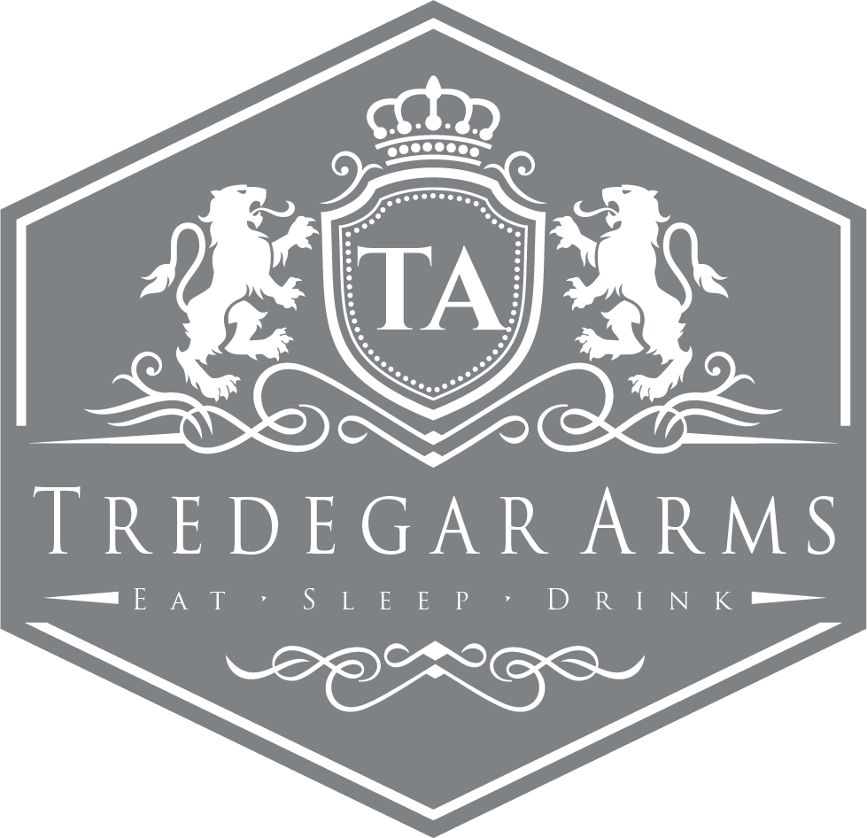**FULL ENGLISH - £5.95**

(Bacon, Sausage, Hash Brown, Black Pudding, Mushrooms, Beans, Grilled Tomato and an Egg of your choice)

Poached Egg and Avocado on Wholegrain Bread with Grilled Tomato **(V) - £4.95**

Smoked Salmon & Scrambled Egg - £4.95

Loaded Pancakes with Bacon & Syrup - £3.50

Eggs Benedict - £3.50