***Children’s Menu***

**£4.95 and includes Fruit Shoot drink**

Sausage, Chips or Mash, Peas & Gravy

Chicken Bites, Chips & Beans

Turkey Dinosaurs, Chips & Beans

Cheese & Tomato Pizza Teds, Chips & Sauce

Macaroni Cheese **(V)**

Beef Burger, Chips & Beans

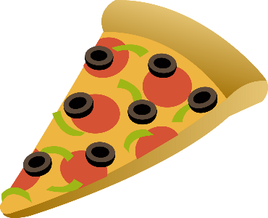

Ice-Cream - £1.00

Vanilla

Chocolate

Strawberry