Tredegar Arms Hotel

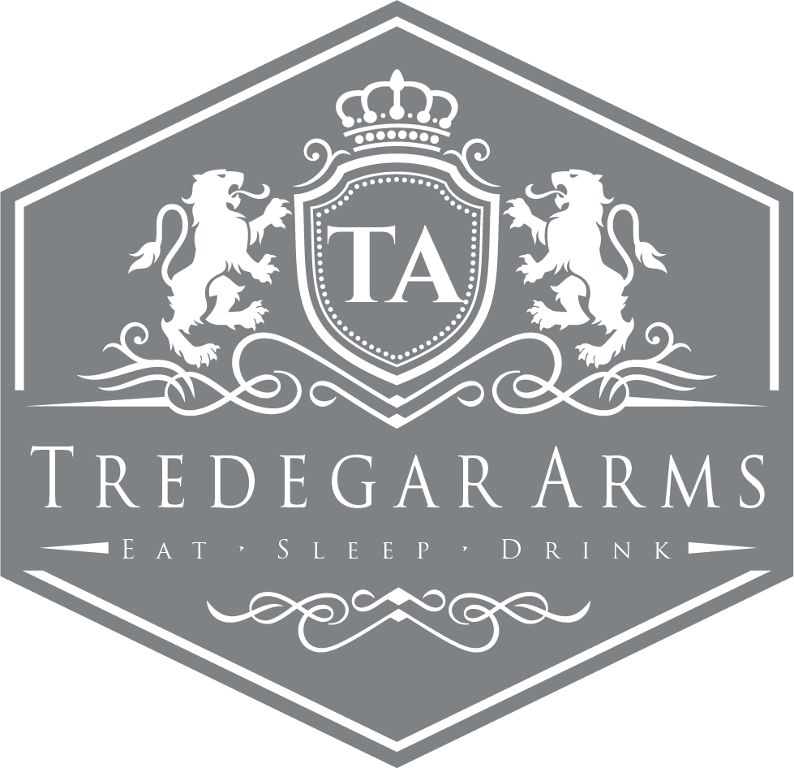Conference Pack

Conference Information

Tredegar Arms Hotel is situated in a popular Welsh town called Tredegar. The building itself has been standing since 1817 and still holds some of its former glory despite recently undergoing a £1.5 million refurbishment.

The Hotel has 10 luxurious bedrooms. A combination of doubles, singles, twins and an executive suite. All rooms are en suite and have Wi-Fi access.

Room Hire Prices

Sirhowy Suite (4 Hours) - £150.00  
 (8 Hours) - £200.00  
*The Sirhowy Suite can hold up to 70 guests*

Restaurant (4 Hours) - £50.00  
 (8 Hours) - £100.00  
*our restaurant can hold up to 30 guests*

Delegate Rates

Half Day Delegate Rate (Minimum number of 12)  
Room Hire  
Option 1 Buffet Lunch  
Jugs of Water  
Two servings of Tea/Coffee and biscuits  
Pens and Paper  
One Flip Chart with Marker Pens  
*£10.00 per delegate*

Full Day Delegate Rate (Minimum Number of 12)  
Room Hire  
Option 1 Buffet Lunch  
Three Servings of Tea/Coffee and Biscuits  
Jugs of Water  
Pens and Paper  
One Flip Chart with Marker Pens  
*£15.00 per delegate*

Menu Options

Option 1 - £11.00 per head (Minimum Number of 12)  
Mixed sandwich platter, potato salad, tomato salad and coleslaw plus five of the following options:

Chicken Drumsticks Spicy Potato Wedges  
Hot Glazed Sausages Quiche  
Mini Spring Rolls Pork Pies  
Warm Sausage Rolls Vegetable Samosas  
Cold Ham Platter French Bread  
Hot Pizza Fingers Pasta Salad  
Warm Pasties Plaice Goujons  
Crisps and Nuts Chicken Goujons  
Breaded Garlic Mushrooms Home Cut Chips

Breakfast Meetings

Option 2 - £5.00 per head   
Light Breakfast including Cereal, Yoghurts, Danish Pastries, Fresh Fruit with the choice of Tea/Coffee and Fruit Juice.

Option 3 - £7.00 per head  
Full Welsh Breakfast   
(Bacon, Sausage, Fried Egg, Tomatoes, Baked Beans, Mushrooms and Hash Browns)  
Along with Cereal, Yoghurts, Danish Pastries, Fresh Fruit, Tea/Coffee and Fruit Juice.

Optional Extras

With your room hire you can also include the following refreshments. The prices are based on one serving per delegate.

Tea/Coffee - £1.60  
Tea/Coffee and Biscuits - £2.60  
Tea/Coffee and Welshcakes - £3.35  
Tea/Coffee and Fruit Cake - £3.85  
Jug of Juice (Orange or Apple) - £5.00  
Mineral Water (Still or Sparkling) - £1.60  
Bacon Sandwiches – £2.60

Room Layouts

Boardroom Stlye

Banqueting Rounds

U-Shape

Classroom Style

Terms and Conditions

1. **Contact** – When booking is confirmed by the return of the booking form to the hotel a contract is deemed to exist.
2. **Numbers** – Final numbers are required 72 hours prior to the date of the conference. This will be the minimum number charged for.
3. **Cancellations** – in the unfortunate event of a cancellation, the following charges will apply.   
   A) Within one month of the event – 20% of the room hire fee  
   b) Within in two weeks of the event – 50% of the room hire fee  
   c) Within in one week of the event – 100% of the room hire fee  
   d) Within 48 hours of the event – Full Payment of anticipated requirements
4. **Times** – All conference finishing times must be strictly adhered to, due to the possibility of the room being required for another function later the same day. All refreshment breaks must be at the specified times unless granted otherwise by the duty manager.
5. **Food and Beverages** – The client will ensure that no food or drink is brought into the hotel premises for consumption. Food left over from the buffets etc cannot be removed from the hotel. The hotel cannot be deemed responsible for any allergic reactions caused by food if said allergy is not stated on the booking form.
6. **Equipment** – Equipment brought to the hotel must comply with all current regulations including PAT testing, the client will be responsible for any damage or injury caused. The hotel cannot be held responsible for the loss or damage of any equipment.
7. **Health and Safety** – The client agrees to take reasonable precautions to ensure that no damage occurs or injury to any person. The client will be responsible for the actions of all guests and contactors for any damage or injury caused whatsoever to persons, hotel property/fixtures or fittings.
8. **Agreement Governed by English Law** - The contract shall be governed in all aspects by English Law.
9. **Insurance** – After all this, you may consider arranging insurance. This can be done for a small premium and cover the cost of cancellation and other liabilities. Please note, any contract of insurance would be made by the client direct with the insurance company.

Tredegar Arms Hotel  
 Conference Confirmation Booking Form

Name: Date of Conference:  
Company: Conference Name:  
Address: No. of Delegates:

Signature of Organiser:

Tel No:  
Email:

Room Choice: Ballroom Restaurant Extension  
Start/Finish Time:

Room Layout: (please underline preferred option)

Classroom Style  
Banqueting Rounds  
Boardroom Style  
U-Shape

Equipment Hire and Quantity:

Flip Chart  
Screen  
O.H.P  
TV/DVD  
Laptop  
Digital Projector  
Microphone  
CD Player

Tredegar Arms Hotel  
Conference Catering Form

Please complete the table below with your requirements for refreshments. Please note: if refreshments are required then all delegates must be catered for.

Option 1 – Buffet   
Option 2 – Light Breakfast  
Option 3 – Full Breakfast

A – Tea/Coffee  
B – Tea/Coffee and Biscuits  
C – Tea/Coffee and Welshcakes  
D – Tea/Coffee and Fruit Cake  
E – Bacon Sandwiches  
F – Mineral Water (still or sparkling)  
G – Jugs of Fruit Juice (orange or apple)

Option 1 choices - Please underline 5

Chicken Drumsticks Spicy Potato Wedges  
Hot Glazed Sausages quiche  
Mini Spring Rolls Pork Pies  
Warm Sausage Rolls Vegetable Samosas  
Cold Ham Platter French Bread  
Hot Pizza Fingers Pasta Salad  
Warm Pasties Plaice Goujons  
Crisps and Nuts Chicken Goujons  
Breaded Garlic Mushrooms Home Cut Chips

|  |  |  |  |
| --- | --- | --- | --- |
| Break | Time Required | Refreshment Option | Number Required |
| Arrival |  |  |  |
| Mid Morning |  |  |  |
| Lunch |  |  |  |
| Mid Afternoon |  |  |  |
| Finish |  |  |  |

Any other information:  
** (Please include any dietary requirements or allergies below) **

Tredegar Arms Hotel  
Morgan Street, Tredegar, Gwent, NP22 3NA

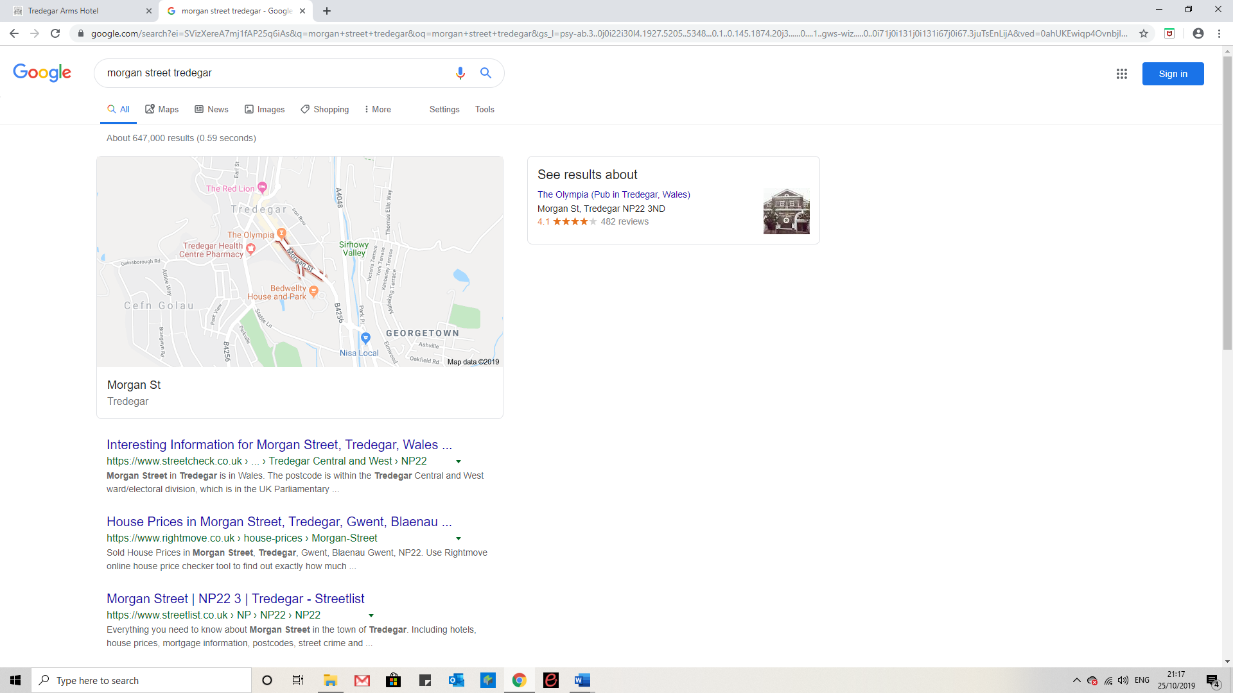

01495 788 463 reservationsta@outlook.com