Function Brochure
Room Hire

The Sirhowy Suite (Up to 70 Guests)
The Sirhowy Suite can accommodate up to seventy
Guests and costs £150.00 to hire out without hotel catering.

Please note, if you require hotel catering with your function the room hire charge is waived.

CANAPE SELECTION

The main events are usually served with drinks after arrival at Tredegar Arms Hotel. An elegant canapé reception is offered to guests at the front of the Hotel.

Please select four of the following options for £5.00;
Should you wish to have any more than four options, each additional item is priced at £1.50 per person thereafter.

Cold Canapés
Chicken & Liver Pate on Melba Toast
Smoked Salmon on Wholegrain Bread
Selection of Mixed Olives
Sausage Cheetos
Vegetable Curry Trigons
Mini Wraps

Warm Canapés
King Prawns with Sweet Chilli Dip
Cheese Sesame Prawn Toast
Duck Spring Rolls with Hoisin Sauce
Mixed Vegetable Samosas & Mango Chutney
Hot Western Style Seasoned Wedges
Honey & Mustard Glazed Sausage
Traditional Welsh Rarebit
Deep Fried Garlic Mushroom and Garlic Mayo Dip

ARRIVAL & TOASTING DRINK
Arrival Drinks

Bucks Fizz.............................................................. £5.25
Prosecco……………………………………………………… £4.00
Pimms and Lemonade............................................£5.50
Sparkling Wine .....................................................£5.95
Spirit and Mixer -...................................................£3.70
Corona ...................................................................£3.30
Budweiser ..............................................................£3.30
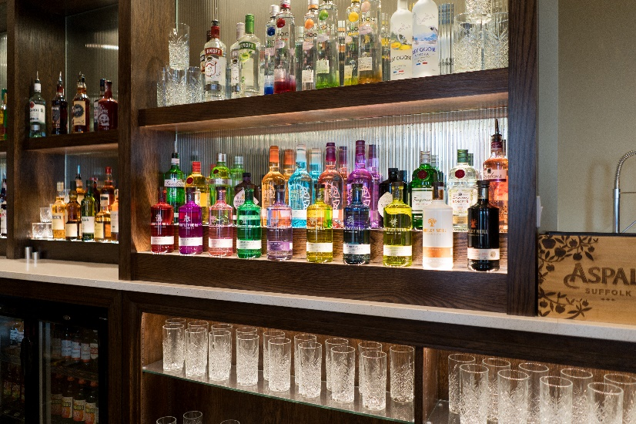
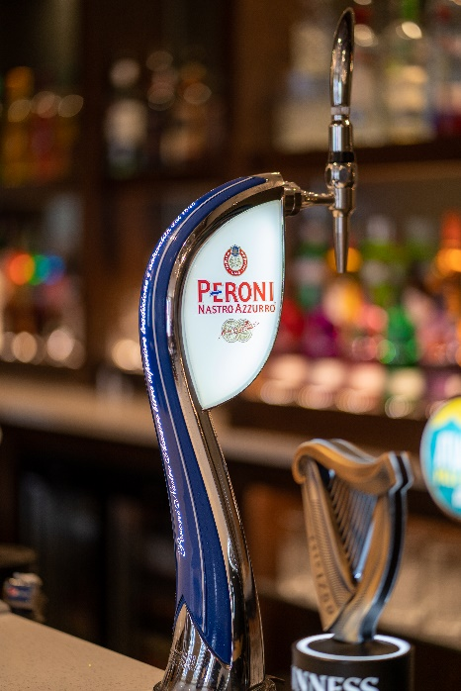

BUFFET OPTIONS

Hog Roast

Fresh Spit Roasted Pig with Bramley Apple Sauce, Homemade Stuffing, Crackling, Hot New Potatoes, Bread Rolls, Potato Salad, Tomato and Onion Salad and Coleslaw. Minimum numbers of 30.

The Hog Roast Buffet is priced at £15.00 per person.
SIGNATURE BUFFET
This buffet choice includes a mixed sandwich platter made up of Beef and Horseradish, Ham and Cheese, Tuna Mayonnaise and Cucumber, Egg Mayonnaise and Cress along with Potato Salad, Tomato and Onion Salad and Homemade Coleslaw.

Please select 4 options for £9, 6 options for £11 or 8 options for £13 from the following menu:

Fries
Mini Steak and Ale Pies
Mini Chicken, Bacon and Leek Pies
Cold Ham Platter
Breaded Garlic Mushrooms with Garlic Mayo Dip
Hot Cheese and Tomato Pizza Finger Slices
Honey and Mustard Glazed Mini Sausages
Selection of Mixed Crisps and Nuts
Plaice Goujons with Tartare Sauce
Mini Chicken Satay Selection
Vegetable Satay
Quiche
Mixed Mini Party Pack
(Pork Pies, Sausage Rolls, Chicken Kievs, Savoury Eggs)

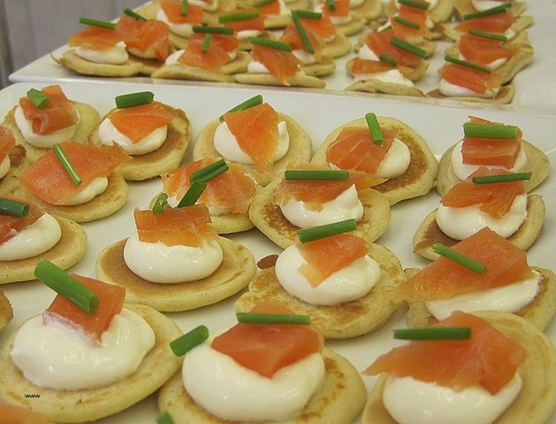
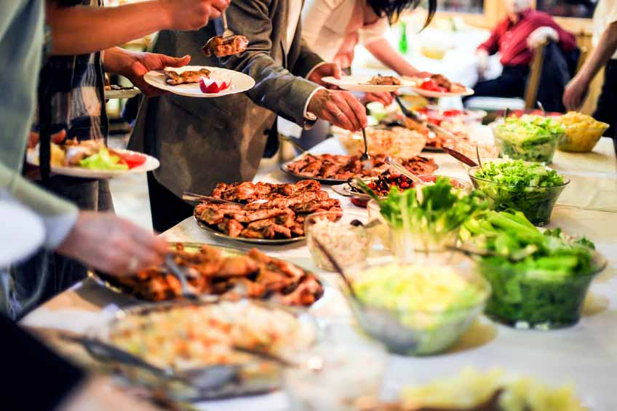

FINISHING TOUCHES

Chair Sash
Complete with a Coloured Sash
£2.50 per cover

Organza Table Runners
Choose from a wide range of colours to compliment your colour scheme £5.00 per table

Resident Disco
£200.00

Tea Lights & Mirrors
£2.00 per table

Sweet Cart & Sweets
£175.00

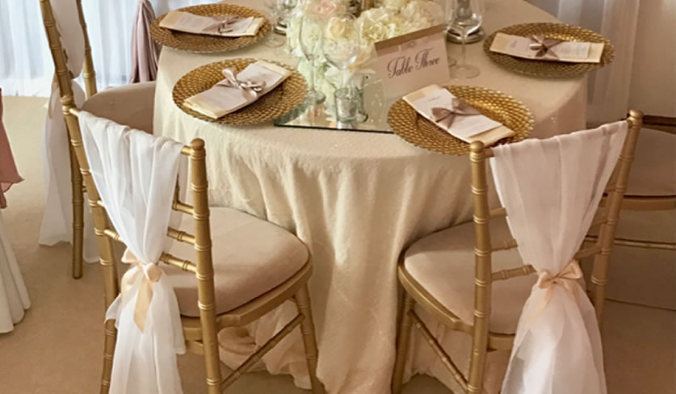
**Please Note – There is a compulsory security fee of £150 that applies for all functions**

