**T**redegar **A**rms **H**otel  
**F**uneral **B**rochure

*Here to help you plan your after-funeral arrangements...*

**Tredegar Arms** **Hotel**

Here at Tredegar Arms Hotel, we understand that organising after-funeral arrangements can add to the distress of losing a loved one.

From the moment you book, our sympathetically experienced staff will be on hand to attend to your every need with the professionalism and sensitivity you would expect.

Our friendly reception team are available from 9am – 11pm to arrange your booking with ease. We are also happy to deal directly with your funeral director should you wish for them to make the arrangements on your behalf.

**F**unction **R**ooms

**The Sirhowy Suite**

Our Sirhowy Suite can comfortably seat up to 70 guests.

**Coach House Restaurant**

Our Coach House Restaurant can comfortably up to 30 guests.

**Additional Facilities**

* Disabled Access
* Use of in-house floral/specific arrangements by our florist
* Reduced rates on accommodation (subject to availability)
* 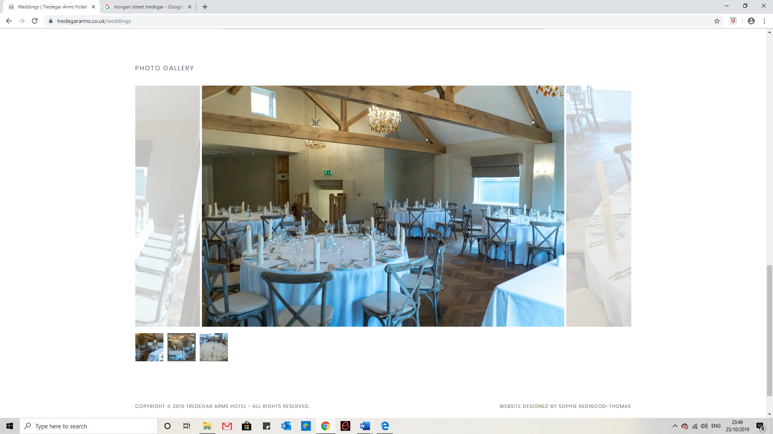Bar tab (up to an agreed limit)

**Buffet Choices**

**Option F1**

A selection of cakes along with fresh Tea and Coffee at £4.95 per head.

**Option F2**

An assorted selection of cakes and homemade sandwiches along with fresh Tea and Coffee at £6.95 per head.

**Option F3**

A mixed sandwich platter, potato salad, tomato salad, coleslaw along with fresh Tea and Coffee and a choice of 3 options from our buffet menu at £8.95 per head.

**Buffet Options**

Chicken Drumsticks

Spicy Potato Wedges

Quiche

Mini Spring Rolls

Vegetable Samosas

Warm Pasties

French Stick

Breaded Garlic Mushrooms

Hot Pizza Fingers

Plaice Goujons

Chicken Goujons

Pasta Salad

Crisps and Nuts

Hot Glazed Sausages

Home Cut Chips

Pork Pies

Warm Sausage Rolls

Platter of Cold Ham

*How to Book*

Contact our friendly reception team via telephone or e-mail from 7am – 11pm. Prices and information are valid from January 2020 – January 2021.

If you wish to book a formal meeting with our Events Coordinator to discuss packages or see the room, you wish to hire this can also be done over the phone.

Tredegar Arms Hotel

Morgan Street, Tredegar, Gwent, NP22 3NA

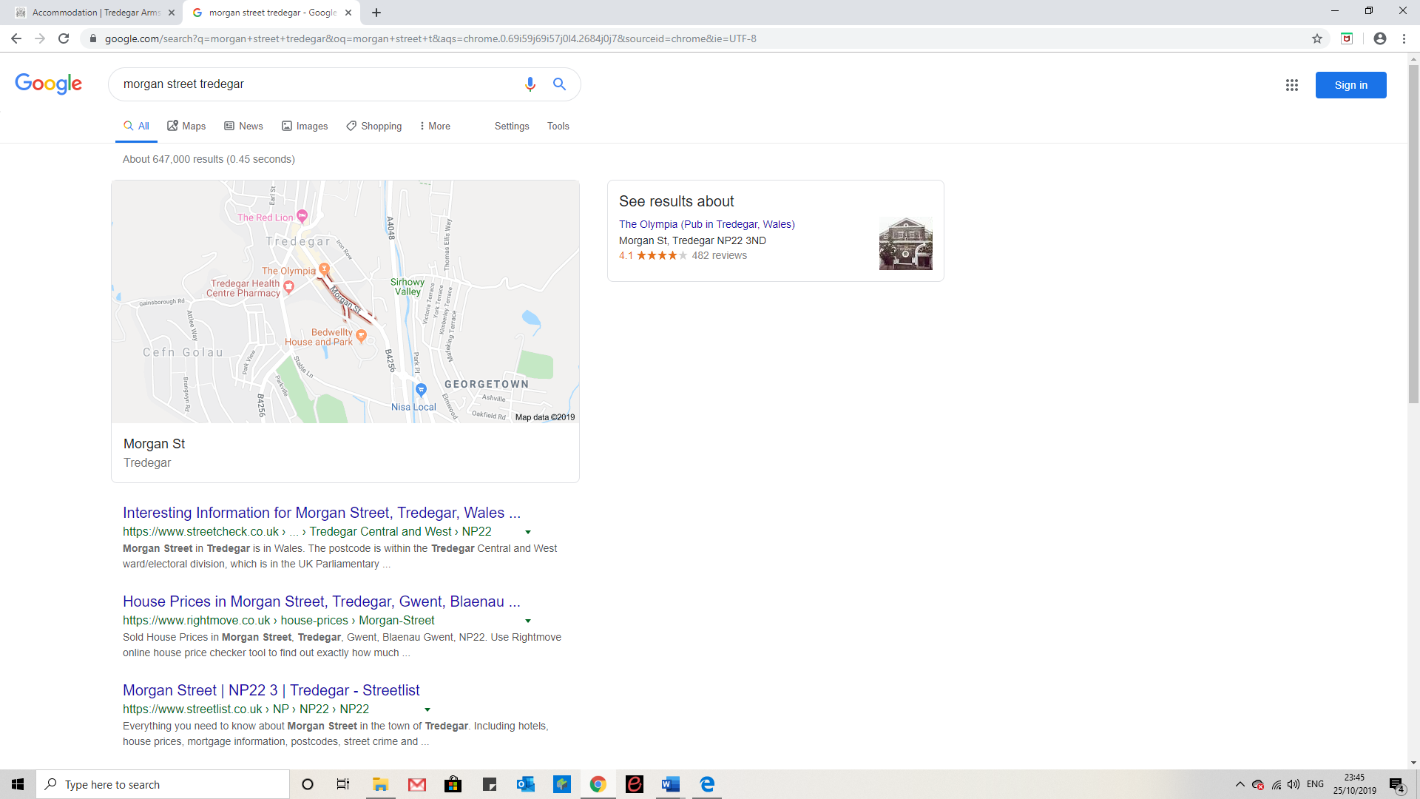

01495 788463 Reservationsta@outlook.com