From: Darric V. Williams (LA Chapter President)
darric.williams@xionnetworksolutions.com
951.634.9143
February 1, 2025
Greetings Family,
Exciting News! 🎉
Our President (Darric Williams) and Staff will be arriving at the luxurious Intercontinental Hotel Miami on June 12th. This stunning hotel, with its breathtaking views of Biscayne Bay, will be the perfect start to our adventure.
If you have still not booked there is still time and room on the boat for you to join us. Please contact:
Kay Fambrough
lfambrough@wth.com
800-259-2408 EXT 33580
Travel Order: 115011086
Group Name: TPWB 2025 Family Reunion
Ship Name: SUNRISE
Sailing Date: 06/14/25

Group price should still be in effect. Here is a link to the itinerary:

https://www.carnival.com/itinerary/5-day-eastern-caribbean-cruise/miami/sunrise/5-days/ecn/?itinportcode=mia&military=N&pastGuest=Y&senior=N&numGuests=2&evsel=&hideSailingEvents=true&locality=1&currency=USD&sailDate=06142025&roomType=IS

We are
On June 13th at 6:00 PM, we'll be gathering for a delightful dinner where we'll be handing out our fabulous swag bags. The restaurant is still to be determined, but rest assured, it will be a fantastic venue. Get ready to capture the moments, as there will be plenty of pictures and movies being shot to commemorate this special evening.
Itinerary:

Itinerary
Date | Day | Port | Arrive | Depart
6/14/2025 | Sat | Miami, FL  Board Ship:  We'll be in Miami, FL. Boarding the ship will begin at 3:30 PM. Get ready to set sail! |  | 3:30 PM
6/15/2025 | Sun | Nassau, Bahamas  We'll have an exciting excursion to either Atlantis or Baha Mar (to be determined) | 10:00 AM | 6:00 PM
 | Mon | Princess Cays, Bahamas  We'll be at Princess Cays, Bahamas for a fun-filled beach day. Enjoy jet skiing, water slides, and fishing | 7:30 AM | 3:30 PM
6/17/2025 | Tue | Grand Turk, Turks & Caicos  Our adventure continues to Grand Turk, Turks & Caicos. Experience the flavors, sightseeing, and lunch, followed by a Jeep adventure tour with a beach stop | 11:30 AM | 6:00 PM
6/18/2025 | Wed | Fun Day @ Seas  It's a fun day at sea! We'll have our reunion banquet at 11:00 AM. Get ready for a day of relaxation and celebration.
6/19/2025 | Thu | Miami, FL  We'll be back in Miami, FL | 8:00 AM

Things to note as we draw closer to the reunion

Dinner to deliver swag bags June 13th @ 6:00pm: Restaurant TBD

Lots of pictures and movies will be shot.
Payment Schedule:
- 1st Installment: $62.50 per person - Due by 03/02/24
- 2nd Installment: $150.00 per person - Due by 04/11/24
- 3rd Installment: $250.00 per person - Due by 07/19/24
- 4th Installment: $250.00 per person - Due by 10/17/24
- 5th Installment: Balance per person - Due by 03/16/25
Please ensure that payments are made promptly to secure your spot for the reunion.
Exciting Swag Pack Details! 🎉

Get ready to show off your family pride with our exclusive TPWB 2025 Family Reunion Swag Bags! Each item will feature either our family logo or the beautiful family reunion artwork. We kindly ask that all orders and payments be submitted by March 3, 2025 to ensure timely delivery.

We discussed the cost of the swag bag being part of the registration fee. If I recall correctly, previous registration fees for reunions were per person. Our new approach is much more affordable and offers great value!

Here's a breakdown of the individual item prices:

T-shirt: $20 each ($25 for sizes 2XL or larger)
Polo: $40 each ($45 for sizes 2XL or larger)
Tumbler: $15 each
Men’s bag: $25
Women’s bag: $25
Now, let's talk about the fantastic swag bag packages:

T-shirts Package:

Sizes S-XL: Includes 2 T-shirts, 2 bags, and 2 tumblers for just $120 + tax
Sizes 2XL and up: Includes 2 T-shirts, 2 bags, and 2 tumblers for $130 + tax

Polos Package:

Sizes S-XL: Includes 2 polos, 2 bags, and 2 tumblers for $160 + tax
Sizes 2XL and up: Includes 2 polos, 2 bags, and 2 tumblers for $170 + tax

These swag bags are a fantastic way to commemorate our family reunion and make sure everyone has a piece of the celebration to take home. Don't miss out on this opportunity to get your hands on these.

Family members not attending the Family Reunion Cruise will be able to purchase the swag pack at the prices shown + shipping and handling.

exclusive items!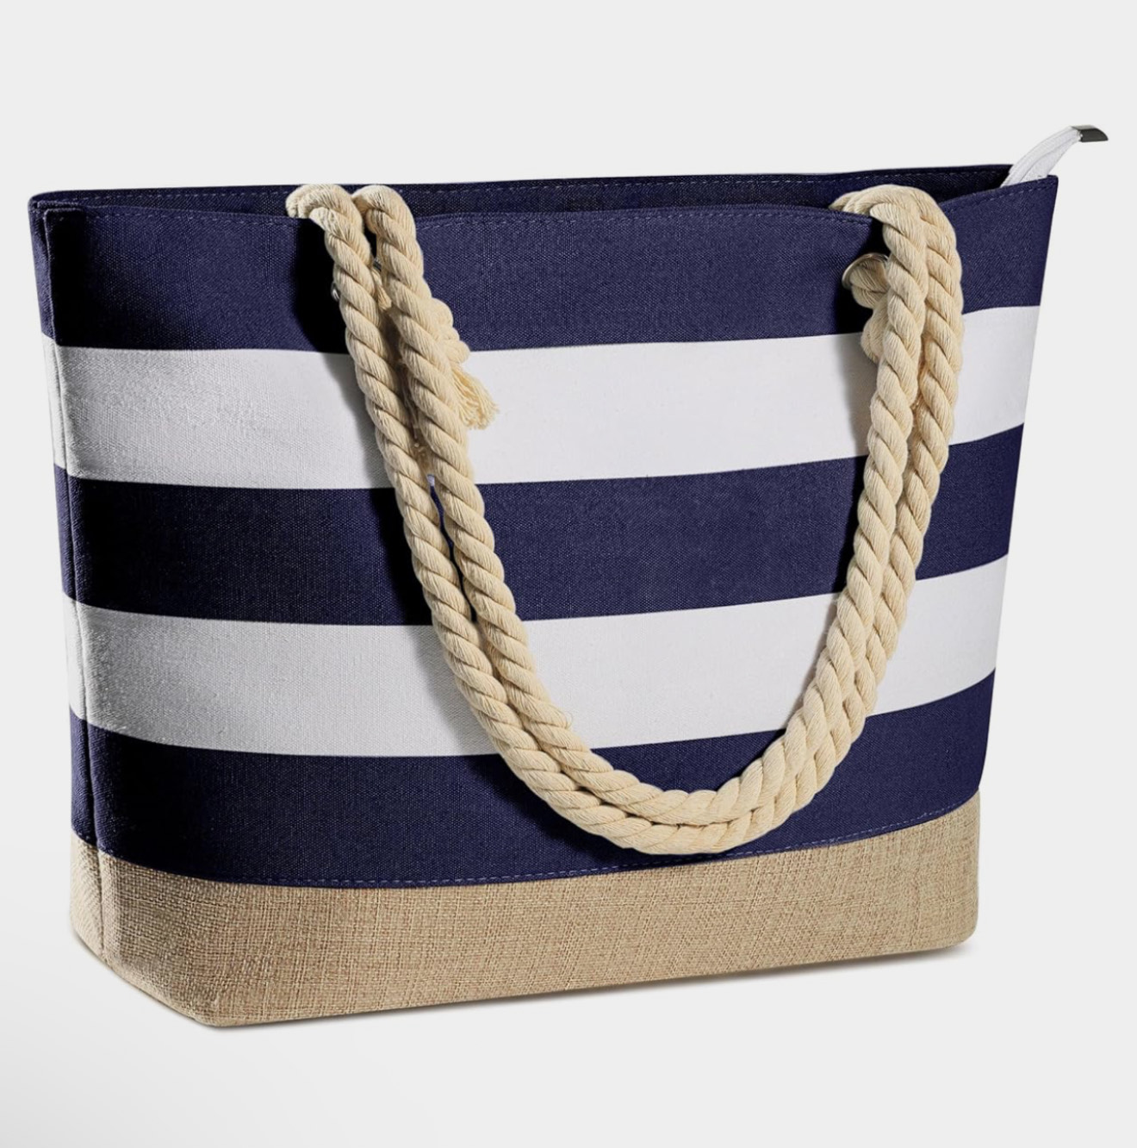

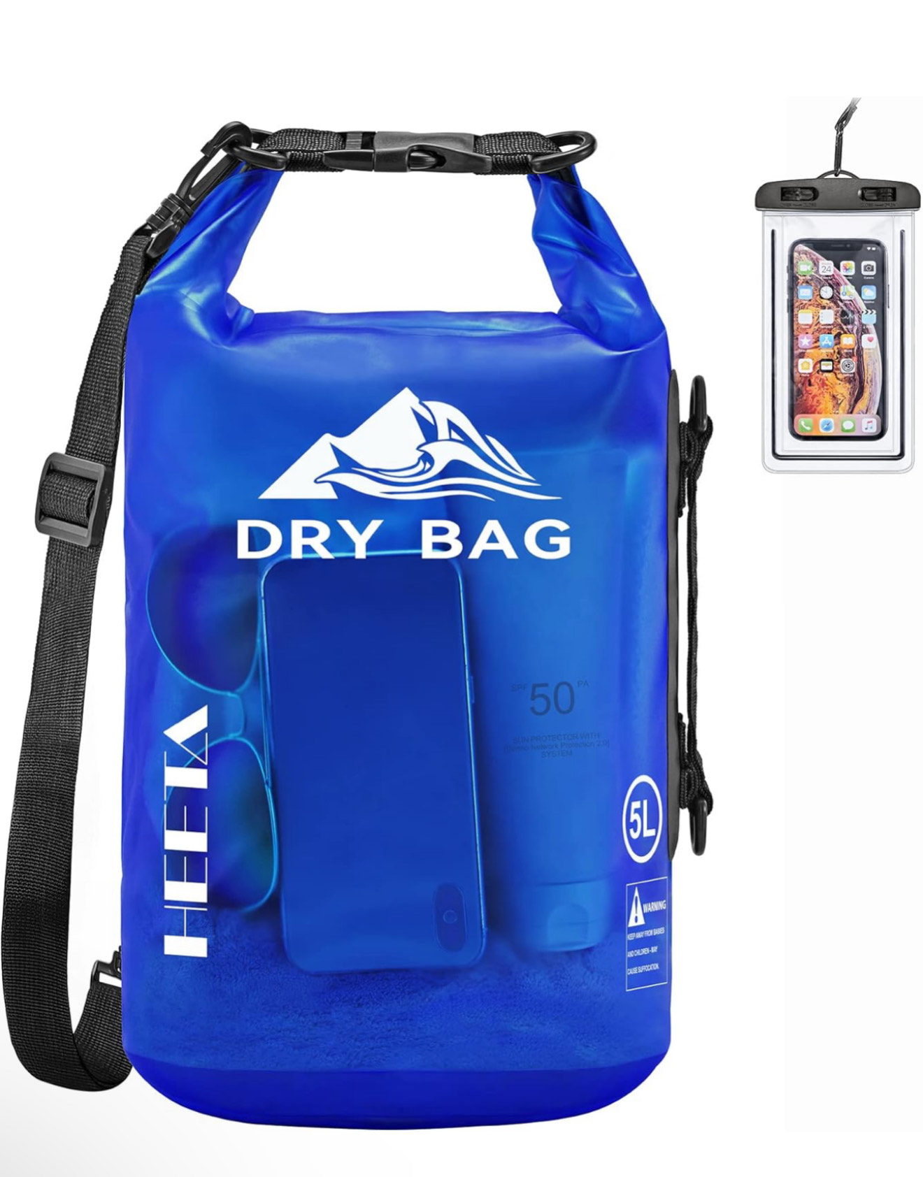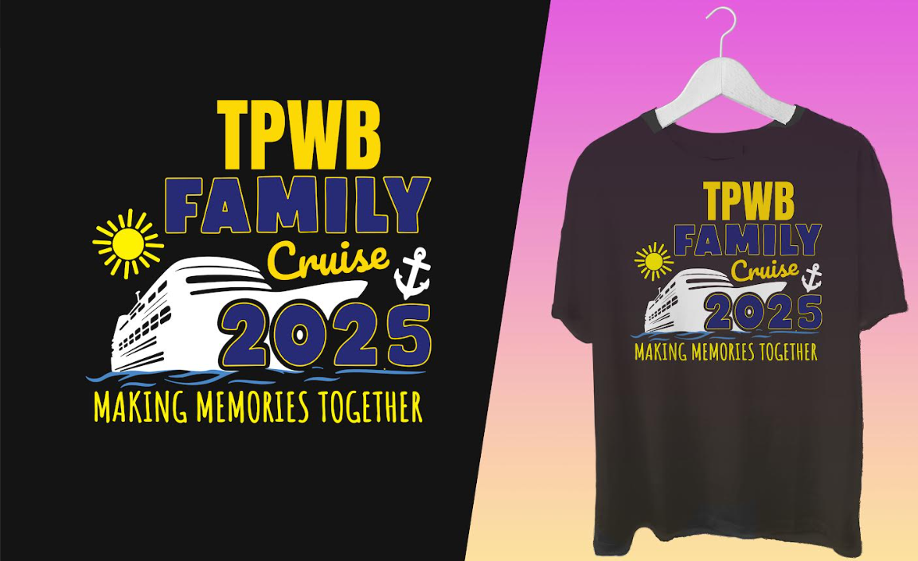

Important Notes:

- 🛳️ No Passports Needed for this cruise: Rest assured; you won't need a passport to join us on this exciting Caribbean adventure.
- 📆 Payment Schedule Tailored for Our Group: Our payment plan is designed to accommodate our family's needs and preferences.
- 🚌 Transportation/Shuttle Transfer: You can schedule transportation through our dedicated agent, Kay Fambrough, at cruises.com.
- 📞Booking Additional People: If you plan to add extra individuals to your room, please book over the phone using our group number. These rooms cannot be booked online.
- 🍽️ Dinner Time: Please select 5:30pm or the earliest dinner time.
- 🎉 Banquet Booking: We'll be booking a special banquet on 6/25/25 while cruising at sea. Get ready for a memorable celebration!
- 💻 Website Information: Here are the details about our dedicated website with booking number #115011086. https://na.eventscloud.com/tpwb25
- 👋 Meet and Greet: Our Meet and Greet will take place at Port Canaveral, FL. Get ready to kick off the festivities with warm hugs and joyful reunions.
As we eagerly anticipate our time together, let's start counting down the days until we can create new memories and strengthen the bonds that unite us as a family. If you have any questions or need further assistance, please don't hesitate to reach out.
Let the countdown to fun begin! 🎊 #TPWB2025 #FamilyReunion
Looking forward to seeing you soon!
Warm regards,
Darric V Williams
LA Chapter President

