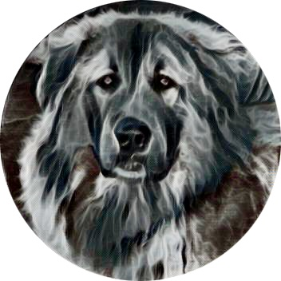
Carolina Caucasian Ovcharkas
Salisbury NC 28147 980-330-9067( call or text)
Name:________________________________Male/Female Date:__________
Phone Number:___________________
Address: _________________________________________________
Total cost: $ ______ minus deposit - $_______ balance: $_______
Is everyone that lives in the home, agreeable to get a CO?______
Have you ever owned a large breed before ?_______, if yes, what?______________________
Do you have any experience with large aggressive dogs?___________________________
Are you willing to socialize your puppy ?_________How? _________________________________
Do you have pets now? ______
If yes, ___________________________________________________________________________
Are current pets spayed/neutered?_________________________
Do you live in a house/condo/apartment? _________________
Do you have a secure place to keep your dog? _____________
Is any fencing 6-foot minimum? _____________
Where will your puppy stay? _______________________________
You realize CO are naturally aggressive towards strangers. _______
Do you have children? _____________ if yes, what ages? __________
Have they been around dogs? ___________
When outside, how will your CO be contained? ________________________________________
Are you willing to spend hours and hours training your CO?___________
Are you willing to take your puppy to classes? ______________________
Have you ever re-homed a pet? ______ If yes, why? ____________________
Do you have a veterinarian? ______ If yes, may we contact them? __________________
Why do you want a Caucasian Ovcharka ? ________________________________________________________________________________________________________________________________________________________________
What do you know about them? ________________________________________________________________________________________________________________________________________________________________
There is a 10% non-refundable deposit. If we are unable to produce your choice(male/female) of pup, we will refund your deposit. You may also move your deposit to another litter. If you change your mind, we will not.
If you are picking up you puppy, please bring a carrier, towels, water & bowl if a long ride.
We love to use pictures of our ‘pack’ on our pages and website, if this is not ok, please let us know.
Caucasian Ovcharkas are beautiful animals, but just not for everyone. You will have big food bills, big vet bills, have to spend lots of time brushing them, getting them accustomed to blow dryers, and socialize them as much as possible when they are young. You cannot over socialize your puppy. They were bred to guard, that instinct cannot be removed, only channeled in the correct way.
Historically, Caucasian Shepherd Dogs were used for the guarding and safe-keeping of herds, flocks and dwellings from predators.
This dog will fiercely protect whoever he believes is his family (including children, other dogs and even cats) but can and will attack everyone else including friends of your children who may come to visit and play.
The Caucasian Shepherd Dog is a very old ancient breed. They have been guarding livestock such as sheep in Caucasia (the mountains between The Black Sea and The Caspian Sea) for at least 600 years. During this time, the breed hasn't changed too much. In fact, their teeth are longer than any other breed which hints at their ancient past.
With a bite force of 550-700 PSI(pitbull bite force is 235 PSI, Rottweiler bite force 328 PSI), the Caucasian Shepherd is a force to be reckoned with.It’s strong will, fearless nature, and ferocity make it a challenge to train at times. You must have a lot of patience and time to work with your Caucasian Ovcharka. Please do your due diligence with training your CO.

We will help you with any issues or problems you may have. If at any point you are unable to care for your animal, contact us. Do not rehome your animal without first contacting us. We reserve the right to have any animals that we bred, returned to us. We will always take back any animal of our breeding, any time.. We truly care about the fates of all the animals we produce and feel responsible for them. This way, you can be more assured that your pet will end up with a person knowledgeable with the breed characteristics, etc... No, you may not get any money refunded. Please do not get into that mind set, money is not the point, is it? The utmost priority is to find an appropriate home for a dog you can not keep. But your animal will get saved by someone who knows the breed, and we will try and get the animal into a good appropriate home.

