COQUINA WATER CONTROL DISTRICT
BUDGET
FISCAL YEAR 2026-2027

DRAFT: 9/23/2026
PROPOSED: 9/23/2026
ADOPTED: 9/23/2026

SIGNED:

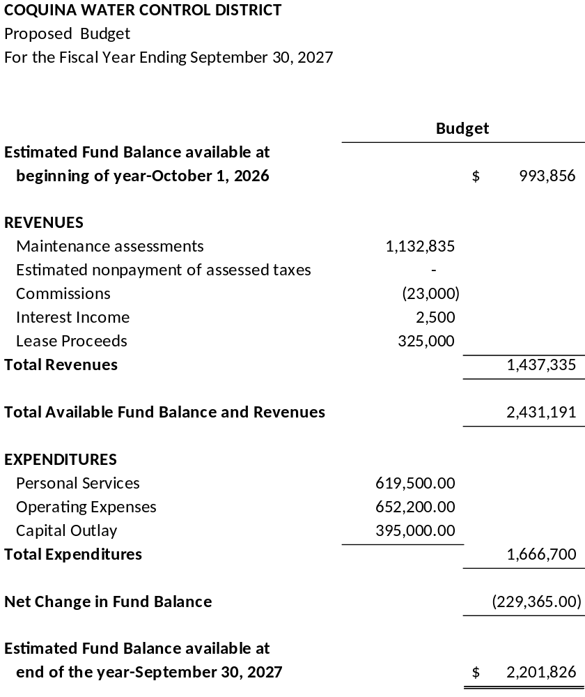

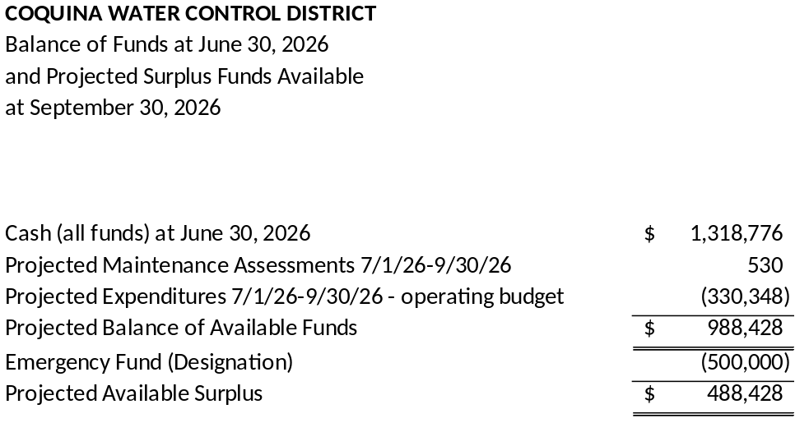

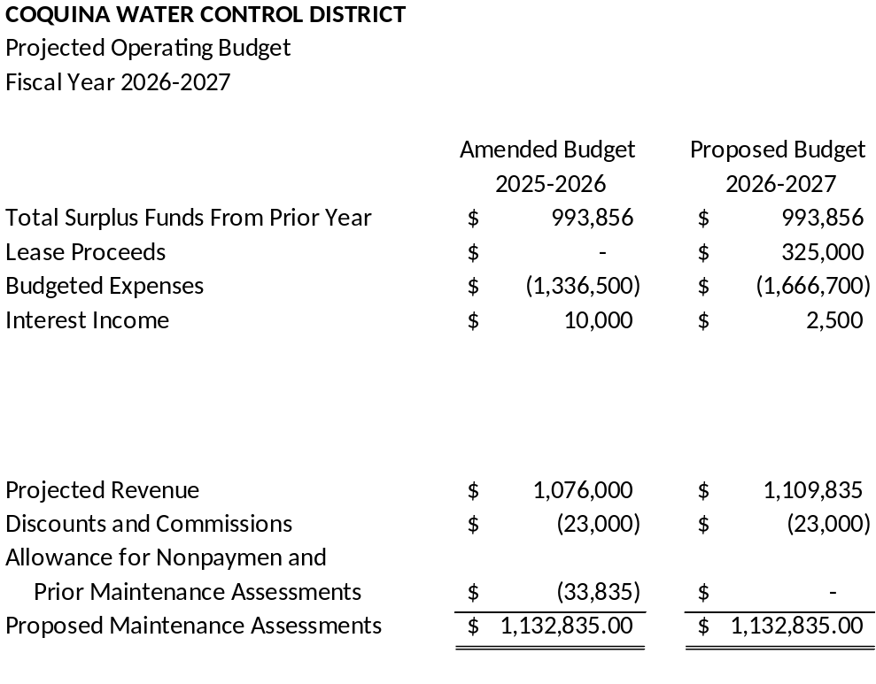

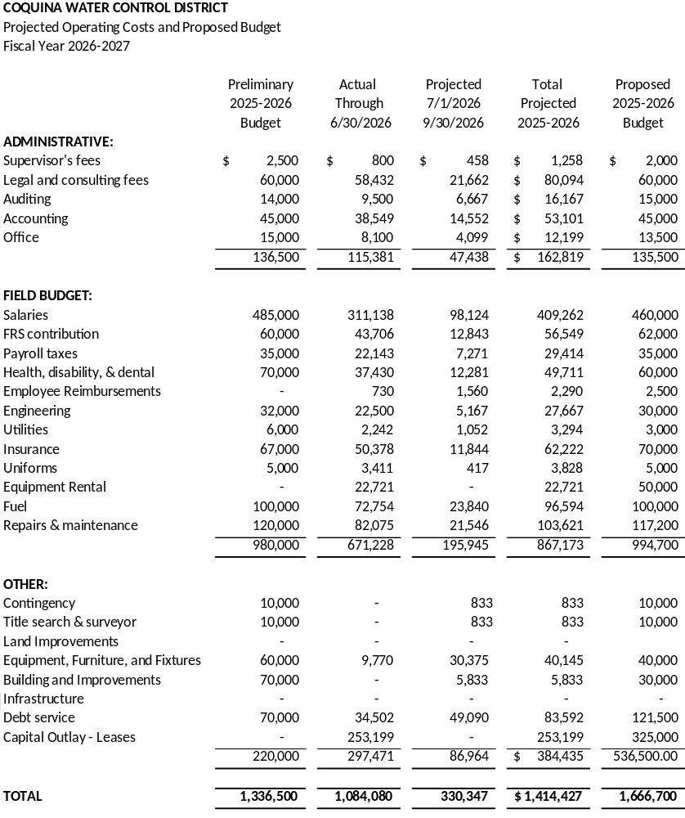

COQUINA WATER CONTROL DISTRICT
Notes to Proposed Operating Budget
Fiscal Year 2026-2027

Administrative Budget:

Supervisors’ Fees
Pursuant to the provisions of Chapter 298 of the Florida Statutes, supervisors are entitled to $50 per day for services rendered on behalf of the District. It is anticipated the Board of Supervisors will meet at a minimum of 12 times during the Fiscal Year 2026-2027 at a cost of $150 per meeting, plus additional miscellaneous days, and expenses.
$2,000
Legal and Consulting Fees
Legal and consulting expenditures for the coming Fiscal Year will cover general legal representation and consulting fees of the District for the period. Litigation, non-reimbursed condemnation expense, and review of contract documents necessary for the execution of work to implement the Plan of Water Management are included in this category.
$60,000
Auditing
Pursuant to the provisions in Chapters 189 and 11 of the Florida statutes, the District is required to file certain audit reports with the Department of Veterans and Community Affairs, the State Controller, and the Auditor General. The financial reporting obligations require that an independent certified audit be conducted of the District’s financial transactions. For this purpose, a CPA firm will be retained. Additionally, we will budget for the Other Post Employment Benefit Actuary Report.
$15,000
Accounting
This segment provides for clerical and accounting anticipated fees. Services to be provided, pursuant to engagements are:
a) Preparation for and attendance at the management and Board meetings
b) Prepare federal form 1099 and 1096 from information provided by District and transmit to federal and state agencies on your behalf.
c) Assist management with budgeting/forecasting process.
d) Monthly recurring accounting functions.
e) Reconcile balance sheet accounts monthly and prepare journal entries, as needed.
f) Assist management with preparation for annual financial statement audit.
g) Monthly assessment collections and accounts payable.
h) Additional services provided.
$45,000

COQUINA WATER CONTROL DISTRICT
Notes to Proposed Operating Budget
Fiscal Year 2026-2027

Office
Accounting supplies, stationery, bank checks, miscellaneous, other supplies necessary in the day-to-day operations as well as telephone, utilities, and uniform.
$21,500
Field Budget:
Personal Services
Salaries, payroll taxes, health, disability and dental insurance, FRS contribution, and mileage reimbursements or travel related reimbursements.
$619,500
Engineering
The engineering allocation is anticipated to cover the Engineer's attendance at District meetings and in providing engineering services of a general nature, such as maintaining the South Florida Water Management District criteria and assisting District personnel on a general basis.
$30,000
Insurance
Insurance cost is for the following coverage:
General Liability, Workers Comp & Contingencies $70,000
Water Control Plan
Estimated costs of design implementation, construction, administrative, outside repairs, parts/supplies, fuel, contingencies, equipment rental, capital related purchases or leases, and the semiannual payments for equipment purchases.
$803,700

