FLOTILLA BOATING AND FISHING CLUB
San Antonio, Texas

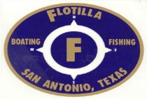

FINANCIAL ASSISTANCE INFORMATION SHEET

- The 2018 Financial Assistance will be awarded to two (2) deserving high school graduates who demonstrate a financial need, personal initiative, academic promise and civic responsibility in the amount of $500.00 each.

- Applications must be received or postmarked by July 1, 2019. Applications received or postmarked after this date will not be considered.

- The recipients of the Financial Assistance Award will be notified by Aug 15, 2019.

- The $500.00 Financial Assistance Award will be made payable to the College or University the student will be attending.

- Applications should be mailed to the following address:

Paul Hiers
8919 Deer Park
San Antonio TX 78251

