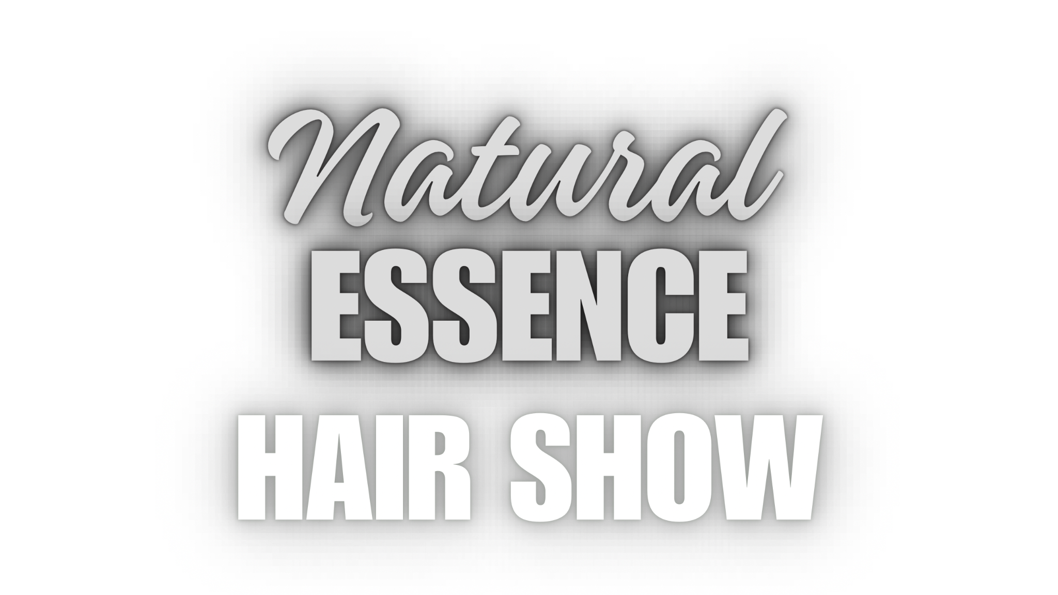

**Website:** [**www.naturalessencehairshow.com**](http://www.naturalessencehairshow.com)

**Email:** [**naturalessencehairshow@butterchoclocs.com**](mailto:naturalessencehairshow@butterchoclocs.com)

Thank you for your interest in advertising with Natural Essence Hair Show!

Be seen by an audience eager to support your Black Owned products or services.

Our vision for this event is to gather in community as we celebrate the beauty of locs, curls and coils, and lifestyle. Showcasing Black beauty, style and culture.

As a lifestyle event, we recognise that being exposed to products and services that cater to a need and improve the quality of our everyday lives is a necessity.

This includes:

natural foods and holistic health care, education/ tuition for children and adult learners, legal and medical services, bridal and formal occasion catering and tailoring, landscaping and construction, as well as locs and hairdressing/ barbering/ beauty services. If you think your business aligns with the vision and audience of Natural Essence Hair Show, we’re happy to hear from you!

There are two advertising packages at a great introductory rate:

**£30 - advert in the Natural Essence printed event day program/ magazine.**

**£50 - advert in Natural Essence event day program/ magazine and social media/ website**

If you’d like to share your business with an audience excited to support Black owned products and services, please fill out the form below and email it back to:

**naturalessencehairshow@butterchoclocs.com**

| Full name |  |
| --- | --- |
| Name of business |  |
| Short description of your business |  |
| Business website |  |
| Business social media handles | Instagram:  TikTok:  Facebook:  LinkedIn:  Other: |
| Contact number |  |
| Contact email |  |
| Other |  |

Once your application has been confirmed, via email, you will be sent an invoice, where you can then pay in full and reserve your advertisement spot.

If you have any further enquiries, please do not hesitate to get in touch.

Kind regards,

Admin Team

Natural Essence Hair Show