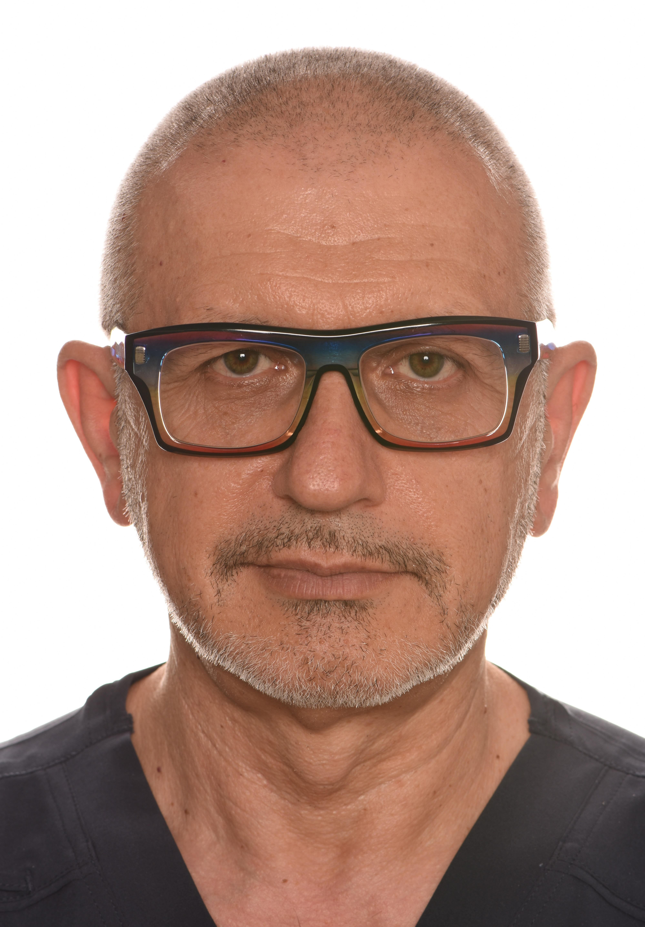 | Dr. Krasimir Zlatev, DMD  Location: Varna, Bulgaria  Phone: +359 887 309 880  Email: dr.krasimirzlatev@vitalboneexperts.com  Instagram: krasimir.zlatev.77  Website: https://vitalboneexperts.academy

Professional Summary
Doctor of Dental Medicine with more than 40 years of clinical experience and extensive international postgraduate education in periodontology, implant dentistry and biological bone augmentation. Founder, co-owner and CEO of Zlatevi Dental Clinic in Varna, Bulgaria, and Co-founder and Managing Director of VitalBoneExperts OÜ. Dedicated to advanced mucogingival and implant surgery. International lecturer on the biological approach to immediate implant placement (IDR), the Khoury Split Bone Block Technique (SBBT), and the SLT semilunar technique for biological bone augmentation. Recipient of multiple national awards for excellence in esthetic dentistry.

Professional Experience
- CEO and Chief Dental Surgeon, Dr. Zlatevi Dental Clinic, Varna, Bulgaria (1985-present)
- Founder and Director of Zlatevi Dental Clinic
- Co-founder and Managing Director of VitalBoneExperts OÜ
- Board Member of the Bulgarian Society of Periodontology and Oral Implantology (BSPOI)
- Performs advanced surgical procedures including guided bone regeneration, biological bone augmentation, implant placement and mucogingival reconstruction
- Integrates digital dentistry and CAD/CAM workflows

Education
Doctor of Dental Medicine (DMD), Medical University of Plovdiv, Bulgaria - Graduated in 1985.

Advanced Education and Certifications
- Postgraduate Program in Periodontology and Implant Dentistry - Prof. Mark Danan (1999-2003)
- Advanced Implant Dentistry - Dr. Carlo Tinti, Italy
- BOPT Technique - Prof. Ignazio Loi (2015, 2016, 2017)
- Periodontal Plastic Surgery - Prof. Giovanni Zucchelli
- Orthodontic Extrusion - Dr. Mauro Fadda
- Masterclass in Biological Bone Augmentation - Dr. Frank Zastrow (2019-2024)
- Training in IDR (Dr. Da Rosa), SBBT (Prof. Fouad Khoury) and SLT (Dr. Frank Zastrow)
- IDR Residency VIP Course, Caxias do Sul, Brazil (2026)

Awards
Winner of the 'Smile of the Year' Award (Dental Tribune Bulgaria): 2009, 2011, 2014.

Lecturing Topics
- IDR - Biological Technique for Immediate Implant Placement
- Biological Bone Augmentation (SBBT)
- Khoury Split Bone Block Technique
- SLT - Semilunar Technique with Intracortical Autogenous Bone Graft and EBC (Dr. Zastrow)

Core Competencies
- Periodontology and mucogingival surgery
- Advanced implant dentistry and bone augmentation
- Immediate implant placement (IDR)
- Digital dentistry and CAD/CAM workflows
- Full-mouth rehabilitation and BOPT
- Soft tissue management
- Clinical leadership and mentoring

Languages
- Bulgarian - Native
- English - Fluent
- Italian - Fluent
- Russian - Conversational

