Mastering English Policy July 2021
St Benet’s Trust
Mastering English is a strategy that provides a progressive and structured approach to teaching reading and writing to primary aged pupils.
This bespoke curriculum has been designed for St Benet’s Trust Schools with approaches adapted from T4W, Power of Reading and the previous National Literacy Strategies.
Professional Development
This strategy is being rolled out across all schools in a systematic way to ensure staff gain knowledge and understanding of the fundamental pedagogical approaches that underpin this strategy. Implementation throughout the school year is designed with:
- cognitive load theory in mind;
- built-in opportunities to reflect;
- whole staff training combined with small group work and individual support;
- progression understanding from R to Y6, as well as year group specific work;
- English leads driving improvements on the ground in schools;
- School improvement and Trust improvement plans all aligning to support the strategy;
- collaboration being woven into the structure so that the schools hosting the training offer opportunities to view books and learning environments;
- resources being developed alongside the strategy to support workload.

The roll out of this strategy, and the approaches that underpin it, are built upon the DFE guidance document ‘The Reading Framework – teaching the foundations of literacy (August 2021).

Mastering English focusses on providing high quality texts mapped out from Reception to Year 6 for children to engage in. For each half term there is a core text that links directly to grammar, punctuation and writing outcomes alongside decoding and comprehension skills. The texts chosen are selected for their diversity and inclusivity. Each year has a range of fiction and non-fiction core texts as well as one poetry text. Texts link, where possible, to wider curriculum materials to support vocabulary development and the building of schemata. Texts get progressively more advanced in language and content material as the strategy progresses throughout the year groups.
Overview documents map out the skills and objectives for each text year on year. To support these there are success criteria grids linked to genres and tied to national curriculum expectations.
Training in this approach has been developed based on staff understanding how children learn to read and write. It links directly with the Structured Systematic Phonics training from the Wensum English Hub and the Little Wondle strategy that schools have chosen from the DFE approved list of schemes.

Mastering English builds on the fundamentals of learning. It has a structured approach within each unit of work and lessons are built around staff modelling the core skills of speaking, listening, reading and writing. This is stated clearly in The Reading Framework (DFE 2021) below:
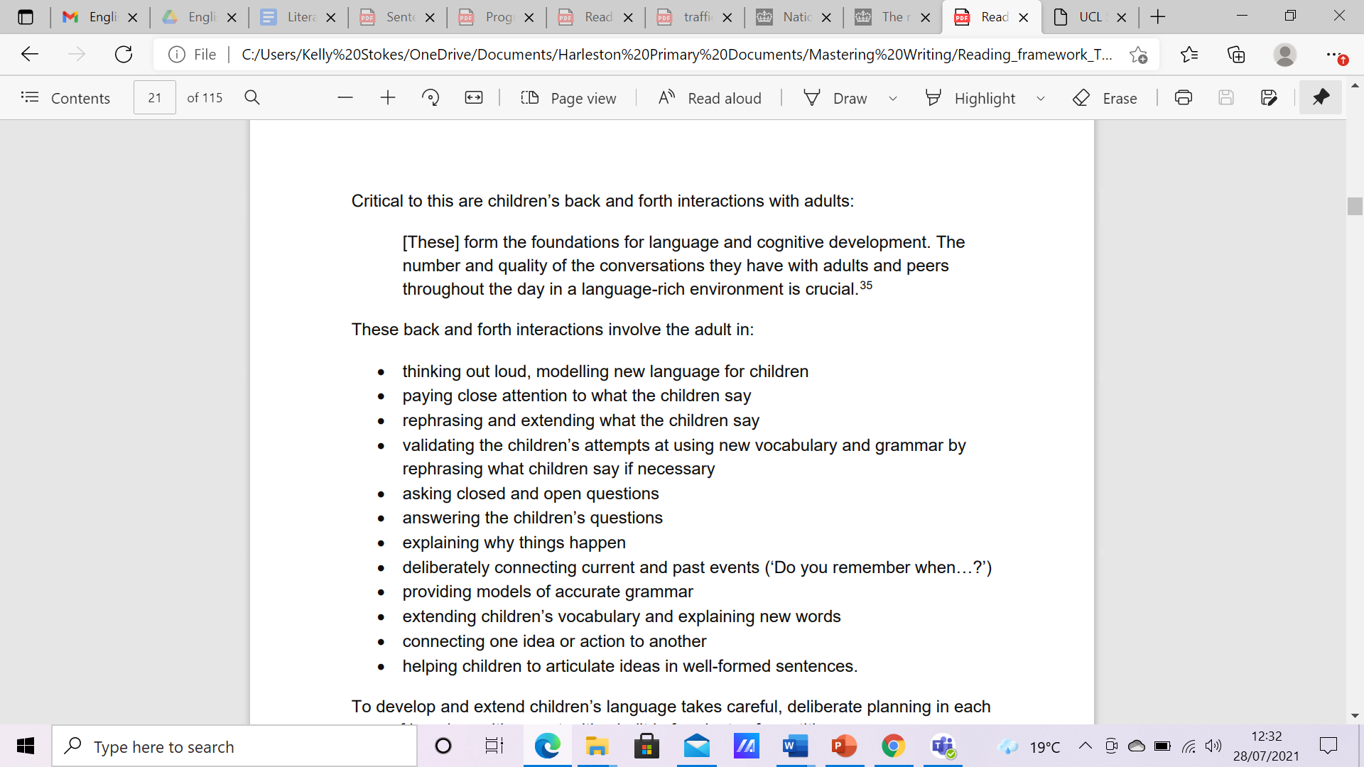

The strategy maps out clearly when, and how, the modelling of these core skills takes place, as well as the vocabulary extension and development needed within each unit of work.
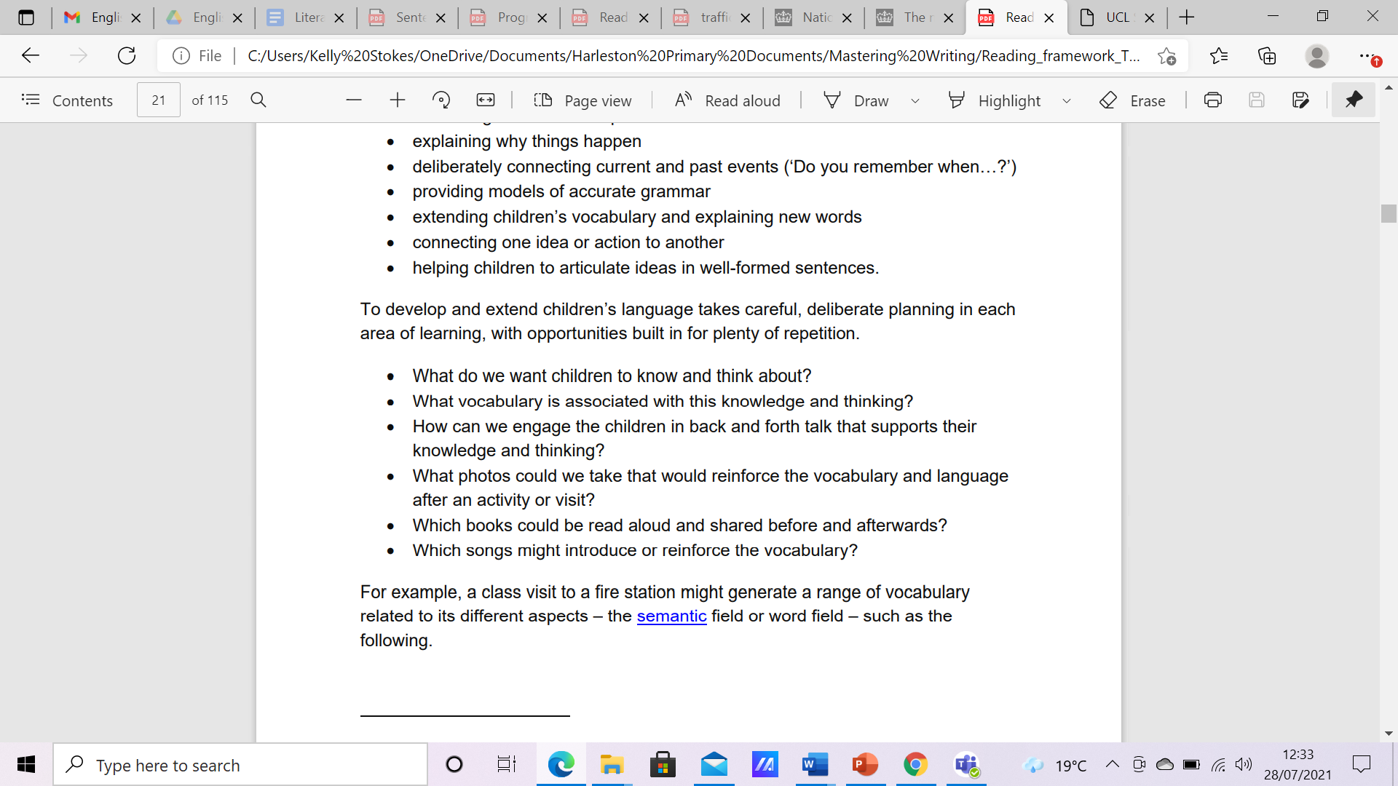

As a trust, the approach is to support the development of this strategy with coaching and mentoring over time.
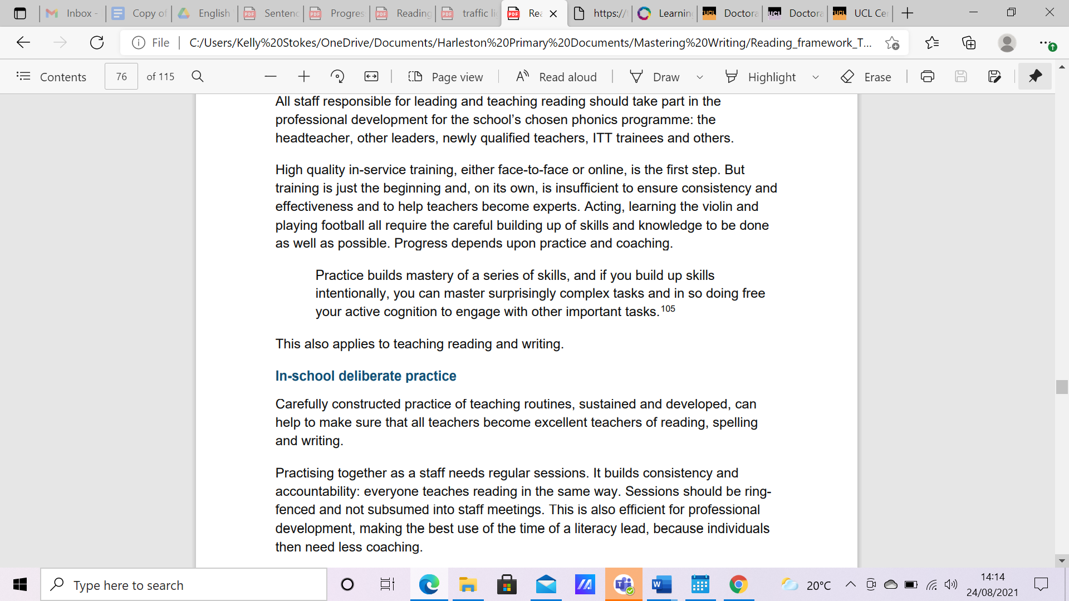
The face to face training is the start, alongside this Subject Leaders will coach staff with the support of the School Improvement Lead. The subject leads will have termly training in how best to support staff from the lead and teachers will have the opportunity to visit schools within, and external, to the trust to gain more experience and a deeper understanding of Literacy. This approach is due to acknowledging that:

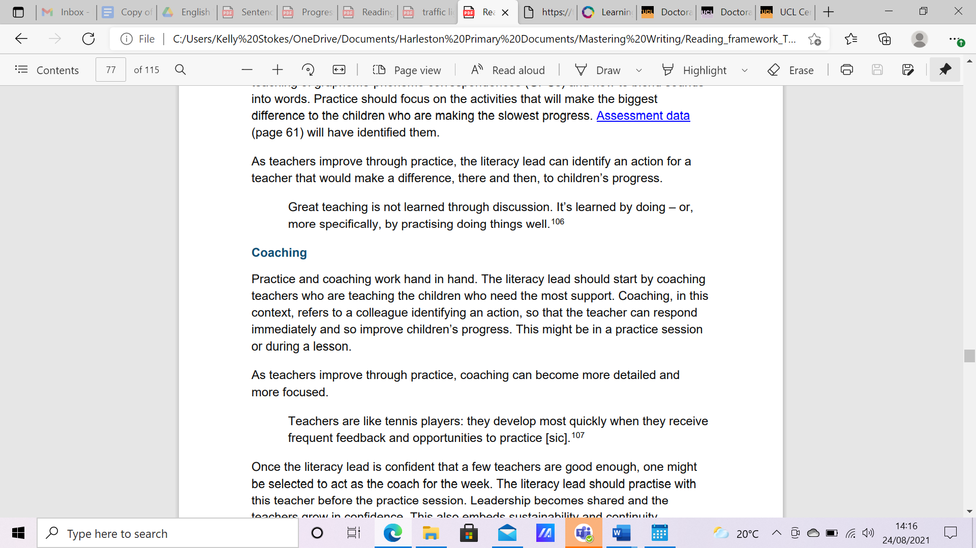
This CPD approach builds the staff training in the same way the strategy builds the core skills for the children.

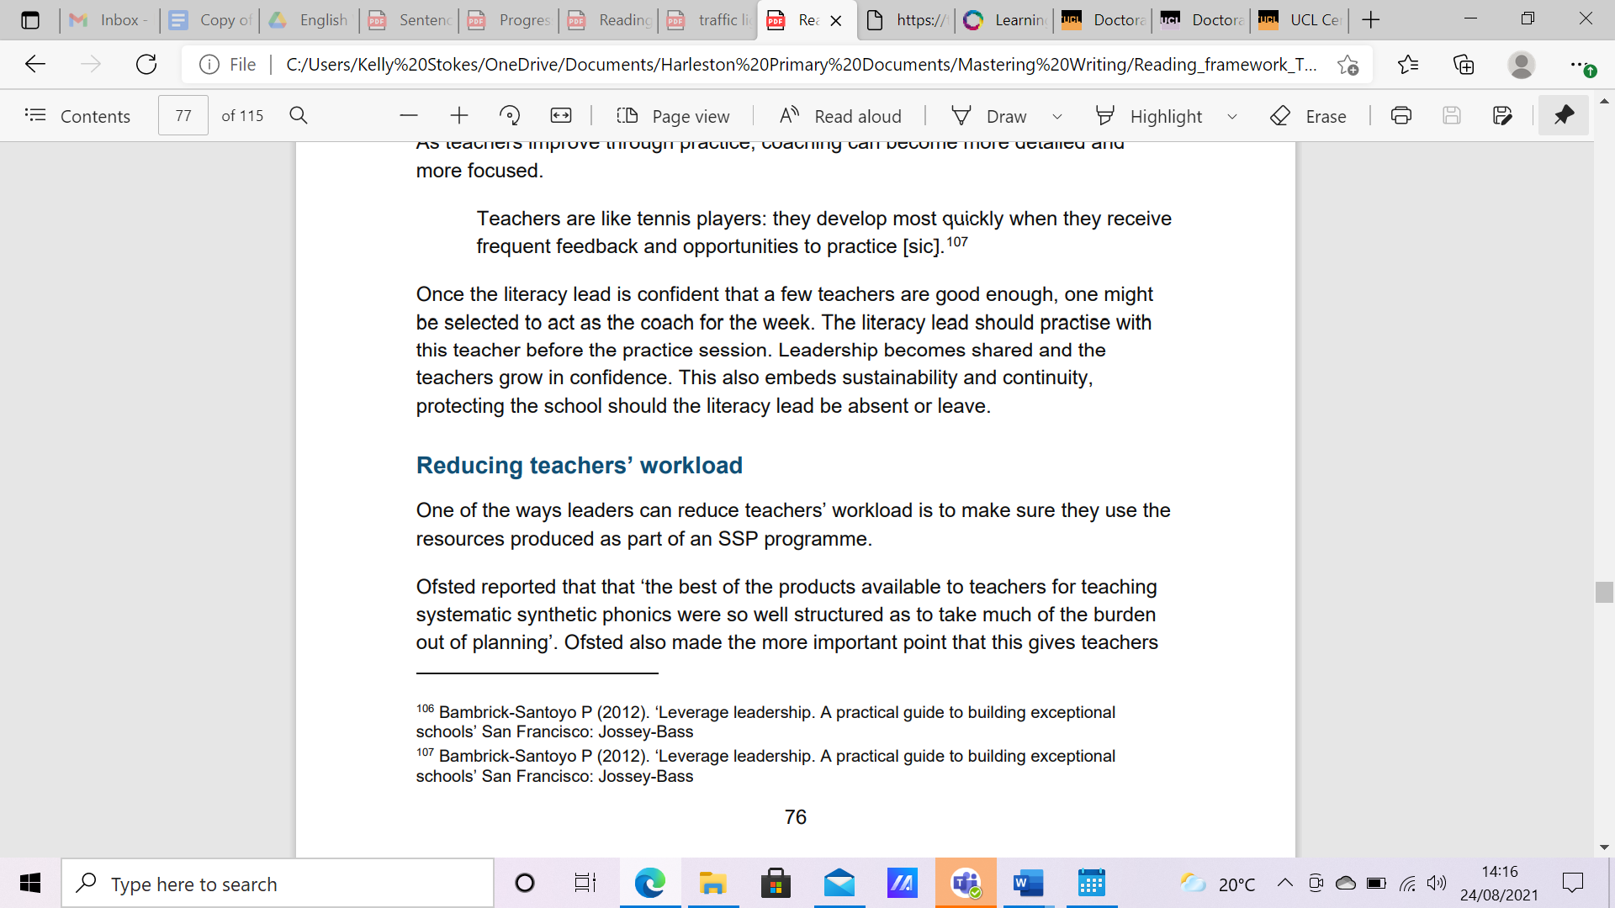

This clear structured approach, reduces workload by allowing teachers to spend more time focussed on how to teach, rather than what to teach.
The strategy runs alongside a clear timetable of expectations for exposing children to opportunities to learn new vocabulary, read for enjoyment and pleasure as well as gain skills in decoding and comprehension.
Expectations:
- Daily phonics session (EYFS / KS1)
- Daily spelling investigation session (KS2)
- Daily shared reading session (storytime / poem time)
- Daily Mastering English session
- Daily intervention sessions for those identified by SLT
- Reading and writing standards cosistent across the wider curriculum as they would be for the Mastering English sessions
Mastering English exposes children to high quality texts and the strategy maps out clearly time to read often in lessons to children as mentioned in The Reading Framework (DFE 2021).
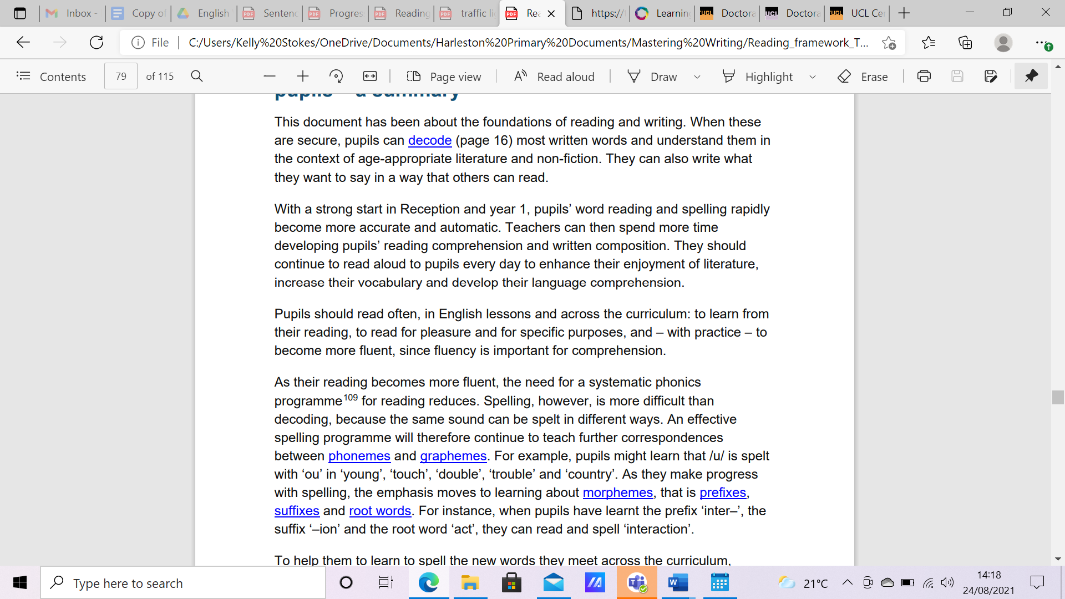

Principles underpinning the strategy:
- Learning and development follow sequences.
- Development and learning proceed at varying rates.
- Development and learning result from an interaction of maturation and experience.
- Development proceeds toward greater complexity, self-regulation, and symbolic or representational capacities.
- Development and learning occur in and are influenced by multiple social and cultural contexts.
- Play and oracy is an important vehicle for developing self-regulation and promoting language, cognition, and social competence.
- Development and learning advance when children are challenged.
- Children’s experiences shape their motivation and approaches to learning.
Learning should be a lifelong process and a rewarding and enjoyable experience for everyone. Through our teaching of Mastering English there is a focus on inspiring the children to learn, equipping them with the skills, knowledge and understanding necessary to be autonomous learners who flourish.
Learning Objectives are:
- Clear and focused based on learning rather than task
- Displayed
- Discussed and explained to the children
- Based on prior attainment, knowledge and understanding
- Progressive and build upon prior knowledge, preparing them for future learning
- Success criteria takes the form of marking ladders which:
- Break down the learning taking place
- Include the steps or 'ingredients' the children need to be successful in their learning
- Are identified by the teacher during the planning process as well as in the strategy materials
- Are discussed with the children during the lesson
- Are displayed clearly throughout the unit of work / session
Differentiation
- Takes place throughout the lesson
- Is matched to children's levels and next steps learning
- May occur through adult support; range and level of resources; time; task; different outcomes
Adult Input
- Engages children in the learning
- Is active and interactive
- Has appropriate pace to ensure maximum learning takes place
- Responds to, and is adapted to, ongoing assessment during the lesson
- Clearly models successful learning/the learning activity
- Generates success criteria
- Is flexible according to the learning taking place
Questioning
- Questions will be asked to assess learning, challenge and deepen thinking and understanding with sufficient processing time given along with rephrases if needed
- The range will include open/closed; higher and lower order (e.g. Bloom's Taxonomy)
- Will be differentiated
- Opportunities will be planned for children to develop their own questions and questioning

Feedback & Marking
- Regular feedback will be given to the children that identifies success and areas for improvement/next steps learning
- Opportunities are planned for children to regularly respond to feedback and marking
- Children are trained to self and peer assess with guidelines and used regularly to enable children to address misconceptions and make improvements to their work
Monitoring & Evaluation
This policy will be used to support the monitoring of teaching and learning in English. It will be regularly reviewed.
Next review spring term 2022.

Appendix 1

Teaching and Learning – Expectations – Mastering English
July 2021

Washing Lines / Displays to have flip chart sheets showing:

- the model text
- vocabulary with pictures and definition
- text features
- language features
- aspects highlighted in different coloured pens
- school handwriting policy modelled

Working walls to have:

- model text
- key language
- NC objectives for the year group
- marking ladder for genre
- handwriting expectations

Teachers to:

- have planned for the whole unit clearly (PowerPoint template provided to support this)
- have written or adapted the model text with a focus on what the children need
- have practised the model text so it is known without the text in front of them
- have prewritten or adapted the shared text so that there is a clear pathway through the learning
- have kept a copy of each model text and put it in a class book that can go up to the next teacher for them to refer to in their teaching
- have linked the learning to homework e.g. take a copy of the model text home to write as a map
- model text maps left to right so it mirrors reading (not snaking around the page)
- use a border around worksheets so they can be cut out neatly and stuck in books
- Mark according to school policy
- Mark cold write carefully to pick out 2 targets for children then teach those areas so they can be stuck on hot write to show targets achieved and progress made
- Teach Mastering English for 1 session a day
- Follow the Mastering English structure overview plan
- Read class texts to the pupils from the reading spine for the age group of children in the class to make sure they are getting the breadth and depth of language needed
- Use things children have already learned when doing short burst writing tasks
- Not always start from the beginning when saying the model text aloud
- Give plenty of opportunities for pupils to respond to marking
- Teach during hot and cold tasks but to make clear the level of input given (do not allow children to flounder)

Organisation of work

- Marking ladders / Success Criterias to be used for all children
- Most children to have for their specific year group National Curriculum Objective Sheets (some e.g. SEND could have year group below or appropriate)
- Cold pieces to be done on paper and not in books. All cold pieces to have an identifier to show it is a cold piece
- Cold pieces to be done prior to the start of the unit – ideally in the week before
- Cold pieces are to have a box around them and trimmed prior to being stuck in
- Cold pieces are stuck into the books to mark the start of the new unit
- Cold pieces to be a photocopy of the English book so the line guides are the same for the children
- Hot pieces are to be written directly into the books with an identifier to show it is a hot piece
- Cold pieces are done, then marking ladders are stuck next to them and assessed against them, unit is taught and then hot piece is done with the marking ladder stuck in again and another assessment done (if a child has achieved all when assessed on the marking ladder at the start of the unit then the greater depth criteria would need to be selected at the end of the cold task and stuck in so that progress can be seen)
- Year 6 and Year 2 to have flexibility in spring term with allowing time to have targeted specific work

