**Weekly grid Year 2 Term Autumn 2 week 2**

|  |  |  |  |  |  |  |  |  |
| --- | --- | --- | --- | --- | --- | --- | --- | --- |
| **Lesson focus** |  **| |  **| | | |  **| |
| **Words** | **Challenge words** | **Oral rehearsal** | **New words** | **Example definitions and sentences** | **New challenge word** | **Find within extract** | **Read/write the sentence**  **Dictation** |
| The Sound /l/ Spelt with ‘-al’ at the end | The sound /l/ spelt with ‘el’ at the end of words.  travel  tunnel | door  floor | al | metal  pedal  oval | Gold and silver are types of metal.  You have to pedal your bicycle.  An oval is a shape. | poor  because | **Wild Weather**  One of the world’s driest places is the Atacama Desert. In some parts of the Atacama, not a single drop of rain has hit the desert **floor.** There can be **local** sandstorms **because** of the dry conditions. These are strong, swirling winds that blow sand into the air covering everything in dust including every **animal** and person in sight. It can make it hard for people to breathe resulting in some people needing **hospital** treatment. | In some parts of the Atacama, not a single drop of rain has hit the desert **floor.** |
| The sound /l/ spelt with ‘el’ at the end of words.  camel  bagel | door  floor | al | medal  local | The winner gets a gold medal at the Olympics.  The local environment is the area near to their home. | poor  because | There can be **local** sandstorms **because** of the dry conditions. |
| The sound /l/ spelt with ‘el’ at the end of words.  squirrel  towel | door  floor | al | animal  loyal | A tiger is a fierce animal.  It is nice to be a loyal friend. | poor  because | These are strong, swirling winds that blow sand into the air covering everything in dust including every **animal** and person in sight. |
| The sound /l/ spelt with ‘el’ at the end of words.  jewel  hazel | door  floor | al | capital  hospital | You must use a capital letter at the beginning of a sentence.  If you are unwell you can go to hospital. | poor  because | It can make it hard for people to breathe resulting in some people needing **hospital** treatment. |
| **Review** | **Quick Quiz**  door, floor, poor, because, animal, capital, hospital, local, metal. | poor – word class – word class in sentence – The light was poor. (determiner, noun, verb, adjective)  because – word class – word class in sentence -The land is flooded because of the rain. (determiner, noun, verb, adjective, conjunction, determiner, noun)  **poor – etymology**  From c. 1200 (“lacking money or resources, destitute of wealth; needy; indigent; also “small, scanty”, also voluntarily and deliberately, “devoid of possesions in conformity with Christian virtues”. From old French *povre* meaning poor, wretched, dispossessed, inadequate, weak, thin”. From Latin pauper “poor, not wealthy”  **because – etymology**  From Late 14th century, from phrase *bi cause*, introducing a subordinate clause or phrase, “by cause, for the reason that,” from by (preposition) + cause (noun)  Modeled on French *par cause*. Originally often followed by *that* or *why.* | | | | | | |

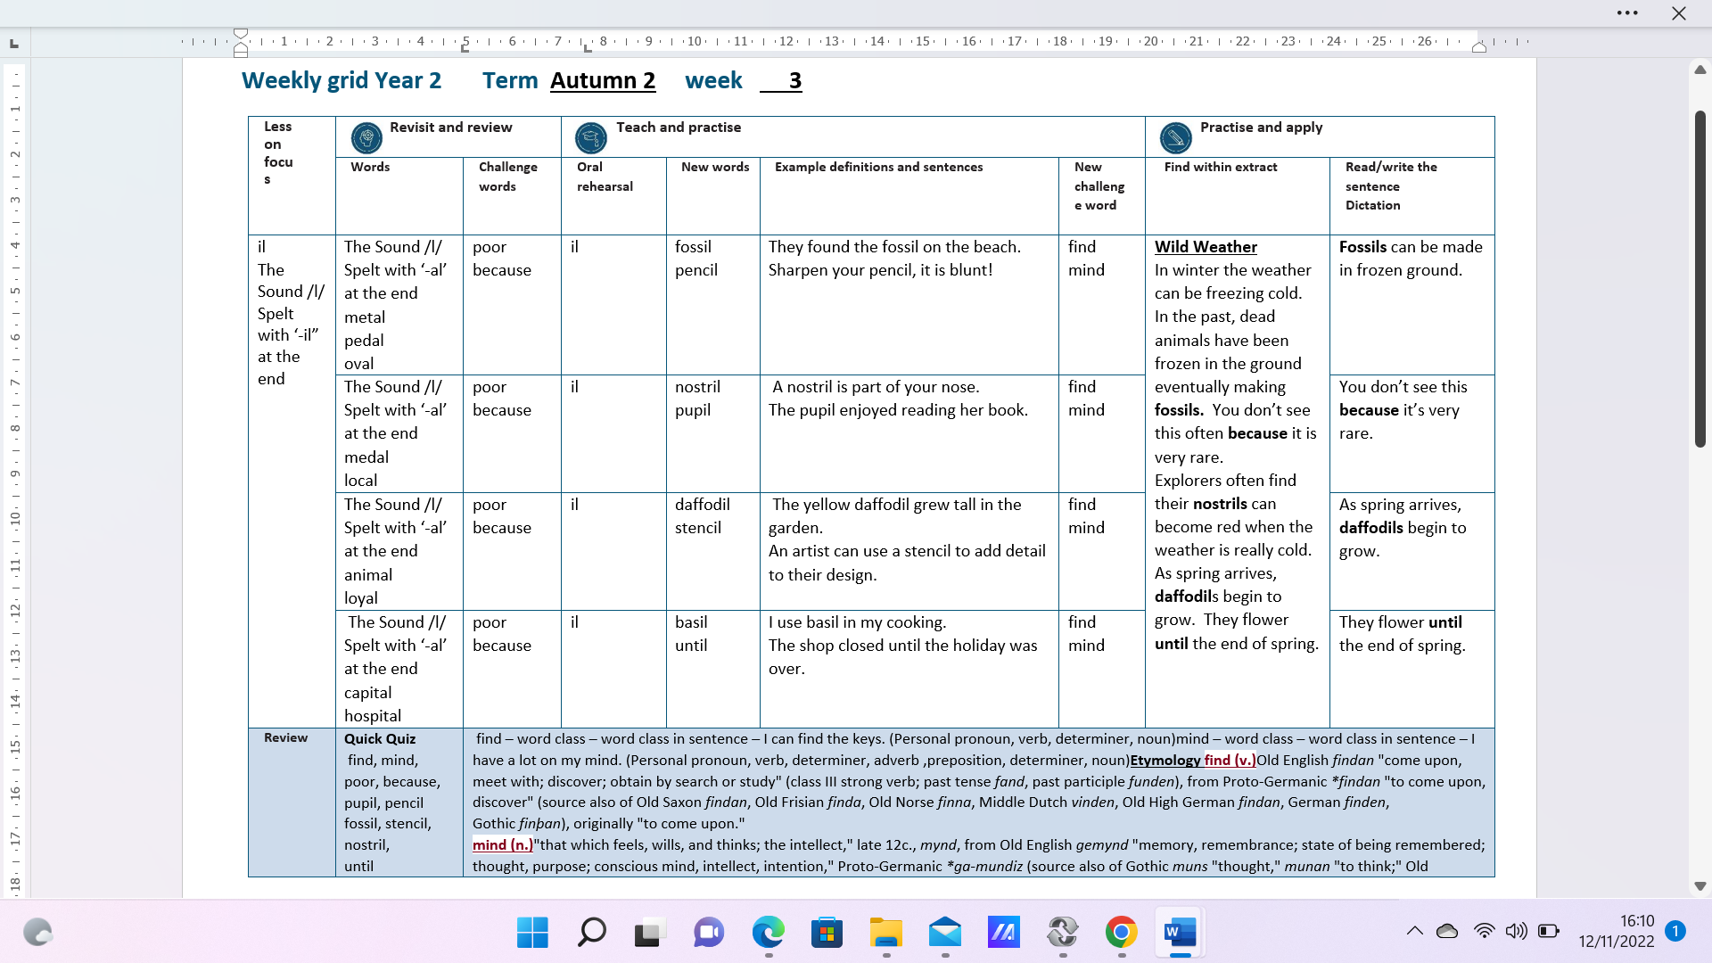

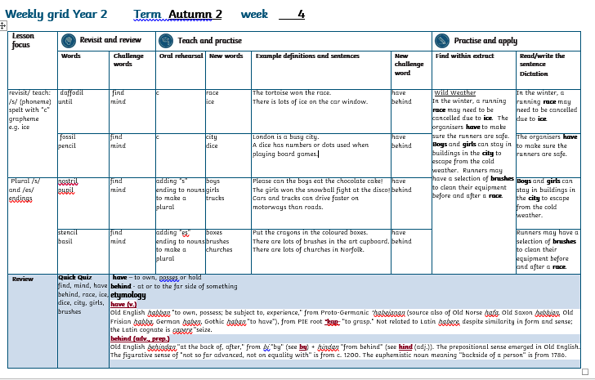

**Weekly grid Year 2 Term Autumn 2 week 5**

|  |  |  |  |  |  |  |  |  |
| --- | --- | --- | --- | --- | --- | --- | --- | --- |
| **Lesson focus** |  **| |  **| | | |  **| |
| **Words** | **Challenge words** | **Oral rehearsal** | **New words** | **Example definitions and sentences** | **New challenge word** | **Find within extract** | **Read/write the sentence**  **Dictation** |
| Teaching  silent /k/ and /g/ at the beginning  of words  teaching suffix  “ed” | race  ice | have  behind | silent /k/ at beg of words | knock  knee | There was a loud knock at the door.  Ouch! My knee is really hurt. | child  children | **Wild Weather**  In bad weather, **children** are often asked to wear extra layers to keep warm. If they fall on the ice and **knock** their **knees**, they should have extra padding. Sometimes, children are **asked** to not jump on icy puddles in case they slip. Once a child **jumped** on an icy puddle and fell badly. Children often are **cuddled** up to their parents to keep warm. | In bad weather, **children** are often asked to wear extra layers to keep warm. |
| city  dice | have  behind | silent /g/ at beg of words | gnome  gnat | Grandad has a big gnome in his garden.  In hot weather, there are lots of gnats flying around rivers and ponds. | child  children | If they fall on the ice and **knock** their **knees**, they should have extra padding. |
| boys  girls  trucks | have  behind | suffix “ed” | worked  jumped | The teacher worked so hard all week.  The children jumped in every puddle. | child  children | Sometimes, children are **asked** to not jump on icy puddles in case they slip. |
| boxes  brushes  churches | have  behind | suffix “ed” | played  asked | Football is played in most countries.  The two lost travellers asked for help. | child  children | Once a child **jumped** on an icy puddle and fell badly. |
| **Review** | **Quick Quiz**  have, behind, child, children, knock, gnat, worked, played, jumped, | **child etymology** [**child (n.)**](https://www.etymonline.com/word/child#etymonline_v_11261) Old English *cild* "fetus, infant, unborn or newly born person," from Proto-Germanic *\*kiltham* (source also of Gothic *kilþei* "womb," *inkilþo* "pregnant;" Danish *kuld* "children of the same marriage;" Old Swedish *kulder* "litter;" Old English *cildhama* "womb," lit. "child-home"); no certain cognates outside Germanic. "App[arently] originally always used in relation to the mother as the 'fruit of the womb'" [Buck]. Also in late Old English, "a youth of gentle birth" (archaic, usually written *childe*). In 16c.-17c. especially "girl child."  **Children etymology** [**children (n.)**](https://www.etymonline.com/word/children#etymonline_v_25917) modern plural of [**child**](https://www.etymonline.com/word/child?ref=etymonline_crossreference) (q.v.  **Word search – see PowerPoint** | | | | | | |

**Weekly grid Year 2 Term Autumn 2 week 6**

|  |  |  |  |  |  |  |  |  |
| --- | --- | --- | --- | --- | --- | --- | --- | --- |
| **Lesson focus** |  **| |  **| | | |  **| |
| **Words** | **Challenge words** | **Oral rehearsal** | **New words** | **Example definitions and sentences** | **New challenge word** | **Find within extract** | **Read/write the sentence**  **Dictation** |
| spelling /r/ sound with “wr” spelling at the beginning of words.  teaching suffix  “er” and “est” | played  asked | Child  children | spelling /r/ sound with “wr” spelling at the beginning of words. | write  wrote  written | We write cards every year.  I wrote my cards at the weekend.  The children had written to their grandparents. | most  only | **Wild Weather**  **Most** people like to wear lots of layers during wild cold weather. Extreme weather can be strong winds, heavy rain, extreme heat or cold; it is **only** classed as extreme when it is worse than recorded history.  During summer 2022, the UK recorded higher temperatures that previous years. Some countries recorded the highest ever temperatures. | Most people like to wear lots of layers during wild cold weather. |
| worked  jumped | Child  children | spelling /r/ sound with “wr” spelling at the beginning of words. | wrong  wrinkle | They went to the wrong island.  The baby elephant grew its first wrinkle. | most  only | It is only classes as extreme when it is worse than recorded history. |
| gnome  gnat | Child  children | adding suffix er | higher  colder | Ben Nevis is higher than Snowdon.  It is colder in Scotland. | most  only | During summer 2022, the UK recorded **higher** temperatures that previous years. |
| knock  knee | Child  children | adding suffix est | highest  coldest | Mount Everest is the highest mountain.  The North Pole is coldest. | most  only | Some countries recorded the **highest** ever temperatures. |
| **Review** | **Quick Quiz**  child, children, most, only, write, wrote, written, wrong, higher. | [**only (adj.)**](https://www.etymonline.com/word/only#etymonline_v_7033)"single as regards number, class, or kind," Middle English *onli*, from Old English *ænlic*, *anlic* "only, unique, solitary," literally "one-like," from *an* "one" (see [**one**](https://www.etymonline.com/word/one?ref=etymonline_crossreference)) + *-lic* "-like" (see [**-ly**](https://www.etymonline.com/word/-ly?ref=etymonline_crossreference#etymonline_v_31075) (1)). Similar formation in Old Frisian *einlik*, Dutch *eenlijk*, Old High German *einlih*, Danish *einlig*. It preserves the old pronunciation of *one*.  Most Old English *mast* "greatest in number, amount, or extent; largest," earlier *mæst*. Used in Old English as superlative of *micel* "great, large" (see [**mickle**](https://www.etymonline.com/word/mickle?ref=etymonline_crossreference)), hence, in later use, superlative of [**much**](https://www.etymonline.com/word/much?ref=etymonline_crossreference). The vowel has been influenced by *more*. Original sense of "greatest" survives in phrase ***for the most part*** (mid-14c.; late Old English had *þa mæste dæl*). Slang ***the most*** meaning "the best, extremely good" is attested from 1953. Also used as an adverb in Old English and in late Old English as a noun, "the greatest or greater number." The sense of "greatest value or advantage" in the phrase ***make the most of*** (something) is by 1520s. Related: *Mostly*. | | | | | | |