Weekly grid Year 3 Term Spring 1 week 1

Lesson focus |   Revisit and review |  |   Teach and practise |  |  |  |   Practise and apply
 | Words – 3 or 4 different each day | Challenge words – 2 same for week | Oral rehearsal | New words - 3 new each day | Example definitions and sentences word class | New challenge word – 2 same for week | Find within extract | Read/write the sentence  Dictation
New teaching – ly suffix no change to root word  R+R – mis prefix | Misspell mishap mistreat | Eight caught | ly suffix no change to root word | Kindly quickly sweetly | adverb: in a kind manner / "‘Never mind,” she said kindly.  adverb: at a fast speed / Reg's illness progressed quickly.  adverb: in a generally pleasing or endearing way / They looked at their children sleeping sweetly. | Continue decide | Oil  Oil is everywhere around us and we continue to use it in many different ways. It is safely used in fertilisers to help us grow food and secretly found in many different types of plastics. Slowly, oil is being phased out of use for running cars. People can now decide to buy new cars that run on electric rather than oil. Usually these electric cars are more expensive, but finally they are becoming more cost efficient. | Oil is everywhere around us and we continue to use it in many different ways.
 | Misbehave mistrust misprint | Eight caught |  | Safely rudely finally | adverb: in a way that gives protection from danger or risk / There is a memento she keeps safely stored away.  adverb: in an offensive or bad-mannered way. / He rudely snatched the water pitcher.  adverb: after a long time, typically when there has been difficulty or delay. / He finally arrived to join us. | Continue decide |  | It is safely used in fertilisers to help us grow food and secretly found in many different types of plastics.
 | Misuse misplace misheard | Eight caught |  | Strongly bravely secretly | adverb: with great power or strength. / She started out swimming strongly.  adverb: in a way that shows a willingness to face and endure danger or pain / He has been hailed a hero after he bravely tackled a thief at a hotel.  adverb:in a secret way; without others knowing. / The two were secretly married in 1751. | Continue decide |  | Slowly, oil is being phased out of use for running cars.
 | Misread misunderstood mislead | Eight caught |  | Usually  Slowly  Endlessly | adverb: under normal conditions / He usually arrives home about one o'clock.  adverb: at a slow speed; not quickly. / They moved forward slowly.  adverb: in a way that has or seems to have no end or limit / The original episodes were endlessly repeated. | Continue decide |  | People can now decide to buy new cars that run on electric rather than oil.
Review | Quick quiz -  Eight caught continue decide misbehave mistrust safely strongly bravely usually | Continue – word class – word classes in a sentence – He was unable to continue with his job. Pronoun verb adjective verb preposition pronoun noun  verb: continue; 3rd person present: continues; past tense: continued; past participle: continued; gerund or present participle: continuing persist in an activity or process.  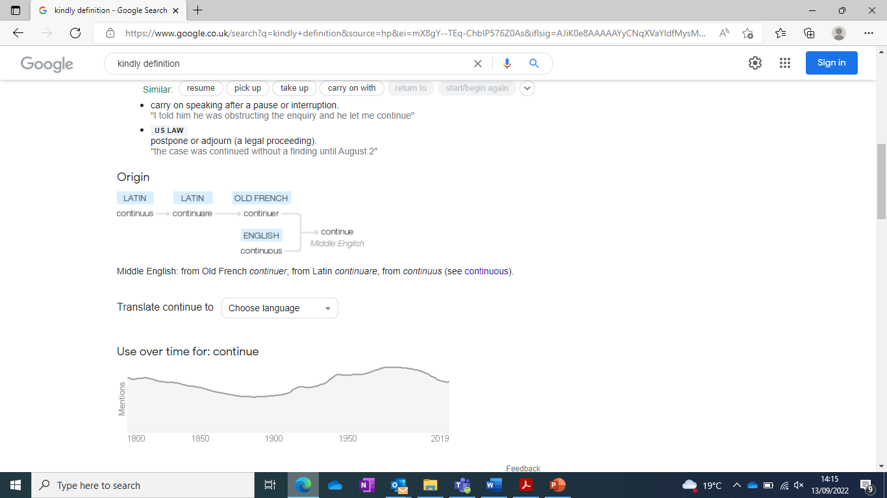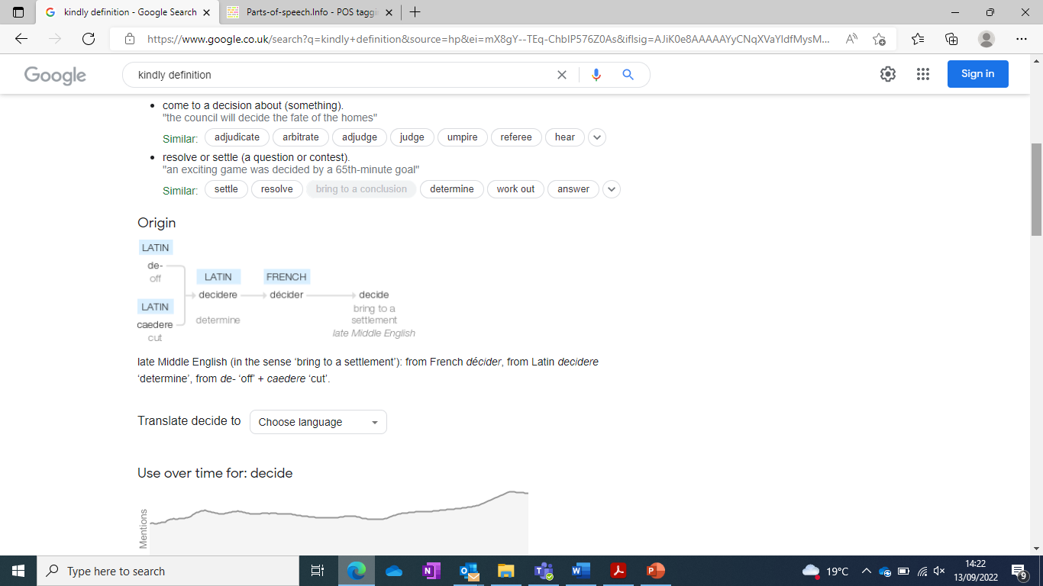  Decide – word class – word class in a sentence – She decided that she liked him. Pronoun verb preposition pronoun verb pronoun  verb / verb: decide; 3rd person present: decides; past tense: decided; past participle: decided; gerund or present participle: deciding / come or bring to a resolution in the mind as a result of consideration.  Create questions and mark schemes for these words.

Weekly grid Year 3 Term Spring 1 week 2

Lesson focus | Revisit and review |  | Teach and practise |  |  |  | Practise and apply
 | Words | Challenge words | Oral rehearsal | New words | Example definitions and sentences | New challenge word | Find within extract | Read/write the sentence  Dictation
New teaching – suffix ly root word ending in y with more than 1 syllable  R+R focus – prefix dis | Dislike  Disobey  Discolour | Centre century | Creating adverbs using the suffix -ly (root word ends in ‘y’ with more than one syllable)  Change y to an I and add ly | Happily angrily lazily | Adverb – in a happy manner – “Let’s go,” she said happily.  Adverb – in a manner resulting from or betraying anger – The rabbit angrily chomped on the carrot.  Adverb – in a manner that shows an unwillingness to exert oneself physically - The cat stretched lazily by the fire. | Island minute | Wind Power  Happily, scientists are working on designs for new and better ways to generate electricity. Over the last century, designs for new and better wind turbines have been easily seen as a solution to eco-friendly power generation. Turbines placed out at sea, off of the coast of islands, generate more electricity. This is because each minute the winds are more constant and stronger than on land. Busily, the blades of turbines rotate vertically around a tower. | Happily, scientists are working on designs for new and better ways to generate electricity.
 | Discover  Disappear  Dishonest | Centre century |  | Easily busily greedily | Adverb - without difficulty or effort – She could easily work out the answer to the sum.  Adverb – in a very active way – As they were busily working, they did not notice the rain had started.  Adverb - excessive desire or appetite for food – They greedily snatched the cakes from the table. | Island minute |  | Over the last century, designs for new and better wind turbines have been easily seen as a solution to eco-friendly power generation.
 | Disallow  Disbelieve  Disapprove | Centre century |  | Messily wearily cheekily | Adverb – untidy or dirty – The messily made bed was a disappointment to Sam’s parents.  Adverb – with extreme tiredness – Wearily, the horse walked on along the muddy track.  Adverb – in an appealingly irreverent way – They cheekily smiled at the camera. | Island minute |  | Turbines placed out at sea, off of the coast of islands, generate more electricity.
 | Discontinue  Disgrace  Disrepair | Centre century |  | Clumsily bumpily hungrily | Adverb – in an awkward and careless way – She climbed clumsily over the hill.  Adverb – uneven surface – The car moved off bumpily towards its destination.  Adverb – in a way that shows a need or desire for food – He hungrily devoured six pieces of bread. | Island minute |  | Busily, the blades of turbines rotate vertically around a tower.
Review | Quick Quiz  Centre century island minute disbelieve disapprove easily messily clumsily hungrily | Island - word class and word class in a sentence – The pirates landed on an island in search of treasure. – Determiner noun verb preposition determiner noun preposition noun preposition noun  Minute – word class and word class in a sentence – The minute hand ticked by slowly during the exam. – determiner adjective noun verb preposition adverb preposition determiner noun  island (n.)  1590s, earlier yland (c. 1300), from Old English igland, iegland "an island," from ieg "island" (from Proto-Germanic *awjo "thing on the water," from PIE root *akwa- "water") + land (n.).  The second syllable (also in Old Frisian alond, Middle Dutch eiland) was added later to distinguish it from homonyms, especially Old English ea "water" (see ea). As an adjective from 1620s.  Spelling modified 16c. by association with similar but unrelated isle. Similar formation in Old Frisian eiland, Middle Dutch eyland, German Eiland, Danish öland, etc. In place names, Old English ieg is often used of "slightly raised dry ground offering settlement sites in areas surrounded by marsh or subject to flooding" [Cambridge Dictionary of English Place-Names].  minute (n.)  "sixtieth part of an hour or degree of a circle," late 14c., from Old French minut (13c.) or directly from Medieval Latin minuta "minute of time; short note," from Latin minuta "a small portion or piece," noun use of fem. of minutus "little, small, minute," past participle of minuere "to lessen, diminish" (from PIE root *mei- (2) "small").  In Medieval Latin, pars minuta prima "first small part" was used by mathematician Ptolemy for one-sixtieth of a circle, later one-sixtieth of an hour (next in order was secunda minuta, which became second (n.)). German Minute, Dutch minuut also are from French. Used vaguely for "short time" from late 14c. As a measure expressing distance (travel time) by 1886. Minute hand "hand which indicates the minutes on a clock or watch" is attested from 1726. Minute-jumper (1890) was the name for the kind of electric clock on which the hands move only at the end of each minute.  Investigate  Find words associated with challenge words.

Weekly grid Year 3 Term Spring 1 week 3

Lesson focus | Revisit and review |  | Teach and practise |  |  |  | Practise and apply
 | Words | Challenge words | Oral rehearsal | New words | Example definitions and sentences | New challenge word | Find within extract | Read/write the sentence  Dictation
New teaching – suffix ly root word ends in le  R+R focus - prefixes re and bi | Bicycle  Biplane  Bisects | Heart breath | Creating adverbs using the suffix -ly (root word ends in ‘le’) - take off le and add ly | Gently simply humbly | ADVERB - with a mild, kind, or tender manner: She gently broke the news to her mum.  ADVERB - in a straightforward or plain manner: She spoke simply and from the heart.  ADVERB - in a way that shows or suggests a modest or low estimate of one's importance; meekly: The servant bowed humbly before his master. | Difficult earth | Take Cover  Wind power to generate electricity is possibly the way to protect the earth. However, it is a difficult power to harness. The wind is incredibly strong and can simply destroy anything in its path in a heartbeat. Hurricanes, tornadoes, monsoons and floods are all increasing in frequency due to climate change. They can simply destroy places all over the world. | Wind power to generate electricity is possibly the way to protect the earth.
 | Bilingual  Biannual  Biangular | Heart breath |  | Nobly horribly terribly | ADVERB - in a way that shows fine personal qualities or high moral principles; gallantly: A great soldier fought nobly in many battles.  ADVERB - in a way that causes horror; shockingly: People are suffering horribly in the aftermath of the cyclone.  ADVERB - very badly or unpleasantly: They came into the kitchen, behaving terribly. | Difficult earth |  | However, it is a difficult power to harness.
 | Reappear  Redecorate  Reapply | Heart breath |  | Possibly incredibly comfortably | ADVERB - perhaps (used to indicate doubt or hesitancy): They found themselves alone, possibly the only survivors.  ADVERB - to a great degree; extremely: Michele was incredibly brave.  ADVERB - in a physically relaxed way that is free from constraint: They lounge comfortably in their armchair. | Difficult earth |  | The wind is incredibly strong and can simply destroy anything in its path in a heartbeat.
 | Repay  Rebuild  Refill | Heart breath |  | Probably visibly durably | ADVERB - almost certainly; as far as one knows or can tell: She would probably never see him again.  ADVERB - in a way that is visible to the eye: The defendant paled visibly as the guilty verdict was announced.  ADVERB - to exist for a long time without significant deterioration in quality or value. The house was simple yet durably furnished. | Difficult earth |  | They can simply destroy places all over the world.
Review | Quick Quiz  Heart breath difficult earth bicycle reappear gently horribly possibly probably | Difficult - word class and word class in a sentence – It is difficult to make decisions. Pronoun verb adjective verb determiner noun  Earth - word class and word class in a sentence – The earth is the third planet from the sun. Determiner noun verb determiner adjective noun preposition déterminer noun  difficult (adj.)  Origin and meaning of difficult  c. 1400, "not easy, requiring or dependent on effort; troublesome, arduous," apparently an unetymological back-formation from difficulty. French has difficile, Latin difficilis. Of persons, "hard to please," from 1580s. Related: Difficultly.  earth (v.)  "to commit (a corpse) to earth," late 14c., from earth (n.). Related: Earthed; earthing.  Look at the word origin of the challenge words and find words that are linked to them.

Weekly grid Year 3 Term Spring 1 week 4

Lesson focus | Revisit and review |  | Teach and practise |  |  |  | Practise and apply
 | Words | Challenge words | Oral rehearsal | New words | Example definitions and sentences | New challenge word | Find within extract | Read/write the sentence  Dictation
New teaching – suffix ly root words ending in ic or al  R+R – prefixes inter and super | Interact  Interfere  Intercity | Busy early | Creating adverbs using the suffix -ly (root word ends in ‘ic’ or ‘al’)  ic + ally  al + ly | Basically frantically dramatically | ADVERB - in the most essential respects; fundamentally: We started from a basically simple idea.  ADVERB - in a hurried, excited, or disorganized manner: The two ladies, competing for his attention, waved frantically at him.  ADVERB - in a way that relates to drama or the performance of drama:  They displayed their talents both musically and dramatically. | Consider enough | Hurricanes  Basically, hurricanes are large, swirling storms that form over warm ocean waters. People in the south of America consider hurricanes to be part of their everyday life. They hit enough each year for people to actually expect damage to their homes. Some hurricanes cause dramatically more damage than others. In August 2005 Hurricane Katrina hit New Orleans and caused flooding that tragically cost the lives of around 1800 people. | Basically, hurricanes are large, swirling storms that form over warm ocean waters.
 | International  Intermediate  Internet | Busy early |  | Magically tragically comically | ADVERB - using or as if by magic: A card seemed to appear magically in his hand.  ADVERB - in a way that involves or causes extreme distress or sorrow: Jim was tragically hurt in a bicycle crash.  ADVERB - in an amusing, ludicrous, or absurd way: A striker comically fumbled a free kick. | Consider enough |  | People in the south of America consider hurricanes to be part of their everyday life.
 | Superman  Supercharged  Supernatural | Busy early |  | Actually accidentally occasionally | ADVERB - as the truth or facts of a situation; really: We must pay attention to what young people are actually doing.  ADVERB - by chance; inadvertently: His alarm went off accidentally.  ADVERB - at infrequent or irregular intervals; now and then: We met up occasionally for a game of football. | Consider enough |  | They hit enough each year for people to actually expect damage to their homes.
 | Superfast  Superfan  Supercool | Busy early |  | Eventually finally dynamically | ADVERB - in the end, especially after a long delay, dispute, or series of problems: Eventually, after midnight, I arrived at the hotel.  ADVERB - after a long time, typically when there has been difficulty or delay: He finally arrived to join us.  ADVERB - in a manner characterised by constant change, activity, or progress: This situation can change dynamically on the timescale of minutes. | Consider enough |  | Some hurricanes cause dramatically more damage than others.
Review | Quick Quiz  Busy early consider enough interact supercharged basically magically actually finally | Consider – word class and sentence – We need to consider how to move forward. Pronoun verb verb adverb pronoun verb adverb  Enough – word class and sentence - I have had enough food for lunch. Pronoun verb verb adjective noun preposition noun  consider (v.)  late 14c., "to fix the mind upon for careful examination, meditate upon," also "view attentively, scrutinize; not to be negligent of," from Old French considerer (13c.) "reflect on, consider, study," from Latin considerare "to look at closely, observe," probably literally "to observe the stars," from assimilated form of com "with, together" (see con-) + sidus (genitive sideris) "heavenly body, star, constellation" (see sidereal).  enough (adj.)  c. 1300, from Old English genog "sufficient in quantity or number," from Proto-Germanic compound *ganog "sufficient" (source also of Old Saxon ginog, Old Frisian enoch, Dutch genoeg, Old High German ginuog, German genug, Old Norse gnogr, Gothic ganohs).  First element is Old English ge- "with, together" (also a participial, collective, intensive, or perfective prefix), making this word the most prominent surviving example of the Old English prefix, the equivalent of Latin com- and Modern German ge- (from PIE *kom- "beside, near, by, with;" see com-). The second element is from PIE *nok-, from root *nek- (2) "to reach, attain" (source also of Sanskrit asnoti "to reach," Hittite ninikzi "lifts, raises," Lithuanian nešti "to bear, carry," Latin nancisci "to obtain").  Write spelling questions for the challenge words and then a mark scheme to show where children may go wrong.

Weekly grid Year 3 Term Spring 1 week 5

Lesson focus | Revisit and review |  | Teach and practise |  |  |  | Practise and apply
 | Words | Challenge words | Oral rehearsal | New words | Example definitions and sentences | New challenge word | Find within extract | Read/write the sentence  Dictation
New teaching –suffix ly exceptions to the rules  R+R focus – prefixes auto and anti | Autograph  Autobiography  Automatic | Their there they’re | Creating adverbs using the suffix -ly (exceptions to the rules) | Truly duly wholly | ADVERB - in a truthful way: He speaks truly.  ADVERB - in accordance with what is required or appropriate; A document duly signed and authorised by the inspector.  ADVERB - entirely; fully: She found herself given over wholly to sensation. | Though notice | Tornadoes  The truly biggest thunderstorms create tornadoes. They’re a spinning column of air, shaped like a fully giant funnel. Though called tornadoes, they are sometimes called twisters because of the way they look. Tornadoes bring the world’s strongest winds. In the USA, in tornado alley, there can be a tornado happening daily. | The truly biggest thunderstorms create tornadoes.
 | Autofocus  Autopilot  Autocorrect | Their there they’re |  | Fully daily | ADVERB - completely or entirely; to the fullest extent: I fully understand what our cat is telling us.  ADVERB - every day: The museum is open daily. | Though notice |  | They’re a spinning column of air, shaped like a fully giant funnel.
 | Antiseptic  Anticlockwise  Antisocial | Their there they’re |  | Publicly dryly | ADVERB - so as to be seen by other people; in public: Some people weep publicly.  ADVERB in a dry way or condition: Evan swallowed drily. | Though notice |  | Though called tornadoes, they are sometimes called twisters because of the way they look.
 | Antidote  Antibiotic  Antigravity | Their there they’re |  | Slyly shyly coyly | ADVERB - in a cunning and deceitful or manipulative manner:  They slyly manipulate situations to their own favour.  ADVERB - in a nervous or timid manner: She smiles shyly, blushing a little.  ADVERB - in an outwardly shy or modest way that is intended to be alluring: She smiles coyly for the camera. | Though notice |  | In the USA, in tornado alley, there can be a tornado happening daily.
Review | Quick Quiz  Their there they’re though notice autograph anticlockwise truly fully dryly coyly | Though – word class and sentence – Though they were speaking quietly, they could still be heard. Preposition pronoun verb verb adjective pronoun verb adverb verb verb  Notice – word class and sentence - The notice was very clear. Determiner noun verb adverb adjective  though (adv., conj.)  c. 1200, from Old English þeah "though, although, even if, however, nevertheless, still, yet;" and in part from Old Norse þo "though," both from Proto-Germanic *thaukh (source also of Gothic þauh, Old Frisian thach, Middle Dutch, Dutch doch, Old High German doh, German doch), from PIE demonstrative pronoun *to- (see that). The evolution of the terminal sound did not follow laugh, tough, etc., though a tendency to end the word in "f" existed c. 1300-1750 and persists in dialects.  ORIGIN  Old English thēah, of Germanic origin; related to Dutch and German doch; superseded in Middle English by forms from Old Norse thó, thau.  notice (v.)  early 15c., "to notify, give notice of" (a sense obsolete since 17c.), from notice (n.). The sense of "to point out, refer to, remark upon" is from 1620s. The meaning "to take notice of, perceive, become aware of" is attested by 1757, but it was long execrated by purists in England as an Americanism (also occasionally as a Scottishism, the two offenses not being clearly distinguished). Ben Franklin noted it as one of the words (along with verbal uses of progress and advocate) that seemed to him to have become popular in America while he was absent in France during the Revolution. Related: Noticed; noticing.  ORIGIN  late Middle English (in notice): from Old French, from Latin notitia ‘being known’, from notus ‘known’ (see notion).  Find synonyms and antonyms of the challenge words.

Weekly grid Year 3 Term Spring 1 week 6

Lesson focus | Revisit and review |  | Teach and practise - all revisit and review of this half terms words |  |  |  | Practise and apply
 | Words | Challenge words | Oral rehearsal | New words | Example definitions and sentences | New challenge word | Investigate / detect
No new teaching – all revisit and review  Time for filling gaps and meeting individual need | Mistreat  Mistrust  Misplace  Mislead | Eight caught | Suffix ly – no change | Kindly quickly sweetly | adverb: in a kind manner / "‘Never mind,” she said kindly.  adverb: at a fast speed / Reg's illness progressed quickly.  adverb: in a generally pleasing or endearing way / They looked at their children sleeping sweetly. | Continue decide | Find the spelling mistakes in this section and explain how the child has gone wrong.  The eight (ate) year old caught (cort) the ball and kindly (kindle) gave it back to his sister.
 | Disobey  Disbelieve  Disappear  Disrepair | Centre century | Suffix ly – change y to i | Happily angrily lazily | Adverb – in a happy manner – “Let’s go,” she said happily.  Adverb – in a manner resulting from or betraying anger – The rabbit angrily chomped on the carrot.  Adverb – in a manner that shows an unwillingness to exert oneself physically - The cat stretched lazily by the fire. | Island minute | Find the spelling mistakes in this section and explain how the child has gone wrong.  In the centre (center) of the island (iland) happily (happyly) stood a little girl.
 | Reappear  Repay  Bicycle  Bisect | Heart breath | Suffix ly - | Gently simply humbly | ADVERB - with a mild, kind, or tender manner: She gently broke the news to her mum.  ADVERB - in a straightforward or plain manner: She spoke simply and from the heart.  ADVERB - in a way that shows or suggests a modest or low estimate of one's importance; meekly: The servant bowed humbly before his master. | Difficult earth | Find the spelling mistakes in this section and explain how the child has gone wrong.  Her heart (hart) was gently (gentle) pumping as she landed back down on earth (erf).
 | Internet  Interfere  Superman  Supernatural | Busy early | Suffix ly - | Basically frantically dramatically | ADVERB - in the most essential respects; fundamentally: We started from a basically simple idea.  ADVERB - in a hurried, excited, or disorganized manner: The two ladies, competing for his attention, waved frantically at him.  ADVERB - in a way that relates to drama or the performance of drama:  They displayed their talents both musically and dramatically. | Consider enough | Find the spelling mistakes in this section and explain how the child has gone wrong.  She ate early (erle) and had enough (enuff) food that she frantically (franticle) then ran to work.
 | Autopilot  Autograph  Anticlockwise  Antigravity | Their there they’re | Suffix ly - | Truly duly wholly | ADVERB - in a truthful way: He speaks truly.  ADVERB - in accordance with what is required or appropriate; A document duly signed and authorised by the inspector.  ADVERB - entirely; fully: She found herself given over wholly to sensation. | Though notice | Find the spelling mistakes in this section and explain how the child has gone wrong.  Though (thow) they were truly (truely) unhappy, there (their) was something to smile about.

