Weekly grid Year 6 Term Autumn 1 week 1 (this is a duplicate of Y5 summer 2 and a revisit and review of the whole of Y5)

Lesson focus |   Revisit and review |  |   Teach and practise |  |  |  |   Practise and apply
 | Words – 3 or 4 different each day | Challenge words – 2 same for week | Oral rehearsal | New words - 3 new each day | Example definitions and sentences word class | New challenge word – 2 same for week | Find within extract | Read/write the sentence  Dictation
New teaching – prefix de  R+R focus – adverbials for possibility and frequency and modal verbs | certainly  definitely  possibly | Controversy  Convenience | Prefix de meaning off or from | deflate  deform  decode | deflate (verb) : let air or gas out of something  The balloon was allowed to deflate slowly so it didn’t burst and frighten people.  deform (verb) : distort the shape of something  The ice-sculpture was left to melt and deform in the sun.  decode (verb) : convert a coded message into intelligible language  In WW2, German’s messages were scrutinised to decode them. | Especially  Exaggerate | Fragile Earth  There is no controversy in the fact that Earth is always changing. We may not notice it from day to day, but it certainly is constantly shifting beneath our feet. You might not notice the mountains slowly wearing away or the valleys starting to deform as they grow deeper or the cliffs we depend on crumbling into the sea, but it is always happening. Meanwhile, forest floors decompose, the temperature of the earth’s atmosphere raises a degree or two and the Earth we depend on is forced to change. | There is no controversy in the fact that Earth is always changing.
 | probably  frequently  perhaps | Controversy  Convenience | Prefix de meaning off or from | decompose  defuse  degree | decompose (verb) : to become rotten  The fruit was left to decompose in the sun as a school experiment.  defuse (verb) : remove the fuse from something to prevent it from exploding  The bomb was set to explode, but the police came to defuse it.  degree (adverb) : the extent to which something happens or is present  The temperature rose degree by degree to become the hottest day of the year. | Especially  Exaggerate |  | We may not notice it from day to day, but it certainly is constantly shifting beneath our feet.
 | often  occasionally  rarely  always | Controversy  Convenience | Prefix de meaning off or from | decent  delete  delight | decent (adjective) : acceptable standards of respectable behaviour  Teachers’ behaviour must be decent as they are role models for the younger generation.  delete (verb) : remove or obliterate information  The delete key on the computer was broken causing lots of issues for students.  delight (verb) : to take pleasure in  The delight was clear on the children’s faces. | Especially  Exaggerate |  | You might not notice the mountains slowly wearing away or the valleys starting to deform as they grow deeper or the cliffs we depend on crumbling into the sea, but it is always happening.
 | might  should  could | Controversy  Convenience | Prefix de meaning off or from | defeat  deserve  depend | defeat (verb) : win a victory in something over someone else  In chess, the object is to defeat your opponent.  deserve (verb) : to do something or have qualities worthy of something  Everyone deserves to be loved.  depend (verb) : to be controlled or determined by something  People depend on the government to run the country. | Especially  Exaggerate |  | Meanwhile, forest floors decompose, the temperature of the earth’s atmosphere raises a degree or two and the Earth we depend on is forced to change.
Review | Quick quiz -  Controversy convenience especially exaggerate occasionally frequently decompose delight deserve decent | Especially – word class – word classes in a sentence – Children especially love spelling quizzes. (noun adverb verb adjective noun)  Exaggerate – word class – word class in a sentence – The runner would exaggerate how quick he could run. (article noun verb pronoun model-verb verb)  especially (adv.)  c. 1400, from especial + -ly (2).  exaggerate (v.)  Origin and meaning of exaggerate1530s, "to pile up, accumulate," from Latin exaggeratus, past participle of exaggerare "heighten, amplify, magnify," literally "to heap, pile, load, fill," from ex, here probably "thoroughly" (see ex-), + aggerare "heap up, accumulate," figuratively "amplify, magnify," from agger (genitive aggeris) "heap," from aggerere "bring together, carry toward," from assimilated form of ad "to, toward" (see ad-) + gerere "carry" (see gest). Sense of "overstate" first recorded in English 1560s. Related: Exaggerated; exaggerating.  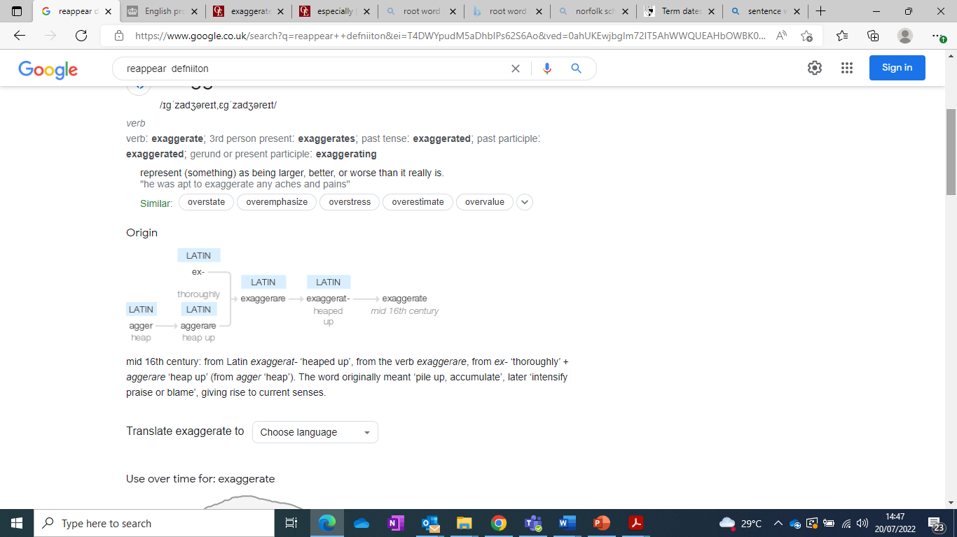  Create questions and mark schemes for these words.
Weekly grid Year 6 Term Autumn 1 week 2

Lesson focus | Revisit and review |  | Teach and practise |  |  |  | Practise and apply
 | Words | Challenge words | Oral rehearsal | New words | Example definitions and sentences | New challenge word | Find within extract | Read/write the sentence  Dictation
New teaching – prefix re  R+R focus – words ending ance / ant | Observance  flamboyance  pleasurance. | Correspond  Criticise | Prefix re- meaning back or again | recycle  rebuild  rewrite | recycle (verb) : convert into reusable material  It is important to recycle to save the environment.  rebuild (verb) : build something again after it has been destroyed  Help is always well received when having to rebuild something.  rewrite (verb) : write something again to alter or improve it  If work needs improvement, a rewrite is recommended. | Hindrance  Excellent | Fragile Earth  The observance of these forces acting on the Earth are seen as both natural and the work of people. We can criticise this and seek revenge, or we can recycle, rebuild and rewrite the future. The relevance of being able to recycle items means that less energy is used to create new things and less waste is being created. There is no time to be hesitant about this change of attitude. | The observance of these forces acting on the Earth are seen as both natural and the work of people.
 | tolerance  relevance jubilance | Correspond  Criticise | Prefix re- meaning back or again | replace  revisit  refresh | replace (verb) : to take the place of  To replace a work in a sentence can make a significant difference.  revisit (verb) : come back to or visit again  We revisit spellings so that they become automatic and require less working memory.  refresh (verb) : give new strength or or energy to something  The refresh key on the computer allows internet sites to show the most up-to-date information. | Hindrance  Excellent |  | We can criticise this and seek revenge, or we can recycle, rebuild and rewrite the future.
 | relevant  tolerant  restaurant. | Correspond  Criticise | Prefix re- meaning back or again | revenge  retrieved  return | revenge (noun) : action or hurting or harming someone in return of a wrong suffered at their hands  The act of revenge is never recommended.  retrieved (verb) : get or bring something back from somewhere  The boy retrieved his degree from the university.  return (verb) : come or go back to a place or person  The children return to school year after year to learn new skills and knowledge. | Hindrance  Excellent |  | The relevance of being able to recycle items means that less energy is used to create new things and less waste is being created.
 | hesitant  expectant  observant | Correspond  Criticise | Prefix re- meaning back or again | reflector  revise  rebellion | reflector (noun) : a piece of glass or metal used for reflecting light in a certain direction  The reflector on his bike made him visible to motorists.  revise (verb) : examine and make corrections or alterations  It is wise to revise for exams.  rebellion (noun) : an act of armed resistance to an established government or leader  The rebellion took place in France to demand democracy. | Hindrance  Excellent |  | There is no time to be hesitant about this change of attitude.
Review | Quick Quiz  Correspond criticise hindrance excellent  Relevance expectant reflector rebellion revenge recycle | Hindrance - word class and word class in a sentence – The over-large suitcase was a hindrance when climbing stairs. (article adjective noun verb article …)  excellent – word class and word class in a sentence – Christmas is excellent. (Noun verb adjective)  hindrance (n.)  mid-15c., a hybrid from hindren (see hinder (v.)) on model of French-derived words in -ance.  excellent (adj.)  "unexcelled, distinguished for superior merit of any kind, of surpassing character or quality, uncommonly valuable for any reason, remarkably good," mid-14c., from Old French excellent "outstanding, excellent," from Latin excellentem (nominative excellens) "towering, prominent, distinguished, superior, surpassing," present participle of excellere "surpass, be superior; to rise, be eminent," from ex "out from" (see ex-) + -cellere "rise high, tower," related to celsus "high, lofty, great," from PIE root *kel- (2) "to be prominent; hill." Related: Excellently.  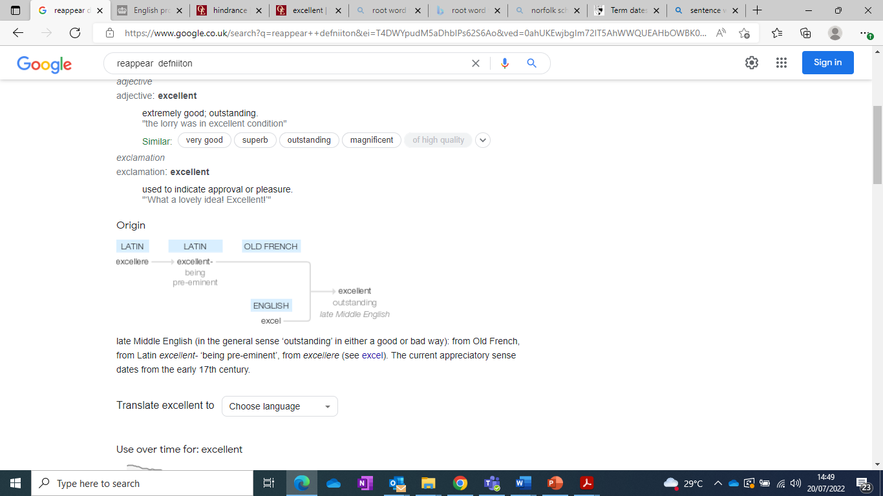  Find antonyms and synonyms of the challenge words.

Weekly grid Year 6 Term Autumn 1 week 3

Lesson focus | Revisit and review |  | Teach and practise |  |  |  | Practise and apply
 | Words | Challenge words | Oral rehearsal | New words | Example definitions and sentences | New challenge word | Find within extract | Read/write the sentence  Dictation
New teaching – prefix over-  R+R focus - words ending -ancy | expectancy  hesitancy  discrepancy; infancy; | Desperate  Determined | Prefix over- meaning too much or more than enough | overthrow  overturn  overslept | overthrow (verb) : remove forcibly from power  The overthrow of Boris Johnson was reported heavily in the newspapers.  overturn (verb): tip something over so it is on its side  The overturn of the lorry on the motorway caused severe congestion.  overslept (verb) : to sleep longer than intended  The pupil overslept due to their alarm malfunctioning. | Existence  Explanation | Fragile Earth  Some of the most powerful, desperate and determined forces that affect our planet take place under the Earth’s surface. Hot molten rock can overthrow the Earth’s crust to cause devasting earthquakes and volcanoes. This can affect the occupancy of the planet as lives can be lost in these natural disasters. Other natural disasters are from above our heads where overcast skies can bring violent storms or we can overcook as heatwaves increase year on year. The overarching theme is that of change. | Some of the most powerful, desperate and determined forces that affect our planet take place under the Earth’s surface.
 | redundancy;; militancy; tenancy; | Desperate  Determined | Prefix over- meaning too much or more than enough | overcook  overreact  overestimate | overcook (verb) : cook for too long  To overcook a piece of food is a travesty.  overreact (verb) : to respond more emotionally or forcibly than is justified  People overreact to small things when they are feeling tired.  overestimate (verb) : to form a too high estimate  Do not overestimate how easy it is to learn new spellings. | Existence  Explanation |  | Hot molten rock can overthrow the Earth’s crust to cause devasting earthquakes and volcanoes.
 | occupancy; consultancy; pregnancy; ascendancy; | Desperate  Determined | Prefix over- meaning too much or more than enough | overuse  overpaid  overlook | overuse (verb) : use too much  People overuse the word ‘literally’.  overpaid (adjective) : paid too highly  People can never say teachers are overpaid.  overlook (verb) : fail to notice  The need to overlook poor spelling is not acceptable. | Existence  Explanation |  | This can affect the occupancy of the planet as lives can be lost in these natural disasters.
 | accountancy; truancy; buoyancy; | Desperate  Determined | Prefix over- meaning too much or more than enough | overbalance  overcast  overarching | overbalance (verb) : fall over through lack of balance  The clowns overbalanced on their unicycles.  overcast (adjective) : dull, grey weather  The overcast sky loomed in the distance.  overarching (adjective) : all embracing  Do people have one overarching mind that spans the two hemispheres? | Existence  Explanation |  | Other natural disasters are from above our heads where overcast skies can bring violent storms or we can overcook as heatwaves increase year on year.
Review | Quick Quiz  Desperate determined existence explanation  Hesitancy occupancy overarching overestimate overuse overslept | Existence - word class and word class in a sentence – Christians believe in the existence of God. (noun verb preposition article verb noun)  Explanation – word class and word class in a sentence – An explanation text is useful in science lessons. (article adjective noun verb preposition adjective noun)  existence (n.) late 14c., "reality," from Old French existence, from Medieval Latin existentia/exsistentia, from existentem/exsistentem (nominative existens/exsistens) "existent," present participle of Latin existere/exsistere "stand forth, come out, emerge; appear, be visible, come to light; arise, be produced; turn into," and, as a secondary meaning, "exist, be;" from ex "forth" (see ex-) + sistere "cause to stand," from PIE *si-st-, reduplicated form of root *sta- "to stand, make or be firm."  explanation (n.) "an act of explaining; a meaning or interpretation assigned," late 14c., explanacioun, from Latin explanationem (nominative explanatio) "an explanation, interpretation," noun of action from past-participle stem of explanare "to make plain or clear, explain," literally "make level, flatten," from ex "out" (see ex-) + planus "flat" (from PIE root *pele- (2) "flat; to spread").  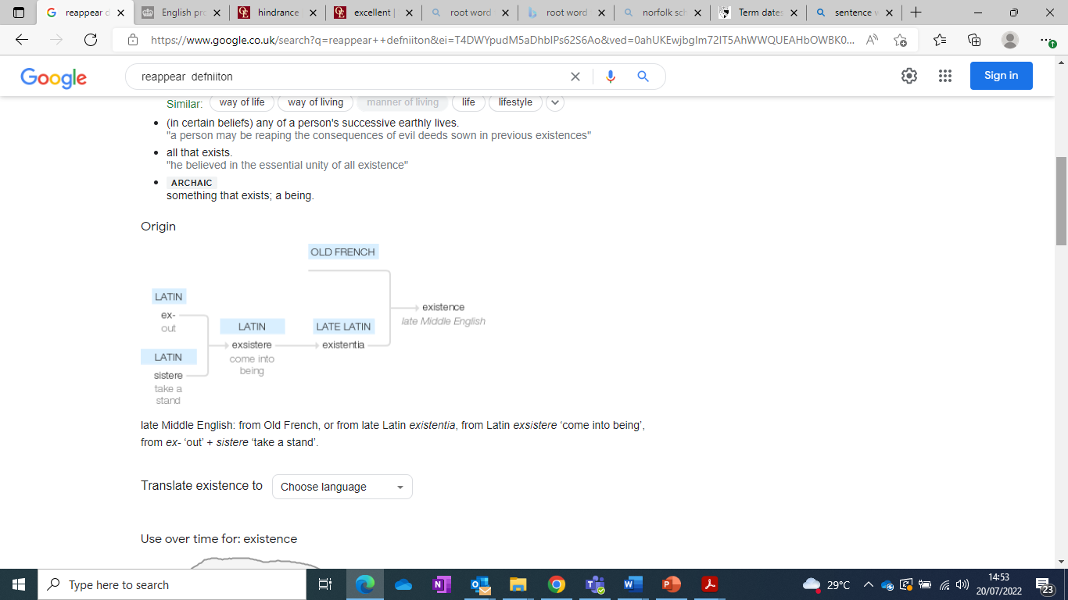  Look at the word origin of the challenge words and find words that are linked to them.
Weekly grid Year 6 Term Autumn 1 week 4

Lesson focus | Revisit and review |  | Teach and practise |  |  |  | Practise and apply
 | Words | Challenge words | Oral rehearsal | New words | Example definitions and sentences | New challenge word | Find within extract | Read/write the sentence  Dictation
New teaching – suffix -ful  R+R – words ending ence and ent | innocence  excellence | Disastrous embarrass | Suffix -ful meaning full of | Boastful faithful  Doubtful | Boastful (adjective) show excessive pride  The boastful singer performed at the Super Bowl half-time show.  Faithful (adjective) remaining loyal  The faithful puppy followed its owner to the store.  Doubtful (adjective) feeling uncertain  It was doubtful that sports day would take place in the rain. | Familiar amateur | Fragile Earth  The innocence of humans changing the landscape without understanding the disastrous consequences has long passed. The beautiful Earth, that once was plentiful, is now doubtful of its future. Confident humans cleared forests to make room for buildings and farm. Boastful landowners mined the coal from beneath the ground and rivers have been diverted to irrigate farms leaving them pitiful and dried up. | The innocence of humans changing the landscape without understanding the disastrous consequences has long passed
 | confidence  existence | Disastrous embarrass | Suffix -ful meaning full of | Fearful thankful beautiful | Fearful (adjective) showing fear  They were fearful of the tiger on the loose.  Thankful (adjective) pleased and relieved  They were thankful for the harvest donations to support the charity event.  Beautiful (adjective) pleasing the senses  The beautiful creature stared calmly at the amazed tourists. | Familiar amateur |  | The beautiful Earth, that once was plentiful, is now doubtful of its future.
 | existent  innocent  decent | Disastrous embarrass | Suffix -ful meaning full of | Pitiful plentiful fanciful | Pitiful (adjective) very small or poor / inadequate  The pitiful creature looked ready to give up their life.  Plentiful (adjective) yielding great quantities  The plentiful crop produced this year was sure to achieve high profits.  Fanciful (adjective) existing only in imagination  The fanciful clothing meant that the star was sure to stand out on stage. | Familiar amateur |  | Confident humans cleared forests to make room for buildings and farm.
 | excellent  confident | Disastrous embarrass | Suffix -ful meaning full of | Merciful dutiful disgraceful | Merciful (adjective) bringing relief  The merciful act of offering a home to the homeless is required from Christians.  Dutiful (adjective) obediently following duty  The army recruits dutifully steps onto the plane heading to war.  Disgraceful (adjective) shockingly unacceptable  It was disgraceful seeing people ignoring others in need. | Familiar amateur |  | Boastful landowners mined the coal from beneath the ground and rivers have been diverted to irrigate farms leaving them pitiful and dried up.
Review | Quick Quiz  Disastrous embarrass familiar amateur innocence innocent boastful fearful plentiful disgraceful | Familiar – word class and sentence – The familiar feeling came over her as she entered her old home. (article adjective noun verb preposition pronoun verb determiner adjective noun)  Amateur – word class and sentence - The Olympics were incredible for the amateur boxer. (article noun verb adverb article adjective noun )  familiar (adj.)- mid-14c., "intimate, very friendly, on a family footing," from Old French famelier "related; friendly," from Latin familiaris "domestic, private, belonging to a family, of a household;" also "familiar, intimate, friendly," a dissimilation of *familialis, from familia (see family).  From late 14c. as "of or pertaining to one's family." Of things, "known from long association," from late 15c. Meaning "ordinary, usual" is from 1590s.  The noun meaning "demon, evil spirit that answers one's call" is from 1580s (familiar spirit is attested from 1560s); earlier as a noun it meant "a familiar friend" (late 14c.). The Latin plural, used as a noun, meant "the slaves," also "a friend, intimate acquaintance, companion."  amateur (n.) 1784, "one who has a taste for some art, study, or pursuit, but does not practice it," from French amateur "one who loves, lover" (16c., restored from Old French ameour), from Latin amatorem (nominative amator) "lover, friend," agent noun from amatus, past participle of amare "to love" (see Amy).  Meaning "one who cultivates and participates (in something) but does not pursue it professionally or with an eye to gain" (as opposed to professional) is from 1786, often with disparaging shades, "dabbler, dilettante," except in athletics, where the tinge formerly shaded the professional. As an adjective, by 1838.  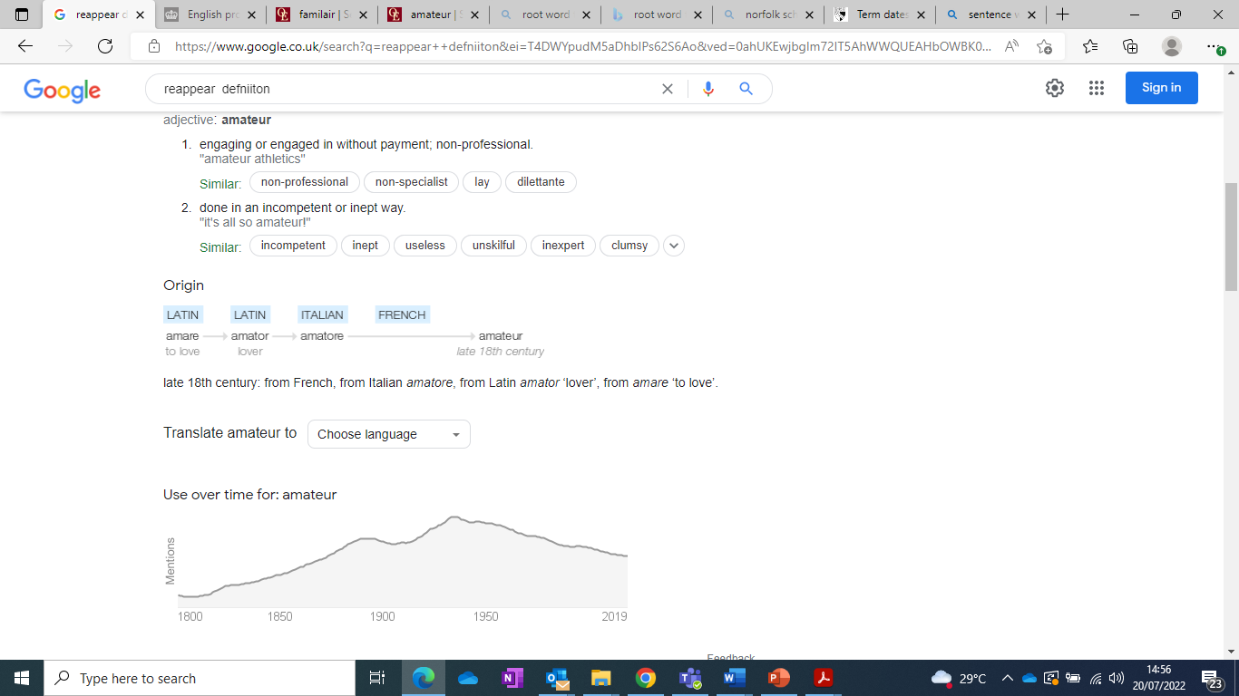  Write spelling questions for the challenge words and then a mark scheme to show where children may go wrong.

Weekly grid Year 6 Term Autumn 1 week 5

Lesson focus | Revisit and review |  | Teach and practise |  |  |  | Practise and apply
 | Words | Challenge words | Oral rehearsal | New words | Example definitions and sentences | New challenge word | Find within extract | Read/write the sentence  Dictation
New teaching – words ending -ire and -al  R+R focus – words ending - ency | Transparency decency  Independency | Environment equipment | Words ending in -al have changed a noun into an adjective | Musical political accidental | Musical (adjective) fond or skilled in music  He was extremely musical.  Political (adjective) relating to government  The political atmosphere was charged on election night.  Accidental (adjective) happening by chance  The window smashing was purely accidental. | Frequently government | Fragile Earth  The environment of planet Earth is made up of tropical areas and frozen lands. The Earth’s hard outer layer has been mathematically calculated as between 5 and 60km thick. This crust is broken into functional parts called plates that have independency with each other. The plates require movement and scrape against each other causing friction that leads to earthquakes and volcanoes. | The environment of planet Earth is made up of tropical areas and frozen lands.
 | Emergency consistency proficiency | Environment equipment | Words ending in -al have changed a noun into an adjective | Mathematical tropical  functional | Mathematical (adjective) relating to maths  The mathematical equation was super fun to complete.  Tropical (adjective) very hot and humid  The tropical temperature was not expected in this part of the country.  Functional (adjective) how something works or operates  The functional furniture fitted into the space well. | Frequently government |  | The Earth’s hard outer layer has been mathematically calculated as between 5 and 60km thick
 | Conveniency  Efficiency  Fluency | Environment equipment | Words ending -ire | Require acquire enquire | Require (verb) need for a purpose  The school require children to wear school uniform.  Acquire (verb) buy or obtain  They acquire the particular chocolate for the birthday cake.  Enquire (verb) aske for information from someone  They always enquire after my family when I meet them. | Frequently government |  | This crust is broken into functional parts called plates that have independency with each other.
 | Decency currency urgency | Environment equipment | Words ending -ire | Esquire vampire bonfire | Esquire (noun) a polite title  The esquire was known for his polite manners.  Vampire (noun) a corpse that drinks blood  The vampire terrorised the town every Halloween.  Bonfire (noun) a large open-air fire  The bonfire was enormous on firework’s night. | Frequently government |  | The plates require movement and scrape against each other causing friction that leads to earthquakes and volcanoes.
Review | Quick Quiz  Environment equipment frequently government musical mathematical require vampire urgency emergency | Frequently – word class and sentence – People frequently play the National Lottery. (noun adverb verb article adjective noun)  Government – word class and sentence - The government is formed through a democratic vote. (article noun verb preposition article adjective noun )  frequently (adv.)  "often and at short intervals," 1530s, from frequent (adj.) + -ly (2).  government (n.)  late 14c., "act of governing or ruling;" 1550s, "system by which a thing is governed" (especially a state), from Old French governement "control, direction, administration" (Modern French gouvernement), from governer "to steer, be at the helm of; govern, rule, command, direct," from Latin gubernare "to direct, rule, guide, govern," originally "to steer, to pilot"(see govern). Meaning "governing power" in a given place is from 1702. Compare governance.  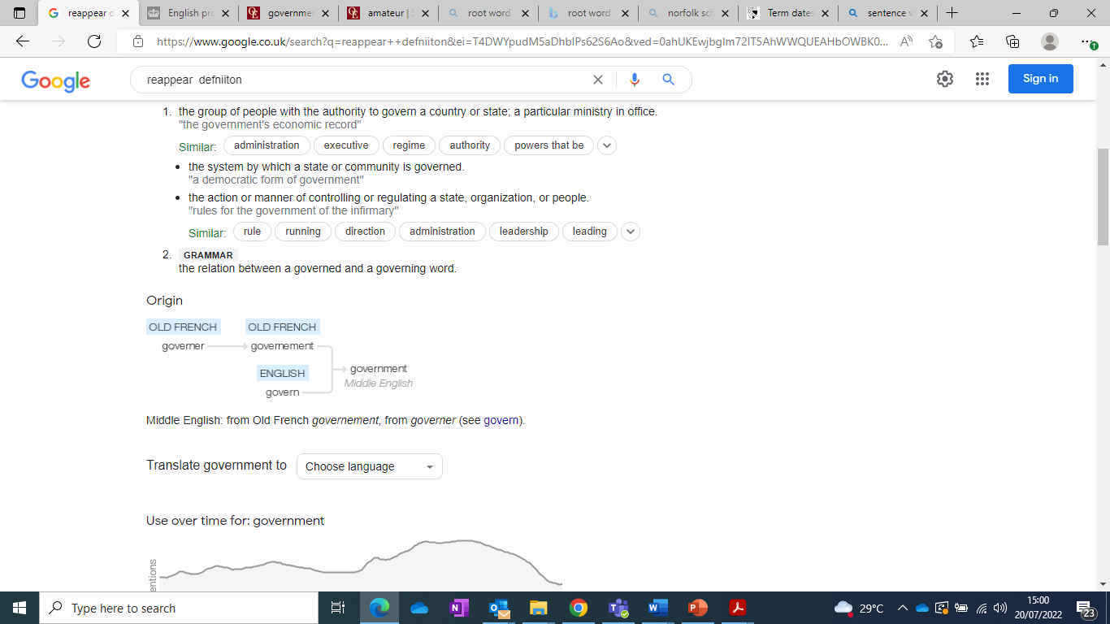  Find synonyms and antonyms of the challenge words.

Weekly grid Year 6 Term Autumn 1 week 6

Lesson focus | Revisit and review |  | Teach and practise - all revisit and review of this half terms words |  |  |  | Practise and apply
 | Words | Challenge words | Oral rehearsal | New words | Example definitions and sentences | New challenge word | Investigate / detect
No new teaching – all revisit and review  Time for filling gaps and meeting individual need | Certainly definitely | Controversy convenience | Prefix de- | Deflate deform decode | deflate (verb) : let air or gas out of something  The balloon was allowed to deflate slowly so it didn’t burst and frighten people.  deform (verb) : distort the shape of something  The ice-sculpture was left to melt and deform in the sun.  decode (verb) : convert a coded message into intelligible language  In WW2, German’s messages were scrutinised to decode them. | Especially exaggerate | Find the spelling mistakes in this section and explain how the child has gone wrong.  There was convenance as the children defanatly de-formed the balloon as they de-flated it.
 | Observance flamboyance | Correspond criticise | Prefix re- | Recycle rebuild rewrite | recycle (verb) : convert into reusable material  It is important to recycle to save the environment.  rebuild (verb) : build something again after it has been destroyed  Help is always well received when having to rebuild something.  rewrite (verb) : write something again to alter or improve it  If work needs improvement, a rewrite is recommended. | Hindrance excellent | Find the spelling mistakes in this section and explain how the child has gone wrong.  The observence to re-cycle means that we can re-build our planet and re-write our future.
 | Expectancy hesitancy | Desperate determined | Prefix over- | Overthrow overturn overslept | overthrow (verb) : remove forcibly from power  The overthrow of Boris Johnson was reported heavily in the newspapers.  overturn (verb): tip something over so it is on its side  The overturn of the lorry on the motorway caused severe congestion.  overslept (verb) : to sleep longer than intended  The pupil overslept due to their alarm malfunctioning. | Existence explanation | Find the spelling mistakes in this section and explain how the child has gone wrong.  The detemined and desparate teacher was to overfrow the headteacher who had over slept.
 | Innocence excellence | Disastrous embarrass | Suffix ful | Boastful faithful doubtful | Boastful (adjective) show excessive pride  The boastful singer performed at the Super Bowl half-time show.  Faithful (adjective) remaining loyal  The faithful puppy followed its owner to the store.  Doubtful (adjective) feeling uncertain  It was doubtful that sports day would take place in the rain. | Familiar amateur | Find the spelling mistakes in this section and explain how the child has gone wrong.  The boastfull child was to embaras his faithfull friend with disaterous consequences.
 | Transparency decency | Environment equipment | Words ending in al and ire | Musical political acquire require | Musical (adjective) fond or skilled in music  He was extremely musical.  Political (adjective) relating to government  The political atmosphere was charged on election night.  Accidental (adjective) happening by chance  The window smashing was purely accidental. | Frequently government | Find the spelling mistakes in this section and explain how the child has gone wrong.  The transparancy of the govment is vital for the environment as politicle movements mean ministers akquir and then lose their seats regularly.

