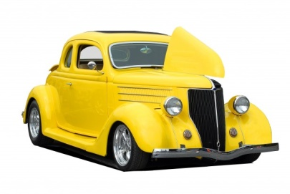
Dryden Fall Festival
Car-Truck-Motorcycle Show
September 28, 2019
Activates for the Whole Family
Crafts and Vendors of all Kinds
Live Music-Parade 11 AM-Fireworks at Dusk
Inflatables-Rockwall- Laser Tag and Much More
Show held At Cardinal Field
Enter through Church Parking Lot at 3334 N. Mill Rd. Dryden MI 48428
(Across from Dryden Elementary, FOLLOW SIGNS)
- $20.00 Fund Raising Registration/Entry Fee. Rain or Shine. Proceeds to Dryden Skate Park Development
- Each Entry = Door Prize Ticket, Goody Bag & 1st 100 Dash Plaques. Register by September 16th and get 1 free dinner ticket from the Dryden Bar which will be onsite.
- Parking starts at 8AM till 11 AM. Vehicles in 11 AM parade can park after. (please register before)
- Show Time Noon till 4 PM. Continued festival parking permitted until 12 AM.
- Follow posted signs and parking attendants.
- 12 trophy classes: Best of: Show, Original, Hotrod, Truck, Bike, 4x4, pre 1969, post 1970, Engine, Paint, Ratrod, Jeep
- Awards and Great Door prizes present at approx. 3:45 PM.
**Event sponsored by Master Automotive and the Village of Dryden Downtown Development Authority**
Questions and info contact Mike Franz 810-796-3223 or email mike@masterautomotive.com
Or visit drydenfallfestival.com or Facebook Event Page-“Dryden Fall Festival Car Show”
-------------------------------------------------------------------------------------------------------------------
Return by September 16, 2019 for Free Dinner Ticket

Name: ____________________________________________ Vehicle Year________________
Address:__________________________________ Make:______________________________
City: ____________________Zip:_____________ Model:______________________________
Email________________________________ Phone: (________)-_________-__________
HOLD HARMLESS AGREEMENT: I the registered owner/agent of the above vehicle understand in consideration of the acceptance of the right to participate, by execution of the entry form. The applicant herby agrees to assume all loss, damage, risk, and liability associated with event participation. It is recognized and acknowledged that this includes, but is not limited to, personal injury and any property damage incurred for any reason whatsoever. I further agree to release hold harmless and indemnify Masters Automotive, Dryden, St. Cornelius Church, all event sponsors, all volunteers and all/any officials, officers, agents and employees from any and or all liability or responsibility whatsoever for injury (including death) to any persons, and/or any damage to any property, or the property of others, arising out of, or resulting from, participation in the Dryden Fall Festival and Car/Truck/Motorcycle Show. Applicant further acknowledges and agrees they are solely responsible for installation and removal of any/all equipment associated with the participation of this event. Signature:_______________________________________Date________________

