West Liberty Cornerstone Faith Church

First Sunday in Advent.

12/01/24 Enter to Worship 10:30 AM

Announcements: Sunday School at 9:30 AM every Sunday. Bible study tonight at 6:00 PM. Prayer meeting Thursday at 6:00 PM.

* Unison Call to Worship – Colossians 3:16

Let the message of Christ dwell among you richly as you teach and admonish one another with all wisdom through psalms, hymns, and songs from the Spirit, singing to God with gratitude in your hearts. Amen.

*Hymn – People’s choice

* Unison Prayer - Romans 10: 9, 10

If you confess with your mouth, “Jesus is Lord and believe in your heart that God raised him from the dead, you will be saved. For it is with your heart that you believe and are justified, and it is with your mouth that you confess and are saved. Amen

*Assurance of Forgiveness (responsively)

One: Hear the good news! God promises that wherever we go in joyful trust, God will go before us and beside us, our
ever present companion and guide.

All: Thanks be to God! Amen.

*Hymn 620 - “Gloria Patri”

Offertory – Please place in the plate by door, Thanks!

*Hymn 623 - “Doxology”

* Unison Prayer of Dedication

Loving God, you save and protect us. Take all that we offer our gifts and ourselves - and use them to proclaim the good news of your salvation and never-ending love. In the name of Christ who calms our deepest fears. Amen.

*Affirmation of Faith (The Apostles Creed)

I believe in God the Father Almighty, Maker of Heaven, and earth; and in Jesus Christ His only Son our Lord; who was conceived by the Holy Ghost, born of the Virgin Mary, suffered under Pontius Pilate was crucified, dead, and buried. He descended into hell; the third day He rose again from the dead. He ascended into heaven and sits on the right hand of God the Father Almighty; from thence He shall come to judge the quick and the dead.

I believe in the Holy Ghost; the Holy Christian church; the communion of saints; the forgiveness of sins; the resurrection of the body; and the life everlasting. Amen.

Sermon – Bob Brown

Prayers of the People – Bob Brown

Communion

*Hymn – People’s choice
* Unison Prayer of Departure - Hebrews 10:23-24
Let us hold fast to the confession of our hope without wavering, for he who has promised is faithful. And let us consider how to provoke one another to love and good deeds. Amen!
*Benediction
Depart to Serve
Postlude
*Please stand if you are able.

PRAYERS OF THE PEOPLE
Our Country -United States of America
Israel
All Government
People dealing with and recovering from Cancer
Our Church
The Church as a Whole
Hurricane victims

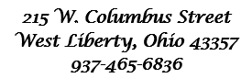



Behold, I lay a stone in Zion, A Cornerstone chosen and precious, and whoever believes in him will not be put to shame” - 1 Peter 2:6

WELCOME!!!!

Adult Sunday School ----------------------------------------9:30 A.M
Church Service ---------------------------------------------10:30 A.M
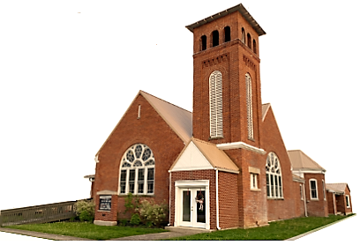
Youth and young adult classes available during church service

