West Liberty Cornerstone Faith Church

11/10/24 Enter to Worship 10:30 AM

Announcements: Sunday School at 9:30 AM every Sunday. Bible study next Sunday at 6:00 PM. Prayer meeting Thursday at 6:00 PM.

* Unison Call to Worship – Hebrews 10:22-25:

Let us draw near with a true heart in full assurance of faith, having our hearts sprinkled from an evil conscience and our bodies washed with pure water. Let us hold fast the confession of our hope without wavering, for He who promised is faithful. Amen.

*Hymn – #138 –“Blest Be the Tie that Binds”

* Unison Prayer - Romans 10: 9, 10

If you confess with your mouth, “Jesus is Lord and believe in your heart that God raised him from the dead, you will be saved. For it is with your heart that you believe and are justified, and it is with your mouth that you confess and are saved. Amen

*Assurance of Forgiveness (responsively)

One: Hear the good news! God promises that wherever we go in joyful trust, God will go before us and beside us, our
ever present companion and guide.

All: Thanks be to God! Amen.

*Hymn 620 - “Gloria Patri”

Offertory – Please place in the plate by door, Thanks!

*Hymn 623 - “Doxology”

* Unison Prayer of Dedication

Loving God, you save and protect us. Take all that we offer our gifts and ourselves - and use them to proclaim the good news of your salvation and never-ending love. In the name of Christ who calms our deepest fears. Amen.

*Affirmation of Faith (The Apostles Creed)

I believe in God the Father Almighty, Maker of Heaven, and earth; and in Jesus Christ His only Son our Lord; who was conceived by the Holy Ghost, born of the Virgin Mary, suffered under Pontius Pilate was crucified, dead, and buried. He descended into hell; the third day He rose again from the dead. He ascended into heaven and sits on the right hand of God the Father Almighty; from thence He shall come to judge the quick and the dead.

I believe in the Holy Ghost; the Holy Christian church; the communion of saints; the forgiveness of sins; the resurrection of the body; and the life everlasting. Amen.

Sermon – Keith Landis

Prayers of the People – Keith Landis

*Hymn – #181 – “Standing on the Promises”
* Unison Prayer of Departure
Heavenly Father, we come before You with hearts full of gratitude. Thank You for the blessings You have bestowed upon us. As we leave this place, help us to carry an attitude of thanksgiving. Remind us of Your goodness and faithfulness in every situation. May our lives be a reflection of our gratitude to You. In Jesus' name, we pray. Amen!
*Benediction
Depart to Serve
Postlude
*Please stand if you are able.

PRAYERS OF THE PEOPLE
United States of America
Israel
All Government officials/politicians
The coming election
People dealing with and recovering from Cancer
Our Church
The Church as a Whole
Hurricane victims





Behold, I lay a stone in Zion, A Cornerstone chosen and precious, and whoever believes in him will not be put to shame” - 1 Peter 2:6

WELCOME!!!!

Adult Sunday School ----------------------------------------9:30 A.M
Church Service ---------------------------------------------10:30 A.M
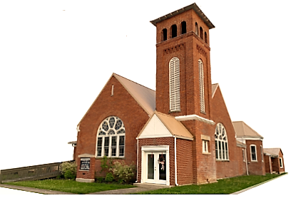
Youth and young adult classes available during church service

