West Liberty Cornerstone Faith Church

10/27/24 Enter to Worship 10:30 AM

Announcements: Sunday School at 9:30 AM every Sunday.

Bible Study next Sunday at 6:00 PM, Prayer meeting Thursday at 6:00 PM.

* Unison Call to Worship – 1 Peter 2:9

But you are a chosen generation, a royal priesthood, a holy nation, His own special people, that you may proclaim the praises of Him who called you out of darkness into His marvelous light. Amen.

*Hymn – #115 “The Church’s One Foundation”

* Unison Prayer - Romans 10: 9, 10

If you confess with your mouth, “Jesus is Lord and believe in your heart that God raised him from the dead, you will be saved. For it is with your heart that you believe and are justified, and it is with your mouth that you confess and are saved. Amen

*Assurance of Forgiveness (responsively)

One: Hear the good news! God promises that wherever we go in joyful trust, God will go before us and beside us, our
ever present companion and guide.

All: Thanks be to God! Amen.

*Hymn 620 - “Gloria Patri”

Offertory – Please place in the plate by door, Thanks!

*Hymn 623 - “Doxology”

* Unison Prayer of Dedication

Loving God, you save and protect us. Take all that we offer our gifts and ourselves - and use them to proclaim the good news of your salvation and never-ending love. In the name of Christ who calms our deepest fears. Amen.

*Affirmation of Faith (The Apostles Creed)

I believe in God the Father Almighty, Maker of Heaven, and earth; and in Jesus Christ His only Son our Lord; who was conceived by the Holy Ghost, born of the Virgin Mary, suffered under Pontius Pilate was crucified, dead, and buried. He descended into hell; the third day He rose again from the dead. He ascended into heaven and sits on the right hand of God the Father Almighty; from thence He shall come to judge the quick and the dead.

I believe in the Holy Ghost; the Holy Christian church; the communion of saints; the forgiveness of sins; the resurrection of the body; and the life everlasting. Amen.

Sermon – Bob Brown

Prayers of the People – Bob Brown

*Hymn – #299 “Amazing Grace”
* Unison Prayer of Departure
Dear Lord, we seek Your renewal and refreshment. As we end our service, renew our spirits and refresh our souls. Fill us with Your love and joy. Help us to find rest in Your presence and to draw strength from Your word. May we leave this place rejuvenated and ready to serve You. In Jesus' name, we pray. Amen!
*Benediction
Depart to Serve
Postlude
*Please stand if you are able.

PRAYERS OF THE PEOPLE
United States of America
Israel
All Government officials/politicians
The coming election
People dealing with and recovering from Cancer
Our Church
The Church as a Whole
Hurricane victims

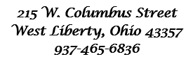



Behold, I lay a stone in Zion, A Cornerstone chosen and precious, and whoever believes in him will not be put to shame” - 1 Peter 2:6

WELCOME!!!!

Adult Sunday School ----------------------------------------9:30 A.M
Church Service ---------------------------------------------10:30 A.M
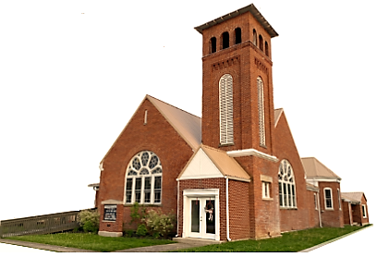
Youth and young adult classes available during church service

