West Liberty Cornerstone Faith Church

11/17/24 Enter to Worship 10:30 AM

Announcements: Sunday School at 9:30 AM every Sunday. Bible study tonight at 6:00 PM. Prayer meeting Thursday at 6:00 PM.

* Unison Call to Worship – Romans 12:1-2

Therefore, I urge you, brothers and sisters, in view of God’s mercy, to offer your bodies as a living sacrifice, holy and pleasing to God—this is your true and proper worship. Do not conform to the pattern of this world, but be transformed by the renewing of your mind. Then you will be able to test and approve what God’s will is—his good, pleasing and perfect will. Amen.

*Hymn – #449 – “Savior Like a Shepherd Lead Us”

* Unison Prayer - Romans 10: 9, 10

If you confess with your mouth, “Jesus is Lord and believe in your heart that God raised him from the dead, you will be saved. For it is with your heart that you believe and are justified, and it is with your mouth that you confess and are saved. Amen

*Assurance of Forgiveness (responsively)

One: Hear the good news! God promises that wherever we go in joyful trust, God will go before us and beside us, our
ever present companion and guide.

All: Thanks be to God! Amen.

*Hymn 620 - “Gloria Patri”

Offertory – Please place in the plate by door, Thanks!

*Hymn 623 - “Doxology”

* Unison Prayer of Dedication

Loving God, you save and protect us. Take all that we offer our gifts and ourselves - and use them to proclaim the good news of your salvation and never-ending love. In the name of Christ who calms our deepest fears. Amen.

*Affirmation of Faith (The Apostles Creed)

I believe in God the Father Almighty, Maker of Heaven, and earth; and in Jesus Christ His only Son our Lord; who was conceived by the Holy Ghost, born of the Virgin Mary, suffered under Pontius Pilate was crucified, dead, and buried. He descended into hell; the third day He rose again from the dead. He ascended into heaven and sits on the right hand of God the Father Almighty; from thence He shall come to judge the quick and the dead.

I believe in the Holy Ghost; the Holy Christian church; the communion of saints; the forgiveness of sins; the resurrection of the body; and the life everlasting. Amen.

Sermon – Keith Landis

Prayers of the People – Keith Landis

*Hymn – #533 – “Jesus Calls Us”
* Unison Prayer of Departure - Hebrews 13:20-21
Now may the God of peace, who through the blood of the eternal covenant brought back from the dead our Lord Jesus, that great Shepherd of the sheep, equip you with everything good for doing his will, and may he work in us what is pleasing to him, through Jesus Christ, to whom be glory forever and ever. Amen!

*Benediction
Depart to Serve
Postlude
*Please stand if you are able.

PRAYERS OF THE PEOPLE
Our Country -United States of America
Israel
All Government
People dealing with and recovering from Cancer
Our Church
The Church as a Whole
Hurricane victims

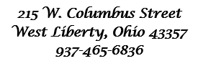



Behold, I lay a stone in Zion, A Cornerstone chosen and precious, and whoever believes in him will not be put to shame” - 1 Peter 2:6

WELCOME!!!!

Adult Sunday School ----------------------------------------9:30 A.M
Church Service ---------------------------------------------10:30 A.M
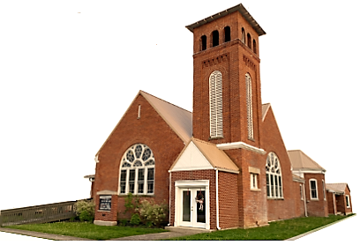
Youth and young adult classes available during church service

