West Liberty Cornerstone Faith Church

12/29/24 Enter to Worship 10:30 AM

Announcements: Sunday School at 9:30 AM every Sunday. Next Bible study Jan. 12, 2025, at 6:00 PM. Prayer meeting Thursday at 6:00 PM.

* Unison Call to Worship – Psalm 57:7, 9-11

My heart, O God, is steadfast, my heart is steadfast; I will sing and make music. I will praise you, LORD, among the nations; I will sing of you among the peoples. For great is your love, reaching to the heavens; your faithfulness reaches to the skies. Be exalted, O God, above the heavens; let your glory be over all the earth.

*Hymn – #573 “I Am Bound by the Promise Land”

* Unison Prayer - Romans 10: 9, 10

If you confess with your mouth, “Jesus is Lord and believe in your heart that God raised him from the dead, you will be saved. For it is with your heart that you believe and are justified, and it is with your mouth that you confess and are saved. Amen

*Assurance of Forgiveness (responsively)

One: Hear the good news! God promises that wherever we go in joyful trust, God will go before us and beside us, our
ever present companion and guide.

All: Thanks be to God! Amen.

*Hymn 620 - “Gloria Patri”

Offertory – Please place in the plate by door, Thanks!

*Hymn 623 - “Doxology”

* Unison Prayer of Dedication

Loving God, you save and protect us. Take all that we offer our gifts and ourselves - and use them to proclaim the good news of your salvation and never-ending love. In the name of Christ who calms our deepest fears. Amen.

*Affirmation of Faith (The Apostles Creed)

I believe in God the Father Almighty, Maker of Heaven, and earth; and in Jesus Christ His only Son our Lord; who was conceived by the Holy Ghost, born of the Virgin Mary, suffered under Pontius Pilate was crucified, dead, and buried. He descended into hell; the third day He rose again from the dead. He ascended into heaven and sits on the right hand of God the Father Almighty; from thence He shall come to judge the quick and the dead.

I believe in the Holy Ghost; the Holy Christian church; the communion of saints; the forgiveness of sins; the resurrection of the body; and the life everlasting. Amen.

Sermon – Bob Brown

Prayers of the People – Bob Brown

*Hymn – #191 “Angels We have Heard on High”
* Unison Prayer of Departure
Let us go forth into the world in peace and dedicated to Your service, O Lord. Let us hold fast to that which is good, render to no person evil for evil, strengthen the faint-hearted, support the weak, help the needy and the afflicted, and honor all people. Let us love and serve the Lord, rejoicing in the power of His Spirit. And may God’s blessing be upon us and remain with us always. Amen!

*Benediction
Depart to Serve
*Please stand if you are able.
PRAYERS OF THE PEOPLE
Our Country -United States of America
Israel
All Government
People dealing with and recovering from Cancer
Our Church
The Church as a Whole
Hurricane victims

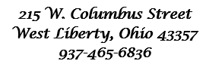



Behold, I lay a stone in Zion, A Cornerstone chosen and precious, and whoever believes in him will not be put to shame” - 1 Peter 2:6

WELCOME!!!!

Adult Sunday School ----------------------------------------9:30 A.M
Church Service ---------------------------------------------10:30 A.M
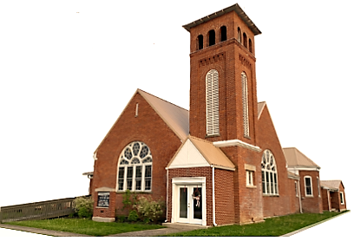
Youth and young adult classes available during church service

