**West Liberty Cornerstone Faith Church**

**September 22, 2024 Enter to Worship 7:00 p.m.**

**DEDICATION CELEBRATION SERVICE**

**Welcome -------------------------------------- Keith Landis**

**Opening Prayer ------------------------------ Keith Landis**

**\*Hymn – #16 “How Great Thou Art” ------- Jayne Griffith**

**A Piece of Tradition ----------------------- Keith Landis**

**The Apostle’s Creed**

I believe in God the Father Almighty, Maker of Heaven, and earth; and in Jesus Christ His only Son our Lord; who was conceived by the Holy Ghost, born of the Virgin Mary, suffered under Pontius Pilate was crucified, dead, and buried. He descended into hell; the third day He rose again from the dead. He ascended into heaven and sits on the right hand of God the Father Almighty; from thence He shall come to judge the quick and the dead.

I believe in the Holy Ghost; the Holy catholic church; the communion of saints; the forgiveness of sins; the resurrection of the body; and the life everlasting. **Amen.**

**\*Hymn – #295 “Blessed Assurance” ------- Jayne Griffith**

**\* Gracious Dismissal ---------------------- Nick Hostetler**

**Ben Griffith**

**Service of Dedication --------------------------- Matt Hostetler**

**(taken from the 1890 Dedication service)**

L- I was glad when they said unto me, Let us go into the house of the Lord.

C - Our feet shall stand within thy gates, O Jerusalem.

L.- Jerusalem is builded as a city that is compact together ;

C.- Whither the tribes go up, the tribes of the Lord,

L.— Unto the testimony of Israel, to give thanks unto the name of the Lord.

C.- For there are set thrones of judgment, the thrones of the House of David.

L.- Pray for the peace cf Jerusalem :

C.—They shall prosper that love thee.

L.- Peace be within thy walls,

C.- And prosperity within thy palaces.

L.- For my brethren and companions' sakes, I will now say, Peace be within thee.

C.- Because of the House of the Lord our God I will seek thy good.

ALL- PSALM 132: 7, 8, 9. We will go into His tabernacles; we will worship at His footstool. Arise, O Lord, into Thy rest; Thou and the ark of Thy strength. Let Thy priests be clothed with righteousness; and let Thy saints shout for joy.

**\*MESSAGE ---------------------------------------- Bob Brown**

**\*Hymn – #453 “It Is Well with My Soul” ---- Jayne Griffith**

**Closing Prayer ------------------------------------- Keith Landis**

**Depart to Serve**

**Postlude**

**\*Please stand if you are able.**

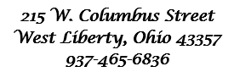



**Behold, I lay a stone in Zion, A Cornerstone chosen and precious, and whoever believes in him will not be put to shame” - 1 Peter 2:6**

**WELCOME!!!!**

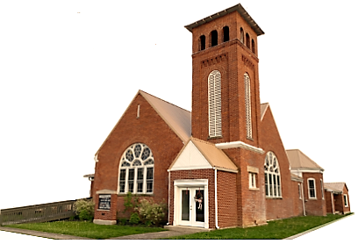 **CELEBRATION SERVICE --------------------------------- 7:00 p.m.**