**West Liberty Cornerstone Faith Church**

**09/29/24 Enter to Worship 10:30 AM**

**Announcements**:  **Sunday School at 9:30 AM every Sunday.**

**Bible Study next Sunday at 6:00 PM, Prayer meeting Thursday** at **6:00 PM. Congregational Meeting**

**\* Unison Call to Worship – 1 Chronicles 16:8-10**

Give praise to the LORD, proclaim His name; make known among the nations what He has done. Sing to Him, sing praise to Him; tell of all His wonderful acts. Glory in His holy name; let the hearts of those who seek the LORD rejoice. Amen.

**\*Hymns – #130 “Bind Us Together”**

**#138 “Blest Be the Tie That Binds”**

**\* Unison Prayer - Romans 10: 9, 10**

If you confess with your mouth, “Jesus is Lord and believe in your heart that God raised him from the dead, you will be saved. For it is with your heart that you believe and are justified, and it is with your mouth that you confess and are saved. **Amen**

**\*Assurance of Forgiveness (responsively)**

One: Hear the good news! God promises that wherever we go in joyful trust, God will go before us and beside us, our

ever present companion and guide.

**All: Thanks be to God! Amen.**

**\*Hymn 620 - “Gloria Patri”**

**Offertory – Please place in the plate by door, Thanks!**

**\*Hymn 623 - “Doxology”**

**\* Unison Prayer of Dedication**

Loving God, you save and protect us. Take all that we offer our gifts and ourselves - and use them to proclaim the good news of your salvation and never-ending love. In the name of Christ who calms our deepest fears. Amen.

**\*Affirmation of Faith (The Apostles Creed)**

I believe in God the Father Almighty, Maker of Heaven, and earth; and in Jesus Christ His only Son our Lord; who was conceived by the Holy Ghost, born of the Virgin Mary, suffered under Pontius Pilate was crucified, dead, and buried. He descended into hell; the third day He rose again from the dead. He ascended into heaven and sits on the right hand of God the Father Almighty; from thence He shall come to judge the quick and the dead.

I believe in the Holy Ghost; the Holy catholic church; the communion of saints; the forgiveness of sins; the resurrection of the body; and the life everlasting. **Amen.**

**Sermon – Keith Landis**

**Prayers of the People** **– Keith Landis**

**\*Hymn – #115 “The Church’s One Foundation”**

**\* Unison Prayer of Departure**

We worship a God of Promise, whose saving Grace brought a people from captivity into a land of promise, whose enduring love still leads us from places of captivity into a promise of peace, forgiveness and eternal life. The promises of God endure forever. The promises of God will be fulfilled. **Amen**!

**\*Benediction**

**Depart to Serve**

**Postlude**

**\*Please stand if you are able.**

**PRAYERS OF THE PEOPLE**

United States of America

Israel

All Government officials/politicians

People dealing with and recovering from Cancer

Our Church

**Behold, I lay a stone in Zion, A Cornerstone chosen and precious, and whoever believes in him will not be put to shame” - 1 Peter 2:6**

**WELCOME!!!!**

**Adult Sunday School ----------------------------------------9:30 A.M**

**Church Service ---------------------------------------------10:30 A.M**

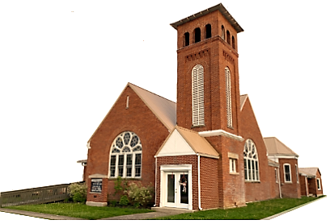

**Youth and young adult classes available during church service**