West Liberty Cornerstone Faith Church

11/24/24 Enter to Worship 10:30 AM

Announcements: Sunday School at 9:30 AM every Sunday. Bible study next Sunday at 6:00 PM. Prayer meeting Thursday at 6:00 PM.

* Unison Call to Worship – Philippians 2:9-11

Therefore, God exalted him to the highest place and gave him the name that is above every name, that at the name of Jesus every knee should bow, in heaven and on earth and under the earth, and every tongue acknowledge that Jesus Christ is Lord, to the glory of God the Father. Amen.

*Hymn – #400 – “Be Thou My Vision”

* Unison Prayer - Romans 10: 9, 10

If you confess with your mouth, “Jesus is Lord and believe in your heart that God raised him from the dead, you will be saved. For it is with your heart that you believe and are justified, and it is with your mouth that you confess and are saved. Amen

*Assurance of Forgiveness (responsively)

One: Hear the good news! God promises that wherever we go in joyful trust, God will go before us and beside us, our
ever present companion and guide.

All: Thanks be to God! Amen.

*Hymn 620 - “Gloria Patri”

Offertory – Please place in the plate by door, Thanks!

*Hymn 623 - “Doxology”

* Unison Prayer of Dedication

Loving God, you save and protect us. Take all that we offer our gifts and ourselves - and use them to proclaim the good news of your salvation and never-ending love. In the name of Christ who calms our deepest fears. Amen.

*Affirmation of Faith (The Apostles Creed)

I believe in God the Father Almighty, Maker of Heaven, and earth; and in Jesus Christ His only Son our Lord; who was conceived by the Holy Ghost, born of the Virgin Mary, suffered under Pontius Pilate was crucified, dead, and buried. He descended into hell; the third day He rose again from the dead. He ascended into heaven and sits on the right hand of God the Father Almighty; from thence He shall come to judge the quick and the dead.

I believe in the Holy Ghost; the Holy Christian church; the communion of saints; the forgiveness of sins; the resurrection of the body; and the life everlasting. Amen.

Sermon – Keith Landis

Prayers of the People – Keith Landis

*Hymn – #519 – “Faith is the Victory”
* Unison Prayer of Departure - Hebrews 13:20-21
With hearts full of gratitude, we close today. We’re thankful for the opportunity to gather, learn, and grow in Your love. May our hearts be filled with Your grace as we depart from this place. We appreciate the wisdom shared and the connections made. Bless each person here and grant us the strength to carry Your message into the world. In Your name, we express our thanks and say, Amen!
*Benediction
Depart to Serve
Postlude
*Please stand if you are able.

PRAYERS OF THE PEOPLE
Our Country -United States of America
Israel
All Government
People dealing with and recovering from Cancer
Our Church
The Church as a Whole
Hurricane victims

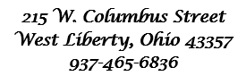



Behold, I lay a stone in Zion, A Cornerstone chosen and precious, and whoever believes in him will not be put to shame” - 1 Peter 2:6

WELCOME!!!!

Adult Sunday School ----------------------------------------9:30 A.M
Church Service ---------------------------------------------10:30 A.M
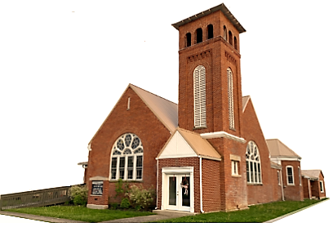
Youth and young adult classes available during church service

