

CHURCH POLICIES

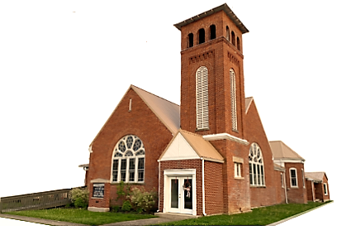

POLICY STATEMENT

In order to provide a safe and secure environment for our ministry participants, and to minimize the ministry’s and workforce vulnerability to unwarranted accusation, the following procedures have been adopted and will be strictly enforced.

VOLUNTEER WORKER SCREENING PROCEDURES

Anyone wishing to work with youth in a church function will be reviewed by the Lead Deacon, who in turn will go over this policy with them to ensure that the policy is enforced and signed with date in 2 copies. (1) Council of Deacons board (2) File with the Church

WAITING PERIOD

No person shall be considered for any position with youth until that person has been regularly involved in our church for at least six (6) months or more.

SUPERVISION

No child will be left unsupervised while under the care of an approved worker who will be responsible for these individuals until released to parent/guardian

RESTRICTIONS

- Children over 5 years shall have one (1) adult female to take girls and one (1) adult male for the boys, to take to the restroom. The restroom will be checked for safety and the adult must wait outside the restroom until the child comes out.
- Children under 5 have one (1) adult female for girls, and one (1) adult male for boys, to assist as needed in the restroom
- Never touch a person’s private areas except as in the case of changing a diaper.
- Never show appearance of impropriety, such as sitting older children on their lap, kissing or embracing, etc…
- Never spank, hit, grab, shake or otherwise physically discipline anyone. Disciplinary problems will be reported to at least 2 Deacon board members.

ILLNESS/INJURY

- Persons who are ill (fever, or have a transmittable disease through coughing or touch) will not be permitted into the activity
- A suitable replacement must be used to replace an ill worker/volunteer and must have the necessary paperwork on file with the Church.
- Reasonable steps should be taken to avoid contact with anyone with body fluids of any kind.
- If a minor injury occurs, first aid will be given, and parent/guardian will be notified of the injury immediately
- If an injury occurs that requires medical attention above first aid, the parent/guardian will be notified immediately, and an ambulance will be called if needed for the injury.
- A record will be kept by the Lead Deacon, and Deacon board, of all illnesses/injuries that occur. A copy of the incident will also be retained by the church.

