**West Liberty Cornerstone Faith Church**

**09/22/24 Enter to Worship 10:30 AM**

**Announcements**:  **Sunday School at 9:30 AM every Sunday.**

**Bible Study Oct. 6 at 6:00 PM, Prayer meeting Thursday** at **6:00 PM. Church celebration this evening at 5: PM.**

**\* Unison Call to Worship – Nehemiah 9:5-6**

Stand up and praise the LORD your God, who is from everlasting to everlasting.” “Blessed be your glorious name, and may it be exalted above all blessing and praise. 6You alone are the LORD. You made the heavens, even the highest heavens, and all their starry host, the earth and all that is on it, the seas and all that is in them. You give life to everything, and the multitudes of heaven worship you. Amen.

**\*Hymn – #175 “Break Thou the Bread of Life”**

**\* Unison Prayer - Romans 10: 9, 10**

If you confess with your mouth, “Jesus is Lord and believe in your heart that God raised him from the dead, you will be saved. For it is with your heart that you believe and are justified, and it is with your mouth that you confess and are saved. **Amen**

**\*Assurance of Forgiveness (responsively)**

One: Hear the good news! God promises that wherever we go in joyful trust, God will go before us and beside us, our

ever present companion and guide.

**All: Thanks be to God! Amen.**

**\*Hymn 620 - “Gloria Patri”**

**Offertory – Please place in the plate by door, Thanks!**

**\*Hymn 623 - “Doxology”**

**\* Unison Prayer of Dedication**

Loving God, you save and protect us. Take all that we offer our gifts and ourselves - and use them to proclaim the good news of your salvation and never-ending love. In the name of Christ who calms our deepest fears. Amen.

**\*Affirmation of Faith (The Apostles Creed)**

I believe in God the Father Almighty, Maker of Heaven, and earth; and in Jesus Christ His only Son our Lord; who was conceived by the Holy Ghost, born of the Virgin Mary, suffered under Pontius Pilate was crucified, dead, and buried. He descended into hell; the third day He rose again from the dead. He ascended into heaven and sits on the right hand of God the Father Almighty; from thence He shall come to judge the quick and the dead.

I believe in the Holy Ghost; the Holy catholic church; the communion of saints; the forgiveness of sins; the resurrection of the body; and the life everlasting. **Amen.**

**Sermon – Keith Landis**

**Prayers of the People** **– Keith Landis**

**\*Hymn – #334 “There is Power in the Blood”**

**\* Unison Prayer of Departure**

This is the day that the Lord has made. This is the day when He can be found. God of all, breath of life, living water, savior, friend. Come as the hungry, feed on His Word. Come as the thirsty, drink of His Love. Come as the faithful, worship the Lord. **Amen**!

**\*Benediction**

**Depart to Serve**

**Postlude**

**\*Please stand if you are able.**

**PRAYERS OF THE PEOPLE**

United States of America

Israel

All Government officials/politicians

People dealing with and recovering from Cancer

Our Church

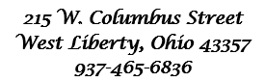



**Behold, I lay a stone in Zion, A Cornerstone chosen and precious, and whoever believes in him will not be put to shame” - 1 Peter 2:6**

**WELCOME!!!!**

**Adult Sunday School ----------------------------------------9:30 A.M**

**Church Service ---------------------------------------------10:30 A.M**

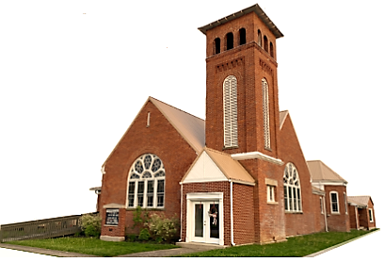

**Youth and young adult classes available during church service**