Occupational Therapy Benevolence Endowment OT-BE
Hurricane Harvey Relief Resources
(http://library.hccs.edu/harveyrelief)

Basic Needs Resources
- Red Cross is providing emergency assistance cash vouchers for Hurricane Harvey relief. Click here to read about the Immediate Emergency Assistance program on the abc13 News website. To apply for this program, follow this link to the Red Cross site to register for this assistance.
- City of Houston Disaster Recovery Information: News, resources & guides.
- Katy ISD Basic Resources Sheet: Katy ISD has compiled a list of free and low-cost resources to support community members seeking assistance. Click link above to open online document.
- Houston Chronicle: Harvey Relief Resource Guide: This helpful guide contains resources and information to meet a variety of needs from disaster clean-up to legal assistance.
- Sketch City Harvey Relief Guide: Sketch City has created a resource guide with a clean and easy to use design. You can get information about local Food Banks, Grocery Store Information, Emergency and Safety Tips, and more!
- One Stop place for Disaster Assistance (employment, financial, food, housing, legal, medical). Click the “Find Assistance” link https://www.disasterassistance.gov/
  - This will help you access FEMA and other services
  - FEMA Disaster Recovery Centers around Houston:
    - https://www.fema.gov/disaster-recovery-centers
- United Way “After the Storm Guide”: https://www.unitedwayhouston.org/assets/uploads/documents/news-publications/Greater-Houston-after-the-storm-2017.pdf
Housing
- ​Mortgage Insurance for Disaster Victims (HUD): Click link here to learn more.
- Help with Rent:
  - GCCSA offers temporary rental assistance for residents of Harris County.
  - TX Department of Housing & Community Affairs: http://www.tdhca.state.tx.us/texans.htm
  - Texas Bar Association Renters' Rights Guide
- Help with Utilities:
  - GCCSA's program, Power II Empower offers assistance with electricity costs for Harris County residents.
- Temporary Shelter:
  - DisasterAssistance.gov: Helpful information for meeting basic needs such as food and shelter after a disaster
  - FEMA Mobile App: Shelters, resources, etc.
  - FEMA Individual Disaster Assistance: Learn how to access disaster relief services
    - FEMA Evacuee Hotel List: Information for transitional shelter options provided by FEMA
  - Air BnB Disaster Response Program: Alternative housing extended through October 9, 2017.
    - Many Air BnB hosts are opening their homes to Harvey evacuees. View listing on Air BnB by visiting this page.
  - Houston Shelter Map: Up to date map to help find nearest shelter that is accepting people
  - Texas State Parks: Free camping for hurricane evacuees
  - American Red Cross: Find an open shelter
    - American Red Cross: Download the emergency app
- HUD.gov Announces Disaster Assistance for Victims of Hurricane Harvey.
- Temporary Home Rental Search: http://www.har.com/temporaryhousing
- Long Term & Permanent Housing help:
  - Call 2-1-1 for help finding any resources
  - Bread of Life: Housing, Food, Job Placement, Counseling, Recovery (ABC News Interview)
  - Housing for Houston: Houston Housing Authority. Housing & Affordable Housing.
  - Catholic Charities: Multi-service agency. Help with Housing, Counseling & Support.
Transportation
- Metro discounts for all HCC students! Learn more about the Student Metro Q Fare Card that gives you 50% off all fares and 5 free rides for every 50 paid trips. Available at HCC ID stations on campus.
- Transportation assistance through Gulf Coast Community Services Association: Learn how to get assistance with transportation costs through GCCSA's partnership with METRO Q Cards.
- Texas Health & Human Services Disaster Assistance Program: Housing and other need based assistance (personal property, transportation, moving/storage, medical/dental, funeral & child care)
- Houston TranStar: Hurricane information & Links
- National Hurricane Center: Updates, safety tips
- Texas Department of Transportation: Current road conditions
- Houston Metro: For up to date route information

Utilities
- Assistance Paying your utility bill
  - ​Public Utility Commission of Texas
  - Power II Empower: Emergency financial assistance with electricity bills.
- Lifeline Telephone & Internet: Federal program that helps lower costs of phone and internet bills
- Low Income Internet Options:
  - Comcast Internet Essentials
  - ATT Access
- Centerpoint Energy: Report electrical outages
- Centerpoint Energy: Sign up to get alerts about electrical outages. You can also call this number to sign up: 713-207-2222
- AT&T: Report service outages for wireless, home phone, and internet after Hurricane Harvey here
Work/Lost Wages
- Unemployment Benefits (part time or full time employees): If you missed 1 day or weeks from work, you can still apply for unemployment benefits. These are for temporary or long term unemployment.
  - US Dept. of Labor: Disaster Unemployment Assistance
  - Texas Workforce Commission: Job resources for veterans
  - Unemployment Benefits due to Hurricane Harvey: http://www.twc.state.tx.us/jobseekers/disaster-unemployment-assistance
- Finding Work
  - HCC Career Centers: http://www.hccs.edu/district/students/career-planning/
  - HCC Financial Coaches: Provides information & resources to help during this emergency: http://www.hccs.edu/programs/financialaid/financial-coach/
  - FEMA & other Texas Jobs: https://wit.twc.state.tx.us/
  - Workforce Solutions: http://www.wrksolutions.com/
  - Bread of Life: Housing, Food, Job Placement, Counseling, Recovery (ABC News Interview)
Child Care
- Worksource: Financial aid for child care
- Texas Health & Human Services Disaster Assistance Program: Housing and other need based assistance (personal property, transportation, moving/storage, medical/dental, funeral & child care)
- Garden City Boys and Girls Club (Acre Homes): After School programs

Resources to Rebuild & Repair
- Disaster Recovery Center: Disaster assistance programs, talk to FEMA representative/status of your case.
- Disaster & Recovery Counseling: Avenue CDC provides HUD certified housing counseling to help apply for FEMA, filing insurance claims, avoiding scams, etc. http://www.avenuecdc.org/recovering-and-rebuilding/
- Debris Removal Guide (https://www.fema.gov/media-library/assets/images/110554):

- 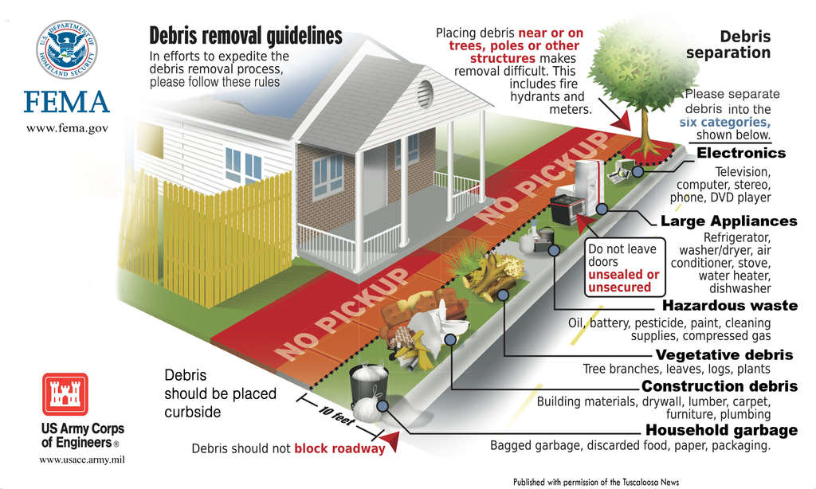

- SBP has provided guides & checklists to assist with relief efforts: FEMA/SBA/Insurance,
- Contractor Fraud Checklist & Avoidance, Mold Remediation, Home Code Compliance-http://sbpusa.org/start-here/
- TXRX Labs: Crafters for Good: Free seminars to help people understand the work that needs to be done to repair damage from Harvey. The seminar will also cover helpful tips and red flags when hiring contractors.
- City of Houston: How to properly dispose of solid waste and debris
- FEMA: How to File a Flood Claim
- FEMA: Dealing with mold & mildew damage in your home
- United Way of Greater Houston: After the Storm recovery guide
- Crisis Cleanup: This website connects disaster relief organizations to the people who need help
- Operation ID: Announcement on recovering your Texas State photo ID
- Small Business Help (may also qualify for loans to help rebuild home)
  - National Small Business Association Loans: http://www.nsba.net/disaster-relief/
  - Small Business Administration Harvey Recovery: https://www.sba.gov/loans-grants/see-what-sba-offers/sba-loan-programs/disaster-loans
  - TX Association of Business. General help: http://www.txbiz.org/2017/08/25/hurricane-harvey/
Library Resources for Home Repair (HCC Students, Faculty, Staff)
Below are links to Home Repair Resources with full-color illustrations and detailed instructions.
These links may require a login with HCC credentials.
Rebuilding/Repair Damage
Videos created by HCC Professors & KHOU
- "How to Completely & Safely do Mold Remediation Yourself" Video by Tom Tynan
- "What about your AC Unit" Video by Tom Tynan
Health & Wellness
Mental & Emotional Health Resources:
- HCC Counselors: Licensed Professional Counselors provides free personal counseling & referral for grief, anxiety, and trauma to all HCC students. For a list of all services offered, follow this link.
- Disaster Help Line for Substance Abuse and Mental Health Service Administration (SAMHSA)
  - Crisis hotline for emotional and psychological support for victims of natural disasters: 1-800-985-5990
  - This helpline has accommodations in place for Spanish Speakers and Deaf/Hard of Hearing. Visit their site to read the details.
  - Text: "TalkWithUs" to 66746
  - Web: www.disasterdistress.samhsa.gov
- Finding Counselors in the Community:
  - Disaster Related Crisis Counseling: Like so many people, you may feel overwhelmed with dealing with the crisis Hurricane Harvey left. United Way of Greater Houston has a 24/7 hotline for your mental health needs. 1-713-970-7070
  - Catholic Charities Flood Relief Hotline: For resources, job loss & counseling, Call 713-874-6664
  - Bread of Life: Housing, Food, Job Placement, Counseling, Recovery (ABC News Interview)
  - Family Houston: Call 713-861-4849
  - HGI Counseling Center: Call 713-526-8390
  - The Montrose Center: Call 713-529-3211
- Disaster Support Groups: Support groups are a great way to talk to other survivors, seek help/tips/resource, and get specific Houston Flooding news.​
  - ​Facebook-often the fastest way to get help, support & information
    - Search various "Harvey" or “Hurricane Harvey” groups
    - Search for your local HOA’s or subdivision group
    - Search for for “Houston Flood 2015 & Beyond: support & Resource” group. Group has an extensive collection of resources under “Files”.
  - Nextdoor: a private social network for you, your neighbors and your community.
  - Depression & Bipolar Support Alliance: provides free support for those living with and those friends and family of those living with depression and bipolar disorders
- Learning more about Coping
  - Coping with Stress from University of Houston
General Health Resources:
- City of Houston: How to protect your health after the hurricane. Helpful tips for cleaning your house safely and preventing the spread of mosquito viruses.
- Texas HIV Medication Program If you lost your HIV medication during the storm, contact the Texas HIV Medication Program. 1-800-255-1090
- National Library of Medicine: Health information for floods, chemical spills, and recovery for those effected by Harvey
- Center for Disease Control: Returning to your flooded home
Medical Equipment Replacement:
- Durable Medical Equipment & Assistive Technology Replacement
Government Agencies
- FEMA Hurricane Harvey Resources
- Harris County
- Fort Bend County
- Montgomery County
- Brazoria County
- Texas Health & Human Services Disaster Assistance Program. Housing & Other needs Assistance (personal property, transportation, moving/storage, medical/dental, funeral & child care). https://yourtexasbenefits.hhsc.texas.gov/programs/other/disaster-help
- City of Houston Harvey Resource Guide: https://goo.gl/C1Cswu
Business Loans
Caren you mentioned a resource for business loans. ?????

