2024

10/26/2024 AMPAM :Wazir Me’ Amur Bey AMPAMGOV.ORG

PROTOCOL HAND BOOK

#### State Official and Diplomats

AMPAM



AMPAM

#### A Moorish Provisional Government

## Allodium Moroccan Praedium Ante Michigan



Diplomats and State Officials: Conduct and Procedures

**Table of Contents**

1. **Title Page**  
   Diplomats and State Officials: Conduct and Procedures

**Introduction**

* + The Nature of Diplomacy
  + Importance of Diplomatic Conduct
  + Overview of Essential Diplomatic Qualities
  + **: Professional Conduct**

Chapter 1

**Section 1**: Integrity and Honesty

* + Definition and Importance
  + Key Aspects  
    B. Confidentiality
  + Definition and Significance
  + Protecting Sensitive Information

**Section 2 : Integrity and Honesty in Diplomacy**  
a. Definition and Importance Building Trust

* + Maintaining Credibility
  + Key Aspects
  + Truthful Representation
  + Transparency in Communication
  + Accountability
  + Adherence to Ethical Standards

Chapter 2

**Confidentiality in Diplomatic Practice**

* Respect for Sensitive Information
* Protection of State Secrets
* Legal Frameworks
* Challenges to Confidentiality
* Promoting Confidentiality

Chapter 3

**Respect for Local Laws and Customs in Diplomacy**  
 SECTION 1 Definition  
SECTION 2 Importance in Diplomacy  
 SECTION 3 Fostering Good Relations  
a. Key Strategies  
b. Challenges

**Section 4: Fostering Good Relations in Diplomacy**  
I. Strategies for Fostering Good Relations

* + Encouraging People-to-People Connections
  + Respect for Sovereignty
  + Diplomatic Visits and Engagements
  + Conflict Resolution  
    II. Challenges in Fostering Good Relations  
    III. Measuring Success in Fostering Good Relations

**Section 5 : Conclusion**

* + Summary of Key Principles
  + The Role of Diplomacy in Global Stability

CHAPTER 4

**Preventing Conflicts in Diplomacy**

**Section 1 . Definition**

* Preventing conflicts involves proactive measures and strategies employed by diplomats and states to avert disputes, tensions, and hostilities between nations.

**Importance in Diplomacy**

1. **Maintaining Peace and Security**
   * **Regional and Global Stability:** Effective conflict prevention is fundamental in averting wars and humanitarian crises.
2. **Promoting Sustainable Relationships**
   * **Long-term Cooperation:** Healthy diplomatic relations reduce the likelihood of disputes and enhance mutual understanding.
3. **Economic Benefits**
   * **Stable Trade Environments:** Peaceful relations facilitate economic growth and reduce military spending associated with conflict resolution.
   * **. Key Strategies for Preventing Conflict**
   * **Open and Transparent Communication**
   * **Regular Dialogue:** Maintaining communication helps clarify intentions and address misunderstandings before they escalate.
   * **Conflict Resolution Mechanisms**
   * **Formal Mechanisms:** Establishing arbitration or mediation frameworks provides structured approaches to resolving disputes.
   * **Cultural and Educational Exchanges**
   * **Promoting Understanding:** Initiatives that foster cultural exchanges can build empathy and reduce stereotypes.
   * **Confidence-Building Measures**
   * **Enhancing Transparency:** Joint military exercises or arms control agreements can help build trust and reduce tensions.

**Section 2 :Addressing Root Causes**

* + **Identifying Underlying Issues:** Engaging in development aid and cooperation can alleviate tensions tied to economic disparities or historical grievances.

**Section 3: Challenges to Preventing Conflicts**

1. **Historical Grievances**
   * **Long-standing Issues:** Past conflicts can complicate trust-building efforts, making dialogue challenging.
2. **Geopolitical Rivalries**
   * **Resource Competition:** Disputes over resources or territory can heighten tensions and escalate into conflict.
3. **Communication Barriers**
   * **Miscommunication Risks:** Cultural differences and language barriers can lead to misunderstandings that exacerbate tensions.

**Section 4: Measuring Success in Conflict Prevention**

1. **Reduction in Tensions**
   * **Monitoring Sentiment:** Assessing public sentiment and diplomatic exchanges can help gauge the effectiveness of conflict prevention efforts.
2. **Successful Conflict Resolutions**
   * **Tracking Outcomes:** Evaluating the success of negotiations and the sustainability of peace agreements is crucial.
3. **Engagement in Joint Initiatives**
   * **Collaborative Projects:** Participation in joint efforts can serve as indicators of cooperative relations and mutual interests.

**Conclusion**

Preventing conflicts is a crucial aspect of diplomacy that contributes to peace, stability, and sustainable international relations. Through strategies like open communication, confidence-building measures, and addressing root causes, diplomats can effectively mitigate tensions and foster cooperative relationships between nations

## CHAPTER 5

## 1.Key Aspects

Credibility and reputation are essential components of effective diplomacy.

### 2. Key Aspects

#### 2.1 Adherence to Local Laws

* **Legal Compliance:**  
  Diplomats must strictly follow the laws of their host countries, including regulations regarding taxation, business operations, and public conduct.
* **Understanding Legal Immunity:**  
  While enjoying certain immunities, diplomats are still expected to respect local laws, fostering goodwill and positive relations.

#### 2.2 Cultural Sensitivity

* **Awareness of Customs and Traditions:**  
  Educating themselves about the host country's cultural practices is vital for diplomats.
* **Adaptation to Local Practices:**  
  Diplomats should adjust their behavior and communication styles to align with local customs.

#### 2.3 Engagement with Local Communities

* **Building Relationships:**  
  Respectful engagement with local communities can lead to better understanding and cooperation.
* **Participating in Cultural Events:**  
  Involvement in local traditions demonstrates respect and willingness to connect with the host nation.

### 3. Challenges to Respecting Local Laws and Customs

* **Cultural Differences:**  
  Misunderstandings may arise from differing cultural norms, leading to unintentional offenses.
* **Pressure from Home Country:**  
  Conflicts between home government directives and local customs can create tension.

### 4. Promoting Respect for Local Laws and Customs

#### 4.1 Pre-Posting Training

Training programs should focus on cultural orientation and legal education relevant to the host country.

#### 4.2 Resource Availability

Diplomats should have access to resources and contacts to help navigate local laws and customs.

#### 4.3 Encouraging Open Dialogue

Creating an environment for questions and feedback fosters understanding and improvement in diplomatic interactions.

### 5. Adherence to Host Country Laws

#### 5.1 Definition

Adherence to host country laws involves complying with legal frameworks while carrying out diplomatic duties.

#### 5.2 Importance in Diplomacy

* **Maintaining Diplomatic Relations:**  
  Compliance fosters positive relations and prevents diplomatic tensions.
* **Respecting Sovereignty:**  
  Demonstrating respect for local governance reinforces equality among nations.
* **Promoting Goodwill:**  
  Adherence to local regulations fosters goodwill and mutual respect.

#### 5.3 Key Aspects of Adherence

* **Understanding Local Laws:**  
  Familiarizing with local laws and engaging legal advisors can assist diplomats.
* **Compliance with Visa and Residency Regulations:**  
  Diplomats must ensure they have all necessary permits and registrations.
* **Observing Local Regulations on Conduct:**  
  Adhering to public behavior and media engagement laws is crucial.

#### 5.4 Challenges to Adherence

* **Complex Legal Systems:**  
  Differences in legal frameworks may lead to misunderstandings.
* **Pressure from Home Country:**  
  Conflicting instructions from home governments can complicate adherence.
* **Cultural Differences:**  
  Acceptable behaviors in one culture may be illegal in another.

#### 5.5 Promoting Adherence to Host Country Laws

* **Pre-Posting Training:**  
  Training on local laws should be mandatory for diplomats.
* **Legal Resources and Support:**  
  Providing access to legal advisors is essential.
* **Fostering a Culture of Compliance:**  
  Encouraging diplomats to prioritize adherence to local laws is key.

### 6. Cultural Sensitivity

#### 6.1 Definition

Cultural sensitivity is the ability to understand and interact respectfully with diverse backgrounds.

#### 6.2 Importance in Diplomacy

* **Building Trust and Rapport:**  
  Cultural sensitivity fosters mutual respect, essential for trust.
* **Effective Communication:**  
  Understanding cultural nuances prevents misunderstandings.
* **Enhancing Cooperation:**  
  Culturally sensitive diplomats facilitate smoother negotiations.

#### 6.3 Key Aspects of Cultural Sensitivity

* **Understanding Local Customs and Norms:**  
  Familiarization with local traditions is crucial.
* **Adapting Behavior and Communication Styles:**  
  Adjusting communication to fit cultural expectations enhances interactions.
* **Listening and Observing:**  
  Actively listening to local perspectives fosters deeper insights.

#### 6.4 Challenges to Cultural Sensitivity

* **Stereotyping and Assumptions:**  
  Avoiding stereotypes is vital to prevent misunderstandings.
* **Cultural Misunderstandings:**  
  Navigating differing values requires careful attention.
* **Pressure from Home Culture:**  
  Balancing home and host cultural expectations demands adaptability.

#### 6.5 Promoting Cultural Sensitivity

* **Pre-Posting Cultural Training:**  
  Training on cultural norms should be provided.
* **Encouraging Cultural Exchanges:**  
  Participation in local events enhances understanding.
* **Creating Support Networks:**  
  Establishing networks for sharing experiences fosters growth.

### 7. Diplomatic Etiquette

#### 7.1 Definition

Diplomatic etiquette refers to established rules governing diplomatic conduct.

#### 7.2 Importance of Diplomatic Etiquette

* **Fostering Respect and Trust:**  
  Adhering to etiquette builds trust between nations.
* **Facilitating Communication:**  
  Proper etiquette prevents misunderstandings.
* **Upholding Professional Standards:**  
  Etiquette reinforces professionalism in diplomacy.

#### 7.3 Key Aspects of Diplomatic Etiquette

* **Proper Address and Titles:**  
  Using appropriate titles shows respect for officials.
* **Gift Giving and Receiving:**  
  Understanding cultural significance in gift-giving is crucial.
* **Dress Code and Appearance:**  
  Adhering to dress codes reflects respect for local customs.
* **Meeting Protocol:**  
  Observing protocols during meetings is essential.
* **Dining Etiquette:**  
  Understanding dining customs prevents offense.
* **Formal Correspondence:**  
  Maintaining proper formats in official communications is vital.
* **Public Conduct:**  
  Maintaining decorum in public settings is necessary.

#### 7.4 Challenges in Diplomatic Etiquette

* **Cultural Differences:**  
  Navigating diverse customs requires research and preparation.
* **Protocol Conflicts:**  
  Conflicting protocols necessitate careful negotiation.
* **Personal Biases:**  
  Self-awareness is essential to overcome biases.

### 8. Formal Communication

#### 8.1 Definition

Formal communication involves structured and respectful exchanges between diplomats.

#### 8.2 Importance of Formal Communication

* **Establishing Authority and Respect:**  
  Using formal titles conveys recognition and respect.
* **Clarity and Precision:**  
  Formal language minimizes misunderstandings.
* **Upholding Diplomatic Protocol:**  
  Following protocols fosters an environment of respect.

## Conclusion

Respecting local laws and customs is fundamental to effective diplomacy. By demonstrating cultural sensitivity and legal compliance, diplomats can build trust, enhance cooperation, and contribute positively to international relations. This commitment to understanding and respecting the complexities of different cultures ensures that diplomatic missions succeed in their objectives and foster lasting relationships between nations.

AMPAM Protocol and Procedures for Diplomats and State Officials.

Introduction:

Diplomacy is the art and practice of managing international relations, serving as a critical mechanism for communication, negotiation, and conflict resolution among nations. It involves a complex interplay of cultural, political, and economic factors, all of which require skilled diplomats who can navigate these challenges with finesse. The success of diplomatic endeavors is often contingent upon the conduct of diplomats and officials, as their actions and decisions can significantly impact bilateral and multilateral relations.

This book aims to outline the fundamental rules and principles that govern the behavior of diplomats. It delves into the essential qualities that diplomats must embody—integrity, honesty, and confidentiality. These traits are not merely ethical guidelines; they are the foundation upon which trust is built between nations. In an increasingly interconnected world, where misunderstandings can escalate into conflicts, the need for effective and principled diplomacy is more crucial than ever.

Throughout this text, we will explore various dimensions of diplomatic practice, including the importance of formal communication, adherence to local laws, and cultural sensitivity. Each chapter will provide insights into the challenges faced by diplomats and the strategies they can employ to foster cooperation and goodwill.

As we embark on this exploration, it is vital to recognize that diplomacy is not only about representing one’s country but also about understanding and engaging with others. The ability to build bridges and facilitate dialogue among diverse cultures is what distinguishes effective diplomats. By emphasizing these principles, this book seeks to equip readers with the knowledge and skills necessary to navigate the complexities of international relations.

In the following chapters, we will delve deeper into the specific rules of conduct that govern diplomatic behavior, the significance of diplomatic immunity, and the responsibilities that come with representing one’s nation on the global stage. Through this comprehensive examination, we aim to highlight the vital role that diplomacy plays in promoting peace, stability, and mutual understanding in an ever-changing world.

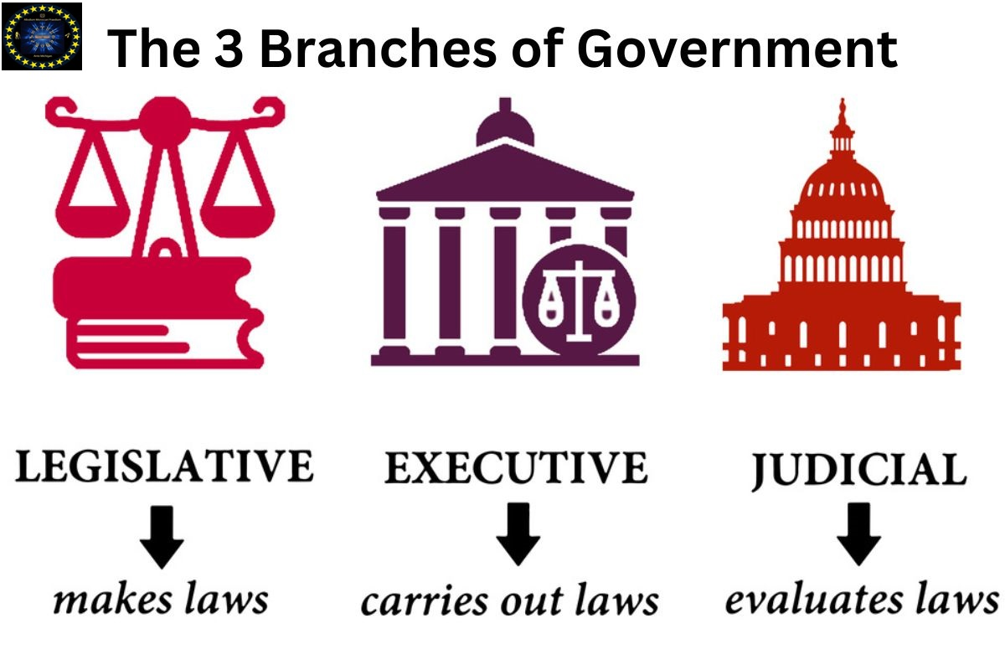

**Chapter 1**

Professional Conduct, Integrity and Honesty

**I.** The backbone of effective diplomacy is the unwavering commitment to integrity and honesty. Diplomats are expected to represent their countries truthfully, embodying ethical standards that reflect their nation's values. **a**. **Integrity**: This refers to the adherence to moral and ethical principles. It encompasses honesty and a strong moral compass, guiding diplomats in their interactions and decisions. **b. Honesty**: This involves truthfulness and transparency in all diplomatic communications and actions. **c. Confidentiality** is another cornerstone of professional conduct in diplomacy. Diplomats must navigate sensitive information with care, respecting the obligation to protect state secrets and confidential communications.

Professional Conduct 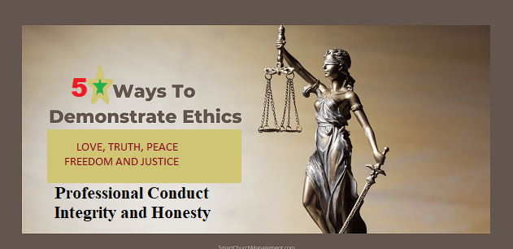Integrity and Honesty

# SECTION 1: Integrity and Honesty in Diplomacy

## 1.1. Definition and Importance

Integrity and honesty are not merely ideals but essential components of effective diplomatic practice. They serve as the foundation upon which trust, credibility, and long-term relationships are built.

### Building Trust

Trust is crucial for successful negotiations and collaborations. Integrity and honesty form the bedrock of this trust, facilitating stronger relationships between nations and diplomatic colleagues. When diplomats embody these values, they create an environment conducive to open dialogue and mutual respect, essential for resolving conflicts and advancing shared interests.

### Credibility

Diplomatic representatives must maintain credibility with both their home country and the host nation. Honest representations bolster this credibility, enhancing reliability in international relations. A diplomat who is perceived as truthful is more likely to be trusted and taken seriously in discussions, fostering a cooperative atmosphere that can lead to productive outcomes.

### Long-term Relationships

Upholding integrity and honesty fosters enduring relationships, essential for successful diplomacy and global cooperation. These principles encourage diplomats to build rapport with foreign counterparts, leading to a more collaborative and stable international community. By prioritizing integrity, diplomats can navigate challenges more effectively, ensuring lasting partnerships that benefit all parties involved.

## 1.2. Key Aspects of Integrity and Honesty

### 1. Truthful Representation

Diplomats must accurately convey their home country's policies, positions, and intentions. Avoiding exaggerations or misrepresentations is crucial, as these can harm relationships and undermine trust. By being forthright, diplomats can facilitate clearer communication and better understanding.

### 2. Transparency in Communication

Open communication with both domestic stakeholders and foreign counterparts is vital. Providing clear, accurate information during negotiations promotes understanding and cooperation. Transparency helps to alleviate suspicions and fosters an environment where all parties feel informed and valued.

### 3. Accountability

Diplomats must take responsibility for their actions and decisions. Acknowledging mistakes and working to rectify them, rather than deflecting blame, reinforces a culture of accountability. This commitment to accountability not only strengthens individual credibility but also enhances the integrity of the diplomatic institution as a whole.

### 4. Adherence to Ethical Standards

Following established ethical guidelines and codes of conduct from international diplomatic bodies and home countries is crucial. Personal interests must not interfere with professional duties, as this can compromise integrity. By adhering to these standards, diplomats uphold the principles of honesty and integrity that are essential for effective diplomacy.

## SECTION 2: Challenges to Integrity and Honesty in Diplomacy

### 2.1. Challenges to Integrity and Honesty

Diplomats often operate within the confines of their government’s expectations, facing pressure to conform to political agendas that may conflict with ethical standards. This pressure can lead to difficult ethical dilemmas, challenging their commitment to integrity.

#### a. Pressure to Compromise

The demands of political leaders and the complexities of international relations can create an environment where compromising on integrity seems necessary. Diplomats may face situations where adherence to honesty could jeopardize political interests or negotiations, forcing them to navigate a fine line between ethical conduct and political expediency.

#### b. Complex Situations

Diplomats may find themselves navigating sensitive issues that could tempt dishonesty or the withholding of information. The intricacies of international relations can blur the lines of ethical behavior, making it vital for diplomats to remain steadfast in their principles. The ability to discern when transparency is essential, even in challenging contexts, is crucial for maintaining integrity.

## SECTION 3: Promoting Integrity and Honesty

### 3.1. Training and Education

Regular training programs focused on ethical conduct ensure that diplomats are equipped to handle ethical dilemmas effectively. Workshops emphasizing negotiation tactics centered around honesty foster a culture of integrity within diplomatic circles, empowering diplomats to prioritize ethical considerations in their work.

### 3.2. Leadership and Role Models

Encouragement from senior officials is critical in promoting integrity as a core diplomatic value. Leaders set examples for others to follow, demonstrating the importance of honesty in their own actions. Highlighting ethical success stories showcases instances of successful diplomacy that prioritize honesty, inspiring current and future diplomats to uphold these principles.

### 3.3. Reporting Mechanisms

Establishing clear reporting channels creates secure and confidential avenues for reporting unethical behavior. Encouraging accountability without fear of retaliation is essential for maintaining a culture of integrity. Furthermore, enforcing penalties for breaches of ethical conduct reinforces the importance of integrity within diplomatic missions.

## Conclusion

Integrity and honesty are foundational to effective diplomacy. They enhance the credibility of diplomats, foster positive international relationships, and ultimately contribute to the overall strength of diplomatic efforts. The rules governing the conduct of diplomats and officials are designed to uphold the principles of integrity, honesty, and confidentiality. By adhering to these rules, diplomats not only represent their countries effectively but also contribute to a more stable and cooperative international community. The journey of diplomacy is one of trust and collaboration, and these principles are essential to navigating it successfully

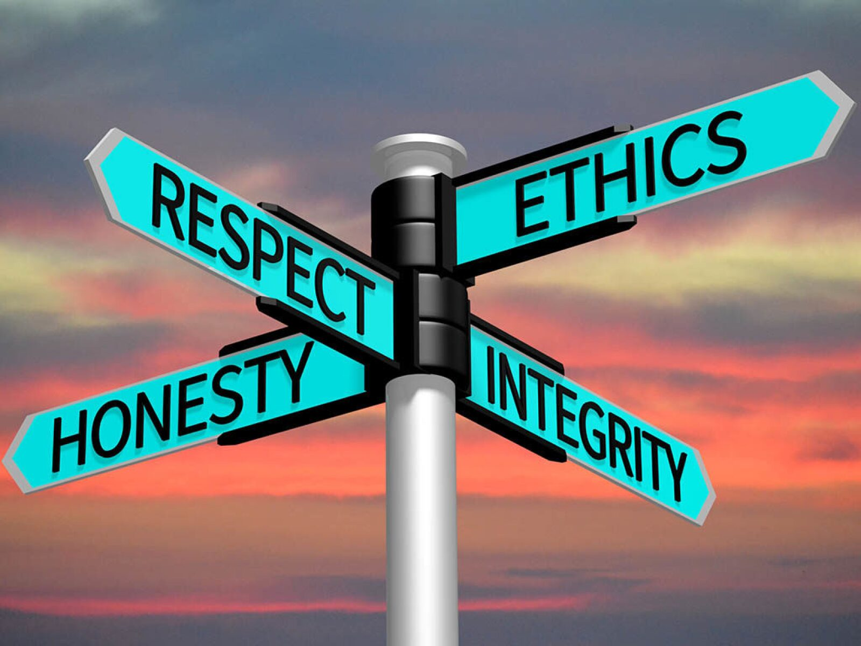

**CHAPTER 2**

**Confidentiality**

**Section 1: Confidentiality in Diplomacy:**

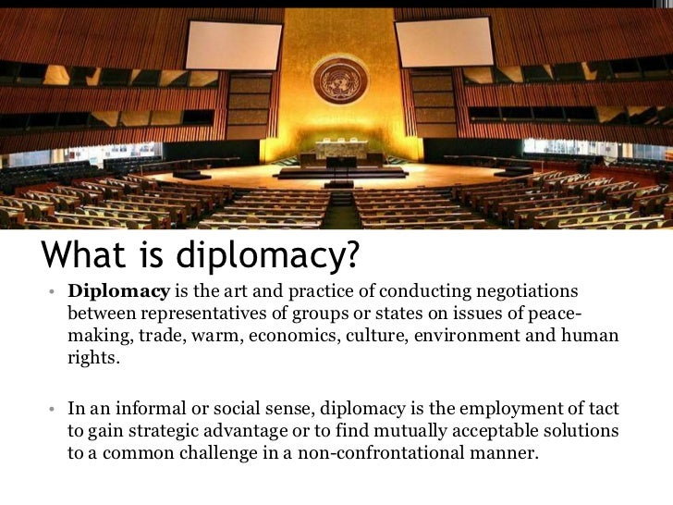 **1.2. Definition of Confidentiality**

Confidentiality in diplomacy refers to the ethical and legal obligation to protect sensitive information from unauthorized disclosure. This includes communications, documents, and negotiations intended to remain private.

**Section 2: Confidentiality in Diplomatic Practice**

**a. Respect for Sensitive Information:** Diplomats often handle sensitive information that, if disclosed, could compromise national security or diplomatic relations. Respecting this confidentiality is paramount.

**b. Protection of State Secrets:** The obligation to protect state secrets extends beyond personal responsibility; it reflects a commitment to national integrity. Diplomatic officials must employ discretion and vigilance in managing confidential communications

**Section 3: Importance of Confidentiality**

**a. Trust Building**: Upholding confidentiality fosters trust between diplomats, encouraging open dialogue.

**b. National Security**: Protecting sensitive information is critical for safeguarding a nation’s interests and security, as breaches can have significant geopolitical consequences.

* **c. Effective Negotiation**: Confidential discussions allow for candid negotiations, enabling diplomats to explore options without public scrutiny.

**Section 4: Key Aspects of Confidentiality**

* 1. **Types of Confidential Information**

**a. Official Communications**: Diplomatic cables, notes, and correspondence that require protection.

**b. Negotiation Details**: Sensitive information disclosed during negotiations that could influence out if leaked.

**c. Intelligence Reports**: Classified information vital to national security and foreign policy.

**4.2. Legal Frameworks**

**a. Vienna Convention on Diplomatic Relations**: Establishes the inviolability of diplomatic correspondence and the importance of confidentiality.

**b. National Laws and Regulations**: Countries have specific laws governing the handling of classified and sensitive information.

**c. Diplomatic Privilege**: Diplomats enjoy certain privileges that protect them from legal actions in the host country, which includes the confidentiality of their official communications.

**Section 5: Challenges to Confidentiality**

**a. Leaks and Whistle blowing**: Unauthorized disclosures can undermine trust and complicate negotiations.

**b. Digital Security**: The rise of digital communication raises cyber security concerns regarding the potential for breaches.

**Section 6: Promoting Confidentiality**

**6.1 Training and Awareness**

* **Regular Training**: Educating diplomats on the importance of confidentiality and best practices for safeguarding sensitive information.
* **Awareness Programs**: Focusing on the risks associated with digital communication and reinforcing security measures.

**6.2 Clear Protocols**

* **Establishing Protocols**: Creating clear guidelines for handling classified information, including access and sharing protocols.
* **Secure Communication Channels**: Implementing secure methods for conducting sensitive discussions.

**6.3 . Accountability Measures**

* **Consequences for Breaches**: Ensuring accountability for breaches of confidentiality to underscore its significance.
* **Regular Audits**: Conducting assessments of information security practices to maintain high standards.

**Conclusion**

Confidentiality is a cornerstone of diplomatic practice, essential for maintaining trust, protecting national interests, and enabling effective negotiations. Upholding this principle strengthens diplomatic missions and contributes to global stability.

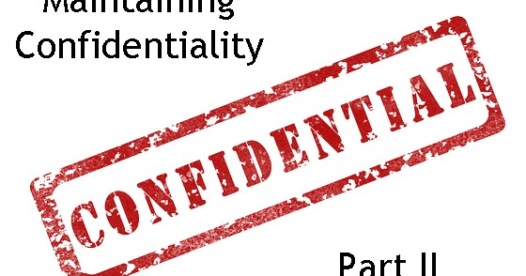

**CHAPTER 3**

**Section 1:**

**Local Laws and Customs in Diplomacy**

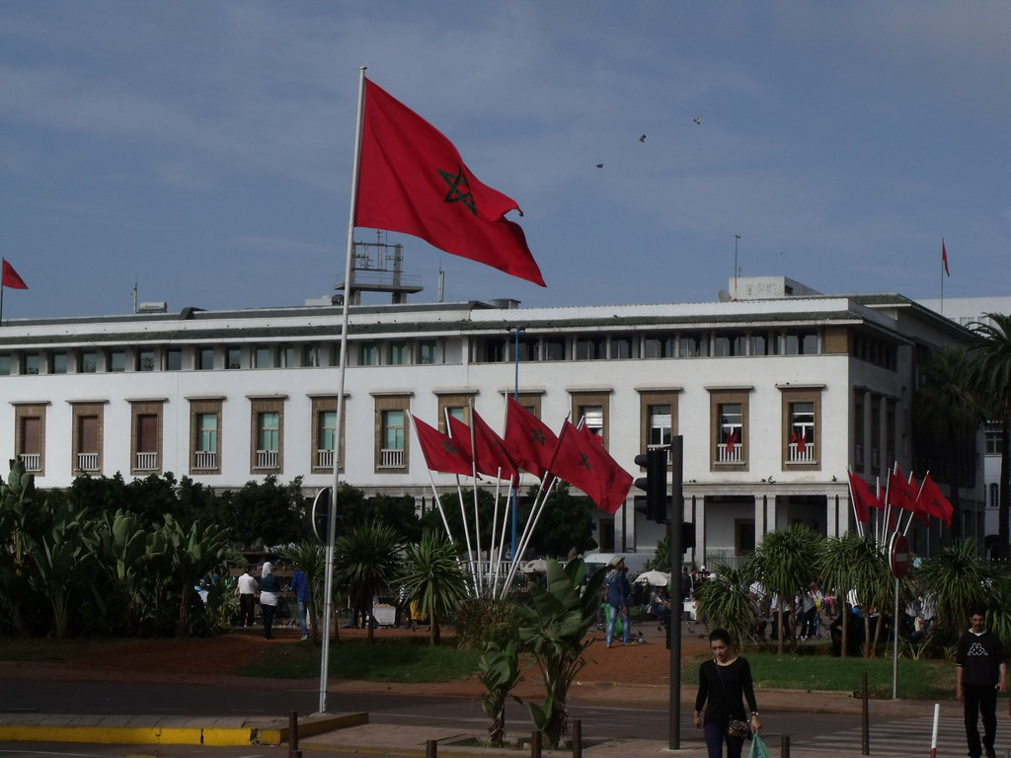

**1.1 Respects for Local Laws and Customs in Diplomacy**

Respect for local laws and customs is the principle that diplomats must adhere to the legal and cultural norms of the host country while conducting their dutiesFostering good relations involves building and maintaining cooperative relationships between nations through effective diplomatic practices. Fostering good relations is essential for effective diplomacy and international cooperation. By employing strategies that promote open communication, cultural engagement, and respect for local laws and customs, diplomats can build lasting partnerships that contribute to global stability and progress. Such efforts are not just beneficial but necessary for navigating the complexities of today’s international landscape.

**1.2. Importance in Diplomacy**

* **Fostering Good Relations**: Adhering to local laws and customs builds positive relationships between the diplomat's home country and the host nation.

**1.3 Importance in Diplomacy**

1. **Promotes Peace and Stability**: Good relations prevent conflicts and encourage peaceful resolutions.
2. **Facilitates Cooperation**: Strong relations enable effective collaboration on global initiatives.
3. **Enhances Credibility and Influence**: Nations with good relations are often viewed as more credible in international affairs.

**Section 2:**

**Fostering Good Relations**

* 1. **Key Strategies for Fostering Good Relations**

**a. Open Communication**: Maintaining transparent dialogue fosters trust and mutual understanding.

**b. Cultural Exchange and Engagement**: Promoting cultural diplomacy through exchanges and educational programs deepens mutual understanding.

Through these principles and practices, diplomats can navigate the complexities of international relations while upholding integrity, confidentiality, and respect for local customs, ultimately contributing to a more stable and cooperative global environment.

**2.3 Fostering Good Relations in Diplomacy**

**1. Encouraging People-to-People Connections**

* **Strengthening Ties Beyond Official Channels**: Facilitating informal interactions among citizens can enhance mutual understanding and goodwill, transcending the limitations of official diplomacy.

**2. Respect for Sovereignty**

* **Acknowledging Sovereignty**: Recognizing the rights of other nations to govern themselves is fundamental to respectful diplomatic engagement.
* **Avoiding Interference**: Steer clear of meddling in domestic affairs to maintain trust and respect, which are vital for sustaining relationships.

**3. Diplomatic Visits and Engagements**

* **Facilitating Official Visits**: Organizing visits by heads of state, ministers, and diplomats can strengthen personal relationships, fostering a deeper understanding.
* **Participation in International Summits**: Active involvement in global conferences demonstrates commitment to collaboration and shared goals.

**4. Conflict Resolution**

* **Proactive Measures**: Address potential conflicts through early negotiation and dialogue to prevent escalation.
* **Third-Party Mediation**: Engaging neutral parties can facilitate resolution and enhance credibility in the eyes of both sides.

**Section 3 : Challenges in Fostering Good Relations**

**3.1. Geopolitical Tensions**

* **Rivalries and Historical Grievances**: Pre-existing animosities can hinder the establishment of positive relations, complicating diplomatic efforts.
* **Competing National Interests**: Diverging priorities can lead to conflicts and misunderstandings, making cooperation difficult.

**3.2. Cultural Misunderstandings**

* **Cultural Norms and Values**: Differences can lead to misinterpretations, potentially straining diplomatic interactions.
* **Failure to Recognize Local Customs**: Ignoring local practices can damage goodwill and hinder effective communication.

**3. 3Domestic Pressures**

* **Political Pressures**: Internal political dynamics can influence how countries engage in diplomacy, sometimes leading to tensions.
* **Public Opinion**: Media portrayals and public sentiment can impact diplomatic strategies and relationships.

**Section 4 :. Measuring Success in Fostering Good Relations**

**4.1. Bilateral Agreements and Treaties**

* **Negotiation Outcomes**: Successful agreements signify healthy relations; monitoring their implementation is crucial for ongoing cooperation.

**2.2. Public Perception and Sentiment**

* **Public Opinion Assessment**: Gauging how citizens view bilateral relations can provide insights into their health, complemented by media analysis.

**3.3. Participation in Joint Initiatives**

* **Engagement in Collaborative Projects**: Participation in joint efforts, such as humanitarian or economic partnerships, indicates strong relations.
* **Tracking Outcomes**: Measuring the success of these initiatives serves as a reflection of diplomatic health.

### Conclusion:

In a world increasingly characterized by interconnectedness, the ability to foster goodwill and mutual understanding is paramount. Diplomatic relationships grounded in respect and cooperation can help mitigate geopolitical tensions and facilitate collaboration on pressing global issues, such as climate change, security, and public health.

Moreover, the application of these principles particularly in the context of nation state can enhance the AMPAM Body Politic credibility on the international stage. By committing to diplomatic practices that honor local customs and legal frameworks, AMPAM Gov not only strengthens its relationships with other nations but also cultivates an environment conducive to peace and mutual respect.

Ultimately, fostering good relations transcends mere diplomatic formalities; it is a foundational pillar that supports a sustainable and collaborative international order. Through continued dedication to these principles, AMPAM can play a crucial role in shaping a more harmonious global community, paving the way for a future defined by shared progress and understanding.

CHAPTER 4

**Preventing Conflicts in Diplomacy**



**Section1:**

**Preventing Conflicts**

* Preventing conflicts involves proactive measures and strategies employed by diplomats and states to avert disputes, tensions, and hostilities between nations. **Conduct at Official Events**: The expected behavior and etiquette that diplomats and officials should observe during formal gatherings, ceremonies, and diplomatic functions.

**1.1 Importance in Diplomacy**

**Maintaining Peace and Security**

* **Regional and Global Stability**: Effective conflict prevention is fundamental in averting wars and humanitarian crises.

**1.2. Promoting Sustainable Relationships**

* **Long-term Cooperation**: Healthy diplomatic relations reduce the likelihood of disputes and enhance mutual understanding.

**1.3. Economic Benefits**

* **Stable Trade Environments**: Peaceful relations facilitate economic growth and reduce military spending associated with conflict resolution.

**Section 2:**

**Key Strategies for Preventing Conflicts**

**2.1. Open and Transparent Communication**

* **Regular Dialogue**: Maintaining communication helps clarify intentions and address misunderstandings before they escalate.

**2.2. Conflict Resolution Mechanisms**

* **Formal Mechanisms**: Establishing arbitration or mediation frameworks provides structured approaches to resolving disputes.

**2.3. Cultural and Educational Exchanges**

* **Promoting Understanding**: Initiatives that foster cultural exchanges can build empathy and reduce stereotypes.

**2.4. Confidence-Building Measures**

* **Enhancing Transparency**: Joint military exercises or arms control agreements can help build trust and reduce tensions.

**2.5. Addressing Root Causes**

* **Identifying Underlying Issues**: Engaging in development aid and cooperation can alleviate tensions tied to economic disparities or historical grievances.

**Section 3 :**

**Challenges to Preventing Conflicts**

**3.1. Historical Grievances**

* **Long-standing Issues**: Past conflicts can complicate trust-building efforts, making dialogue challenging.

**3.2. Geopolitical Rivalries**

* **Resource Competition**: Disputes over resources or territory can heighten tensions and escalate into conflict.

**3.3. Communication Barriers**

* **Miscommunication Risks**: Cultural differences and language barriers can lead to misunderstandings that exacerbate tensions.

**Section 4:**

**Measuring Success in Conflict Prevention**

**4.1. Reduction in Tensions**

* **Monitoring Sentiment**: Assessing public sentiment and diplomatic exchanges can help gauge the effectiveness of conflict prevention efforts.

**4.2. Successful Conflict Resolutions**

* **Tracking Outcomes**: Evaluating the success of negotiations and the sustainability of peace agreements is crucial.

**4.3. Engagement in Joint Initiatives**

* **Collaborative Projects**: Participation in joint efforts can serve as indicators of cooperative relations and mutual interests.

### Conclusion:

Preventing conflicts is a crucial aspect of diplomacy that contributes significantly to peace, stability, and sustainable international relations. By employing strategies such as open communication, confidence-building measures, and addressing root causes, diplomats can effectively mitigate tensions and foster cooperative relationships between nations. The importance of conflict prevention extends beyond immediate benefits; it promotes long-term stability and economic prosperity, which are essential for the well-being of states and their nationals.

Furthermore, while challenges such as historical grievances and geopolitical rivalries persist, proactive measures and structured approaches to dialogue and resolution can overcome these hurdles. The commitment to fostering understanding through cultural exchanges and collaborative projects can bridge divides and build trust.

In summary, the proactive prevention of conflicts not only enhances regional and global security but also lays the groundwork for future cooperation and mutual respect among nations. As states continue to navigate complex international landscapes, prioritizing conflict prevention will be essential for achieving a peaceful and prosperous global community.

## 

**CHAPTER 5**

**Key Aspects of Formal Communication**

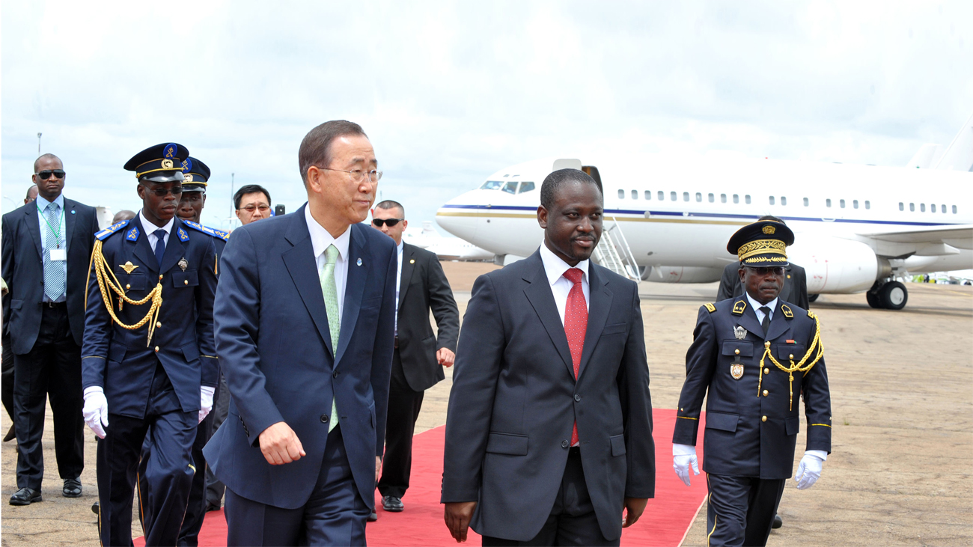

**Section 1**

**Formal Communication**

**1.1. Use of Formal Titles and Respectful Language**

* **Titles**: Always address diplomats and officials with their appropriate titles, such as "Your Excellency," "Ambassador," or "Minister."
* **Respectful Language**: Use courteous and diplomatic language that reflects respect for the individual and their office. Avoid informal expressions or slang.

**1.2. Proper Protocol in Written Communications**

* **Format**: Adhere to formal formats for diplomatic notes, letters, and official correspondence, including proper salutations and closings.
  + *Example*: Start with "Dear [Title] [Last Name]," and close with "Sincerely" or "Respectfully."
* **Clarity and Brevity**: Be concise and to the point while including all necessary information. Avoid overly complex language that may confuse the recipient.
* **Content**: Clearly state the purpose of the communication, ensuring alignment with diplomatic norms and maintaining a respectful tone.
* **Signature**: Include the sender's title and position under the signature to reinforce authority and context.

**1.3. Consistency in Communication**

* Maintain a consistent tone and level of formality in all written and verbal communications to reinforce professionalism.
* Use formal communication across all platforms, including emails, official letters, and public statements.

**Section 2**

**Challenges in Formal Communication**

**2.1. Cultural Variations**

* Different cultures have varying norms regarding formal titles and communication styles. Understanding these differences is crucial to avoid offending the recipient.
* Being aware of local customs can help tailor formal communication appropriately.

**2.2. Misinterpretation of Tone**

* Formal language can sometimes be perceived as cold or distant. Striking a balance between formality and warmth is essential to maintain rapport.
* Careful consideration of word choice and phrasing can help convey both respect and friendliness.

**2.3. Rapid Communication Needs**

* In urgent situations, the pressure to communicate quickly may lead to informal language or shortcuts, potentially compromising diplomatic decorum.
* Diplomats should strive to maintain formal communication standards even in urgent scenarios.

**Section 3**

**Conduct at Official Events**

* **Conduct at Official Events**: The expected behavior and etiquette that diplomats and officials should observe during formal gatherings, ceremonies, and diplomatic functions.

**3.1. Importance of Proper Conduct**

**a. Representation of Home Country**

* + Diplomats serve as representatives of their home country. Their behavior reflects on themselves and their nation.
  + Maintaining a professional demeanor enhances the reputation of the home country and fosters goodwill.

**b. Building Relationships**

* + Proper conduct at official events facilitates the establishment and strengthening of diplomatic relationships.
  + Positive interactions can lead to future cooperation and collaboration on various issues.

**c. Upholding Protocol and Respect**

* + Adhering to established protocols demonstrates respect for the hosts and the significance of the event.
  + It shows awareness of the cultural and diplomatic norms that govern official gatherings.

**Section 4**

**. Key Aspects of Conduct at Official Events**

**4.1 Dress Code and Appearance**

* + **Appropriate Attire**: Adhere to the specified dress code (formal, business, or cultural) to4show respect for the occasion and hosts.
  + **Personal Grooming**: Maintain a polished appearance that reflects professionalism.

**4.2 Punctuality**

* + Arriving on time is crucial to demonstrate respect for the hosts and the event schedule.
  + Late arrivals can disrupt proceedings and may be seen as disrespectful.

**4.3 Greetings and Introductions**

* + Use proper forms of address and titles when greeting attendees, especially senior officials.
  + Introduce oneself and others according to protocol, ensuring that seniority and titles are respected.

**4.4Engagement and Interaction**

* + Participate actively and respectfully in discussions, being mindful of local customs and communication styles.
  + Avoid controversial topics that may lead to discomfort or conflict during conversations.

**4.5Networking Etiquette**

* + Engage in conversations with other attendees to build relationships, while respecting personal boundaries.
  + Know when to listen and when to contribute to discussions, fostering a collaborative atmosphere.

**4.6 Dining Etiquette**

* + Observe proper table manners, including the use of utensils, napkins, and conversation etiquette during meals.
  + Be aware of dietary restrictions and preferences, especially when hosting or attending events with food.
  1. **Behavior During Ceremonial Events**
  + Follow protocol during formal ceremonies, such as standing for national anthems or observing moments of silence.
  + Pay attention to speeches and presentations, showing respect through attentive listening.

**Section 5**

**Challenges in Conducting at Official Events**

**5.1Cultural Differences**

* + Different cultures may have unique expectations regarding behavior, greetings, and interactions. Understanding these variations is essential to avoid missteps.
  + Diplomats must be adaptable to local customs to ensure respectful conduct.

**5.2Pressure to Network**

* + The pressure to network and make connections can lead to overly familiar behavior or inappropriate topics of conversation.
  + Striking a balance between professionalism and friendliness is key.
  1. **Managing Distractions**
  + Official events may be challenging due to external distractions or interruptions. Diplomats should remain composed and focused.
  + Being prepared to handle unexpected situations gracefully is essential.

**Conclusion**

**Conclusions on Conduct at Official Events**

Formal communication and proper conduct at official events are cornerstones of effective diplomacy. By adhering to established protocols, using respectful language, and demonstrating professionalism, diplomats can foster positive relationships and uphold the integrity of international relations. These elements not only serve to enhance individual interactions but also contribute to the broader objectives of peace, cooperation, and mutual respect among nations.

1. **Foundation of Trust**: Effective communication is essential for building trust between diplomats and their counterparts. When diplomats communicate clearly and respectfully, they lay the groundwork for open dialogue and collaboration. This trust is vital in navigating complex negotiations and resolving conflicts.
2. **Reinforcement of Diplomatic Norms**: By exemplifying proper conduct, diplomats reinforce the norms and values that underpin international diplomacy. This adherence to etiquette not only sets a standard for others but also demonstrates a commitment to the principles of diplomacy, such as sovereignty, respect, and equality among nations.
3. **Crisis Management**: In times of tension or crisis, the ability to communicate effectively and maintain decorum becomes even more critical. Diplomats who can navigate difficult conversations with tact and professionalism can help de-escalate situations and work towards constructive solutions, ultimately contributing to stability.
4. **Promotion of National Interests**: Thoughtful conduct at official events aligns with the strategic interests of a nation. By presenting a united front and showcasing diplomatic acumen, diplomats can advocate for their country's priorities while fostering an environment conducive to dialogue and negotiation.
5. **Cultural Diplomacy**: Engaging with diverse cultures through formal events not only enriches diplomatic relationships but also promotes cultural understanding and appreciation. By respecting and celebrating cultural differences, diplomats can bridge gaps and foster a sense of global community.
6. **Legacy of Diplomacy**: The way diplomats conduct themselves at official events contributes to the legacy of their profession. Positive interactions and respectful communication can lead to lasting partnerships that transcend political differences, influencing future generations of diplomats and shaping the trajectory of international relations.
7. **Empowerment Through Education**: Continued education and training in diplomatic protocols and effective communication strategies empower diplomats to excel in their roles. Such preparation enables them to navigate the complexities of international interactions with confidence and competence.
8. **Long-term Relationships**: The relationships built at official events often extend beyond immediate interactions. By nurturing these connections, diplomats can facilitate long-term partnerships that are essential for tackling global challenges, from climate change to security issues.

In conclusion, formal communication and proper conduct at official events are not merely procedural; they are vital to the success of diplomatic endeavors. By embodying these principles, diplomats can create an atmosphere of respect and cooperation that enhances international relations. Ultimately, their actions have the power to shape global narratives, foster peace, and promote a world where dialogue prevails over discord. Through their commitment to professionalism and ethical conduct, diplomats can leave a lasting impact on the international stage, contributing to a more harmonious and interconnected world.

**Chapter 6.**

**Interactions with Other Diplomats**

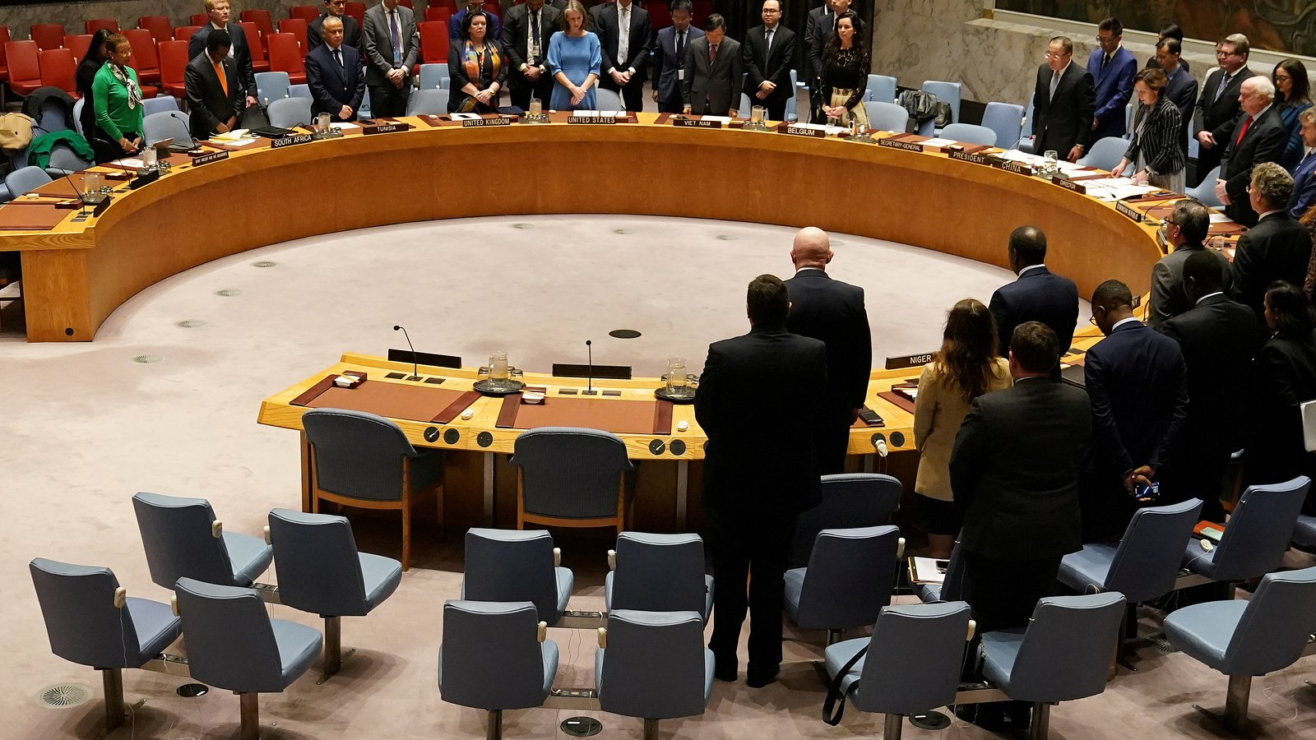

Interactions with other diplomats are crucial for building relationships, negotiating treaties, and addressing global issues. Here are some key aspects:

**Section 1.**

**Formal Meetings**

* Diplomats often participate in bilateral and multilateral meetings to discuss official matters, negotiate agreements, and coordinate on international policies.

**1.1. Social Functions**

* Informal gatherings, such as receptions or cultural events, provide opportunities for diplomats to network and foster personal relationships, which can be beneficial during negotiations.

**1.2 Communication**

* Regular communication through emails, phone calls, and reports helps maintain ongoing dialogue, share information, and resolve conflicts.

**1.3. Cultural Exchange**

* Understanding and respecting each other’s cultures can enhance diplomatic relations. Events showcasing cultural heritage can bridge gaps and promote goodwill.

**1.4. Crisis Management**

* In times of crisis, quick and effective communication with other diplomats is essential to coordinate responses and mitigate issues.

**1.5. Building Alliances**

* Working together on common goals, such as climate change or security, helps create alliances and strengthen international cooperation.

**1.6 Protocol and Etiquette**

* Adhering to diplomatic protocols and etiquette is vital to maintaining respect and professionalism in interactions.

Successful diplomacy relies on a mix of formal and informal interactions, emphasizing the importance of relationship-building in international relations.

**Section 2.**

**Respectful Engagement**

Respectful engagement in diplomacy is vital for fostering understanding and collaboration. Here are some key principles:

1. **Active Listening**: Truly hearing what others say promotes trust and shows that their perspectives are valued.
2. **Cultural Sensitivity**: Being aware of and respecting cultural differences can prevent misunderstandings and build rapport.
3. **Open Communication**: Encouraging honest dialogue while remaining courteous helps address issues constructively.
4. **Empathy**: Trying to understand the motivations and concerns of others fosters stronger relationships.
5. **Constructive Feedback**: Offering feedback in a respectful manner can enhance discussions and lead to better outcomes.
6. **Professionalism**: Maintaining a professional demeanor, regardless of the situation, upholds the integrity of diplomatic relations.
7. **Conflict Resolution**: Approaching disagreements with a problem-solving mindset can turn conflicts into opportunities for growth.
8. **Inclusivity**: Ensuring all voices are heard, especially from less powerful states, promotes equity and mutual respect.
9. By prioritizing these principles, diplomats can create a more collaborative and respectful environment, leading to more effective international cooperation

In conclusion, interactions with other diplomats are crucial for building relationships, negotiating treaties, and addressing global issues. The blend of formal meetings and informal engagements establishes a foundation for effective diplomacy.

**Section 1: Formal Meetings** underscores the structured nature of diplomatic interactions, where bilateral and multilateral meetings play a pivotal role in shaping international policies. Social functions enhance these interactions, allowing diplomats to build personal connections that can prove advantageous in negotiations. Communication is vital, facilitating ongoing dialogue and conflict resolution, while cultural exchanges deepen mutual understanding and foster goodwill. In crisis situations, timely communication is essential for coordinated responses, and collaborative efforts on shared challenges, like climate change, help build alliances. Adhering to protocols and etiquette ensures professionalism and respect in all dealings.

**Section 2: Respectful Engagement** emphasizes the importance of creating a collaborative atmosphere through principles such as active listening, cultural sensitivity, and open communication. These practices not only enhance understanding but also pave the way for constructive dialogue and conflict resolution. By fostering empathy and professionalism, diplomats can strengthen relationships and ensure that all voices, especially those from less powerful states, are acknowledged and valued.

Ultimately, successful diplomacy hinges on a delicate balance of formal and informal interactions, underscoring the necessity of relationship-building and mutual respect in international relations. By prioritizing these elements, diplomats can navigate the complexities of global diplomacy more effectively, leading to enhanced cooperation and a more peaceful world.

Bottom of Form

CHAPTER 7

**Section 1 Responsibility for Actions**

**1.1. Accountability for Actions**

Diplomats are responsible for their decisions and actions while representing their countries. This includes adherence to international laws, ethical standards, and their nation’s foreign policy objectives. Accountability ensures that diplomats act in the best interest of their country and maintain the integrity of their role.

**1.2. Mechanisms for Reporting Misconduct**

To uphold accountability, it’s essential to have clear mechanisms for reporting misconduct or violations of conduct. These may include:

* **Internal Reporting Systems**: Establishing confidential channels within diplomatic missions where staff can report unethical behavior or violations without fear of retaliation.
* **Whistleblower Protections**: Implementing policies that protect individuals who report misconduct, ensuring they are shielded from negative repercussions.
* **Anonymous Hotlines**: Providing anonymous reporting options can encourage individuals to come forward with information about misconduct.
* **Oversight Committees**: Creating independent committees to review reported cases of misconduct, ensuring fair and impartial investigations.
* **Training and Awareness**: Regularly training diplomats on ethical conduct, the importance of accountability, and the procedures for reporting misconduct can foster a culture of integrity.

**1.3. Consequences for Misconduct**

Clearly defined consequences for misconduct reinforce accountability. These can range from formal reprimands to dismissal, depending on the severity of the violation.

**1.4. Regular Audits and Reviews**

Conducting periodic audits and reviews of diplomatic activities can help identify any patterns of misconduct and reinforce the importance of accountability. By implementing these measures, diplomatic missions can create an environment where accountability is prioritized, and ethical standards are upheld.

**Section 2**

**. Performance Evaluation**

Performance evaluation is crucial for ensuring that diplomats effectively fulfill their roles and responsibilities. Here are key components of an effective evaluation system:

**2.1. Clear Objectives**

Establish specific, measurable objectives for diplomats based on their roles and the goals of their missions. This provides a clear framework for evaluation.

**2.2. Regular Assessments**

Conduct periodic performance reviews (e.g., annually or biannually) to assess diplomats’ progress toward their objectives and overall effectiveness.

**2.3. 360-Degree Feedback**

Incorporate feedback from multiple sources, including peers, supervisors, and stakeholders. This comprehensive approach provides a well-rounded view of a diplomat’s performance.

**2.4. Competency Framework**

Develop a set of competencies relevant to diplomatic work, such as negotiation skills, cultural awareness, and crisis management. Evaluations can assess proficiency in these areas.

**2.5. Self-Assessment**

Encourage diplomats to conduct self-assessments as part of the evaluation process. This promotes self-reflection and accountability.

**2.6. Professional Development Plans**

Use performance evaluations to identify areas for improvement and create tailored professional development plans. This supports continuous learning and growth.

**2.7. Documentation and Reporting**

Maintain thorough records of performance evaluations, including feedback, assessments, and action plans. This documentation can be important for career advancement and accountability.

**3.8. Incentives for High Performance**

Recognize and reward high-performing diplomats to motivate and encourage excellence. This can include promotions, awards, or opportunities for prestigious assignments.

**9.9. Addressing Underperformance**

Establish clear procedures for addressing underperformance, including support and remediation plans to help diplomats improve.

**10.10. Stakeholder Engagement**

Involve relevant stakeholders in the evaluation process, especially for diplomats working in international contexts. Their perspectives can provide valuable insights.

By implementing a robust performance evaluation system, diplomatic missions can enhance accountability, promote professional growth, and ensure that diplomats are effectively serving their countries’ interests.

**CHAPTER 8**

**Diplomatic Immunity and Limitations**

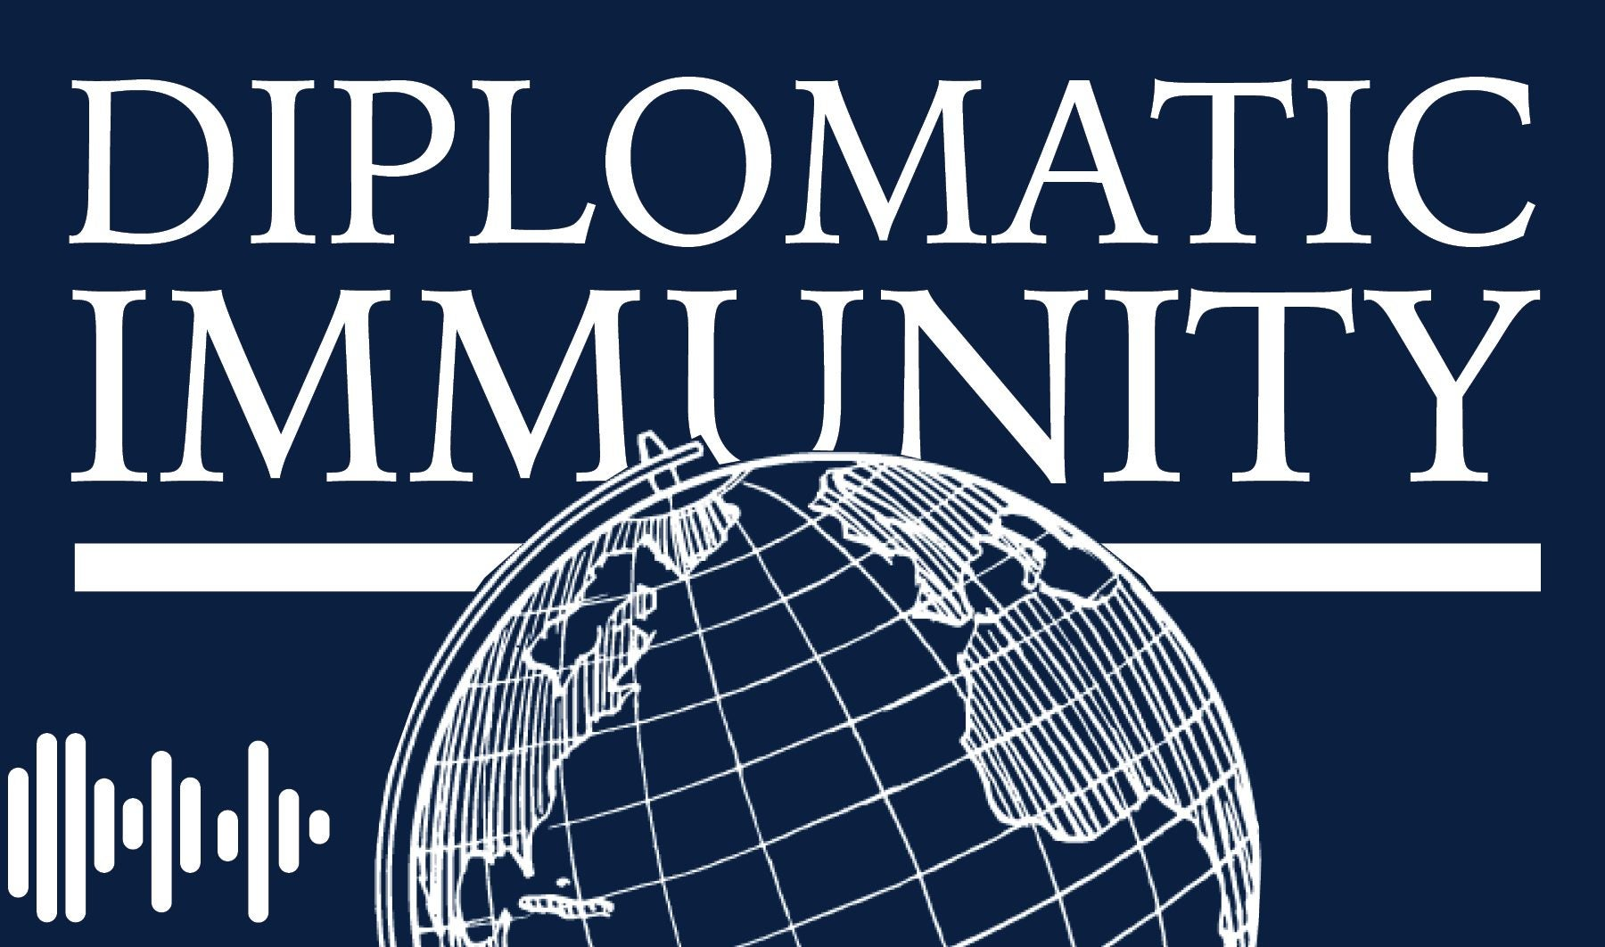

**SECTION 1**

**Diplomatic Immunity and Limitations**

Diplomatic immunity is a fundamental principle in international law that protects diplomats from legal actions in their host countries. However, it comes with limitations and responsibilities. Here’s an overview:

**1.1. Purpose of Diplomatic Immunity**

* **Protection of Diplomats**: Ensures that diplomats can perform their duties without fear of harassment or coercion from the host state.
* **Promotion of International Relations**: Facilitates open and effective communication between nations.

**1.2. Scope of Immunity**

* **Personal Immunity**: Diplomats are generally immune from arrest and prosecution for both civil and criminal matters while serving in their official capacity.
* **Official Acts**: Actions taken in the course of their diplomatic duties are typically protected, allowing diplomats to perform their roles effectively.

**1.3. Limitations on Immunity**

* **Not Absolute**: Immunity does not protect diplomats from actions related to private activities (e.g., business dealings or serious crimes) that are unrelated to their diplomatic functions.
* **Waiver of Immunity**: The sending state can choose to waive a diplomat’s immunity, allowing local authorities to take action.
* **Exclusions for Certain Roles**: Some positions, such as honorary consuls, may have limited immunity compared to full diplomatic representatives.

**1.4. Responsibilities of Diplomats**

* **Respect Local Laws**: Diplomats are expected to respect the laws and regulations of the host country. Abusing immunity can lead to tensions in diplomatic relations.
* **Avoiding Criminal Activity**: Engaging in criminal behavior can result in expulsion and damage to diplomatic relations, even if immunity applies.

**1.5. Mechanisms for Addressing Misconduct**

* **Diplomatic Channels**: If a diplomat is accused of misconduct, the host country typically raises the issue through diplomatic channels rather than through legal proceedings.
* **Expulsion**: The host country may declare a diplomat persona non grata, leading to their removal from the country, especially in cases of serious misconduct.

**1.6. International Treaties and Conventions**

* **The Vienna Convention on Diplomatic Relations (1961)** outlines the principles of diplomatic immunity and the responsibilities of diplomats and host states.

**1.7. Enforcement Challenges**

* While immunity protects diplomats, it can also pose challenges for host states in addressing criminal behavior or serious misconduct, necessitating a careful balance between protection and accountability.

By understanding the principles and limitations of diplomatic immunity, diplomats can navigate their responsibilities more effectively, ensuring respectful and productive international relations.

**A. Understanding of Immunity**

Diplomatic immunity is a legal framework that protects diplomats from certain legal actions in their host countries, allowing them to perform their duties without interference. Here are the key aspects to understand:

**1. Legal Basis**

* **Vienna Convention on Diplomatic Relations (1961)**: This international treaty establishes the rules of diplomatic immunity and the obligations of sending and receiving states.

**2. Types of Immunity**

* **Personal Immunity**: Diplomats cannot be arrested or prosecuted for criminal acts while in their host country.
* **Functional Immunity**: Protects diplomats from legal actions related to their official duties. This means that actions performed in the course of their work are generally immune from prosecution.

**3. Limitations of Immunity**

* **Non-absolute**: Immunity does not cover private matters unrelated to official duties, such as personal business transactions or actions outside the scope of diplomatic functions.
* **Waiver**: The diplomat’s home country can choose to waive their immunity, allowing for prosecution or civil suits in the host country.
* **Persona Non Grata**: Host countries can expel diplomats for serious misconduct, regardless of their immunity status.

**4. Responsibilities of Diplomats**

* Diplomats are expected to respect the laws of the host country. Misuse of immunity can lead to diplomatic tensions and negative repercussions.

**5. Reporting Misconduct**

* Host countries typically address allegations of misconduct through diplomatic channels rather than legal proceedings, fostering communication and resolution.

**6. Cultural Sensitivity**

* Understanding local laws and customs is crucial. Diplomats should navigate their roles with cultural awareness to avoid misunderstandings and maintain good relations.

**7. Public Perception**

* Misconduct by diplomats can lead to public outcry and damage the reputation of the sending country, emphasizing the importance of responsible behavior.

By grasping these principles, diplomats can effectively balance their privileges with their responsibilities, promoting constructive international relations.

**B. Limits of Immunity**

While diplomatic immunity provides significant protections for diplomats, it is not absolute. Here are the key limits to understand:

**1. Scope of Protection**

* **Personal vs. Official Acts**: Immunity typically covers actions taken in the course of official duties. However, actions related to private activities—such as personal business dealings or crimes committed outside the scope of diplomatic work—are not protected.

**2. Waiver of Immunity**

* **Consent of the Sending State**: The home country of a diplomat can choose to waive their immunity, allowing legal proceedings to take place in the host country. This is often done in cases involving serious allegations.

**3. Serious Crimes**

* **Exclusions for Grave Offenses**: Some serious crimes, particularly those involving violence, human trafficking, or drug offenses, may lead to the host country taking action, including expulsion, even if immunity applies.

**4. Persona Non Grata**

* **Expulsion**: A host country has the right to declare a diplomat persona non grata, effectively removing them from the country. This can occur for reasons of misconduct or actions that threaten national security or public order.

**5. Limited Immunity for Certain Roles**

* **Honorary Consuls**: Individuals in certain diplomatic roles, like honorary consuls, may not receive the same level of immunity as full diplomats.

**6. Local Laws and Regulations**

* **Expectation of Compliance**: Diplomats are expected to adhere to the laws of the host country. Violations can lead to diplomatic repercussions, even if they fall within the realm of protected activities.

**7. Civil Actions**

* **Limited Civil Liability**: While diplomats enjoy immunity from criminal prosecution, they may still be subject to civil suits for actions that fall outside their official duties.

**8. International Accountability**

* **Diplomatic Channels**: Allegations of misconduct are typically handled through diplomatic communication rather than the legal system, emphasizing the importance of dialogue and resolution.

Understanding these limits is crucial for diplomats to navigate their roles responsibly, ensuring that they uphold the principles of international law while maintaining respectful relations with host countries.

**Conclusion**

Upholding these rules is essential for fostering positive international relations, promoting trust, and ensuring effective diplomatic engagements. Diplomats play a crucial role in representing their countries and must navigate complex cultural and legal landscapes with professionalism and respect.

Chapter 8

**Breaching of the Peace in Diplomacy**

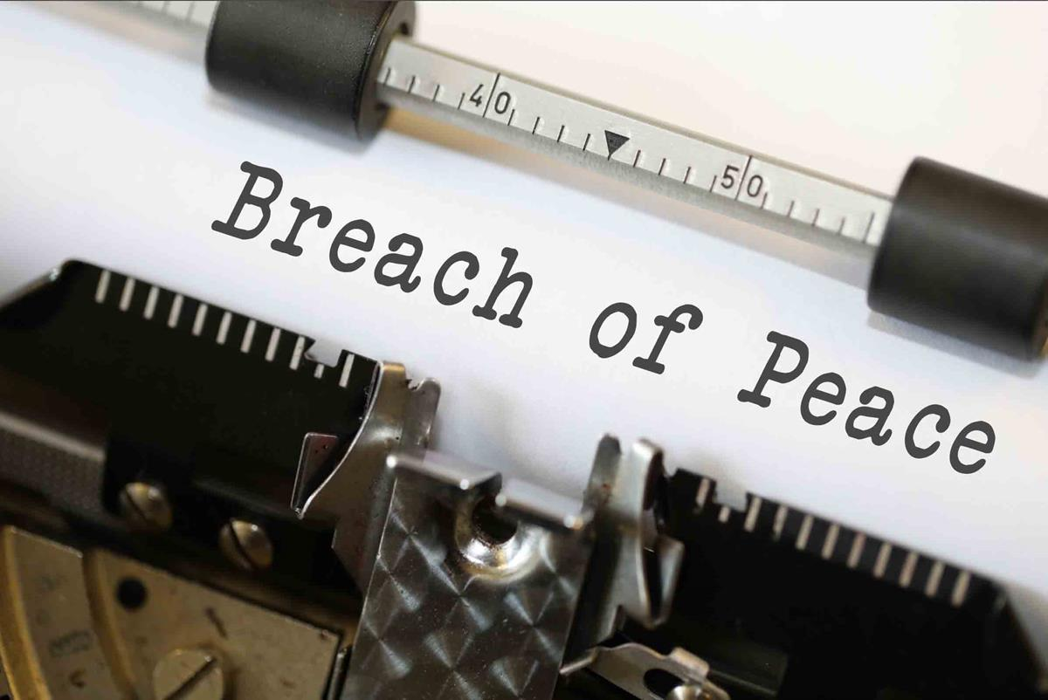

**Introduction**

This policy outlines the responsibilities of state officials regarding breaches of peace and establishes clear procedures to address such incidents. It aims to ensure that all state officials conduct themselves in a manner that promotes peaceful relations and upholds the integrity of diplomatic engagements. State officials must adhere to the highest standards of conduct to prevent breaches of peace. This includes engaging in respectful dialogue, honoring international agreements, and acting in the best interests of both their country and the global community. Any actions that may lead to a breach of peace are strictly prohibited and will be addressed promptly. By incorporating these elements, the policy and code of conduct will not only provide a solid foundation for diplomatic interactions but also promote a culture of peace, collaboration, and respect among nations. Through continuous commitment to these principles, state officials can play a pivotal role in fostering a more harmonious international landscape.

**Section 1**

**Breaching the Peace for State Officials**

.

**1.1 Scope**

This policy applies to all state officials, including diplomats, ambassadors, and government representatives, in both domestic and international contexts.

**Section 2**

**Procedures**

**2.1. Awareness and Training**

* **Mandatory Training:** All state officials must undergo training on international law, conflict resolution, and cultural sensitivity upon appointment and periodically thereafter.
* **Resource Availability:** Access to updated materials on diplomatic protocols and peacekeeping strategies will be provided.

**2.2. Conduct Guidelines**

* **Communication:** Maintain open and respectful communication, avoiding inflammatory language and actions that could escalate tensions.
* **Diplomatic Engagement:** Actively seek diplomatic solutions to conflicts and engage in constructive dialogue with all parties involved.
* **Crisis Management:** Follow established protocols for crisis situations, ensuring timely and coordinated responses.

**2.3. Reporting Breaches**

* **Immediate Reporting:** State officials must report any actions or events that may constitute a breach of peace to their superiors immediately.
* **Documentation:** All incidents must be documented thoroughly, including context, actions taken, and any responses from involved parties.

**2.4. Investigation Process**

* **Initial Review:** Upon receiving a report, a designated oversight committee will conduct an initial review of the incident to determine its nature and severity.
* **Full Investigation:** If warranted, a full investigation will be conducted, involving relevant stakeholders and experts in international law and diplomacy.

**2.5. Disciplinary Actions**

* **Consequences for Breaches:** Depending on the severity of the breach, consequences may range from formal reprimands to termination of employment. This may also include legal action if applicable.
* **Appeal Process:** State officials have the right to appeal any disciplinary action through established channels.

**2.6 Preventive Measures**

* **Regular Reviews:** Policies and procedures will be reviewed regularly to ensure effectiveness and relevance in preventing breaches of peace.
* **Feedback Mechanism:** Establish a system for state officials to provide feedback on potential improvements to the policy.

**Section 3**

**Code of Conduct**

**3.1. Integrity**

* Act with honesty and integrity in all interactions, both domestically and internationally.

**3.2. Respect**

* Treat all individuals with respect, regardless of their nationality, culture, or position.

**3.3. Accountability**

* Take responsibility for actions and decisions, understanding their impact on peace and international relations.

**4.4. Confidentiality**

* Maintain confidentiality regarding sensitive information and discussions that could affect diplomatic relations.

**3.5. Professionalism**

* Uphold professionalism in all conduct, ensuring that personal beliefs do not interfere with official duties.

**3.6. Cultural Sensitivity**

* Be aware of and sensitive to cultural differences, adapting communication and behavior accordingly to promote understanding.

**3.7. Commitment to Peace**

* Prioritize peaceful resolutions to conflicts and engage in practices that foster goodwill and collaboration.

.

**Section 4**

**Guidelines for Conduct**

**4.1 Clear Guidelines for Conduct**

* Establish explicit protocols for interactions between state officials, including standards for communication, negotiation, and conflict resolution.
* Outline procedures for reporting and addressing breaches of conduct, ensuring transparency and prompt action.

**4.2. Training and Capacity Building**

* Implement regular training programs on diplomatic etiquette, cultural sensitivity, and conflict management to equip officials with the skills needed for effective engagement.
* Promote workshops and seminars that emphasize the importance of non-violent communication and negotiation strategies.

**4.3. Mechanisms for Accountability**

* Create independent bodies to oversee adherence to the code of conduct, allowing for impartial investigations into reported incidents.
* Establish consequences for violations, reinforcing the importance of accountability in maintaining trust.

**4.4. Promoting Inclusivity and Representation**

* Encourage the inclusion of diverse perspectives in diplomatic processes, ensuring that all nations, particularly smaller or less powerful ones, have a voice.
* Foster environments that value and respect different cultural backgrounds, enhancing mutual understanding.

**4.5. Collaboration with International Organizations**

* Partner with international organizations to align the code of conduct with global standards and best practices in diplomacy.
* Engage in joint initiatives that promote peacebuilding and conflict resolution, leveraging the expertise of established organizations.

**4.6. Monitoring and Evaluation**

* Regularly assess the effectiveness of the policy and code of conduct through feedback from state officials and relevant stakeholders.
* Adapt and revise guidelines based on emerging challenges in international relations and the evolving nature of diplomacy.

**4.7. Public Awareness and Engagement**

* Promote awareness of the code of conduct among the public and civil society, highlighting the importance of peaceful diplomacy and international cooperation.
* Encourage dialogue between governments and citizens to foster a culture of respect and understanding on a national and global scale.

**4.8. Commitment to Sustainable Development**

* Align diplomatic efforts with sustainable development goals, recognizing that addressing global challenges such as poverty, inequality, and climate change is essential for long-term peace.
* Advocate for collaborative approaches to sustainability that involve multiple stakeholders, reinforcing the interconnectedness of nations.

By incorporating these elements, the policy and code of conduct will not only provide a solid foundation for diplomatic interactions but also promote a culture of peace, collaboration, and respect among nations. Through continuous commitment to these principles, state officials can play a pivotal role in fostering a more harmonious international landscape.

Bottom of Form

**Conclusion**

This policy and code of conduct serve as a framework for state officials to prevent breaches of peace and to address any incidents effectively. By adhering to these guidelines, state officials can contribute to a more stable and respectful international environment, fostering trust and cooperation among nations. Continuous education, accountability, and a commitment to peaceful diplomacy are essential for achieving these objectives. his policy and code of conduct serve as a framework for state officials to prevent breaches of peace and to address any incidents effectively. By adhering to these guidelines, state officials can contribute to a more stable and respectful international environment, fostering trust and cooperation among nations. Continuous education, accountability, and a commitment to peaceful diplomacy are essential for achieving these objectives