DOG PHOTO INDENTIFICATION & CITY TAG INFORMATION

OWNER: _______________________
ADDRESS: _____________________

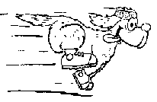 PHONE –
Attach photo here HOME: ______________________

WORK: ______________________

CELL: _______________________

DOGS NAME: ___________________

SEX: M or F DOB: _________

SPAYED / NEUTERED: Y or N

YEAR | PAID DATE | TAG # | RABIES EXPIRES | ISSUED BY | YEAR | PAID DATE | TAG # | RABIES EXPIRES | ISSUED BY
2014 |  |  |  |  | 2020
2015 |  |  |  |  | 2021
2016 |  |  |  |  | 2022
2017 |  |  |  |  | 2023
2018 |  |  |  |  | 2024
2019 |  |  |  |  | 2025

