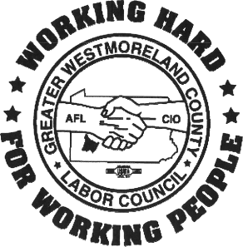 Greater Westmoreland County
Labor Council Scholarship 2025

GWCLC IS PROUD TO OFFER A $1,000 SCHOLARSHIP FOR 2025

OUR LABOR COUNCIL, AN AFFILIATE OF THE AFL-CIO, REPRESENTS THE COLLECTIVE INTERESTS OF OUR AFFILIATED UNIONS OF WESTMORELAND COUNTY. WE ASSIST LOCAL UNIONS WITH ORGANIZING CAMPAIGNS, COMMUNITY SERVICES, CIVIL RIGHTS ISSUES AND WORK WITH CHARITABLE ORGANIZATIONS. WE PLAY AN INVALUABLE ROLE IN THE STRUGGLE FOR WORKING PEOPLE.
Eligibility
A son, daughter, stepchild or legally adopted child of an active or retired affiliate member of The Greater Westmoreland County Labor Council. Members must be dues paying and in good standing with their respective unions. The awardee will be a graduating high school senior who will enter college or trade school the school year immediately following graduation. The recipient must provide proof of school acceptance and enrollment to receive the award.
ESSAY QUESTION: How has a union impacted you and your family’s life?
Essay must be 500 words, double spaced on 8x11.5 paper, preferably as a Word document or PDF and void of any identification.
Please complete the form on the reverse of this page and submit it with your essay. The deadline for submission is Thursday, May 15, 2025.

Scholarship Application
__________________________________ _______________________________
Name Name of school (college) you will attend

Student address—House # & Street City State Zip

Phone # of student E mail address

Union Affiliation/Name/Local # Signature of Local Union Officer
____________________________________________________________________________________________
Union Member Name Relationship to Applicant

The application deadline is Thursday, May 15, 2025.
Please return this form, in Word or PDF format, along with your essay via Email to: gwclaborcouncil@gmail.com
or USPS mail to GWCLC One Northgate Square, Suite 110 Greensburg, PA 15601

