**Community Family & Internal Medicine**

**Universal Vaccine Records App: Vaccine Genie Initiative**

We looking for interns ages 14 and above to help us make tracking medical history a little easier for everyone. We are in the customer discovery and initial prototype testing phase and need volunteers who want to help us make a difference. Below is a list of our current Internship Positions. Please send your CV to [fang@mercerfamilymed.com](mailto:fang@mercerfamilymed.com). For those who are under 18 years old when the internship starts, one of your legal guardians such as a parent will need to co-sign your internship agreement. CPT letters are available for college International Students.

All interns should have good organization and communication skills and has daily access to computer/laptop and personal email. Comfort with Word, Excel Spreadsheet, Google drive/sheets and video conferencing a plus but we can train you if you are unfamiliar.

Thank you for considering us

**Vaccinegenie.com** 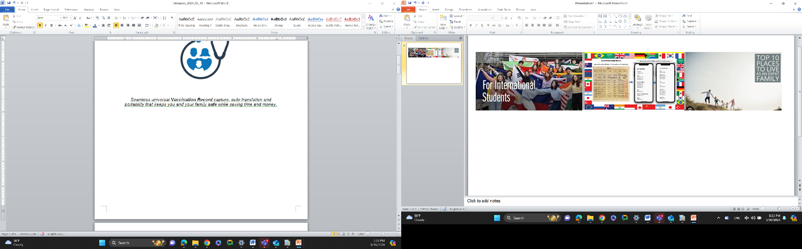

|  |  |  |  |
| --- | --- | --- | --- |
| Position | Openings | Description | Hours/  week |
| Jira Project Manager | 1 | Excellent organization and communication skills  Will keep projects and team on track  May take on responsibilities of other team members as needed  Familiar with Jira | 3-20 |
| Customer Discovery  Specialist | 5 | Conduct B2C, B2B, B2BC interviews  Fluent in other languages besides English a plus | 2-5 |
| Business Analysis | 2 | Customer base research report based on initial target consumer  Find suitable funding and networking opportunities and write up/refine pitch deck and business summaries as needed  Should have business and accounting experience or education  Fluent in other languages besides English a plus | 2-5 |
| iOS App Quality Analyst | 1-2 | Functionality Testing, Usability Testing, Compatibility testing on different apple products/devices, performance testing, security testing, Documentation and Communication | 2-5 |
| Android App Quality Analyst | 1-2 | Functionality Testing, Usability Testing, Compatibility testing on different Android products/devices, performance testing, security testing, Documentation and Communication | 2-5 |
| React Native Developer | 1 | **API Integration:** Integrate with back-end services and APIs, ensuring seamless communication between the app and server-side components.  **Cross-Platform Development:** Utilize React Native's cross-platform capabilities to write code once and deploy it to multiple platforms, such as iOS and Android.  **State Management:** Implement state management solutions, such as Redux or MobX, to manage the app's data and ensure consistent behaviour across different parts of the application.  **App Development:** Design, develop, and maintain mobile applications using the React Native framework and Node.js, ensuring high-quality code, performance, and user experience.  **IMP:** Familiar with **FHIR format** & fhir-json-client API and JSON. | 3-20 |
| Product Designer | 1 | UI/UX design enhancements for the Vaccine Genie app and website, prototype development and testing to actualize design concepts. Should be familiar with Figma design for both mobile and web interfaces, HTML and CSS. | 10-30 |
| Relational Database Designer | 1 | Create and maintain database structures to efficiently store and retrieve critical health data. Collaborate with developers and stakeholders to ensure seamless integration and scalability. Experience or education with creating database required | 2-10 |
| Machine Learning Engineers | 1 | Design and implement machine learning algorithms to enhance data analysis and predictive capabilities to provide users and partner with alerts and useful data | 2-10 |
| Large Language Model Architects | 1 | Develop and optimize natural language processing (NLP) algorithms to enable communication between users and the app. Shape the linguistic framework and ensure user-friendly interaction. Chatbot development experience a plus. | 2-10 |