Conscious Awareness

Step into change quiz

An Overview today
This will give you a view of your situation today. Just rate your satisfaction from 1-10.
1 being totally unsatisfied to 10 being total bliss.
Please don’t take too much time rating your satisfaction, just the first number that comes to you. You can always analyse it later. Your gut reaction is normally spot on.
1-10 SCALE 1……2………3.….……4.…....…5….…….6………7………8………9……10
Family life
Love life
Friends
Work/ Career
Environment/ where you live
Health
Fitness
Fun
Creativity
Religion/ Spirituality
Money
Free time
Community involvement
Other

Close up
List the 3 areas where you scored the lowest
.
.
.
List the 3 areas where you scored the highest.
.
.
.
Which path?
Please now answer these 2 questions1. What are the three main activities/ things that make up your week?
.
.
.

2.What are the three most important activities/ things in your life?
.
.
.
Conclusion
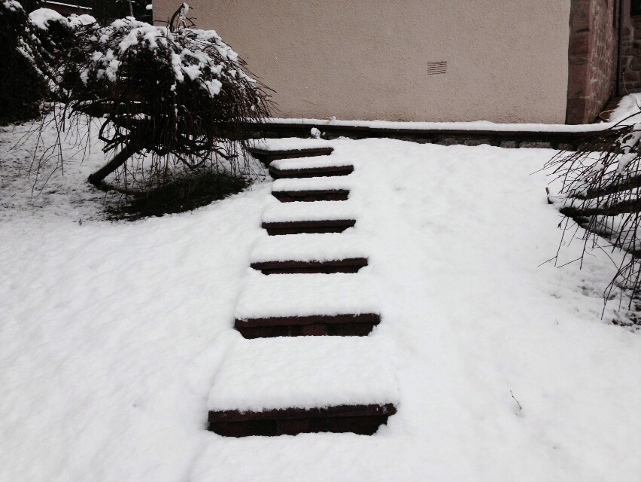
Next Steps?

Identifying 3 areas to start working on

What would you like to change?

What actions will you take?

REVISIT
In 3-6 months, you can revisit this questionnaire.
Do it without looking at your last answers and then see the difference.
Again, write down your new plan of action.

Feeling snowed under?
Book a call
If you fancy a chat to help you gain more clarity, or even how to implement the first steps. Click the below link to set up an appointment or send me an email.
Good luck and thanks
www.consciousawareness.co.uk

