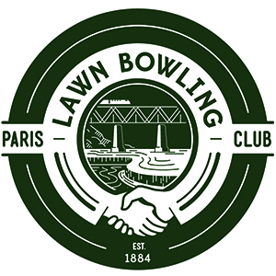
2019 PARIS LAWN BOWLING CLUB
NEW MEMBERSHIP APPLICATION/RENEWAL FORM

Membership cost for the 2019 Paris Lawn Bowling Club season $75.00
Price includes a mandatory association fee for the Ontario Lawn Bowls Association.

Please check one box below:

NEW Membership Application Membership Renewal

How to Complete Form & Submit Payment:

1) Complete and sign your form electronically. Return form by email, and submit a separate e-transfer payment of $75.00 via your online banking to <parislawnbowlingclub@gmail.com>

OR

2) Print out and complete the form, bring it in person to the club located at 169 Grand River Street North, Paris ON along with your $75 annual membership fee, payable either in cash or cheque.

Please make your cheque payable to Paris Lawn Bowling Club. Your cashed cheque will be your receipt.

Full Name:

Address:

City: | ON:

Telephone: | Cell:

Email Address:

Person to notify in case of emergency:

Name: | Telephone:

I hereby make application for membership in the Paris Lawn Bowling Club and agree to abide by the Club’s Constitution, By-laws, Rules & Regulations.

Signature:  S  (Please print if filing electronically) | Date:

PARIS LAWN BOWLING CLUB 169 GRAND RIVER STREET NORTH PARIS ON
PARISLAWNBOWLINGCLUB.CA

