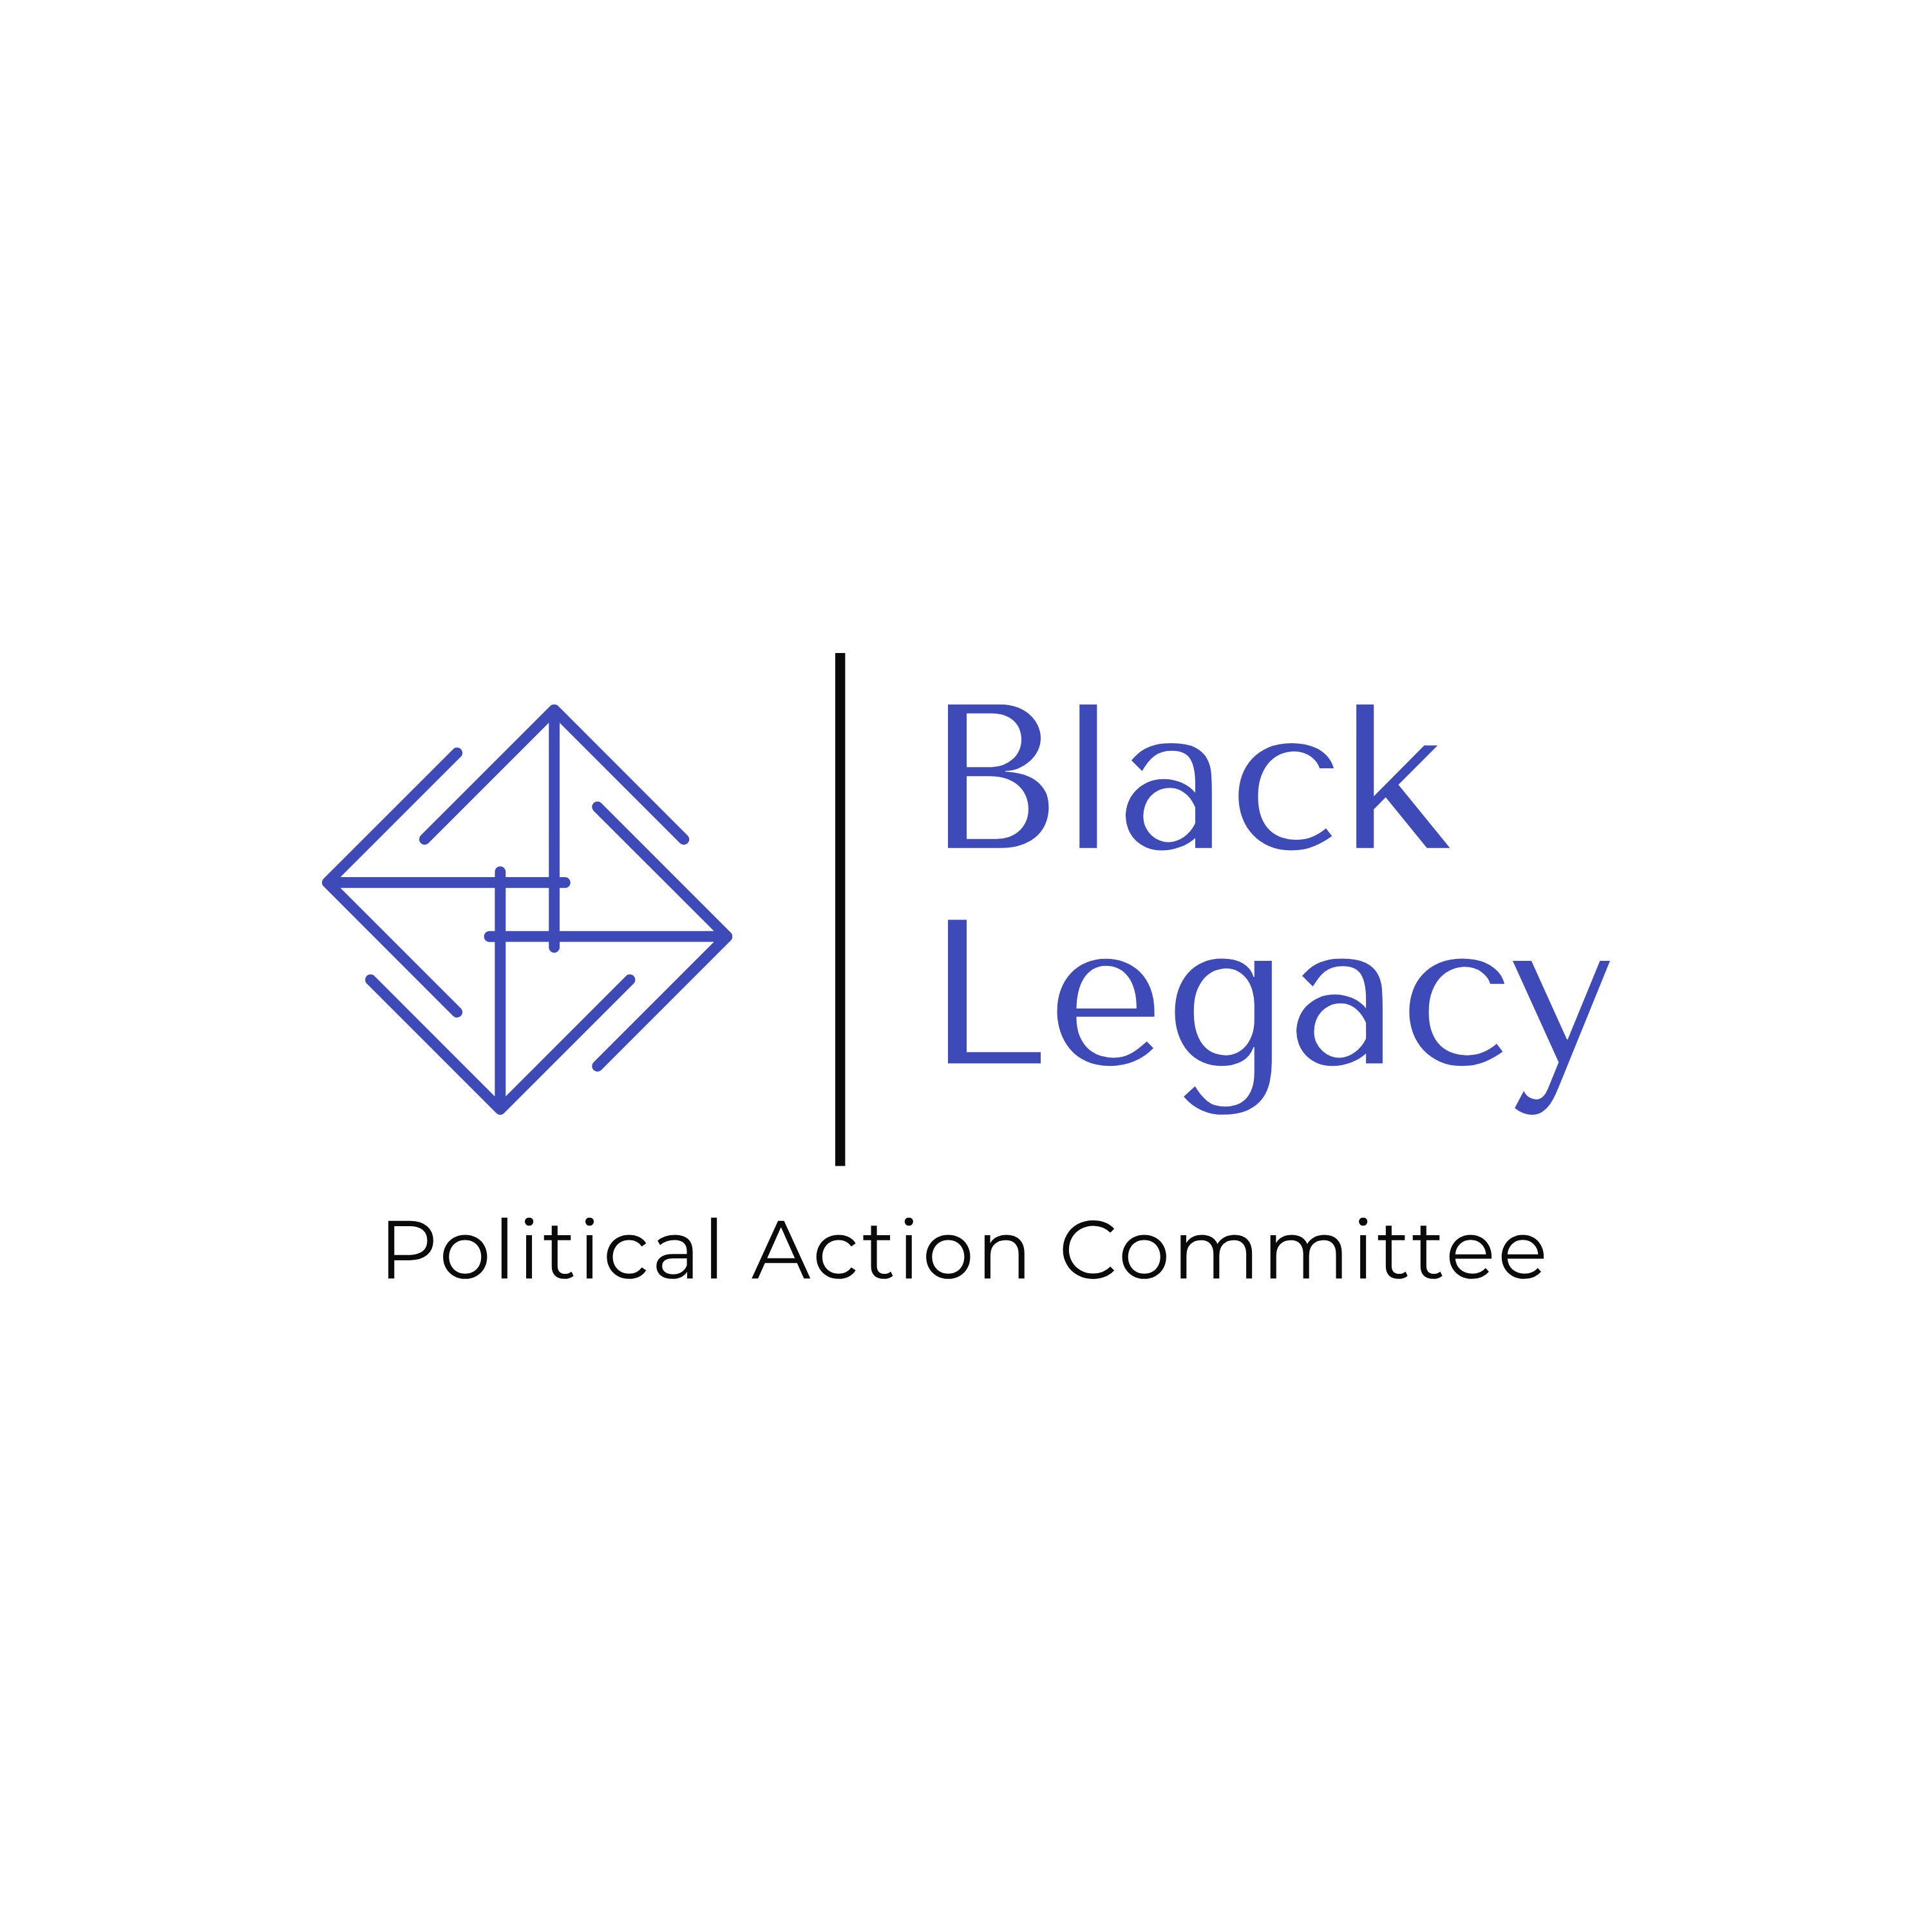

Please make checks payable to:

Black Legacy PAC
c/o Marva Diaz Strategies
1121 L St., Suite 602
Sacramento, CA 95814
FPPC ID# 1467230

State Election Law Requires The Following Information
*Optional

Name: ________________________________________________________

Company: _____________________________________________________

If the contributor is a limited liability company (LLC), please identify the individual primarily responsible for approving the contribution:

______________________________________________________________

Street Address: _________________________________________________

City/State/Zip: __________________________________________________

Phone*: ______________________________________ cell / work / home

Email* ________________________________________________________

Occupation: ___________________________________________________

Employer (or name of business, if self-employed): ______________________

Contributions to Black Legacy PAC are not tax deductible. Our committee may accept unlimited contributions from individuals, business entities, and political committees. Donors must use their own funds to make contributions and may not be reimbursed by their employer or any other person or entity. All individual contributors must be U.S. citizens or permanent residents.

For more information, please contact Marva Diaz (916) 712-8426 or MarvaDiaz@gmail.com.

