SSLA 2018 Annual Meeting and Conference

March 16 – 18, 2018

Mountain Lodge and Conference Center

42 McMurray Rd, Flat Rock, NC

828-693-9910

Once again we return to the mountains of North Carolina for a weekend of fun, education and creativity. Attached you will find some of the activities planned for this year. Whether you are coming to learn, create, be inspired or just relax and hang out with folks who share your interests we are looking forward to seeing you.

The Fiber Folks have come up with a new event for your finished product and a People’s Choice Award in each category.

The hiking fans will return to Rumbling Bald for a Hank Balch Memorial Pack Challenge.

Breakout Groups back the Lodge; decision making in the show ring both Performance and Showmanship. How are my show points calculated and how does SSLA Sweepstakes work. Camelid Health Care Concerns.

After Lunch we will all join back together for our afternoon speaker Dr. Lauren L Griffeth, Extension Leadership Specialist with the UGA Extension Division.

Our Annual Meeting will take place after the speaker and before the banquet. If you have any issues concerning the organization please email them to Mary Rose at mrc604@tampabay.rr.com prior to, therefore making sure they get added to the agenda.

Live Auction to benefit the Scholarship fund. If you wish to donate items to the Live Auction or the Raffle, which will be going on all weekend. Contact Nancy Miller-Borg at [alallama@aol.com](mailto:alallama@aol.com).

Keynote Speaker:

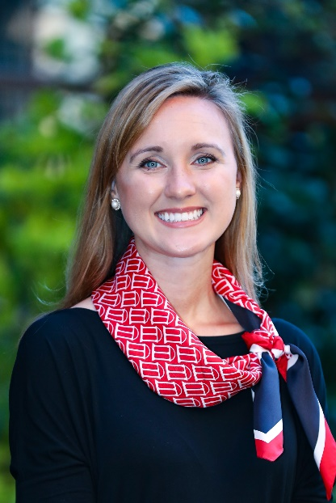Dr. Lauren Ledbetter Griffeth is an Extension Leadership Specialist in the College of Agricultural and Environmental Sciences and Warnell School of Forest Resources at the University of Georgia. Formerly, Griffeth was Director of Major and Planned Gifts at the Athens Regional Foundation and has held a variety of development roles for the Office of the Vice President of Instruction, UGA Foundation, and Georgia 4-H Foundation. She has contributed to raising over $7 million in private support for education and healthcare during her career.

As a faculty in the Department of Agricultural Leadership, Education and Communication, Griffeth’s research interests include: workplace learning, generational differences in the workplace, organizational development, and women’s leadership development. She is a triple dawg, obtaining a bachelors in agriculture, masters of education and a doctoral degree in adult education from the University of Georgia. She completed certificate programs in Human Resources and Organizational Development as well as Qualitative Studies.

Griffeth has logged over 300 hours of teaching and training, and currently provides leadership to the Advancing Georgia’s Leaders in Agriculture and Forestry Program, Extend and Extension Academy professional leadership programs. She also consults with private industry clients for leadership and organizational development. She has been published in the Harvard Business Review and is a columnist for the Pink Tractor Magazine.

She is certified in the: Myers-Briggs Type Indicator, Strenghtsfinder 2.0, Change Style Indicator, and the Thomas Kilman Conflict Style Indicator assessment.

Griffeth resides in Watkinsville with her husband Tim and their two children, Tanner (5) and Lillian (2).

Camelid Reproduction Health:

Dr. María Ferrer received her veterinary degree in 2000 from the University of Buenos Aires, Argentina. She earned her MS degree from Louisiana State University in 2005, and became a Diplomate of the American College of Theriogenologists in the same year. Dr. Ferrer started her career as a research fellow and then private practitioner in Argentina. Dr. Ferrer worked as a Clinical Assistant Professor (2006-2013) and Clinical Associate Professor (2013-2014) at Kansas State University, before accepting her current position as an Associate Professor in Theriogenology at the University of Georgia in 2014. Dr. Ferrer has a special interest in reproduction in South American Camelids. Her research in Argentina focused on follicular wave synchronization, superovulation and embryo transfer in llamas and semi-captive vicugnas. She was the coordinator of the Alpacas on Campus Program at Kansas State University in 2014, participated in several continuing education courses for alpaca owners and veterinarians, and continued her research on evaluation of fetal well-being and readiness for birth in alpacas.

Hank Balch Memorial Hike:

Returning to the same trails we hiked last year bring your llama or just come on the hike. This will be a PLTA Challenge Event should you wish to participate, if you are not a member of PLTA there is a $10.00 per person fee to enter. If you wish to register your llama with PLTA that will be an additional $10.00 but not necessary to participate.

We will be leaving the Lodge at 7:30 am to ensure we are back by Noon.

Rumbling Bald Trail

The Rumbling Bald Trail is a loop trail that meanders through a beautiful hardwood forest along the south face of Rumbling Bald Mountain, revealing huge boulder fields and the base of the cliff areas. The parking area for this trail is located off Boys Camp Road between Chimney Rock and Lake Lure. Once at the trailhead follow the orange trail blazes through the bouldering areas, past the cliff base, and back to the parking area.

**Trail Location:**

Rumbling Bald Access **Trail Length:**1.50 miles **Trail Type:**Round Trip

**Trail Difficulty:**Moderate **Trail Use:** Hiking **Trail Surface:**Natural surface Gravel **Trail Blaze:** orange circle

Fiber Room:

We will again, be offering the popular “Make and Take” activity for conference members to produce a fiber product during the SSLA Conference.  All supplies will be provided for a small fee, to cover presenter’s costs.  Join us Saturday morning 9-12 and make a finished product to take home.

We will also like to invite all SSLA members to bring or mail their own fiber creations to the conference for a “Show and Tell”.  What a great way for all members to see what you have created throughout the year.   The finished items must be primarily of camelid fiber (60/40) be woven, felted, hand spun, knitted or crocheted.   Please supply with the item on a 5x7 card: the details of materials used, what the article is or will be used for, and the time involved in producing the item.  Your efforts will not go unnoticed.  We will have a People’s Choice award in each division for the articles displayed during the conference.

Example of hours involved with creating a finished product.

The Value of a Navajo Rugs Activity:

3 feet by 5 feet handspun, vegetable dyed wool

Shearing (2 sheep) 2 hours,

Cleaning Wool 10 hours,

Carding Wool 50 hours.

Spinning the Wool: Floor rug, weft count 15-20 hours 90

Fine tapestry, weft count 20-40 hours 130

Extra Fine, weft count 40-60, hours count 160,

Very fine, weft count 60-90 hours 200,

Super fine, weft 90-120 hours 275.

Washing 8 hours.

Plant Gathering (5 Colors) 15 hours

Dyeing 40 hours,

Warping Loom 18 hours,

Weaving 160 hours.

Total hours involved Floor Rug, 393 hours,

Fine Tapestry, 433 hours.

Extra Fine Tapestry, 463 hours.

Questions?  Please respond to Tracy Weaver, [lotsallamas@earthlink.net](mailto:lotsallamas@earthlink.net) or 727-456-3578

Making Decisions in the Show Ring:

This is designed to help the handler best show there animal for the best possible outcome in Performance and Showmanship. Explanations on how you loss or gain points with every decision you make. Learn what the Judge sees and how they score. This will be presented by ALSA/ILR Judge and Handler Cathie Kindler and ALSA Judge and Masters Performance Handler Lauren Wright.

How Show Scoring Work, Calculating Placements and Sweepstakes Awards:

Presented by Show Superintendent and Clerk Cheryl Lambert, with Vicki Sundberg, SSLA Sweepstakes Chairperson. How are placements calculated and scored? How are ALSA placement different from ILR and SSLA Sweepstakes?

Making this easier to understand with visual and actual scenarios.

Camelid Health Care:

Stay tuned, work in progress will be announced shortly

Photo Contest:

Bring your favorite llama themed photographs. Members can view the Gallery of Photos and vote on their favorite. Top three photographs will be awarded prizes.

Looking forward to seeing you all there