2018 UT Camelid Farm Day

TO PARTICIPATE: Call UT at **(865) 974-8387** to register by the March 20 deadline. Let them know if you and any companions also need lunch.

EVERYTHING YOU NEED TO KNOW:

**Date:** Saturday, March 24, 2017

**Time:** 9:30 a.m. until about 4:00 p.m.

**Place:** UT Research/Teaching Farm - see attached map with location marked.

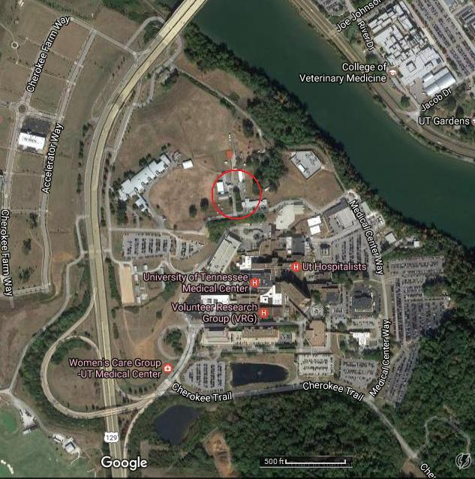**Directions:**Take the Cherokee Farm exit off of Hwy 129. Southbound on Alcoa Hwy, this is the first exit south of the Buck Karnes Bridge; turn right after exiting and go through the tunnel under the highway; continue to the T and turn left, go about a quarter mile; take the first left and you will see the facility on the left in about a quarter mile. Northbound on Alcoa Highway, the Cherokee Farm exit is the first exit after the UT Hospital exit; turn right at the T, go about 0.1 mile; take the first left and you will see the facility on the left in about a quarter mile.

**UT Large Animal Registration:** (865) 974-8387

**Registration Deadline:** Tuesday, March 20, 2016

**Organizing Veterinarian:** Ricardo Videla, DVM, MS, DACVIM

Regards, Susan *Susan Gawarecki  
Pathfinder Farm  
Andersonville, TN*