FRIDAY NIGHT SUNSET RIVER CRUISE (LIMIT 40)   
FEATURED SPEAKERS: ELIZABETH TAYLOR,

MARTY MCGEE BENNETT, BRENDA CRUM,

DEB & ULIN ANDREWS   
SSLA ANNUAL MEMBERSHIP MEETING   
AWARDS BANQUET & LIVE AUCTION  
RAFFLES   
SILENT AUCTION   
VENDOR MARKET

NETWORKING

MEMBERSHIP MEETING, & AWARDS BANQUET

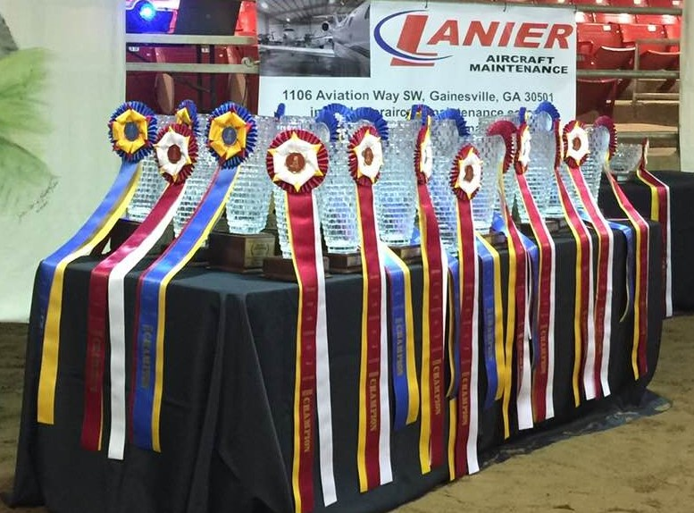

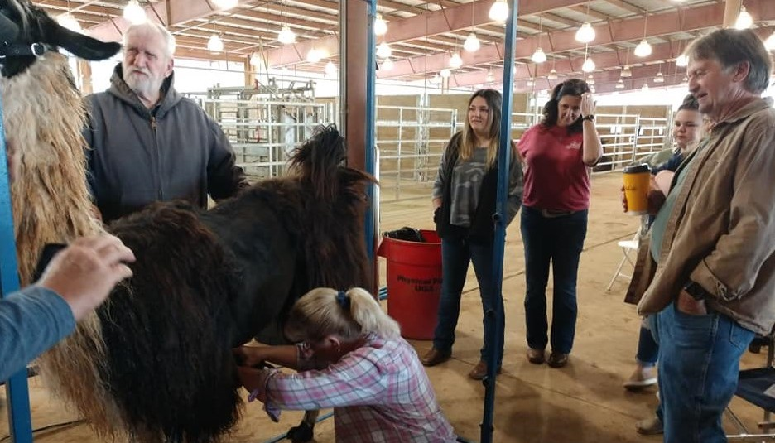

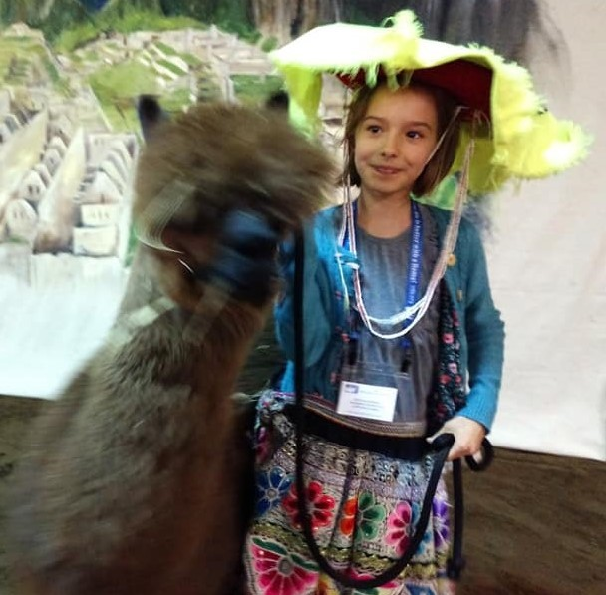

**HOTEL ON SITE: Make your own reservations**

at **800-632-6262** and refer to Booking Name Southern States Llama Association (SSLA). Call in block will be held until cutoff off date of Wednesday, February 17, 2021. Reservations received after this date will be on a rate and space available basis.

Thursday & Sunday Nights: $118

Friday & Saturday Nights: $143

Thursday & Sunday Nights $152 Friday & Saturday Nights: $177

Standard Hotel Rooms (King or Double)

Patio Water View

ANNUAL EDUCATIONAL CONFERENCE,

**Because l f i better with a llama**

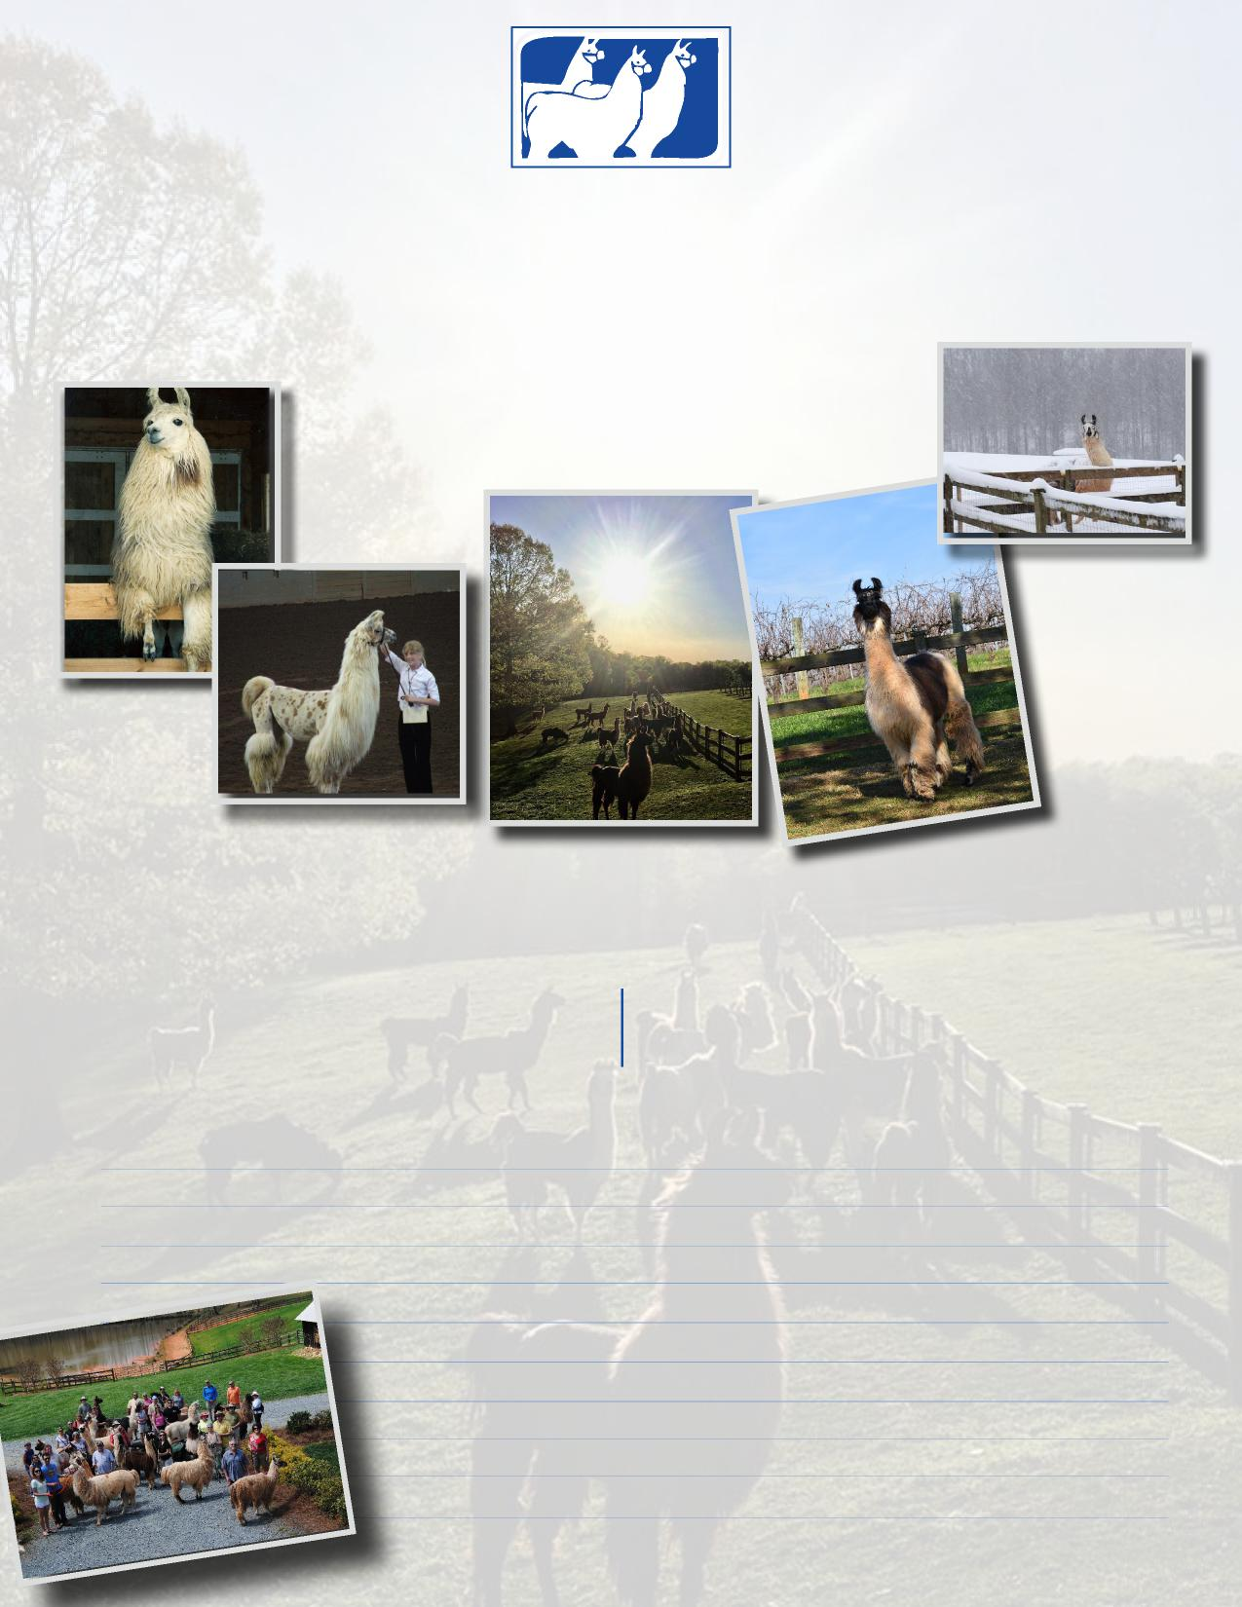

**SOUTHERN STATES LLAMA ASSOCIATION’S**

**Plantation on Crystal River**

9301 West Fort Island Trail, Crystal River, FL, 34429

MARCH 19-21, 2021

**Because life is better with a llama!**

**SOUTHERN STATES LLAMA ASSOCIATION’S**

**Annual Conference, Membership Meeting & Awards Banquet**

***Plantation on Crystal River***

9301 West Fort Island Trail, Crystal River, FL 34429

10-20-20

**CONFERENCE HIGHLIGHTS**

FRIDAY NIGHT SUNSET RIVER CRUISE (LIMIT 40)   
FEATURED SPEAKERS: ELIZABETH TAYLOR,

MARTY MCGEE BENNETT, BRENDA CRUM,

DEB & ULIN ANDREWS   
SSLA ANNUAL MEMBERSHIP MEETING   
AWARDS BANQUET & LIVE AUCTION  
RAFFLES   
SILENT AUCTION   
VENDOR MARKET

NETWORKING



**SPONSORSHIP AND ADVERTISING PACKAGES**

SSLA is seeking Conference Level sponsors and print advertisers for the upcoming event. Please consider promoting your farm, products, service or store. This conference will be at Plantation on Crystal River Florida. In recognition that Crystal River coastal waters are home to the largest population of **manatees** on the west coast of Florida, the conference packages are given Florida Endangered or Threatened Species names. Note: the sponsorship is for the SSLA Conference not any endangered species organization.

need sponsors for this conference.

**No outside food can be served for group activities. SSLA contract includes Saturday continental breakfast, break snacks, Saturday evening banquet and Sunday morning breakfast. Friday evening meal and all lunches are individual’s responsibility. The resort has in-house West 82 Bar & Grill and Tiki Bar.**

Kim Kyst

678-481-3759 kim@kyst.org kkyst@eminc.biz

Mary Rose Collins

352-726-1104mrc604@tampabay.rr.com

Tracy Weaver

727-457-3578lotsallamas@earthlink.net

Vicki Sundberg

910-269-1422homesweethome_3@yahoo.com

YOUR 2021 CONFERENCE PLANNING TEAM

**March 19 - 21, 2021**

Thank you so much for your continued support of our organization and program. We look forward to seeing you at the conference.

**SOUTHERN STATES LLAMA ASSOCIATION’S**

**Because life is better with a llama!**

**Annual Conference Presenter Line-Up**

Deb & Ulin Andrews: Log Cabin Llamas. This renown national llama show team will continue their grooming demonstration from the 2020 Conference: **Show Grooming Part II**

Brenda Crum: Golden Spirit Alpacas. Brenda will focus her talks on the Business aspect and Nutrition of camelids.

“When we purchased alpaca, we invested in a long-term opportunity to raise livestock that keeps on giving. We strive to preserve the health of our animals with a continual focus on quality to protect that investment. We know our animals, study them, monitor them and of course, enjoy them.”

Elizabeth Taylor: Spotted Circus Alpacas and Llamas. Fiber Room Activities. Choices of topics she has available are (We will need to refine to fit time available):

* Soap Felting
* needle felting toys
* drop spindling
* carding fiber
* dyeing demos
* washing demo
* How to setup PayPal, Etsy and Ravelry so that at the end of the weekend the participant will have a live online presence.  We will go through taking photographs and creating listings on Etsy and how to price your items.  We will then cover where to tell the world about your products so that they can then buy them from you.  This class requires a strong Wi-Fi connection point and for people to have an iPad or computer.  Depending on the number and skill level of the participants this can be a one day or two-day class

Marty McGee Bennett: Multiple Specific Sessions, Banquet Speaker Entertainment. Choices of topics she has available are (We will need to refine to fit time available):

* The Science of Behavior… Why your llama or alpaca won’t do what you want and how you can change it without fear or force.  Classroom 1hour
* Why is it that how your Catch your Camelid is the SINGLE most important influence on how cooperative he/she will be about having his toenails trimmed. Classroom and demo/hands on 1-1.5 hours
* Leading with Refinement… Learning neutral contact and re-balancing signals you can use to truly communicate with your hands using a lead rope. Demonstration and hands on 1 hour
* Solving Haltering Issues- The incredible importance of halter fit. Using the TTouch to teach your camelid to enjoy having his head and mouth touched. Talk and demo with hands on.  1-1.5 hours
* Using your body position and an escape route to give injections without fear or force. Demo 30-45 min
* Banquet Presentation: 40 years of Life on the Road… Hey is that a penguin on your head? Talk with Slides 20 min

