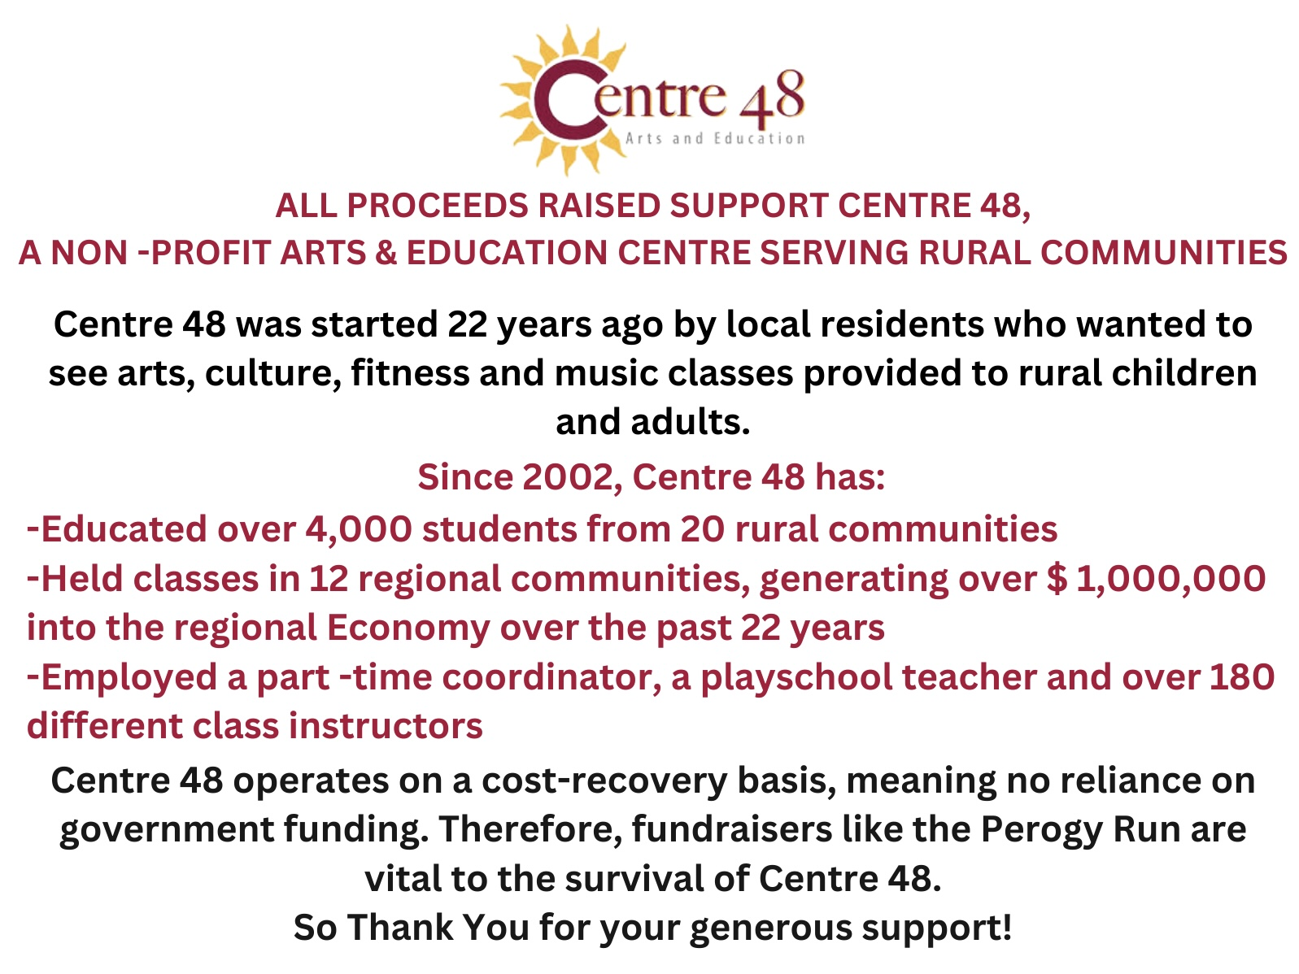

Email completed forms to [centre48.southsask@gmail.com](mailto:centre48.southsask@gmail.com)

Payment can be transferred to the same email or chq’s can be mailed to

Centre 48 Box 457 Montmartre, Sk. S0G 3M0

Registration Form- Please Register by May 22, 2025

19yrs + $60**** 6-18yrs $30 **** 5 & under Free

Name: __________________________________________________

Mailing Address: __________________________________________

Home #:__________________________________________________

Email: ____________________________________________________

Age: ____________ Entry Fee Included: _____________________



Saturday May 24, 2025 @ 10 a.m- 213 1st Ave E, Montmartre, Sk.

*Snacks & Coffee at 9:00 a.m. *Scenic rural route *Homemade Perogy Lunch

* Join us for this family friendly run around our beautiful town of Montmartre & Kemoca Park. To register: www.runningroom.com or (306)424 -7048

5K/10K Walk or Run 1KM Kids Fun Run

21st Annual Perogy Run Saturday, May 24, 2025 - 10 a.m.

PLEDGE SHEET - RUN/WALK - 1K/5K/10K

**Name:**  **Amount Pledged:**

|  |  |
| --- | --- |
|  |  |
|  |  |
|  |  |
|  |  |
|  |  |
|  |  |