Kitchen  Breakfast Sandwich 9.00  Eggs*, cheese, bacon, chipotle aioli: toast, croissant or wrap  Avocado Toast 9.75  Avocado, jalapeno tomato jelly, garlic puree on our house toast, dressed greens  The Continental 11.50  House toast with homemade jam and butter, poached egg or scramble*, bacon or sausage, dressed greens  Frittata (Changes Daily) 9.50  Baked eggs with potatoes, cheese. Like quiche without a crust. Comes with toast or salad  Breakfast Tacos 7.00  Eggs*, cheese, bacon, lettuce, spicy pickled pepper honey onions  Salmon Toast 11.25  Eggs*, lox*, dill sauce, greens, capers, red onion, house toast or wrap  No Carb Blast 12.50  Two eggs* poached or scrambled, bacon, spicy sausage and blue cheese, bed of greens  House Toast 5.00  House toast with homemade jam and butter  Farro Bowl 10.25  Organic farro, poached egg*, bacon, sautéed grape tomato & onion, pesto, mascarpone, toast  Additions  Bacon 3 Spicy Sausage 3 Avocado 3 Poached Egg 2.5  Scramble 2.5 Cured Salmon 4 Extra Toast 2 Dressed Greens 3  Kitchen closes at 2:00  *Consuming raw or undercooked fish or eggs may increase your risk of foodborne illness | Espresso Drinks  Latte 5.00 5.75 6.50  Espresso, milk  Mocha 5.50 6.25 7.00  Dark chocolate, espresso, milk  Vanilla Latte 5.50 6.25 7.00  House made vanilla syrup, espresso, milk  Caramel Latte 5.50 6.25 7.00  Caramel sauce, espresso, milk  Caramel Macchiato 5.75 6.50 7.25  Espresso, vanilla, milk, caramel drizzle  Americano 3.00 3.75 4.50  2, 3 or 4 shots with water  Cappuccino 5.00 5.75 6.50  Espresso, milk, lots of foam  Espresso 2.75 3.00 3.75  Single, double, triple  Brewed Coffee  French Press 2.75 3.00 3.25  All French pressed - .50 refills  Cold Brew 4.50 5.00 5.50  Lots of caffeine and smooth  Iced French Press 2.75 2.95 3.25  Chilled French press over ice | Signature Drinks  Rose Vanilla Latte 5.75 6.50 7.25  Rosem, vanilla syrup, milk  Honey Vanilla Latte 5.75 6.50 7.25  Honey, vanilla syrup, milk  Aztec Mocha 5.75 6.50 7.25  Cinnamon, dark chocolate, milk  Coco Mocha 5.75 6.50 7.25  Coconut syrup, dark chocolate, milk  Small & Strong  Classic (before they even thought of flat white) 4.25  Perfect café drink! Better than a flat white  8oz double shot latte – hot only  Mocha Europa (they haven’t thought of it yet) 4.75  Think chocolate Cortado!  8oz double shot mocha – hot only  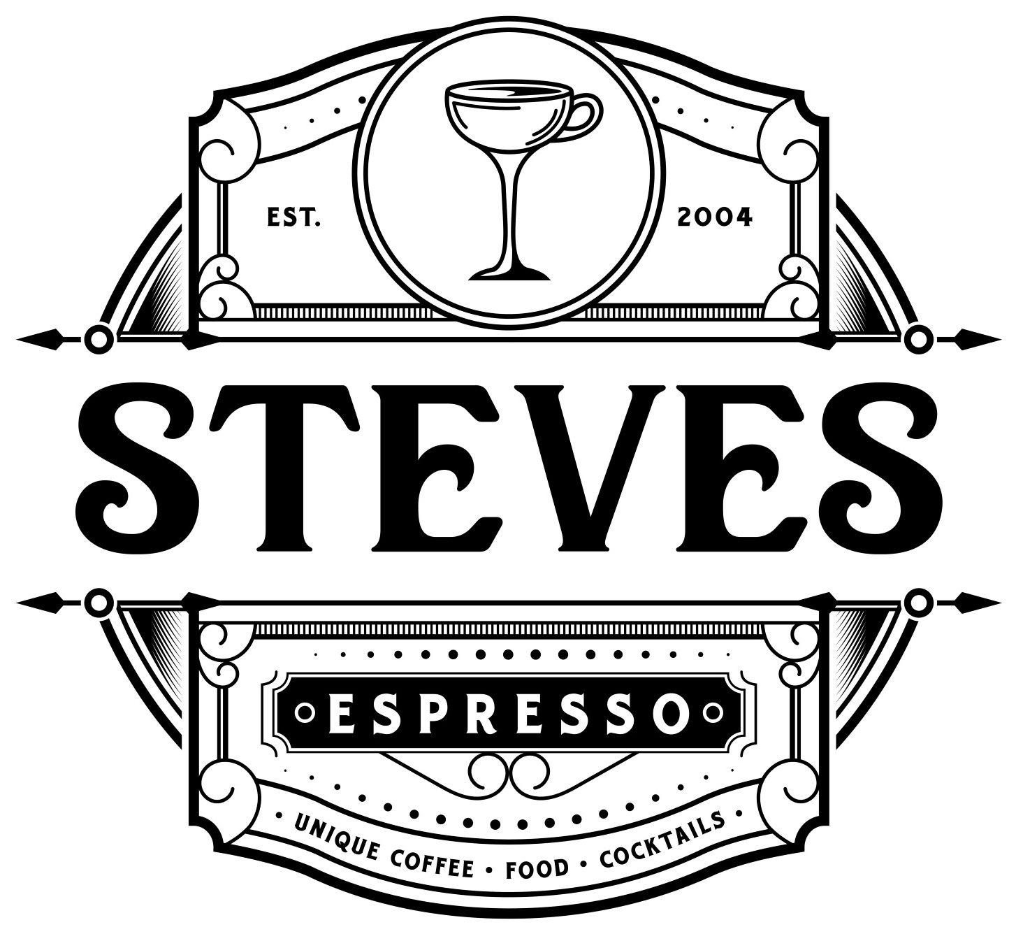  Extras  Alternative Milk +50  Shot +75 Flavor +75 Breve +75 | Non Coffee  Lemonade 3.50 4.00 4.50  House-made with cane sugar and real lemon  Arnold Palmer 3.50 4.00 4.50  Black or green iced tea with house made lemonade  Custom Iced Tea 4.25  Any of our loose-leaf teas iced 24 oz  Italian Soda 3.50 4.00 4.50  Flavored pure cane syrup, soda water and cream  Hot Chocolate 3.50 4.00 4.50  House-made sauce with steamed milk  Hot Tea 4.25  Choose from our large selection of premium teas  Chai and Tea Lattes  Chai Latte 5.00 6.00 7.00  House-made chai  Monster Matcha 5.25 6.25 7.25  House-made, slightly sweetened  Lavender Chai 5.00 6.00 7.00  House-made chai  London Fog Latte 5.00 6.00 7.00  House-made Earl Grey vanilla syrup

