

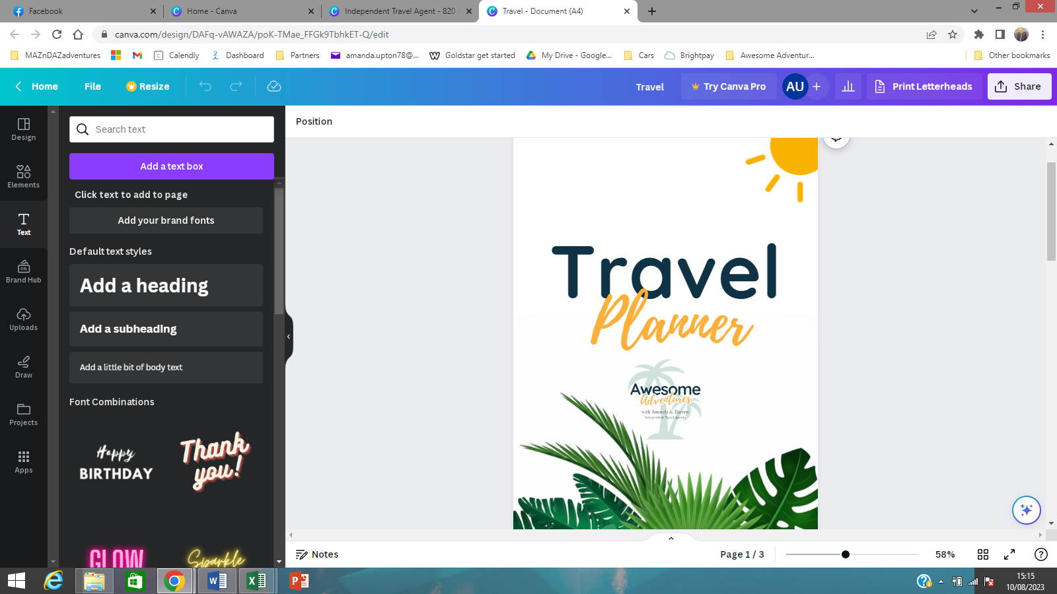





If found, please return to:

[Enter details here]

How to use this planner

*All text is editable so you can edit the headings to suit your requirements and then print your planner to fill out with your travel party, partner or children.*

The first section is stage 1 of planning your trip and getting all your ideas down on paper. A great opportunity to get everyone involved with the planning.

Once your trip has been booked, the second section is to create a daily calendar of your plans.

The third section is the all-important checklists to keep you organised.

The final section is an opportunity for you to journal each day of your trip.

Contents

Planning & Options

Dates

Destinations

Accommodation

Transport

Restaurants / Cafes

Budget

Itinerary

Daily Calendar

Checklists

Packing

To-Do

Day of Departure

Emergency Contacts

Making Memories

Daily Journal



Where do we want to stay:

Where do we want to go:

Available dates to travel:

Planning & Options

How are we getting there:



How much do we want to spend:

Where do we want to eat:



Day 2 – Evening

Dinner:

Activities:

Day 2 – Afternoon

Lunch:

Activities:

Day 2 – [date] - Morning

Breakfast:

Activities:

Day 1 – Evening

Dinner:

Activities:

Day 1 – Afternoon

Lunch:

Activities:

Day 1 – [date] - Morning

Breakfast:

Activities:

Itinerary



Day 4 – Evening

Dinner:

Activities:

Day 4 – Afternoon

Lunch:

Activities:

Day 4 – [date] - Morning

Breakfast:

Activities:

Day 3 – Evening

Dinner:

Activities:

Day 3 – Afternoon

Lunch:

Activities:

Day 3 – [date] - Morning

Breakfast:

Activities:



Day 6 – Evening

Dinner:

Activities:

Day 6 – Afternoon

Lunch:

Activities:

Day 6 – [date] - Morning

Breakfast:

Activities:

Day 5 – Evening

Dinner:

Activities:

Day 5 – Afternoon

Lunch:

Activities:

Day 5 – [date] - Morning

Breakfast:

Activities:



Day 7 – Evening

Dinner:

Activities:

Day 7 – Afternoon

Lunch:

Activities:

Day 7 – [date] - Morning

Breakfast:

Activities:



Packing List

Checklists

|  |  |  |  |
| --- | --- | --- | --- |
| **ITEM** | **PACKED** | **ITEM** | **PACKED** |
|  |  |  |  |
|  |  |  |  |
|  |  |  |  |
|  |  |  |  |
|  |  |  |  |
|  |  |  |  |
|  |  |  |  |
|  |  |  |  |
|  |  |  |  |
|  |  |  |  |
|  |  |  |  |
|  |  |  |  |
|  |  |  |  |
|  |  |  |  |
|  |  |  |  |
|  |  |  |  |
|  |  |  |  |
|  |  |  |  |
|  |  |  |  |
|  |  |  |  |
|  |  |  |  |
|  |  |  |  |

To -Do

|  |  |  |  |
| --- | --- | --- | --- |
| **TASK** | **DONE** | **TASK** | **DONE** |
|  |  |  |  |
|  |  |  |  |
|  |  |  |  |
|  |  |  |  |
|  |  |  |  |
|  |  |  |  |
|  |  |  |  |
|  |  |  |  |
|  |  |  |  |
|  |  |  |  |
|  |  |  |  |
|  |  |  |  |
|  |  |  |  |
|  |  |  |  |
|  |  |  |  |
|  |  |  |  |

Day of Departure

|  |  |
| --- | --- |
| **TASK** | **DONE** |
|  |  |
|  |  |
|  |  |
|  |  |
|  |  |
|  |  |
|  |  |
|  |  |
|  |  |
|  |  |
|  |  |
|  |  |
|  |  |
|  |  |
|  |  |
|  |  |



Emergency Contacts

|  |  |  |  |
| --- | --- | --- | --- |
| **NAME** | **RELATIONSHIP / COMPANY** | **TEL No** | **EMAIL / REF No’s** |
|  |  |  |  |
|  |  |  |  |
|  |  |  |  |
|  |  |  |  |
|  |  |  |  |
|  |  |  |  |
|  |  |  |  |
|  |  |  |  |
|  |  |  |  |
|  |  |  |  |
|  |  |  |  |
|  |  |  |  |
|  |  |  |  |
|  |  |  |  |
|  |  |  |  |
|  |  |  |  |



**Date:**

Making Memories

Daily Journal

**Today’s Adventures**



**Today’s Best Bits**

**Today’s Weather**



**Date:**

Making Memories

Daily Journal



**Today’s Adventures**



**Today’s Best Bits**

**Today’s Weather**



**Date:**

Making Memories

Daily Journal

**Today’s Adventures**



**Today’s Best Bits**

**Today’s Weather**



**Date:**

Making Memories

Daily Journal



**Today’s Adventures**



**Today’s Best Bits**



**Today’s Weather**



**Date:**

Making Memories

Daily Journal

**Today’s Adventures**



**Today’s Best Bits**



**Today’s Weather**

**Date:**

Making Memories

Daily Journal

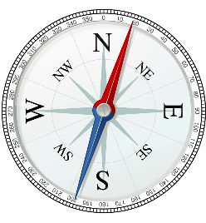

**Today’s Adventures**



**Today’s Best Bits**



**Today’s Weather**

**Date:**

Making Memories

Daily Journal

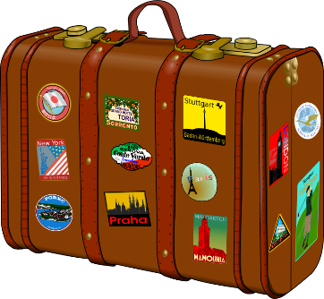

**Today’s Adventures**



**Today’s Best Bits**



**Today’s Weather**



We hope you have an awesome adventure!

[**www.awesome-adventures.co.uk**](http://www.awesome-adventures.co.uk)

[**enquiries@awesome-adventures.co.uk**](mailto:enquiries@awesome-adventures.co.uk)