* Establish at least one designated health check station to which each employee must report at the start of the workday
* Designate at least one employee to administer daily verbal checks at the health check station
* Per CDC recommendations, maintain a 6 feet distance between the employees being screened and the health check administrator

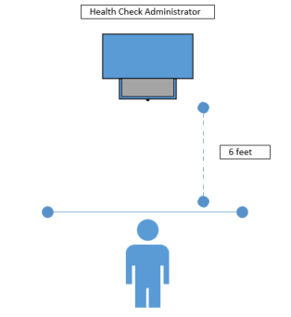

* Please notify all employees as to the location of the health check station(s) and require them to check in daily.
* Administrators are to perform the health screen per Alta’s *COVID-19 Employee Health Screening Policy*