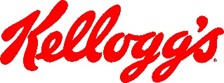

March 23, 2020

To: Federal, state or local law enforcement and public health and safety officials

From: Kellogg Company

**Re: Request for ongoing supplier operations and passage of supplier’s** **employees** **performing essential Food and Agriculture activities**

Please be informed that the bearer of this letter is a critical supplier of goods and services to the Kellogg Company (“Kellogg”). Kellogg manufactures food products that are consumed daily in homes and businesses around the globe. Without the production and distribution of these products, we risk seeing widespread shortages of food in a variety of different markets.

In fact, a variety of governments around the globe have declared food supply to be especially critical during the COVID-19 pandemic.

Specifically in the United States, the Department of Homeland Security has identified the food and agriculture industries among 16 critical infrastructure industries that should continue responsible operations during these coronavirus containment efforts.

The individual in possession of this letter is a business-critical Kellogg supplier and is essential to our continuing food production and associated supply chain operations, including transportation, warehousing services, maintenance, provision of services, and other minimum basic operations.

Please do not hesitate to contact Kellogg’s should you have any questions regarding this letter or our food production operations.

Sincerely,

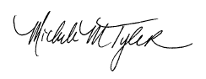

Michele M. Tyler

Chief Procurement Officer

[Shelly.vantreeck@kellogg.com](mailto:Shelly.vantreeck@kellogg.com)

Ph: 269-961-3634