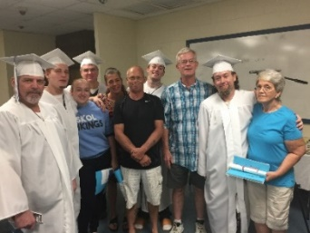 Metro Chaplaincy Program

- Established by in 2002
- Chaplaincy complex in Metro Jail includes a chapel & classroom for inmates
- Chaplain and staff administrator responsible for coordinating pastoral, religious and educational services
- Funding and volunteer support provided by area congregations
- Pre-release services include GED classes by Goodwill Easterseals, Celebrate Recovery and Fatherhood Initiative.

Congregational Support

3 Circle Church | Dawes Community Church | Orchard Assembly of God
Antioch Baptist Church | Divine Unity Outreach Center | Our Savior Catholic Church
Cathedral of the Immaculate Conception | First Baptist Church of Mobile | Peace and Goodwill PB Church
Catholic Archdiocese of Mobile | Holy Family Catholic Church | People of Mars Hill Ministries
Cedar Park Baptist Church | Homebase Christian Ministries | Revelation Missionary Baptist Church
Center Point Assembly of God | Jehovah's Witness Kingdom Hall | Right Way Christian Center Church
Christ the King Catholic Church | Life Church Mobile | St. Dominic Catholic Church
Christ United Methodist Church | Lilly Baptist Church | St. Joseph Catholic Church
Christ Church Cathedral | Luke 4:18 Fellowship | St. Pius X Catholic Church
Church of The Little Flower | Midway Missionary Baptist Church | Walk by Faith Christian Ministries
City of Refuge for Men | Mission of Hope | Way of Life Community Church
Cottage Hill Baptist Church | Mobile Masjid of A-Islam | Wesley Chapel United Methodist Church
Crimson Cross Ministries | Mobile Terrace Christian Center | Wings of Life
Dauphin Way United Methodist Church | Newness of Life Outreach Center | Word of Life Community Church

2018 Report

Trained Volunteers 367

Attendance, Religious Services 14,334 males 3692 Females Baptisms 23

Attendance, Fatherhood Initiative Classes 238 males 199 females

Attendance, Celebrate Recovery 234 males 261 females

GED* students 158 males 128 females 2018 Graduates 22 To Date 214
* General Educational Development/High School Equivalency Diploma
Certified instruction and testing by Goodwill Easterseals of the Gulf Coast

For more information: www.mobileinterfaith.org maic.quest@gmail.com 251.308.8725

