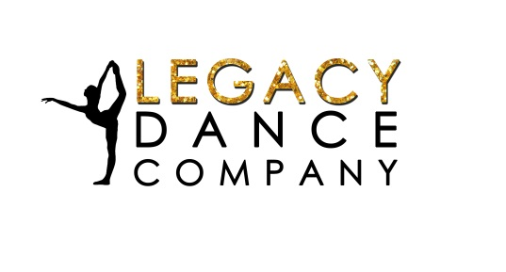**2019 – 2020**

**Revised 5/15/2019**

**Timeline of Events (Tentative)**

**May 2019**

Start Collecting Sponsorships ASAP

Peperoni Fundraiser- Money due by June 9th

Group 1: Dillon’s Grill Fundraiser TBD 4:45pm-7pm

**June 2019 ($400)**

Krispy Kreme Fundraiser May 27th- June 9th; Delivery June 13th

31 Bags by Suzette- June 10th- June 24th (2 weeks for delivery)

Team Slumber Party at LDC Friday June 7th at 6:30

Car Wash/ Can Drive Fundraiser at Les Schwab Saturday June 8th @ 8:30 (Pre-sell Tickets starting June 2nd)

Showcase Recital June 9th – Fundraising Opportunities (Flowers and Raffle Baskets)

Western Days/ Parade/ Glitter Tattoos Friday and Saturday June 28th and 29th

**July 2019 ($400)**

Stayton Highlights Dance Camp July 19th, 20th and 21st (Free Performance July 21st @3:00pm)

Master Classes:

Acro Camp July 9th and 11th

Friday July 12th Jazz

**August 2019 ($400)**

All sponsors due by August 1st (Must submit LOGO)

Master Classes:

Friday August 2nd Ballet

Saturday August 3rd Hip Hop

Dancing and Glitter Tattoos at Fair Aug 7th- 10th

Daily Doubles Aug. 19th, 20th, 21st and 22nd (AM: 7-8 at Ochoco Creek Park, PM: 3-6 at gym)

Car Wash/ Can Drive Fundraiser- Aug. 24th at Les Schwab @ 8:30 (Pre-sell Tickets starting Aug 10st)

Fan Gear Fundraiser starting Aug. 31st- Oct. 1st

**September 2019 ($400)**

Classes Begin Sept. 9th

Friday Practice Starts Sep. 13th 3:30-5:30

Group 2: Dillon’s Grill Fundraiser TBD 4:45pm-7pm

Krispy Kreme Fundraiser Sep. 9th- 23rd; Delivery Sep. 26th

**October 2019 ($400)**

All Company Fees Due by Oct. 1st

Team Slumber Party at LDC Friday Oct. 18th at 6:30

**November 2019**

Christmas Light Parade- Sat. Nov. 23rd Set up 8:30

**December 2019**

Holiday Showcase Sat. Dec. TBD Rehearsal @8 Showtimes @ 1:00 and 6:00

West Coast Elite Competition Milwaukie HS December 14th (MAYBE) (ALL TEAM)

**January 2019**

Dancesation Competition at Milwaukie HS January TBD (GROUP ONLY)

Extreme Dance Competition Date and Location TBD (ALL TEAM)

**February 2020**

West Linn Jr Competition at West Linn HS Feb. TBD (GROUP ONLY)

Rex Putnam Jr. Dance Competition Feb. 29th Location TBD (ALL TEAM)

**March 2020**

Valley Starlight’s Competition at Santiam HS March 7th (GROUP ONLY)

Legacy Dance Company Elite Jr. Competition at CCHS March 14th (ALL TEAM)

**April 2020**

Oregon Junior Dance Team Championships April TBA (Location TBD) (GROUP ONLY)

Act 1 Talent (SOLOS/DUET/ TRIO ONLY)

End of the Year Awards/Exhibition April (Exact Date, Time and Location TBD)

**\*\*\*Stay tuned for a few summer senior practices to learn choreography\*\*\***