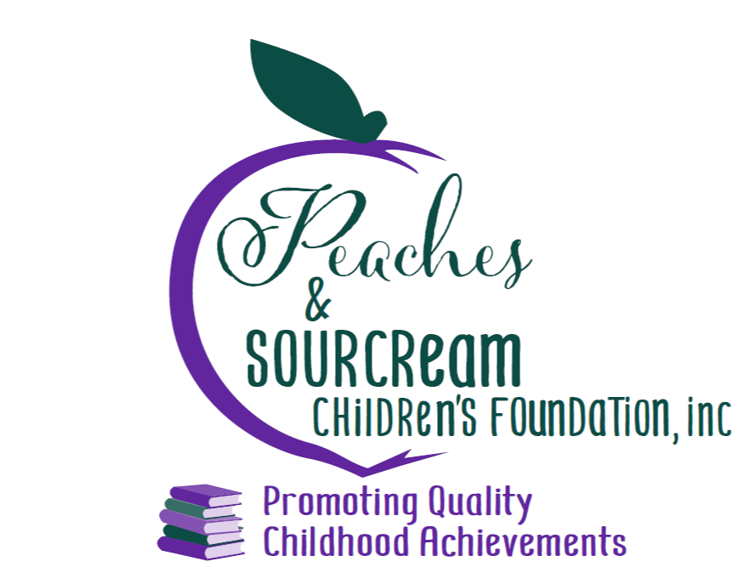
Peaches and Sourcream Children’s Foundation
Online Summer Reading Rewards Program 2021

- The Invisible Boy by Trudy Ludwig ( 40 pages)
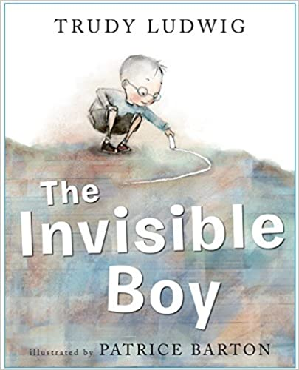

Meet Brian, the invisible boy.
Nobody in class ever seems to notice him or think to include him
in their group, game, or birthday party . . . until, that is, a new kid
comes to class. When Justin, the new boy, arrives, Brian is the
first to make him feel welcome, and when Brian and Justin team
up to work on a class project together, Brian finds a way to shine.

- The Most Magnificent Thing by Ashley Spires ( 32 pages)
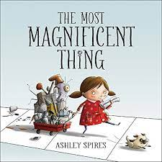

A little girl and her canine assistant set out to make the most
magnificent thing. But after much hard work, the end result is
not what the girl had in mind. Frustrated, she quits. Her assistant
suggests a long walk, and as they walk,
it slowly becomes clear what the girl needs to do to succeed.

- The Stinky Cheese Man : And Other Fairly Stupid Tales by Jon Scieszka (56 pages)
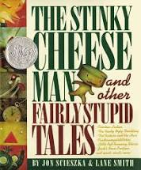

The star of the book is Jack, Jack and the Beanstalk
who tells the stories and deals with the rest of the cast.
There is a very loud and annoying Little Red Hen that
comes in to complain about no one helping her make
her bread (or do anything). Chicken Little believes that
the sky is falling and demands that someone call the
President until the table of contents crushes her and the others.

4. The Bad Seed by John Jory ( 40 pages)
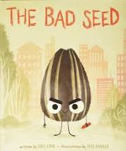

A bad seed gleefully tells us how very very
Bad he is, all the mean things he has done.
Then he explains that he wasn't always bad
and what changed him, and about the loving
extended family he once had until the sunflower
he called home was harvested and his huge family
was scattered to the winds literally.

- Pete the Cat I love My White Shoes by Eric Litwin & James Dean (40 pages)
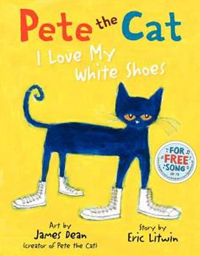

Don't miss the first and bestselling book in the beloved Pete the Cat series
Pete the Cat goes walking down the street wearing his brand-new white shoes.
Along the way, his shoes change from white to red to blue to brown to WET
as he steps in piles of strawberries, blueberries, and other big messes
But no matter what color his shoes are, Pete keeps movin' and groovin'
and singing his song...because it's all good. Pete the Cat: I Love My White Shoes.

5a. Pete the Cat Rocking in My School Shoes
5b. Pete the Cat and His Four Groovy Buttons
5c. Pete the Cat and His Magic Sunglasses
5d. Pete the Cat and the New Guy
5e. Pete the Cat and the Bedtime Blues
5f. Pete the Cat and the Missing Cupcakes
5g. Pete the Cat and the Cool Cat Boogie
5h. Pete the Cat and the Supercool Science Fair

- The Word Collector by Peter H. Reynolds ( 40 pages)
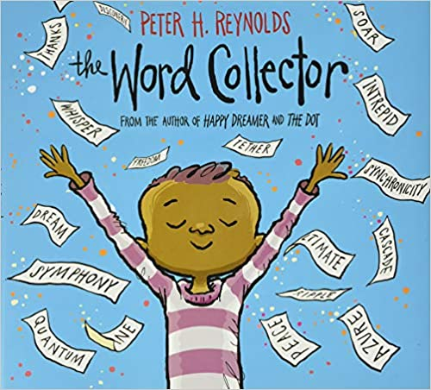

Some people collect stamps. Some people collect coins.
Some people collect art. And Jerome? Jerome collected
words . . . In this extraordinary new tale from Peter H. Reynolds,
Jerome discovers the magic of the words all around him
-- short and sweet words, two-syllable treats, and multisyllable words
that sound like little songs. Words that connect, transform, and empower.

- Counting on Katherine: How Katherine Johnson Saved Apollo 13 by Helaine Becker ( 40 pages)
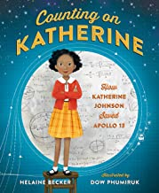

The bold story of Katherine Johnson, an African-American mathematician
who worked for NASA during the space race and was depicted in the film Hidden Figures.
You've likely heard of the historic Apollo 13 moon landing. But do you know about the
mathematical genius who made sure that Apollo 13 returned safely home? As a child,
Katherine Johnson loved to count. She counted the steps on the road, the number of dishes
and spoons she washed in the kitchen sink, everything! Boundless, curious, and excited by
calculations, young Katherine longed to know as much as she could about math, about the universe.
From Katherine's early beginnings as a gifted student to her heroic accomplishments as a prominent
mathematician at NASA, Counting on Katherine is the story of a groundbreaking American woman
who not only calculated the course of moon landings but, in turn,
saved lives and made enormous contributions to history.

- Only One You by Linda Kranz. (32 pages)
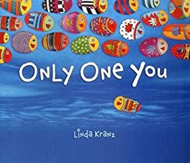

There's only one you in this great big world. Make it a better place. Adri's mama and
papa share some of the wisdom they have gained through the years with their eager son.
Their words, simple and powerful, are meant to comfort and guide him as he goes about
exploring the world.

- AdA Twist, Scientist by Andrea Beaty (32 pages)
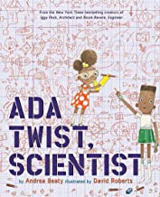

Ada Twist’s head is full of questions.Even when her fact-finding missions and elaborate
scientific experiments don’t go as planned, Ada learns the value of thinking her way
through problems and continuing to stay curious.

9a. Sofia Valdez Future Prez
9b. Rosie Revere, Engineer
9c. IGGy Peck, Architect

- Sir Cumference and the Dragon of PI: A Math Adventure by Cindy Neuschwander (32 pages)
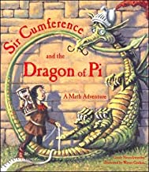

Join Sir Cumference and the gang for more wordplay, puns, and problem solving in the
clever math adventure about place-value and counting by tens. Sir Cumference and Lady Di
planned a surprise birthday party for King Arthur, but they didn’t expect so many guests to show up.
How many lunches will they need? And with more guests arriving by the minute, what about dinner?
Sir Cumference and Lady Di count guests by tens, hundreds, and even thousands to help young readers
learn place-value. Fans will love this new installment of the Sir Cumference series that makes math fun and
accessible for all.

10a. Sir Cumference and the Sword in the Cone
10b. Sir Cumference and All the King’s
10c. Sir Cumference and the First Round Table
10d. Sir Cumference and the Isle of Immeter
10e. Sir Cumference and the Roundabout Battle
10f. Sir Cumference and the Off-the-Charts Dessert
10g. Sir. Cumference and the Fracton Faire

- I Am Enough by Grace Byers (32 pages)
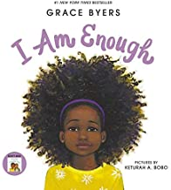

This is a lyrical ode to loving who you are, respecting others, and being kind to one another comes from
We are all here for a purpose. We are more than enough. We just need to believe it.

11a. I Believe I Can by Grace Byers

- I Promise by LeBron James ( 32 pages)
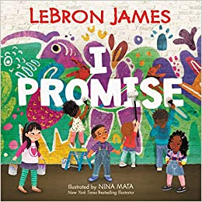

I Promise is a lively and inspiring picture book that reminds us that tomorrow’s success starts with the
promises we make to ourselves and our community today.
Featuring James’s upbeat, rhyming text and vibrant illustrations
perfectly crafted for a diverse audience by #1 New York Times bestselling and Geisel Honor
winning artist Nina Mata, this book has the power to inspire all children and families to be their best.
Perfect for shared reading in and out of the classroom, I Promise is also a
great gift for graduation, birthdays, and other occasions.

- What Do You Do With An Idea? by Kobi Yamada (36 pages)
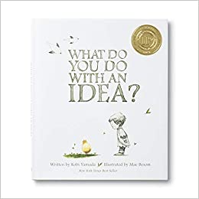

This is the story of one brilliant idea and the child who helps to bring it into the world.
As the child's confidence grows, so does the idea itself. And then, one day, something amazing happens.
This is a story for anyone, at any age, who's ever had an idea that seemed a little too big, too odd, too difficult.
It's a story to inspire you to welcome that idea, to give it some space to grow, and to see what happens next.
Because your idea isn't going anywhere. In fact, it's just getting started.

13a. What Do You Do With A Chance? By Kombi Yamada
13b. What Do You Do With A Problem? By Kombi Yamada

- Most Marshmallows by Rowboat Watkins ( 40 pages )
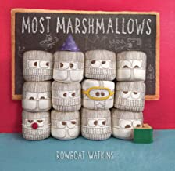

Most marshmallows are born into marshmallow families, play with marshmallow friends,
and go to marshmallow school where they learn to be squishy. Most marshmallows read
a book before bed and then fall asleep to dream ordinary marshmallow dreams.
But, this book isn't about most marshamallows, is it? No. That's because author
Rowboat Watkins knows that, just like you, some marshmallows have big dreams, and
just like you, these marshmallows can do anything they set their minds to.
This sweet and silly book is an inspiring reminder to everyone that by being true to ourselves,
each of us has the power to be extraordinary. Whether for a new parent or a recent graduate,
the message here will fit the bill.

- Just a Little Bit by Ann Tompert ( 32 pages)
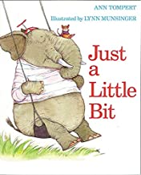

When an elephant and a mouse try to play on a seesaw,
they need help from a vast number of animal friends to balance the scales.

- Mystery Math: A First Book of Algebra by David Adler ( 32 pages)
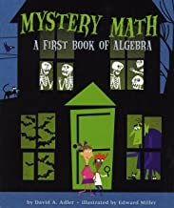

Boo! There is a mystery behind every door of the creepy haunted house.
Luckily, algebra will help you solve each problem.
By using simple addition, subtraction, mulitplication, and division,
you'll discover that solving math mysteries isn't scary at all -- it's fun!

- Place Value by David Adler. (32 pages)
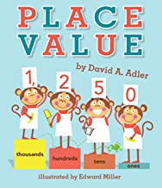

You had better not monkey around when it comes to place value.
The monkeys in this book can tell you why! As they bake the biggest
banana cupcake ever, they need to get the amounts in the recipe correct.
There’s a big difference between 216 eggs and 621 eggs.
Place value is the key to keeping the numbers straight. Using humorous art,
easy-to-follow charts and clear explanations,
this book presents the basic facts about place value while
inserting some amusing monkey business.

- They All Saw A Cat by Brendan Wenzel (44 pages)
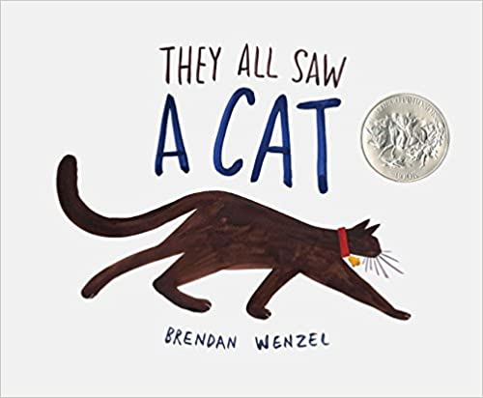

The cat walked through the world, with its whiskers, ears, and paws . . .
In this glorious celebration of observation, curiosity, and imagination,
Brendan Wenzel shows us the many lives of one cat, and how perspective
shapes what we see. When you see a cat, what do you see?

- A Stone Sat Still by Brendan Wenzel ( 56 pages)
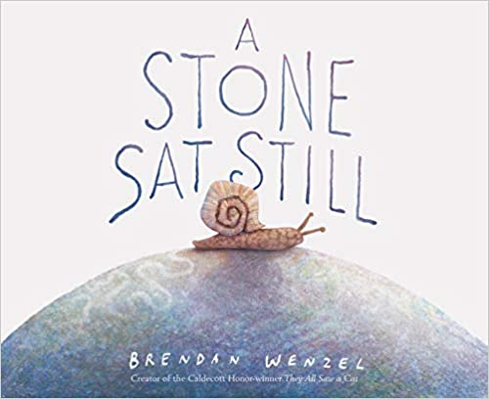

This is a story of a seemingly ordinary rock—but to the animals that use it,
it is a resting place, a kitchen, a safe haven...even an entire world.
This is a gorgeous exploration of perspective, perception, and the passage of time,
with an underlying environmental message that is timely and poignant

- The Five Chinese Brothers by Claire Hutchet Bishop ( 64 pages)
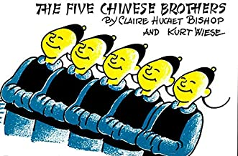

The classic picture book about five clever brothers, each with a different
extraordinary ability, has been in print for almost 80 years

- The Seven Chinese Brothers by Margaret Mahy (40 pages)
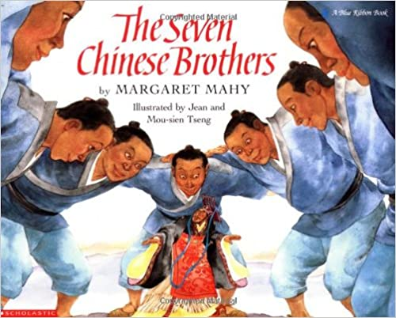

A magnificently illustrated and authentic retelling of the classic Chinese
folktale of the seven brothers and their supernatural gifts.

- Each Kindness by Jacqueline Woodson ( 32 pages)
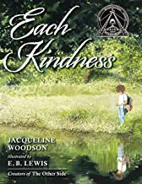

Chloe and her friends won't play with the new girl, Maya.
Every time Maya tries to join Chloe and her friends, they reject her.
Eventually Maya stops coming to school. When Chloe's teacher gives
a lesson about how even small acts of kindness can change the world,
Chloe is stung by the lost opportunity for friendship, and thinks about how
much better it could have been if she'd shown a little kindness toward Maya.

- Henry’s Freedom Box by Ellen Levine (40 pages)
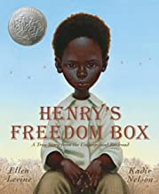

Henry Brown doesn't know how old he is. Nobody keeps records of slaves' birthdays.
All the time he dreams about freedom, but that dream seems farther away than ever when
he is torn from his family and put to work in a warehouse. Henry grows up and marries,
but he is again devastated when his family is sold at the slave market.
Then one day, as he lifts a crate at the warehouse, he knows exactly what he must do:
He will mail himself to the North. After an arduous journey in the crate, Henry finally has a
birthday -- his first day of freedom.

- Moses: When Harriet Tubman Led Her People to Freedom by Carole Boston Weatherford (48 pages)
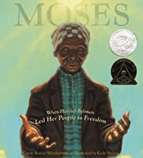

Born into slavery, Harriet Tubman hears words from God one summer night and
decides to leave her husband and family behind and escape.
Taking with her only her faith, she must creep through woods with hounds at her feet,
sleep for days in a potato hole, and trust people who could have easily turned her in.
But she was never alone.

- Knock Knock by Daniel Beaty (40 pages)
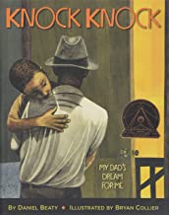

Every morning, I play a game with my father.
He goes knock knock on my door
and I pretend to be asleep
till he gets right next to the bed.
And my papa, he tells me, "I love you."

But what happens when, one day, that "knock knock" doesn't come?
This powerful and inspiring book shows the love that an absent parent can
leave behind, and the strength that children find in themselves as they grow
up and follow their dreams.

26.Stand Tall Molly Lou Mellon by Patty Lovell ( 32 pages)
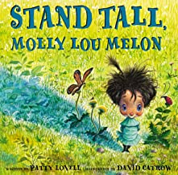

Be yourself like Molly Lou Melon no matter what a bully may do.
Molly Lou Melon is short and clumsy, has buck teeth, and has a voice that sounds
like a bullfrog being squeezed by a boa constrictor. She doesn't mind.
Her grandmother has always told her to walk proud, smile big, and sing loud,
and she takes that advice to heart. But then Molly Lou has to start in a new school.
A horrible bully picks on her on the very first day, but Molly Lou Melon knows just what to do about that.

26a. Speak Up Molly Lou Mellon
26b. Have Fun Molly Lou Mellon

- I Like Myself by Karen Beaumont. (32 pages)
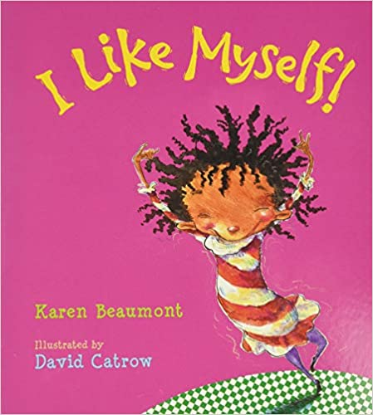

High on energy and imagination, this ode to self-esteem encourages kids to
appreciate everything about themselves—inside and out. Messy hair?
Beaver breath? So what! Here's a little girl who knows what really matters.

- Move Over Rover by Karen Beaumont ( 40 pages)
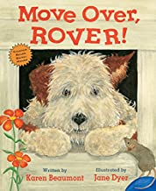

It's raining cats and dogs! Good thing Rover is snuggled safe and dry inside
his doghouse--until, one by one, many creatures shows up looking for a cozy
place to sit out the storm. But who's the very unwelcome surprise visitor?
Skunk, of course. Suddenly that doghouse isn't quite so crowded after all!

- Uncle Jed’s Barbershop by Margaret King Mitchell ( 40 pages)
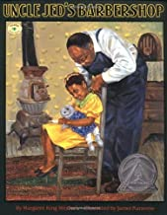

Everyone has a favorite relative. For Sarah Jean, it’s her Uncle Jed.
Living in the segregated South of the 1920s, where most people are sharecroppers,
Uncle Jed is the only black barber in the county and has to travel all over the county
to cut his customers’ hair.He lives for the day when he could open his very own barbershop.
But there are a lot of setbacks along the way. Will Uncle Jed ever be able to open a shiny new shop?

- Thank You, Mr. Falker by Patricia Polacco ( 40 pages)
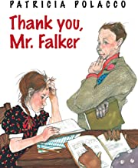

Trisha could paint and draw beautifully,
but when she looked at words on a page, all she could see was jumble.
It took a very special teacher to recognize little Trisha's dyslexia: Mr. Falker,
who encouraged her to overcome her reading disability. Patricia Polacco will never forget him,
and neither will we.

- The Undefeated by Kwame Alexander (40 pages)
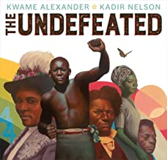

The Undefeated, this poem is a love letter to black life in the United States.
It highlights the unspeakable trauma of slavery, the faith and fire of the civil rights
movement, and the grit, passion, and perseverance of some of the world's greatest heroes.
The text is also peppered with references to the words of Martin Luther King, Jr., Langston Hughes,
Gwendolyn Brooks, and others, offering deeper insights into the accomplishments of the past,
while bringing stark attention to the endurance and spirit of those surviving and thriving in the present.

- Don’t Let the Pigeon Stay Up Late by Mo Willems (40 pages)
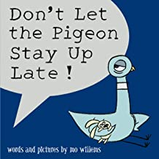

31a. Don’t Let the Pigeon Drive the Bus by Mo Willems
31b. The Pigeon Has to Go to School by Mo Willems
31c. The Pigeon Needs a Bath by Mo Willems
31d. The Pigeon Wants a Puppy by Mo Willems

- If You Give A Mouse A Cookie by Laura Numeroff (40 pages)
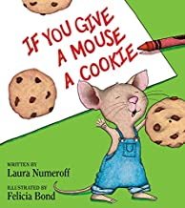

If a hungry little mouse shows up on your doorstep, you might want to give him a cookie.
And if you give him a cookie, he'll ask for a glass of milk. He'll want to look in a mirror
to make sure he doesn't have a milk mustache, and then he'll ask for a pair of scissors
to give himself a trim....

32a. If You Give a Pig a Pancake
32c. If You Give a Dog a Donut
32d. If You Give a Cat a Cupcake
32e. If You Take a Mouse to School

- Hair Love by Matthew A. Cherry ( 32 pages)
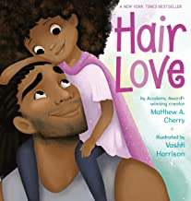

Zuri's hair has a mind of its own. It kinks, coils, and curls every which way.
Zuri knows it's beautiful. When Daddy steps in to style it for an extra special
occasion, he has a lot to learn. But he LOVES his Zuri, and he'll do anything
to make her -- and her hair -- happy.

- Goldie Locks Has Chicken Pox by Erin Dealey (40 pages)
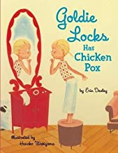

When Goldie Locks spies her spot, her mother knows it must be chicken pox.
Soon after, a steady stream of storybook favorites— including the Three Bears
and Little Bo Peep— stop by to wish Goldie Locks a speedy recovery.
But how will Goldie Locks get well when her little brother just won’t stop teasing her?

- Just Read! By Lori Degman. ( 32 pages)
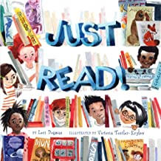

Learning to read is a big accomplishment, and this exuberant picture book
celebrates reading in its many forms. In lively rhyme, it follows a diverse
group of word-loving children who grab the opportunity to read wherever
and whenever they can. They read while waiting and while sliding or swinging;
they read music and in Braille and the signs on the road. And, sometimes,
they even read together, in a special fort they’ve built. The colorful, fanciful
art and rollicking text will get every child more excited about reading!

- The Name Jar by Yangsook Choi. (40 pages)
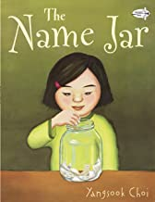

Being the new kid in school is hard enough, but what about when nobody can pronounce
your name? Having just moved from Korea, Unhei is anxious that American kids will not like her.
So instead of introducing herself on the first day of school, she tells the class that
she will choose a name by the following week. Her new classmates are fascinated
by this no-name girl and decide to help out by filling a glass jar with names for her
to pick from. But while Unhei practices being a Suzy, Laura, or Amanda, one of her
classmates comes to her neighborhood and discovers her real name and its special meaning.
On the day of her name choosing, the name jar has mysteriously disappeared.
Encouraged by her new friends, Unhei chooses her own Korean name and helps
everyone pronounce it—Yoon-Hey.

- Are You My Mother by P.D. Eastman (72 pages)
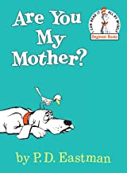

When a mother bird's egg starts to jump, she hurries off to make sure she has something
for her little one to eat. But as soon as she's gone, out pops the baby bird. He immediately
sets off to find his mother, but not knowing what she looks like makes it a challenge.
The little hatchling is determined to find his mother,
even after meeting a kitten, a hen, a dog, and a Snort.
.

- A Chair For My Mother by Vera B. Williams ( 32 pages)
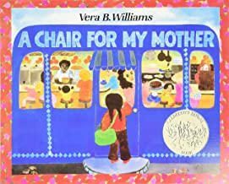

After their home is destroyed by a fire, Rosa, her mother, and grandmother save their coins
to buy a really comfortable chair for all to enjoy.

- I Got the Rhythm by Connie Schofield-Morrison (32 pages)
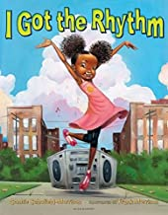

On a simple trip to the park, the joy of music overtakes a mother and daughter.
The little girl hears a rhythm coming from the world around her- from butterflies,
to street performers, to ice cream sellers everything is musical! She sniffs,
snaps, and shakes her way into the heart of the beat, finally busting out in an
impromptu dance, which all the kids join in!
.

- Jabari Jumps by Gaia Cornwall. (32 pages)
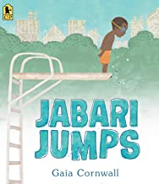

Jabari is definitely ready to jump off the diving board. He’s finished his swimming
lessons and passed his swim test, and he’s a great jumper, so he’s not scared at all.
“Looks easy,” says Jabari, watching the other kids take their turns. But when his
dad squeezes his hand, Jabari squeezes back. He needs to figure out what kind
of special jump to do anyway, and he should probably do some stretches before
climbing up onto the diving board. In a sweetly appealing tale of overcoming your fears,
Gaia Cornwall captures a moment between a patient and encouraging father and a determined
little boy you can’t help but root for.

- Jabari Tries by Gaia Cornwall ( 32 pages)
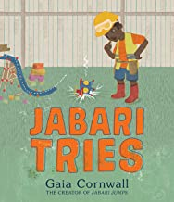

Jabari is making a flying machine in his backyard! “It’ll be easy. I don’t need any help,
” he declares. But it doesn’t work! Jabari is frustrated. Good thing Dad is there for a pep
talk and his little sister, Nika, is there to assist, fairy wings and all.

- I Am So Mad by Jamilia Tyler (20 pages)
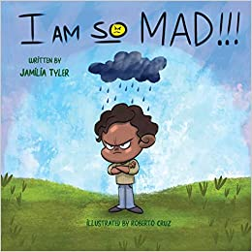

This book is about a kid who is having a bad day and things just keep getting worse.
After talk with his mom, he learns ways he can feel better even when he's down and
how to manage his anger.

- Last Stop on Market Street by Matt De La Pena ( 32 pages)
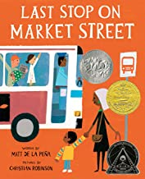

Every Sunday after church, CJ and his grandma ride the bus across town. But today,
CJ wonders why they don’t own a car like his friend Colby.
How come they always have to get off in the dirty part of town?
Each question is met with an encouraging answer from grandma,
who helps him see the beauty—and fun—in their routine and the world around them

- Bear Stays Up for Christmas by karma Wilson (40 pages)
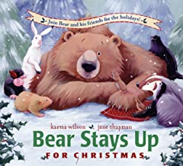

Bear’s friends are determined to keep Bear awake for Christmas! So they wake Bear up and
have him help them find a Christmas tree, bake cakes, hang up stockings, and sing Christmas songs.
Bear stays up—by discovering that giving is one of the best Christmas presents of all!

43a. Bear Snores On
43b. Bear Wants More
43c. Bear Feels Sick
43d. Bear Feels Scared
43e. Bear Says Thanks
43f. Bear’s Loose Tooth
43g. Bear’s New Friend

- Miss Suzy by Miriam Young ( 40 pages)
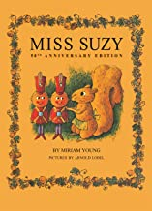

Miss Suzy is a little gray squirrel who lives happily in her oak-tree home until
she is chased away by some mean red squirrels. Poor Miss Suzy is very sad.
But soon she finds a beautiful dollhouse and meets a band of brave toy soldiers.

- Just Ask!: Be Different, Be Brave, Be You! by Sonia Sotomayor ( 32 pages )
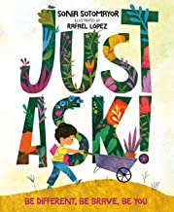

Feeling different, especially as a kid, can be tough.
But in the same way that different types of plants and flowers make
a garden more beautiful and enjoyable, different types of people
make our world more vibrant and wonderful.

- Milo Imagines the World by Matt De La Pena (40 pages )
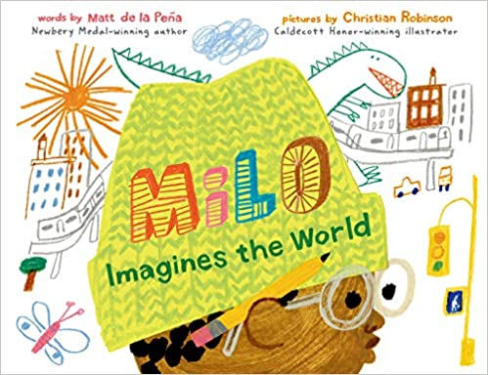

Milo is on a long subway ride with his older sister. To pass the time, he studies the
faces around him and makes pictures of their lives. There's the whiskered man
with the crossword puzzle; Milo imagines him playing solitaire in a cluttered
apartment full of pets. There's the wedding-dressed woman with a little dog
peeking out of her handbag; Milo imagines her in a grand cathedral ceremony.
And then there's the boy in the suit with the bright white sneakers; Milo imagines
him arriving home to a castle with a drawbridge and a butler. But when the boy
in the suit gets off on the same stop as Milo--walking the same path, going to
the exact same place--Milo realizes that you can't really know anyone just by looking at them.

- Unstoppable Me by Susan Verde ( 32 pages)
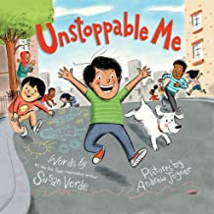

I am movement
Heat
Static electricity
Fueled by food
And powered by PLAY!
Unstoppable Me is about the sort of energetic child we all know and love
― full of fun and play...and a bit exhausting! In this book, we see an
unstoppable little boy, run, jump, and soar through his day.
He takes a little time to refuel, then he's back at it―zooming and zipping around.

- Where’s Rodney by Carmen Bogan. (32 pages)
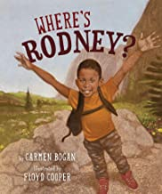

Rodney is that kid who just can’t sit still. He's inside, but he wants to be outside.
Outside is where Rodney always wants to be. Between school and home,
there is a park. He knows all about that park. It’s that triangle-shaped place
with the yellow grass and two benches where grown-ups sit around all day.
Besides, his momma said to stay away from that park. When Rodney finally
gets a chance to go to a real park, with plenty of room to run and climb
and shout, and to just be himself, he will never be the same.

- Maybe Something Beautiful: How Art Transformed a Neighborhood by F. Isabel Campoy. (40 pages)
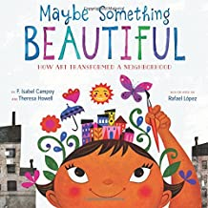

What good can a splash of color do in a community of gray? As Mira and her neighbors discover,
more than you might ever imagine! Based on the true story of the Urban Art Trail in San Diego,
California, Maybe Something Beautiful reveals how art can inspire transformation
—and how even the smallest artists can accomplish something big. Pick up a paintbrush
and join the celebration!

- Jingle Bells, Homework Smells by Diane De Groat. ( 32 pages)
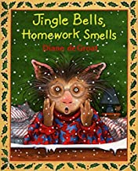

When Mrs. Byrd gives the class homework for the weekend,
Gilbert just can't seem to find the time to do it. That's because it's almost Christmas,
and Gilbert has other important things to do, like decorating Christmas cookies,
ice skating with his friends, and helping his family find the perfect Christmas tree.
What will Gilbert do when Monday morning comes?

- Llama Llama, Red Pajamas by anna Dewdney ( 34 pages)
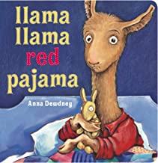

Llama Llama’s tale of nighttime drama has charmed readers for over a decade and
makes an ideal story for bedtime reading.

51a. Llama Llama Misses Mama
51b. Llama Llama Holiday Drama

- Schomburg: The Man Who Built The Library by Carole Boston Weatherford. ( 48 pages)
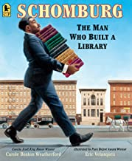

Amid the scholars, poets, authors, and artists of the Harlem Renaissance stood an
Afro–Puerto Rican named Arturo Schomburg. This law clerk’s life’s passion was to
collect books, letters, music, and art from Africa and the African diaspora and bring
to light the achievements of people of African descent through the ages.
When Schomburg’s collection became so big it began to overflow his house ,
he turned to the New York Public Library, where he created and curated a collection
that was the cornerstone of a new Negro Division. A century later, his groundbreaking collection, known as the
Schomburg Center for Research in Black Culture, has become a beacon to scholars all over the world.

- Islandborn by Junot Diaz. (48 pages)
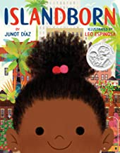

Every kid in Lola's school was from somewhere else.
Hers was a school of faraway places. So when Lola's teacher asks the
students to draw a picture of where their families immigrated from, all the kids are excited.
Except Lola. She can't remember The Island—she left when she was just a baby.
But with the help of her family and friends, and their memories—joyous, fantastical,
heartbreaking, and frightening—Lola's imagination takes her on an extraordinary
journey back to The Island. As she draws closer to the heart of her family's story,
Lola comes to understand the truth of her abuela's words: “Just because
you don't remember a place doesn't mean it's not in you.”

- Abuela by Arthur Dorros ( 40 pages)
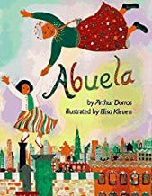

Come join Rosalba and her grandmother, her abuela, on a magical journey
as they fly over the streets, sights, and people of New York City which sparkles below.
The story is narrated in English, and sprinkled with Spanish phrases as Abuela points
out places that they explore together. The exhilaration in Rosalba’s and Abuela's story
is magnified by the loving bond that only a grandmother and granddaughter can share.

- Curious George Visits The Library: A Bilingual Book by Jorge El Curioso. (24 pages)
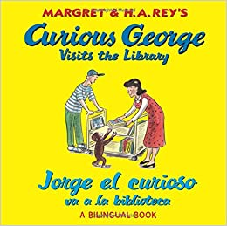

George is lucky to arrive at the library just in time for story hour but it’s not easy for a little
monkey to sit still too long. George finds so many books he wants to read and
can’t wait to take them home. From selecting books to getting his very own library card,
George’s day at the library celebrates all the fun of reading!
The new English/Spanish edition includes highly readable text and bilingual bonus activities.

- Lucia the Luchadora by Cynthia Leonar Garza ( 32 pages)
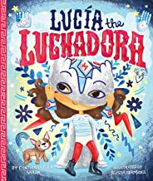

Lucía zips through the playground in her cape just like the boys, but when they tell her "girls can't
be superheroes," suddenly she doesn't feel so mighty. That's when her beloved abuela reveals a
dazzling secret: Lucía comes from a family of luchadoras, the bold and valiant women of the Mexican
lucha libre tradition. Cloaked in a flashy new disguise, Lucía returns as a recess sensation! But when
she's confronted with a case of injustice, Lucía must decide if she can stay true to the ways of the luchadora
and fight for what is right, even if it means breaking the sacred rule of never revealing the identity behind her
mask. A story about courage and cultural legacy, Lucía the Luchadora is full of pluck, daring, and heart.

- Dreamers by Yuyi Morales. (40 pages)
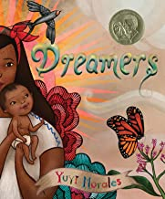

Dreamers is a celebration of making your home with the things you always carry: your resilience,
your dreams, your hopes and history. It's the story of finding your way in a new place, of navigating
an unfamiliar world and finding the best parts of it. In dark times, it's a promise that you can make
better tomorrows. This lovingly-illustrated picture book memoir looks at the myriad gifts migrantes
bring with them when they leave their homes. It's a story about family. And it's a story to remind us
that we are all dreamers, bringing our own strengths wherever we roam.
.

- Mrs. Wishy-Washy’s Farm by Joy Cowley (32 pages)
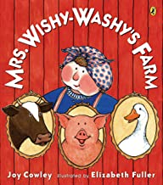

Uh-oh. Mrs. Wishy-Washy is at it again. Rubbing and scrubbing all the animals on the farm.
But this time they aren't standing for it. Duck, Cow, and Pig are leaving mean old
Mrs. Wishy-Washy for good! They run away to the big city. But they get lost, wander into a
restaurant, and even stumble into a hardware store and get covered in paint! Where is
Mrs. Wishy-Washy when they need her? Maybe her farm isn't so bad after all . . .

58a. Mrs. Wishy-Washy
58b. Mrs. Wishy-Washy and the Big Wash
58c. Mrs. Wishy-Washy’s Tub

- The Tiny Seeds by Eric Carle ( 36 pages)
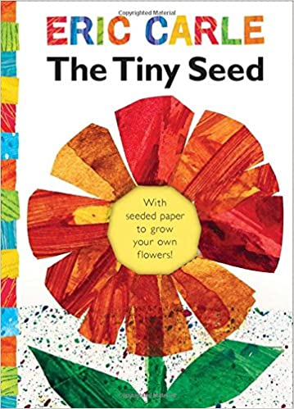

Eric Carle’s classic story of the life cycle of
a flower is told through the adventures of a tiny
seed. This mini-book includes a piece of
detachable seed-embedded paper housed on the
inside front cover. Readers can plant the entire
piece of paper and watch as their very own tiny
seeds grow into beautiful wildflowers.

- Lola at the Library by Anna McQuinn (32 pages)
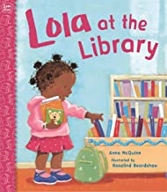

Learn about the library, checking out books, and story time with Lola.
Every Tuesday Lola and her mommy go to the library. Lola meets her friends there.
They share books and don't have to be quiet all the time. The nice librarian tells stories.
There is a big machine that buzzes Lola's books in and out, and she can take any books
she wants home with her. Lola and her mommy always stop for a treat on the way home.
No wonder Lola loves the library.

60a. Lola Goes to School
60b. Lola Plants a Garden
60c. Lola Loves Stories
60d. Lola Gets a Cat

- Ellen Earns Her Own Money by Lisa Bullard ( 24 pages)
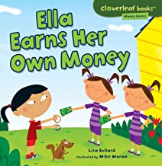

How should we handle our money? Ella really wants a soccer ball.
But she doesn't have enough money to buy one. So she decides to earn her own money.
Ella cleans the car for her mom, gives the neighbor's dog a bath, and sells bracelets to her
friends to earn cash. Will she have enough money to buy the ball in the end? Read this book
to find out! These simple, engaging stories present basic financial literacy concepts,
such as saving, spending, borrowing, and comparison shopping to build a foundation
for a lifetime of money smarts.

61a. Lily Learns about Wants and Needs
61b. Shanti Saves Her Money
61c. Brody Borrows Money
61d. Gabriel Gets a Great Deal

- Mean Jean Recess Queen by Alexis O’Neill ( 32 pages)
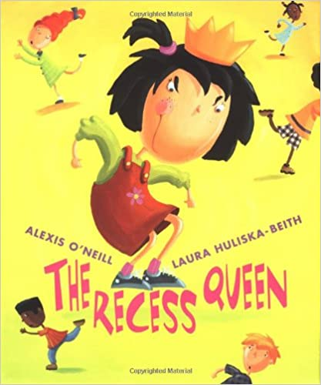

Mean Jean was Recess Queen and nobody said any different.
Nobody swung until Mean Jean swung. Nobody kicked until Mean
Jean kicked. Nobody bounced until Mean Jean bounced. If kids ever crossed
her, she'd push 'em and smoosh 'em lollapaloosh 'em, hammer 'em,
slammer 'em kitz and kajammer 'em. Until a new kid came to school!
With her irrepressible spirit, the new girl dethrones the reigning recess
bully by becoming her friend in this infectious playground romp.

