Building Libraries at Home
2021-2022

The Wonderful Things You Will Be by Emily Winfield Martin
Grade: PreK-2nd
Lexile Measure: AD520L
Guided Reading Level: J
Stars: 5
PSCF’s Availability: 7
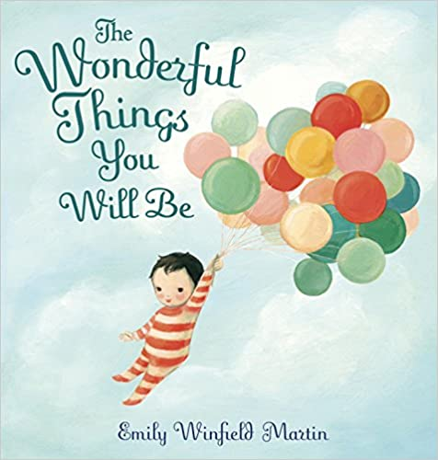
From brave and bold to creative and clever, Emily Winfield Martin's rhythmic rhyme expresses all the loving things that parents think of when they look at their children. With beautiful, lush illustrations and a stunning gatefold that opens at the end, this is a book that families will love reading over and over.

Last Stop on Market Street by Matt DE LA Pena
Grade: K-3rd
Lexile Measure: AD610L
Guided Reading Level: M
Stars: 5
PSCF’s Availability: 6

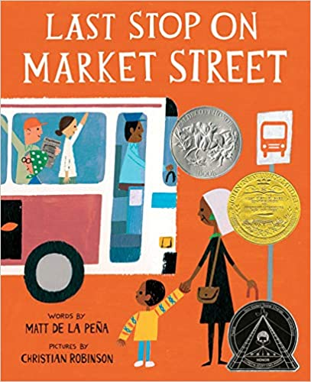
Every Sunday after church, CJ and his grandma rode the bus across town, but today, CJ wonders why they don’t own a car like his friend Colby. Why doesn’t he have an iPod like the boys on the bus? How come they always have to get off in the dirty part of town? Each question is met with an encouraging answer from grandma, who helps him see the beauty—and fun—in their routine and the world around them.

Enemy Pie by Derek Munson
Grade: K-2nd
Lexile Measure: AD550L
Guided Reading Level: M
Stars: 4 1/2
PSCF’s Availability: 4
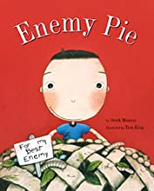
It was the perfect summer until Jeremy Ross moved into the house down the street and became neighborhood enemy number one. Luckily Dad had a surefire way to get rid of enemies: Enemy Pie. But part of the secret recipe is spending an entire day playing with the enemy! In this funny yet endearing story one little boy learns an effective recipe for turning a best enemy into a best friend.

I Got the Rhythm by Connie Schofield-Morrison
Grade: PreK-2nd
Lexile Measure: AD170L
Guided Reading Level: K
Stars: 5
PSCF’s Availability: 5

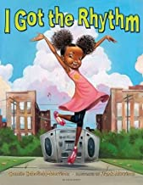
On a simple trip to the park, the joy of music overtakes a mother and daughter. The little girl hears a rhythm coming from the world around her- from butterflies, to street performers, to ice cream sellers everything is musical! She sniffs, snaps, and shakes her way into the heart of the beat, finally busting out in an impromptu dance, which all the kids join in on!

The Bad Seed by Jory John
Grade: K-2nd
Lexile Measure: AD390L
Guided Reading Level: J
Stars: 5
PSCF’s Availability: 3

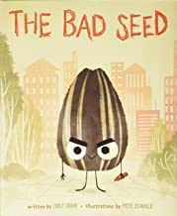
A little seed with a bad attitude decides he wants to be happy. Lessons about acceptance and the will to change blossom. "A comical read-aloud" -SLJ, starred review

The Recess Queen by Alexis O’Neill
Grade: PreK-2nd
Lexile Measure: AD550L
Guided Reading Level: L
Stars: 4 1/2PSCF’s Availability: 3

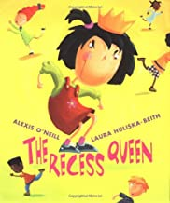
Mean Jean was Recess Queen and nobody said any different. Nobody swung until Mean Jean swung. Nobody kicked until Mean Jean kicked. Nobody bounced until Mean Jean bounced .If kids ever crossed her, she'd push 'em and smoosh 'em lollapaloosh 'em, hammer 'em, slammer 'em kitz and kajammer 'em. Until a new kid came to school! With her irrepressible spirit, the new girl dethrones the reigning recess bully by becoming her friend in this infectious playground romp.

Hair Love by Matthew A. Cherry
Grade: PreK-3rd
Lexile Measure: AD480L
Guided Reading Level:
Stars: 5
PSCF’s Availability: 7

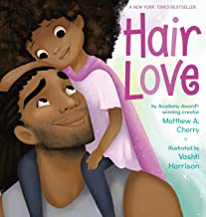
Zuri's hair has a mind of its own. It kinks, coils, and curls every which way. Zuri know
s it's beautiful. When Daddy steps in to style it for an extra special occasion, he has a lot to learn. But he LOVES his Zuri, and he'll do anything to make her -- and her hair -- happy.
Time for School, Little Blue Truck by Alice Schertle
Grade: PreK-2nd
Lexile Measure: AD520L
Guided Reading Level: J
Stars: 5
PSCF’s Availability: 7

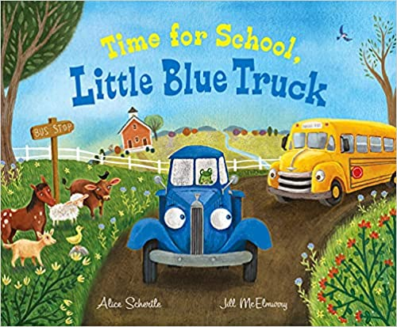
Little Blue Truck and his good friend Toad are excited to meet a bright yellow school bus on the road. They see all the little animals lined up in the school bus’s many windows, and Blue wishes he could be a school bus too. What a fun job—but much too big for a little pickup like Blue. Or is it? When somebody misses the bus, it’s up to Blue to get his friend to school on time. Beep! Beep! Vroom!

I Promise by LeBron James
Grade: PreK-2nd
Stars: 5
PSCF’s Availability: 5

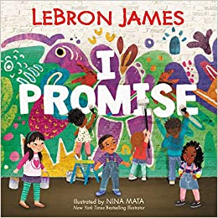
I Promise is a lively and inspiring picture book that reminds us that tomorrow’s success starts with the promises we make to ourselves and our community today.

Be Strong by Pat Zietlow Miller
Grade: PreK-2nd
Stars: 4 1/2
PSCF’s Availability: 4

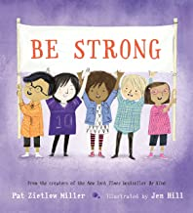
When her gym class must face the school rock-climbing wall, Tanisha is discouraged. Her muscles are weak, and she knows she'll never reach the top like Cayla.
But maybe strength is about more than just muscles.
The Very Hungry Caterpillar by Eric Carle
Grade: K-1st
Lexile Measure: AD460L
Guided Reading Level: J
DRA Level: 16-18
Stars: 5
PSCF’s Availability: 2

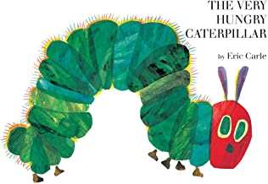
The very hungry caterpillar literally eats his way through the pages of the book—and right into your child's heart..."

Grumpy Monkey by Suzanne Lang
Grade: PreK-K
Lexile Measure: AD460L
Stars: 5
PSCF’s Availability: 7

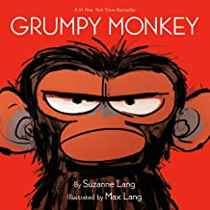
Jim the chimpanzee is in a terrible mood for no good reason. His friends can't understand it--how can he be in a bad mood when it's SUCH a beautiful day? They have lots of suggestions for how to make him feel better. But Jim can't take all the advice...and has a BIT of a meltdown. Could it be that he just needs a day to feel grumpy?
The Big Umbrella by June Bates
Grade: Pre K-3rd
Lexile Measure: AD370L
Guided Reading Level: H
Stars: 5
PSCF’s Availability: 2

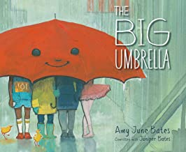
By the door there is an umbrella. It is big. It is so big that when it starts to rain there is room for everyone underneath. It doesn’t matter if you are tall. Or plaid. Or hairy. It doesn’t matter how many legs you have. Don’t worry that there won’t be enough room under the umbrella. Because there will always be room.
Lyle, Lyle, Crocodile by Bernard Waber
Grade: 2nd-3rd
Lexile Measure: AD840L
Guided Reading Level: M
DRA Level: 20
Stars: 5
PSCF’s Availability: 5

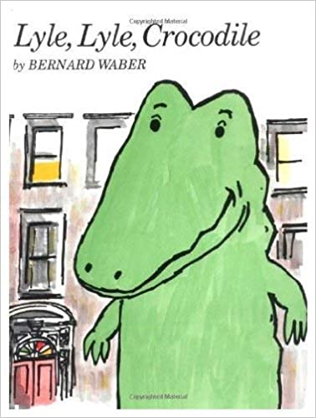

Lyle the crocodile lives in a house on East 88th Street in New York City. Lyle enjoys helping the Primm family with everyday chores, and playing with the neighborhood kids. He’s the happiest crocodile any home ever had…until one neighbor insists that Lyle belongs in a zoo! Mr. Grumps and his cat, Loretta, don't like crocodiles, and everything Lyle does to win them over seems to go wrong. It will take all of Lyle’s charm—and courage—to reveal the hero, and friend, behind the big, crocodile smile.

Don’t Go to School by Maire Zepf
Grade: PreK-2nd
Lexile Measure: AD460L
Stars: 4
PSCF’s Availability: 3

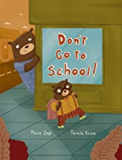
What can a little bear do when he’s ready for his first day of school—but his mother isn’t? “DON”T GO TO SCHOOL!” she wails. “STAY HERE WITH ME!” Mommy sulks, she’s shy, she even throws a tantrum. Can Benno convince her that everything’s okay? He comes up with an ingenious idea to help her adjust—one that many a mom and dad will recognize. This humorous story will reassure and delight nervous children, while parents feeling a little sad to see their babies grow up and march off to school will empathize with Moms!

A Sick Day for Amos McGee by Philip Snead
Grade: PreK-1st
Lexile Measure: AD760L
Guided Reading Level: M
DRA Level: 20-24
Stars: 5
PSCF’s Availability: 5

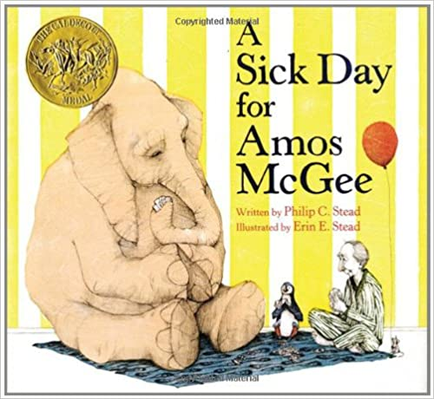
Friends come in all sorts of shapes and sizes. In Amos McGee’s case, all sorts of species, too! Every day he spends a little bit of time with each of his friends at the zoo, running races with the tortoise, keeping the shy penguin company, and even reading bedtime stories to the owl. But when Amos is too sick to make it to the zoo, his animal friends decide it’s time they returned the favor.

The Pigeon Has to Go to School! by Mo Willems
Grade: K-3rd
Lexile Measure: AD450L
Guided Reading Level: J-K
DRA Level: 16-18
Stars: 5
PSCF’s Availability: 21

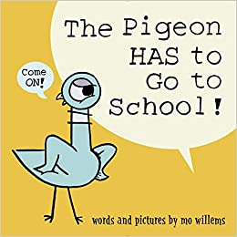
Why does the Pigeon have to go to school? He already knows everything! And what if he doesn't like it? What if the teacher doesn't like him? What if he learns TOO MUCH!?!

Should I Share My Ice Cream by Mo Willems
Grade: PreK-1st
Lexile Measure: AD260L
Guided Reading Level: H
DRA Level: 14
Stars: 5
PSCF’s Availability: 3

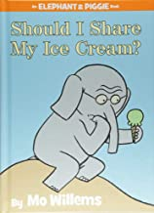
Gerald is careful. Piggie is not.
Piggie cannot help smiling. Gerald can.
Gerald worries so that Piggie does not have to.
Gerald and Piggie are best friends.

There Is a Bird on Your Head! by Mo Willems
Grade: PreK-2nd
Lexile Measure: AD210L
Guided Reading Level: G
DRA Level: 12
Stars: 5
PSCF’s Availability: 1

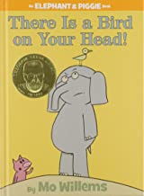

Are You Ready to Play Outside? by Mo Willems
Grade: K-2nd
Lexile Measure: AD140L
Guided Reading Level: G
DRA Level: 12
Stars: 5
PSCF’s Availability: 1

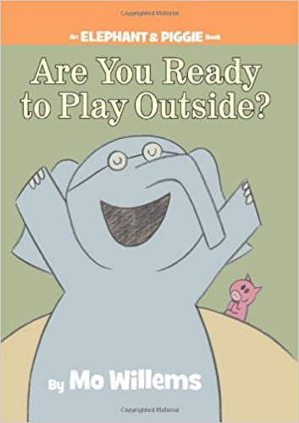

Gerald and Piggie are best friends.
Gerald is careful. Piggie is not.
Piggie cannot help smiling. Gerald can.
Gerald worries so that Piggie does not have to.

Only One You by Linda Kranz
Grade: PreK-1st
Lexile Measure: AD480L
Guided Reading Level: I
DRA Level: 16
Stars: 4
PSCF’s Availability: 4

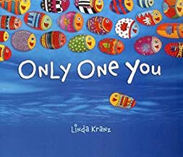
There's only one you in this great big world. Make it a better place. Adri's mama and papa share some of the wisdom they have gained through the years with their eager son. Their words, simple and powerful, are meant to comfort and guide him as he goes about exploring the world.

Think Big, Little One by Vashti Harrison
Grade: PreK-K
Lexile Measure: AD570L
Guided Reading Level: I
DRA Level: 16
Stars: 5
PSCF’s Availability: 4

Featuring eighteen women creators, ranging from writers to inventors, artists to scientists, this board book adaptation of Little Dreamers: Visionary Women Around the World introduces trailblazing women like Mary Blair, an American modernist painter who had a major influence on how color was used in early animated films, environmental activist Wangari Maathai, and architect Zaha Hadid.
The Gruffalo by Julia Donaldson
Grade: K-1st
Lexile Measure: AD200L
Guided Reading Level: L
DRA Level: 20-24
Stars: 5
PSCF’s Availability: 8

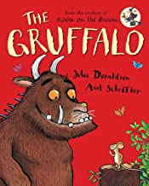

A mouse is taking a stroll through the deep, dark wood when along comes a hungry fox, then an owl, and then a snake. The mouse is good enough to eat but smart enough to know this, so he invents . . . the Gruffalo! As Mouse explains, the Gruffalo is a creature with terrible claws, and terrible tusks in its terrible jaws, and knobbly knees and turned-out toes, and a poisonous wart at the end of its nose. But Mouse has no worry to show. After all, there’s no such thing as a Gruffalo.

Corduroy by Don Freeman
Grade: PreK-4th
Lexile Measure: AD600L
Guided Reading Level: K
DRA Level: 16-18
Stars: 5
PSCF’s Availability: 12

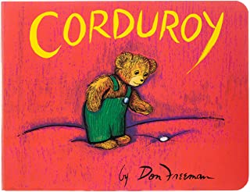

Lola at the Library by Anna McQuinn
Grade: PreK
Lexile Measure: AD480L
Guided Reading Level: I
DRA Level: 16
Stars: 5
PSCF’s Availability: 3

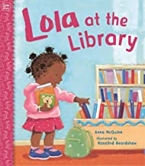
Learn about the library, checking out books, and story time with Lola. Every Tuesday Lola and her mommy go to the library. Lola meets her friends there. They share books and don't have to be quiet all the time. The nice librarian tells stories. There is a big machine that buzzes Lola's books in and out, and she can take any books she wants home with her. Lola and her mommy always stop for a treat on the way home. No wonder Lola loves the library.

Where’s Rodney? By Carmen Bogan
Grade: 1st-3rd
Lexile Measure: AD580L
Guided Reading Level: L
DRA Level: 20-24
Stars: 4 1/2
PSCF’s Availability: 4

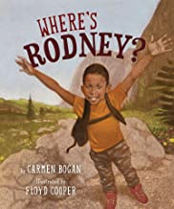
Rodney is that kid who just can’t sit still. He's inside, but he wants to be outside. Outside is where Rodney always wants to be. Between school and home, there is a park. He knows all about that park. It’s that triangle-shaped place with the yellow grass and two benches where grown-ups sit around all day. Besides, his momma said to stay away from that park. When Rodney finally gets a chance to go to a realpark, with plenty of room to run and climb and shout, and to just be himself, he will never be the same.

Jabari Jumps by Gaia Cornwall
Grade: K-2nd
Lexile Measure: AD490L
Guided Reading Level: J
DRA Level: 16-18
Stars: 5
PSCF’s Availability: 7

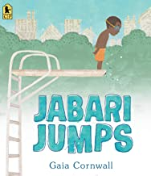
Jabari is ready to jump off the diving board. He’s finished his swimming lessons and passed his swim test, and he’s a great jumper, so he’s not scared at all. “Looks easy,” says Jabari, watching the other kids take their turns. But when his dad squeezes his hand, Jabari squeezes back. He needs to figure out what kind of special jump to do, and should he do some stretches before climbing up onto the diving board.

The Bear Ate Your Sandwich by Julia Sarcone Roach
Grade: 2nd- 3rdK
Lexile Measure: AD490L
Guided Reading Level: L
Stars: 5
PSCF’s Availability: 1

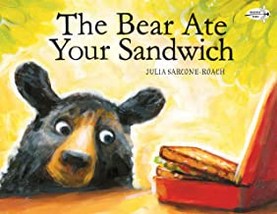
By now I think you know what happened to your sandwich.
But you may not know how it happened.
So let me tell you.
It all started with the bear . . .
Oddbird by Derek Desierto
Grade: PreK-K
Lexile Measure: AD750L
Guided Reading Level: U
Stars: 5
PSCF’s Availability: 2

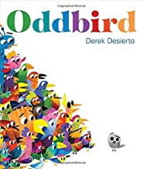

It’s SO hot outside. All the fancy birds are gathered around the water, wishing they could cool off. But they don’t want to get wet and ruin their fine feathers.
Oddbird isn’t worried about his feathers; he wants to go for a refreshing dip. But he doesn’t fit in.He’s not fancy, or colorful. He’s just…different. The other b
irds don't want him around. How can he join them? Oddbird's story is one all readers will relate to, and ultimately celebrate.

I Affirm Me by Nyasha Williams
Grade: PreK-3rd
Stars: 5
PSCF’s Availability: 1

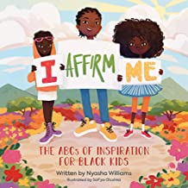
From A is for Afro, to J is for Justice, to R is for Rally, this alphabet book offers affirmations featuring Black children and role models to help children nurture and embrace their authentic selves and to enjoy the magic of childhood.

All Are Welcome by Alexandra Penfold ( For the Fulton Montessori School)
Grade: PreK-3rd
Lexile Measure: AD370L
Guided Reading Level: L
DRA Level: 20
Stars: 5
PSCF’s Availability: 1

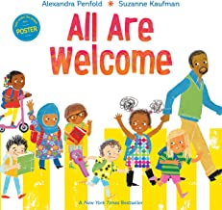

In our classroom safe and sound.
Fears are lost and hope is found.
Discover a school where all young children have a place, have a space, and are loved and appreciated.
Of Thee I Sing by Barack Obama ( One For the Fulton Montessori School)
Grade: PreK-3rd
Lexile Measure: AD830L
Guided Reading Level: R
Stars: 5
PSCF’s Availability: 2
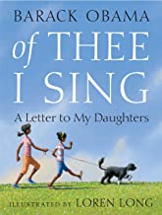
In this poignant letter to his daughters, Barack Obama has written a moving tribute to thirteen groundbreaking Americans and the ideals that have shaped our nation. From the artistry of Georgia O'Keeffe, to the courage of Jackie Robinson, to the patriotism of George Washington, Obama sees the traits of these heroes within his own children, and within all of America’s children.

The King of Kindergarten by Derrick Barnes
Grade: PreK-K
Lexile Measure: AD720L
Guided Reading Level: L
DRA Level: 20
Stars: 5
PSCF’s Availability: 1

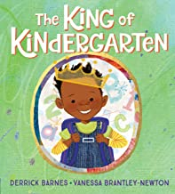
The morning sun blares through your window like a million brass trumpets. It sits and shines behind your head--like a crown. Mommy says that today, you are going to be the King of Kindergarten!
Starting kindergarten is a big milestone--and the hero of this story is ready to make his mark! He's dressed himself, eaten a pile of pancakes, and can't wait to be part of a whole new kingdom of kids. The day will be jam-packed, but he's up to the challenge, taking new experiences in stride with his infectious enthusiasm! And afterward, he can't wait to tell his proud parents all about his achievements--and then wake up to start another day.

Only the Cat Saw by Ashley Wolff ( For the Fulton Montessori School)
Grade: PreK-K
Lexile Measure: AD310L
Guided Reading Level: H
DRA Level: 14
Stars: 5
PSCF’s Availability: 1

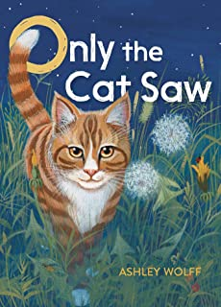
When night falls, a family eases into supper, bath, and bedtime. But while their day is ending, their farm cat’s adventures have just begun! Only the cat sees the sun set over a flock of sheep, an owl stalking a mouse, a shooting star...and much, much more. This peaceful, visually stunning story explores what happens at night when no one—well, almost no one—is watching.

Lemon’s Are Not Red by Laura Vaccaro Seeger (For the Fulton Montessori School)
Grade: PreK-1st
Stars: 5
PSCF’s Availability: 1

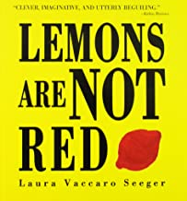
And it goes from carrots that are not purple through reindeer that are not white. The book ends with "The moon is not BLACK / The moon is SILVER / The night is BLACK / Good night! And the reader sees a tranquil night landscape and a house with the lights turned out.

The Relatives Came by Cythnia Rylant
Grade:1st-2nd
Lexile Measure: AD940L
Guided Reading Level: L
DRA Level: 20-24
Stars: 5
PSCF’s Availability: 1

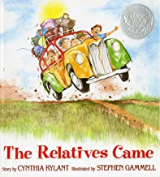

In a rainbow-colored station wagon that smelled like a real car, the relatives came. When they arrived, they hugged and hugged from the kitchen to the front room. All summer they tended the garden and ate up all the strawberries and melons. They plucked banjos and strummed guitars.
When they finally had to leave, they were sad, but not for long. They all knew they would be together next summer.

Frog and Toad Are Friends by Arnold Lobel
Grade: K-2nd
Lexile Measure: AD400L
Guided Reading Level: K
DRA Level: 16-18
Stars: 5
PSCF’s Availability: 1

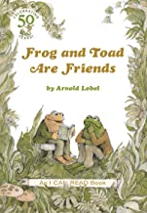
From writing letters to going swimming, telling stories to finding lost buttons, Frog and Toad are always there for each other—just as best friends should be.

Frog and Toad Together by Arnold Lobel
Grade: K-2nd
Lexile Measure: AD330L
Guided Reading Level: K
DRA Level: 16-18
Stars: 5
PSCF’s Availability: 2

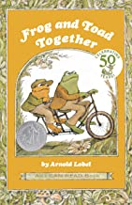
Frog and Toad are best friends—they do everything together. When Toad admires the flowers in Frog's garden, Frog gives him seeds to grow a garden of his own. When Toad bakes cookies, Frog helps him eat them. And when both Frog and Toad are scared, they are brave together.

Days With Frog and Toad by Arnold Lobel
Grade: 1st-3rd
Lexile Measure: AD490L
Guided Reading Level: K
DRA Level: 16-18
Stars: 5
PSCF’s Availability: 1

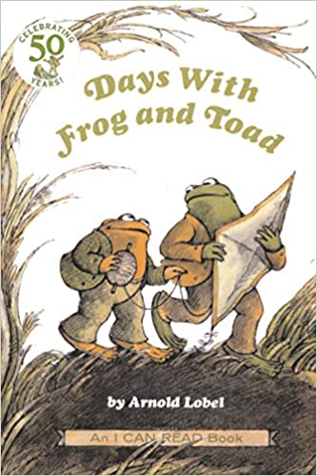

Frog and Toad All Year by Arnold Lobel
Grade: K-2nd
Lexile Measure: AD480L
Guided Reading Level: K
DRA Level: 16-18
Stars: 5
PSCF’s Availability: 1
.
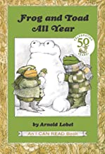

Compost Stew by Mary Mckenna Siddals ( For the Fulton Montessori School)
Grade: PreK-2nd
Lexile Measure: AD780L
Guided Reading Level: K
Stars: 5
PSCF’s Availability:

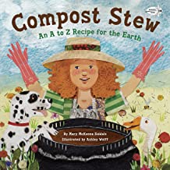
Kids everywhere are seeking knowledge about the environment and climate change. Not only is composting becoming more common in households and residential gardens, but many school gardens feature compost piles, too. But how do you start a compost pile? What’s safe to include?

