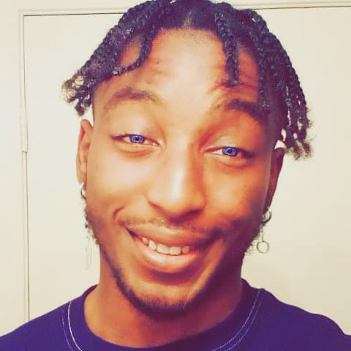 |  | Jovan Taylor  ACTOR ~ MODEL ~ SCREENWRITER
Profile  Jovan, the head of Morning Sun Productions, is enthusiastic about acting, modeling, crew work and screenwriting. Young and full of creative ideas, Jovan has already starred in a few short films and theatre productions. Recently, Jovan has contributed his writing skills and ideas to major episodics such as Stranger Things and The Thrilling Adventures of Sabrina. Jovan is a very skilled actor who is ready for more!  Contact  PHONE:  602-460-7337  WEBSITE:  http://morningsunproductions.com/  EMAIL:  kanekiken304@gmail.com  Social Media  https://instagram.com/comedianjojojapan?igshid=k4qkx2z7kt6f  https://twitter.com/JojoTaylor993?s=09 |  | WORK EXPERIENCE  Acting  Tempe Improv Club – Stand Up Comedy – 2016-2019  Fake Plugs – Grant – Short Film -- 2019  Theatre  Camp Rock 2 Final Jam – Luke – Raul Castro Middle School – 2007  Shakespeare’s Macbeth Story – Macbeth – Compadre Academy – 2015  Crew  Stunt Coordinator – Shakespeare’s Macbeth Story – 2015  Props person – Shakespeare’s Macbeth Story -- 2015  Screenwriting  A Mother’s Love – Short Film – Drama/Crime Thriller -- 2017  Young Blood – Episodic – Supernatural/Action Adventure -- 2016  Smile For Me – Feature Film – Slasher --2016  Shizuka Yuki: Across Paradise Valley – Feature Film – Fantasy -- 2016  The Closet Game Universe – Episodic Short Film – Horror – 2018  Strawberry – Episodic Short Film – Drama/Crime Thriller – 2018  Writers – Feature -- Romantic Comedy – 2019  The Cat Killer: Nancy – Feature – Horror – 2019  The Sunnyville Family Cult – Episodic – Thriller – 2019  The Ouiji Chronicles – Episodic – Horror – 2019  Fake Plugs – Short Film – Comedy – 2019  Stranger Things – 4 Episodes – Supernatural/Thriller Episodic -- 2019  The Chilling Adventures of Sabrina – 1 Episode – Supernatural/Thriller Episodic -- 2019  Modeling  Team Hearts Clothing – 2017  Born Dead Clothing -- 2018  Halifornia Brand Ambassador --2019  SKILLS  Skateboarding; Choreography; Dancing; Singing; Gymnastics; Bartending; Speaks Japanese, Chinese and Korean; Plays Alto Saxophone; Plays drums;

