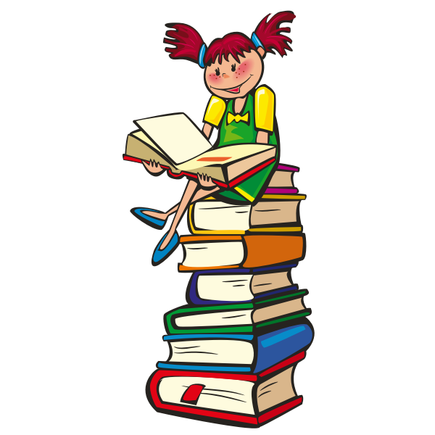
English 1 - 9th Grade
English 2 - 10th Grade
English 3 - 11th Grade

Supply List
- 3-ring binder (1 inch or larger)
- notebook paper
- dividers
- blue or black pens
- a marbled composition notebook
- highlighter
- something used to color (crayons, markers, or colored pencils)
- a calendar, assignment notebook, or planner to keep track of assignments (this can be a hard copy or digital calendar or organizational app)
- pack of index cards lined or unlined
- a positive attitude and an open mind

aelkins@hobgoodcharterschool.org

