|  |
| --- |
| “Bring the vision back into television” http://listverse.files.wordpress.com/2010/02/6a00d83451e28a69e2011570fd1479970b-800wi.jpg |
| http://consumerist.com/images/31/2008/12/thumbchart.jpg  Get One  Your television becomes the window to the information age. Your TV saves and / or makes you or your business money? |

*The MaxBox “Entertain in a Box” & “Biz in a Box” solves all your professional and personal needs. “Bring the vision back into television and take the personal out of personal computer”. Take with you to your business, in your vehicle and back to home.*

The television is not just for entertainment any more. Our exclusive hardware and software applications allows for your TV to make you money and maximize ROI.

[](http://www.thebookpc.com/product_info.php/cPath/68_33/products_id/429)

The one solution for all your personal and professional needs.

NOW YOUR TV MAKES YOU MONEY

*“Bring the vision back into television and take the personal out of personal computer”, with MaxBox. Our specialized database information architecture and proprietary hardware configurations and designs, MaxMedia modes, allows for you to promote products / services through video, slideshows, commercials etc. You configure rotations at the click of a button from any location. Let your customers truly see who you are through your vision.*

[](http://www.fotosearch.com/CSP029/k0292261/)



That was then; this is now! “reality TV of commercial trade” custom to your brand.

[](http://www.fotosearch.com/UNF016/u14135341/)

Edit and display hundreds of commercials. Rotations selected by you right to your TV, projected on your wall, building or billboard.

NOW YOUR TV MAKES YOU MONEY



They say pictures are worth a thousand words, we say video is worth a million!

[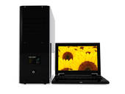](http://www.fotosearch.com/CSP147/k1476961/)

[](http://www.fotosearch.com/OJO149/pe0058962/)

[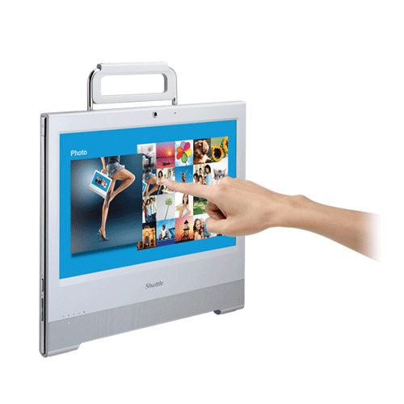](http://www.thebookpc.com/product_info.php/products_id/470)

[http://www.fotosearch.com/bthumb/UNC/UNC109/u14489708.jpg](http://www.fotosearch.com/UNC109/u14489708/) An instrument at one time for only the elite. [](http://www.fotosearch.com/CSK006/pr101901/)

Manage your FREE CyberCentre Mall from any location in the world from your cell phone and deliver coupons, specials, right on your virtual web mall and to your email and cell phone database

[](http://www.fotosearch.com/CSK009/pr87807/)

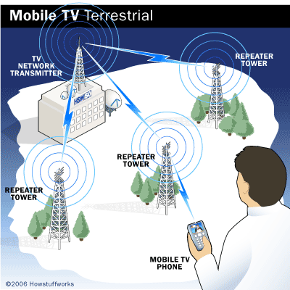

The MaxBox and its affiliated concerns allows for your vision to become a reality for all to see across the globe. Display on the outside of your building for traffic to see, display on you TV in your location of business, display on your wall. Moreover, brand you through our systems from a geocentric marketing campaign to a global market campaign. “From day to day mandated utilities to cyberspace; the world is our marketplace”.

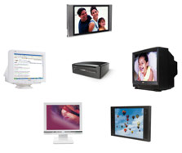[YouTube](http://go.microsoft.com/fwlink/?LinkId=205724)[Twitter](http://go.microsoft.com/fwlink/?LinkId=205722)[Facebook](http://go.microsoft.com/fwlink/?LinkId=205721)Windows

MaxBox On the go……. The same MaxBox for your business, take out of office and plug in your vehicle. Digitize and computerize your auto, yacht, boat, jet. Hands free, dictate all you need to the MaxBox send an email, make a phone call, anything your PC can do, now do right in your vehicle. Hands Free!!! Or use our exclusive MTS MaxBox touch screen. When Parked! Comes equipped with GlobeTrak GPS to track you, where you are going and where your children are at all times.

[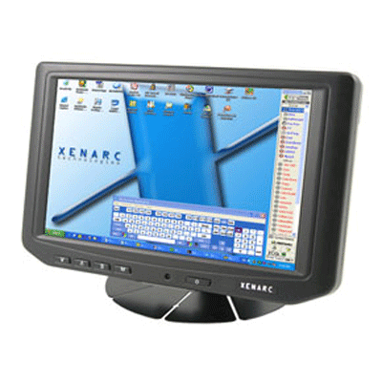](javascript:popupWindow('http://www.thebookpc.com/popup_image.php?im_type=subimage1&pID=453'))[](javascript:popupWindow('http://www.thebookpc.com/popup_image.php?im_type=subimage2&pID=453'))

Sits right on your dash, mounts anywhere. Anything and everything your computer will do MaxBox does and more - at work, on the go, at home.

Computerize and digitize your home or vehicle. Plus always know where your children are.

GlobeTrak GPS inclusive in MaxBox, however, GPS provisioning exclusively by GlobeTrak does not restrict tracking to MaxBox location.

[](http://eflagler.com/Index.aspx?CPID=9286)

Do you know where your children are?

[www.eflagler.com/globtrak.htm](http://www.eflagler.com/globtrak.htm)

Now you can!

From This



To This

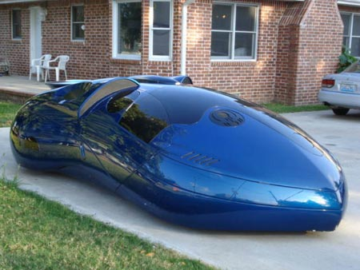Extra Cost for Body Work

“Communications and Commerce for Our New World”

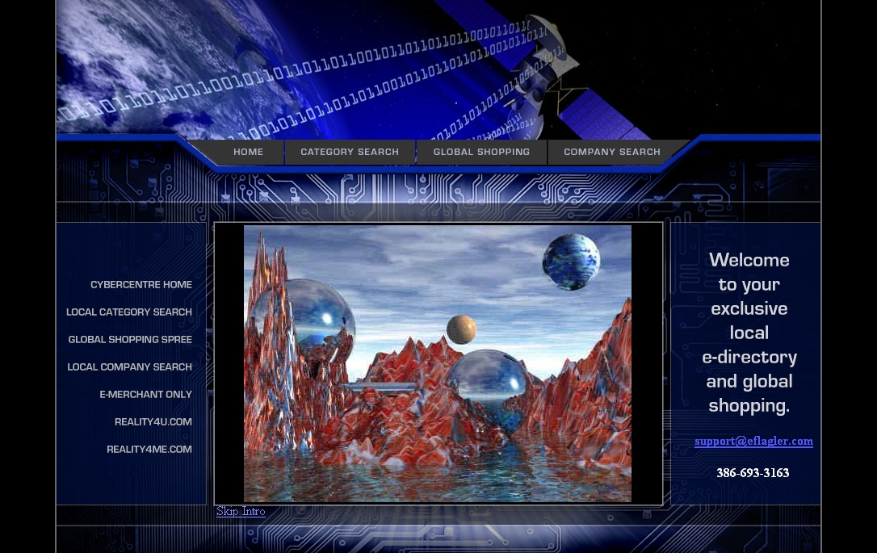

Complete turn-key web interface solutions for unlimited product inventory, company information, product information, video feeds for company branding and every product or service offered, ecommerce, online / offline marketing. Does your website pull Internet traffic? Does your Website integrate with Cell Phone Marketing (Coupons, Specials, Ticketing)? Does your TV or PC make you money? Need a more efficient system for receiving payments and tracking inventory? MaxBox point-of-sale systems utilize the most advanced technology and fastest processors combined with the most current hardware available. So instead of reducing your shelf space, start operating your business more efficiently with MaxBox point-of-sale systems at your business, in your vehicle, at your home.

Limited Time Only FREE CyberCentre Virtual Mall

Complete Merchant Services and Custom POS

NOW YOU SHOW YOUR PRODUCTS, SERVICE & BRAND ON EVERYONE’S TV, MONITOR, OR CELL PHONE

“THE ONLY BOX THAT PAYS”

Light up your Professional Life with Illumination Station Signs

“Your brand in a new light”

[](http://www.fotosearch.com/CSP352/k3527876/) RIDE ON OUR INFORMATION SUPERHIGHWAY (WEB)



As you Drive Down the road, you will see the brake lights light up and sky dim from day to night. Now that would catch your attention. Illumination Station Billboards and Signs. (ROAD)





Windows or Linux Operating System.

Windows



[](http://click.linksynergy.com/fs-bin/click?id=qx05EOw7dW4&offerid=173504.10000403&type=4&subid=0%20)

[](http://eflagler.com/Index.aspx?CPID=9263)

[](http://eflagler.com/%20%09http:/linksynergy.walmart.com/fs-bin/click?id=qx05EOw7dW4&offerid=130188.10004210&type=3&subid=0)





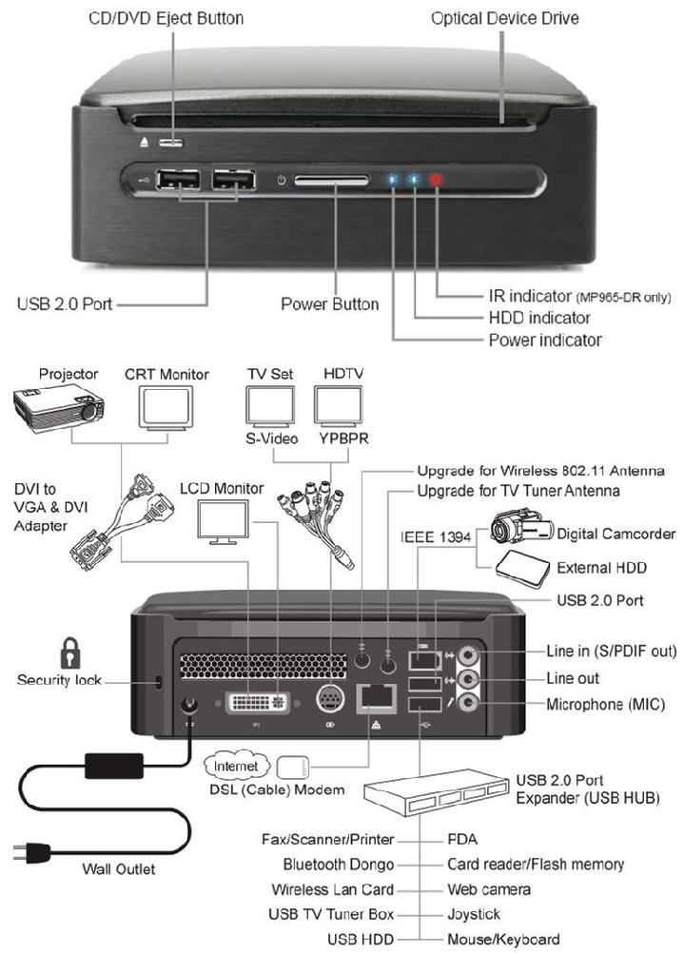

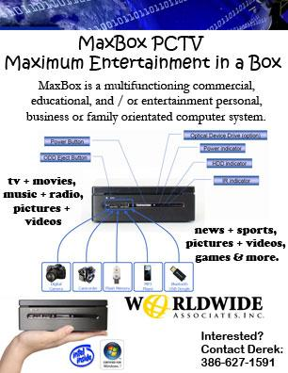

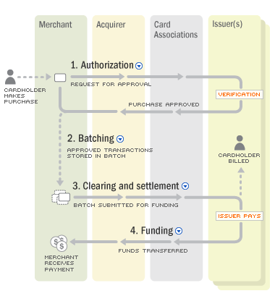

“Reality TV of commercial trade” allows you to create unlimited commercials or presentations from any location on any product or service, the branding is you. They say pictures are worth a thousand words, we say video is worth a million.

Start showing your town, your city, the world who you really are. Simple editing process and upload. Be seen on any TV, your business wall (inside or out), your billboard with video for free! Then show the world.

[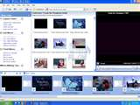](http://fr.brothersoft.com/screenshots/src/394/44178894.eb97c00e9e3221196f709d055829dc75.jpg)

Then, quite simply, get paid!

[](http://www.ecu.edu/cs-cas/biology/images/money_1.jpg)

MaxBox

“The box that pays”

Then, simply, take home and have some fun! “Unify the world; one family at a time”.

**MaxBox PCTV “Maximum Entertainment in a Box”**

**Say Good-Bye-Bills No more Cable Bills!!! No More Phone Bills!!! Save $100.00 dollars or more a month.**

**That’s$1,200 to $2,000 a year. $144,000 average lifetime savings**

**(Depending on your existing cable and landline telephone bill).**

* **FREE TV (New movie releases, classics, to TV episodes and programming)**
* **FREE MOVIES**
* **FREE MUSIC**
* **FREE NEWS**
* **FREE SPORTS**
* **FREE LONG DISTANCE CALLING**
* **FREE COMPUTER / WINDOWS VISTA OPERATING SYSTEM**
* **FREE DVD / BLURAY PLAYER**
* **FREE BLUETOOTH**
* **FREE SURROUND SOUND SYSTEM**
* **FREE WIRELESS INTERNET DEVICE**
* **FREE WIRELESS KEYBOARD AND MOUSE**
* **FREE WIRELESS REMOTE**
* **FREE FREE FREE**

**MaxBox PCTV - Find More Than 100,000 DVD Titles on MaxBox PCTV and its affiliates with up to 17,000 movies to watch on your TV NOW!!!**

* MaxBox and its affiliate concerns now features more than 100,000 titles and television programs.
* MaxBox and its affiliated concerns also offers free DVD shipping, no late fees with so many titles to choose from, you will love the convenience and value MaxBox has to offer.
* In conjunction with, “county to global” website and affiliated concerns Facebook, Yahoo, Twitter, Google, Bing, MSN, MSNBC, Fox, Disney, PBS, CBS, ABC, Universal Studios, Hollywood studios such as Walt Disney Pictures, Sony Pictures Entertainment, Overture Films, Revolution Studios, Miramax Films, Touchstone Pictures, Hollywood Pictures, Pixar, TriStar, Screen Gems, Sony Classics and Warren Miller Films. Select first-run theatrical films The Weinstein Company, IFC and Yari Film Group are also available. You name it we got it. If we don’t contact us.

[New Releases](http://www.netflix.com/BrowseGenres/New_Releases/gnr?lnktrk=GID_NR) and watch immediately

[Action & Adventure](http://www.netflix.com/BrowseGenres/Action_Adventure/296?lnktrk=GID_296)

[Anime & Animation](http://www.netflix.com/BrowseGenres/Anime_Animation/623?lnktrk=GID_623)

[Blu-ray](http://www.netflix.com/BrowseGenres/Blu-ray/2444?lnktrk=GID_2444)

[Children & Family](http://www.netflix.com/BrowseGenres/Children_Family/302?lnktrk=GID_302)

[Classics](http://www.netflix.com/BrowseGenres/Classics/306?lnktrk=GID_306)

[Comedy](http://www.netflix.com/BrowseGenres/Comedy/307?lnktrk=GID_307)

[Documentary](http://www.netflix.com/BrowseGenres/Documentary/864?lnktrk=GID_864)

[Drama](http://www.netflix.com/BrowseGenres/Drama/315?lnktrk=GID_315)

[Faith & Spirituality](http://www.netflix.com/BrowseGenres/Faith_Spirituality/2108?lnktrk=GID_2108)

[Foreign](http://www.netflix.com/BrowseGenres/Foreign/2514?lnktrk=GID_2514)

[Horror](http://www.netflix.com/BrowseGenres/Horror/338?lnktrk=GID_338)

[Independent](http://www.netflix.com/BrowseGenres/Independent/343?lnktrk=GID_343)

[Music & Musicals](http://www.netflix.com/BrowseGenres/Music_Musicals/2310?lnktrk=GID_2310)

[Romance](http://www.netflix.com/BrowseGenres/Romance/371?lnktrk=GID_371)

[Sci-Fi & Fantasy](http://www.netflix.com/BrowseGenres/Sci-Fi_Fantasy/373?lnktrk=GID_373)

[Special Interest](http://www.netflix.com/BrowseGenres/Special_Interest/2223?lnktrk=GID_2223)

[Sports & Fitness](http://www.netflix.com/BrowseGenres/Sports_Fitness/2190?lnktrk=GID_2190)

[Television](http://www.netflix.com/BrowseGenres/Television/2197?lnktrk=GID_2197)

[Thrillers](http://www.netflix.com/BrowseGenres/Thrillers/387?lnktrk=GID_387)

Get Yours Today!!! Limited Time Only and Restrictions Apply*