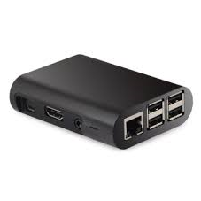

The
“MAX”
Opportunity

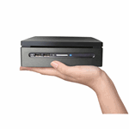

MaxBox / MaxTech Digital Hub
“Communications and Commerce for our New World”
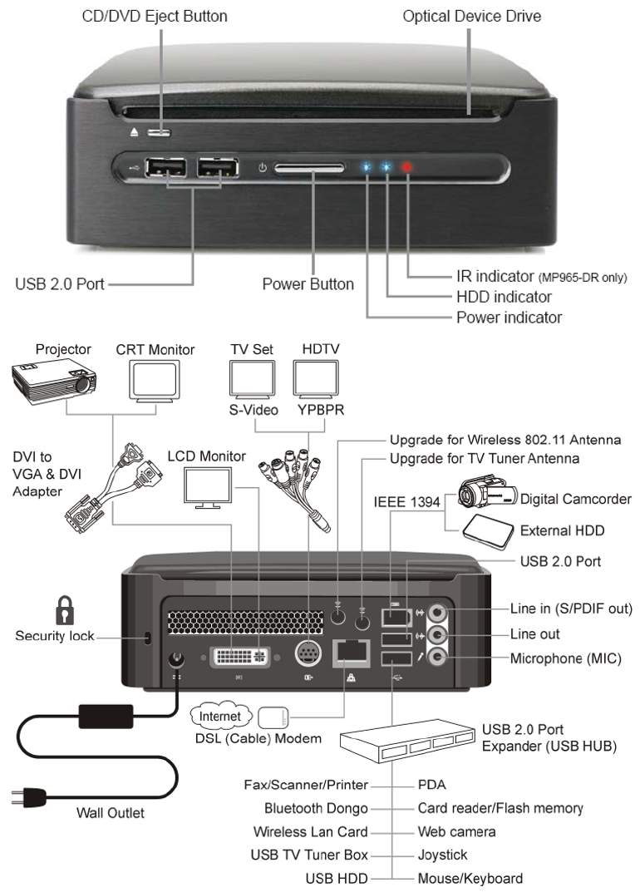

Brief product and service description

In order to ascertain the full notion and concept of the product offered; a full scope understanding of the various internal marketing methodologies of MaxTech and the Worldwide Max consortium must be understood. In simple terms, the product is twofold, the original onset of the product line are various traditional and technologically advanced marketing and advertising tools to assist in the customer generation for small to medium size businesses and the licensing opportunity for geographic expansion. “Once the firm has identified its market segment opportunities, it has to decide how many and which ones to target” (Kotler & Keller, 2006, p. 261). Including all household’s “Liquidation Station” My electronic garage sale the pictorial or video scroll and buy exclusive feature on any computer or cell phone. The MaxBox and cell phone becomes a portable office allowing merchants to display video of business, product and service line and send out redeemable video coupons or swipe credit card on the spot for instant purchasing.
In Section II MaxBox MDU focal point and target market share pertains to large retailers for resale of hardware MaxBox only. The MaxBox MDU is currently engaged in the facilitation of its proprietary configuration, information architecture and hardware technological enhancements with hotels, motels, educational facilities, hospitals, condominium associations, huge conglomerates etc., for customer branding with various income streams uniquely designed to create passive income for such organizations. Within ninety-days of joint venture licensee and the Max consortium pertaining to small business venue as further disclosed here within, a unified marketing and sales campaign is geared be in effect. The Max consortium, MaxTech database and software applications, MaxBox business and entertainment hardware applications and Max towers / Max energy, in juxtaposition, with one another established the last mile solution for any organization and community small to large. The following information is a brief outline for the company’s potential joint venture partner. The company reserves the right to accept or decline any potential engagements with any business and / or individual.

MaxTech’s consumer strategy behind the product

For all intent of practical purposes, this document will display the opportunistic environment for entrepreneurs to duplicate our model systems and capitalize in their exclusive local jurisdiction. The first opportunity consists of a traditional printing company, in juxtaposition with, MaxTech’s integrated “Push and Pull” marketing methodologies, which comprise of traditional printing publications, our exclusive online Internet marketing approaches, online “county to global” platforms, “Cell Cash” cell phone marketing platforms and the MaxBox, as further disclosed here within.
The frontal assault, as it may, to capture clientele in a given county assists in driving traffic to the small business, “brick n mortar door” and the small business, “electronic store”, and inadvertently, allows MaxTech and its joint venture licensee to utilize and leverage the small business traffic to the brick and mortar store and the small business electronic store’s online presence to sell other product and services under the auspice of the WorldWide Associates Max consortium.

The market for which this one aspect one product is intended

The small business market is a viable source and a tremendous market segment. MaxTech “county to global / reality tv of commercial trade” database platforms consist of 19 million small businesses. Businesses can be listed in the “county to global” website portals for free. The small business owner is permitted to upload logos, company description, company information (address, phone numbers, email, etc.), unlimited product pictures and descriptions, and videos about the local small business and continuous video production on product and service line. This is given to the small business owner for free. “Mega marketing is the strategic coordination of economic, psychological, political, and public relations skills, to gain the cooperation of a number of parties in order to enter “ (Kotler & Keller, 2006, p . 260). By offering what no other company offers for free, Max and its JV Licensees are permitted to utilize their business and electronic web presence for other products and services to be sold and essentially create branding, brand awareness, brand recognition, to brand equity for Max Worldwide. “Brand equity is the added value endowed to products and services” (Kotler & Keller, 2006, p. 276).
Furthermore, MaxBox and MaxTech licensees will sell value added services designed to generate more customers to the small business and track return on investment through Internet and cell phone traffic. “A company may benefit from converging industry trends and introduce hybrid products or services that are new to the market” (Kotler & Keller, 2006, p. 52).

How customer needs are fulfilled by the MaxTech opportunity.

The company realizes that duplication is essential in order to open various target markets; United States counties, cities and International global markets. The approach is predicated on MaxTech granting exclusive areas to the joint venture licensee in turn, revenues are earned by our joint venture to open and manage that specified county, or market segment. Due to the branding of Max and its affiliated concerns, MaxTech will scrutinize who it will allow to own the opportunity rights in a given territory. Some of the beneficial constituents are, including but not limited to, sufficient working capital, marketing and advertising history, printing and technical concerns, Internet Marketing (SEO / VSEO) and moreover, successful sales track record. “The prospect theory maintains that consumers frame decision alternatives in terms of gains and losses according to value functions” (Kotler & Keller, 2006, p. 203). In turn, MaxTech can facilitate a turnkey operation inclusive of a full printing company, Internet Marketing and cell phone marketing platforms. The company has also built the back office to which all administrative, technical, and sales issues are easily accessed and streamlined. The American Marketing Association defines a brand as, “a name, term, sign, symbol, or design, or a combination of them, intended to identify the goods or services of one seller or group of sellers and to differentiate it in some way from those of competitors”( Kotler & Keller, 2006, p. 274).

Identification of competitive offerings and MaxTech’s differentiation

The notion of a Franchise is similar to that of purchasing an existing business; although not a franchise the MaxTech eliminates many start-up issues and unknown effects of a traditional start-up business. MaxTech proprietary platforms and systems are designed to grant the JV the ability to engage in a profitable small business with revenue generation within potentially the first two months of operations. “Franchising is a legal agreement that allows one business to be operated using the name and business procedures of another” (Green & Katz, 2009, p. 159). MaxTech’s opportunity, in its truest form, is to assist the JV licensee, with a turn-key well rounded business model and literally become the branded company in that area for all small business needs, from business cards to Internet or television commercials. “Franchises may range from “turnkey,” in which every part of setting up the business is handled by professionals, to those in which the only thing that is franchised is the right to use the business name” (Green & Katz, 2009, p. 143). There are many opportunities available with various features and benefits. The Max opportunity allows for the entrepreneur to earn substantial income and create traffic for various other products and services, including approved licensees products and or services. “The value-delivery system includes all the experiences the customer will have in the way to obtaining and using its offering” (Kotler & Keller, 2006, p. 143).
MaxTech’s marketing mix and how to successfully address problem recognition

Competition can always be fierce and healthy competition is usually well served. MaxTech has analyzed and studied various local and national companies, which purport to be the final solution for small business needs, however, many are costly and only utilize a limited amount of resources to assist the consumer, all of which demand money upfront. On the onset, the local publication, Internet web portals and “Cell Cash” platforms are free to selected businesses as MaxTech and its licensee’s entrée into a particular market. MaxTech and its licensees must continuously analyze and track, most importantly, local competitor’s to know your competition and to be able to differentiate the features and benefits of the MaxTech platform and competition.
“And a company is more likely to be hurt by emerging competitors or new technologies than by current competitors” (Kotler & Keller, 2006, p. 343). The value-added features and benefits to both the small business customer and MaxTech’s licensee make a suitable win / win situation for all parties involved. “A company’s positioning and differentiation strategy must change as the product, market, and competitors change over the product life cycle (PLC)” (Kotler & Keller, 2006, p. 321).

Recommendations to better use the marketing mix in developing marketing strategy for both the problem recognition stage and in the buying process.

Since our information architecture and designs are proprietary and quite technologically advanced, educating the small business customer and the new JV licensee will be part of the marketing and selling process. The pricing reflects a no investment to the JV licensee, upload businesses are free, approximately $1.00 per business in that city or county, as further disclosed herewithin. The coaching, consulting and training are an important component for distribution; to ensure and solidify simple sales presentation. “Marketing communications include advertising, the sales force, public relations, packaging, and any other signal that the firm provides about itself and its products” (Hawkins, Mothersbaugh & Best, 2007, p. 19). The “KISS” principle; Keep it simple Socrates will be part of the distribution channels in order to acquire points-of-presence and customer acquisition. Both MaxTech and its JV licensees must initiate the rationale within the scope of constant change elements, as it pertains to technology, the customer must be educated as to the change initiatives set forth through our integrated marketing modules and the external environments within the marketing approaches. “Extended decision making involves an extensive internal and external information search followed by a complex evaluation of multiple alternatives and significant post purchase evaluation” (Hawkins, Mothersbaugh & Best, 2007, p. 513). Although pricing is within the financial wherewithal for small businesses and the entrepreneur, a solid understanding must be accomplished in order to fully recognize the value of all of MaxTech’s components. MaxTech has instituted a systemic approach to marketing and is aimed at educating its potential customers to buy the services and / or purchase the business opportunity “It is estimated that there are more than 10,000 printed directories aimed at both consumers and trade buyers (and many of these are online)” (Lane, King, & Russell, 2008, p. 467). Most people understand print publications and its possible effects; however, as technology enhances the resources accessible to small business and business opportunity seekers must be available also. MaxTech’s solutions are the viable source for small business owners to generate more income and the entrepreneur who seeks to build his or her own business. The peripheral services would include the auxiliary services that the merchant may not be currently engaged in, i.e., search engine optimization (SEO), video search engine optimization (VSEO), and / or redeemable coupons to cell phones to video commercials with the MaxBox Merchant at potentially hundreds of locations and and cell phones. Inclusive, on the go business transactions right from cell phone, more importantly, The MaxBox residential and commercial vast array of functionalities, as further disclosed here within. These peripheral components will serve as an enhanced marketing medium to enhance return on investment for the customer. “The marketing mix is the product, price, communications, distribution, and services provided to the target market” (Hawkins, Mothersbaugh & Best, 2007, p. 19).

Identification of Local Marketing Issues

Major opportunity/challenge faced in MaxTech local

Within the scope of today's economic fluctuations and globalization era, the element of change has become an unprecedented potential for opportunity, not just huge conglomerates, but for small to medium sized businesses. The small business medium, although not a small niche market, is the preeminent frontal assault embedding through our Worldwide Max Consortium and significant branding within the local county environments.
The small business market segment represents an estimated 64% of the United States Gross Domestic Product (GDP) and will affirmatively remain our firm’s mainstay and the element for success for one aspect of one division of our firm. The following clearly identifies and solidifies the merits and the exponential opportunistic environment for the local county brick and mortar offline and online small business sector and how Worldwide Max Consortium inapt ability committed, to assist local merchants, hereinafter referred to as e-merchants, ‘drive traffic to their local business electronic store and to their local brick and mortar doors’ inclusive, “Point of Cell Cash”. Worldwide MaxTech’s exclusive applications and designs through means of our proprietary database configurations, information architecture, ‘county to global platforms’, and moreover integrated marketing methodologies and business models insure maximum marketing performance levels. This assurance is asserted by giving all local businesses a search engine ready, ecommerce website for free, hereinafter referred to as, In-eShop ecommerce portals. Often times carefully selecting e-merchants for In-eShop multimedia me for free, as further disclosed here within.
However, there exist two primary challenges within the market place of the small business realm. Simply and respectfully stated, "Ignorance”, and lack of sufficient knowledge as to the solutions and remedies to become the predominant competitor within the small businesses owners market place. “Knowledge is not power; the application of the pertinent and relevant knowledge truly is power”.
Another challenge is the proper, concise and facilitation of customer branding for that local merchant. Local merchants will have the opportunity to exemplify and clearly radiate its business missions, objectives, scopes, product or service lines, et al. However, Worldwide Max can only consider allocating its resources to a small portion of the selective business market, unlike other antiquated organizational infrastructure and other current services will inflict competition even within the scope of their own marketing programs. For instance, the hundreds of local directories which currently dominate search engines and often times conflict consumer’s case specific local search specified results. A consumer may be looking for a specific local merchant, click on a local directory and find, sometimes, pages of competitors, ultimately creating confusion and imparting competition.
Worldwide MaxTech brands case specified results within the first and second tier search engines with targeted results to its clients on the search engines and local directories “Pull”, in juxtaposition with its traditional "Push" print and media and "Push & Pull" cash from cell phone platforms.

Identification of decisions made for local merchants

The major decisions to be made are simply what small business, within its categorized element of business, will the company consider becoming the leader in that particular region, in this case the county, for optimal category and keyword searches. For instance, the company intends to exclusively promote one to three types of businesses in its category, i.e. Churches, Accountants, Restaurants, Computers, etc.

External Analysis

External evaluations Worldwide MaxTech takes into consideration during the decision making process

Globalization and how commerce is conducted has changed; given these two constituents, extensive marketing mediums have changed. The integrated marketing methodologies are predominately captured and utilized by large organizations, of which, have the financial capital and human resource capital to implement corporate level branding. Companies, products, and services are all impacted synonymously with the market segments psychological rationale. A company in simplistic terms, in order to create a specified demand for a given product must implement strategies to effectively create brand awareness. This brand awareness can be administered through push or pull marketing approaches or a combination there from.
The decisions to be made from the perspective of the small business owner are to conform to various methodologies and technological advancements due to an external changing environment. The small business owner must learn and adapt to the various change initiatives set forth; as technical means of communications and commerce are conducted. “It is estimated that there are more than 10,000 printed directories aimed at both consumers and trade buyers (and many of these are online)” (Lane, King, & Russell, 2008, p. 467). MaxTech’s integrated “Push & Pull” marketing methodologies encompass traditional and conventional means of exposure. However, it is clearly evident that “Pull Marketing Strategies” increase revenues and free cash flow, not just net income, due to the increased returns on investment (ROI). Search engines and online directories are geared towards those consumers looking for the case specified merchant in a geographic terrain to essentially - “BUY”. Depending on the merchants marketing and branding, including but not limited to, web presence, ecommerce capabilities, pricing, the combination of the properly orchestrated marketing approach, increase brand awareness, brand recognition, and brand equity, all are attributes to the local and global success of any organization. Inclusive, the sum of all components are the levels of expectancy any consumer desires and all businesses strive to ascertain. Worldwide MaxTech provisions these value added services and increases targeted traffic to local businesses online stores (In-eShop); to the local merchant’s brick and mortar door.
The question of the Internet and cell phones as an instrument advertising and marketing medium is no longer, can they work? But how does one integrate soluble cost effective solutions customized to one’s entrepreneurial activity to small or large business endeavors.
The majority of household own a computer and have Internet access, e-commerce has grown exponentially and there are over 4.1 billion cell phones in the world today, with approximately 300 million smart phones with purchases of smart phones increasing exponentially. The MaxTech Worldwide integrated “Push & Pull” exclusive marketing methodologies contribute to the overall entrepreneurial orientated small to large business. However, is dedicated now to the small business entrepreneur.

Internal Analysis

Internal evaluations of Worldwide MaxTech that should be taken into consideration during the decision making process

The business model of the Worldwide Max consortium is to assist local merchants through means of our exclusive and proprietary marketing methodologies and in turn leverage our considerations and assistance to utilize the local merchant free In-eShop and paid In-eShop products and services to cross promote Worldwide and Max consortium's products and services.
Our pricing models, due to our intellectual property, exclusive business models, information architecture and benchmarks are often given to local merchants for free; where even competition may charge in excess of three thousand to ten thousand dollars for inferior systemic integrations. Our systems which have been utilized by large organizations have been transformed and transfigured to appeal to the budgetary constraints most small businesses encompass. The degree and quantitative positioning within the keyword and / or specified category in that particular county will only be a few at a given time, however, premium pricing will work, in juxtaposition, with premium promotion and positioning.
To utilize Worldwide Max consortium’s hybrid combined transformational means of advertising and marketing; to the most efficient and cost-effective means of marketing and advertising is unparalleled in the industry. The overall encompassing objective is to not only procure initial new customer base for local e-merchants, rather, impose a continuum of correspondence to its existing customer base and maintain maximum retention levels and maximize returns on investments
Alternatives
Alternatives to take advantage of the opportunities and solutions identified

Rather have sales personnel trained to close voluminous businesses (e-merchants) in a local county, as the primary means of marketing, MaxTech concedes to coach; the qualified professional consultant; job task performance is to educate and incorporate the MaxTech's integrated marketing methodologies specifically designed for a chosen few small business owner’s to be the leader in his or her regional area within the realm of traditional and electronic directory categories, traditional marketing mediums, search engine optimization, multimedia web sites, herein referred to as, “In-eShop Multimedia Me”. The company has opted to give free to every business in its county local directory, not just local listings, which search engines spiders and crawlers cannot read, but search engine optimized e-commerce capable portals (websites) equipped with company information, address, emails, phone numbers, contact information, unlimited listings of products / services (within reason), along with pictures, logo’s, pricing, etc.
Although coaching / instruction, and education processes are advantageous; sales and closing our clientele is the ultimate objective as is the case in any business. Although, the potential client will acquire the information necessary to make a qualified and quantified decision as to the degree of utilizing our exclusive advantageous services, our coaches and advisors are trained to increase sales from all scenarios. “They will pay a premium to the firm that best satisfies their needs; the niche is not likely to attract other competitors; the niche gains certain economies though specialization; and the niche has size, profit, and growth potential”(Kotler & Keller, 2006, p. 242).

Evaluation of strengths and weaknesses of alternative measures

The strength of our firm and representative’s are to assist in the knowledge mandated to compete locally, regionally, nationally and globally. “Knowledge is not power! The proper application of the pertinent knowledge; truly is power”. The weakness lies in the local merchant’s ability to understand and recognize what one must do in order to compete and even survive in today's era. Similarly compared to the entre of Wal-Mart, Target, and other recognized one stop shops in local communities, these conglomerates have redesigned the scope and climate of the small business model. Small business owners who were sophisticated and savvy enough to recognize the inevitable market penetration, these huge conglomerates would procure in juxtaposition with, the potential risk of putting the local business owner out of business have established their niche market and remain a provider of service or deliverer of a specified product unparalleled to that of a conglomerate.

Decisions and Implementation

Propositioning the viable solution to the so-called challenge

Inclusive is a 19 million small business database, the company will opt and choose various pricing packages and promotions for companies in its case specified category or keyword terminology, consolidated on a countywide basis, “county to global”. “The value proposition consists of the whole cluster of benefits the promises to deliver” (Kotler & Keller, 206, p. 143). The combination of traditional, online, and cell phone ease of marketing are now available to local county merchants through Worldwide Max, which has only been accessible and economically feasible for larger organizations to global conglomerates, until now with Worldwide Max integrated marketing solutions.
Another impedance on the decision making process and foregoing action for small businesses has been the entre processes into the global marketplace. Global Shopping Worldwide is an automatic global positioning instrument for all local county merchants to also earn on the sales or clicks derived from their In-eShop multimedia site. The notion of globalization is not economically feasible, nor, a viable option for a local small business merchant, the Worldwide Max can administer the notion of the globalization process by opening over 300 recognized world renowned conglomerates, i.e., Wal-Mart, Tiger Direct, Macy’s with hundreds of thousands to millions of products for customers to purchase and the local merchant community cluster to capitalize on.

Decisive Implementation

Worldwide MaxTech’s proposed combined resources and solutions have worked in the past and continue to work for clientele today.

"Integrated marketing communications (IMC) could be called simply common sense. In the past, many marketing functions - advertising, promotion, packaging, direct marketing, public relations, events - were created and managed independently in most organizations. Today, a brand's equity is best strengthened through the integrated use of all marketing communication tools working from a single strategy. It is imperative to projects a single, cohesive brand image into the marketplace and into the consumers mind. The result has been what is labeled integrated marketing communications" (Lane, King, & Russell, 2008, p. 11).

Worlwide Max’s integrated “Push & Pull” exclusive marketing methodologies utilize and leverage most successful means of advertising. Many services are offered free as an investment in the local county merchant business. However, the ultimate objective is to simply drive traffic through print, online, media, cell phone advertising to the local county merchant’s In-eShop ecommerce and In-eShop Multimedia electronic store and their brick n mortar door. Including MaxBox Video Signage Displays. “Virtually every magazine, newspaper, and major broadcast outlet has some Internet presence” (Lane, King, & Russell, 2008, p. 419). The premium Internet presence pulls targeted customers and initiates purchasing online, initiates call ins or drive in consumers willing and ready to buy from that local merchant, e-merchant.
The key element for all facets of marketing is brand equity for all local business owners to supersede its local, perhaps, global competitive forces. “The value of how such people as consumers, distributors, and salespeople think and feel about a brand relative to its competition over a period of time” (Lane, King, & Russell, 2008, p. 419).

MaxTech / Max Box Merchant Service Integration

MaxBox serves the needs for two lifestyles as it may pertain to business and pleasure. “The mere ownership effect, or the endowment effect is the tendency of an owner to evaluate an object more favorably than a non-owner” (Hawkins, Mothersbaugh & Best, 2007, p. 437). The MaxBox includes the independent self-conceptualized notion, “The independent self-concept emphasizes personal goals, characteristics, achievements, and desires” (Hawkins, Mothersbaugh & Best, 2007, p. 434) and the interdependent self-conceptualized notion, “The interdependent self-concept emphasizes family, cultural, professional, and social relationships” (Hawkins, Mothersbaugh & Best, 2007, p. 434), due to the mere fact that the MaxBox is an elite; one of a kind proprietary business tool and a family orientated home entertainment device; the product initiates all conceptualized notions to initiate the psychological standpoints for consumers to make a purchase . The business owner or entrepreneur wears two hats, the businessman / woman and more often than not, the family man / woman. The professional businessman / woman personality is that of independent conceptualized notion; the personalized (family) man / woman personality is that of the interdependent conceptualized psychological notion, hence triggering the purchasing process. “We define purchase involvement as the level of concern for, or interest in, the purchase process triggered by the need to consider a particular purchase” (Hawkins, Mothersbaugh & Best, 2007, p. 511). Business owners, for the most part, spend much of their time and invest sacrificially into their business. Many of which would also like to spend time with children their family. The MaxBox is that technological advancement which administers and triggers the ultimate processes encompassing two important aspects in life; their business and their family life. “If the consumer anticipates these benefits in advance and values them, he or she is much more likely to buy the brand” (Hawkins, Mothersbaugh & Best, 2007, p. 232).

Max Slogan, “Bring the vision back into television; take the personal out of personal computer, unifying the world one family at a time”. Hence, leading the purchase process to encompass the experience of a personalized endowment for enhanced family and personal living. “A peak experience is an experience that surpasses the usual level of intensity, meaningfulness, and richness and produces feelings of joy and self-fulfillment” (Hawkins, Mothersbaugh & Best, 2007, p. 436).
The following is a clear depiction as to the commercial applications.

MaxTech / Max Box Product Decisions
Brand name
The integrated marketing processes of the MaxTech web interface and software solutions and MaxBox hardware solutions, hereinafter referred to as, the Max or Max consortium are unparalleled in the market place. The Max brand as reflected in this document will encompass the desirable mandated business and personal components instrumental for today’s financial managerial concerns, to marketing management and methodologies. The company has chosen to regionalize its market penetration to the small business market segment, inevitably arising as the prominent and most recognized instrument for local county merchants on a regional county wide basis. The unique direct sales approach, in juxtaposition, with its proprietary configurations and designs will set forth a paradigm shift as to how the marketing industry and organizations conduct operations of today, as further disclosed herewithin.
Max marketing mix methodologies utilizes its hybrid traditional “Push” marketing through means of printed local county publications, television, and radio for small business branding and the Max consortium branding. The MaxTech marketing “Pull” Internet SEO and VSEO marketing methodologies and its, “cashcell”, “Push & Pull” cell phone marketing are the primary branding mechanisms to merchants. As for the Internet, “Four out of five advertisers who use Internet advertising use it as a branding device (79%) and two- thirds use it to drive information gathering for an offline transaction (65%). Slightly less than three in five advertisers (58%) use Internet advertising to drive online transactions while 57 percent say the use it to promote community around their brand” (Sachoff, 2009, p. 1). Furthermore, statistical analysis and evidence predominantly substantiates Internet presence and advertising, “The survey found that the majority of Americans (65%) feel they cannot live without Internet access” (Sachoff, 2009, p. 1). Internet access simply reflects supply and demand for web presence, ecommerce, and Internet related aspects. A simplified, do it yourself commercial reality TV, yet, powerful online presence, in juxtaposition with the integrative computational Linux / Windows functionalities, exclusive ecommerce mall, security, on-site commercial advertising campaigns, merchant credit card services will only help strengthen a brand and generate sales, with maximum return on investment. Including all household’s “Liquidation Station” My electronic garage sale the pictorial or video scroll and buy exclusive feature.
See Table 1
Functionality
The MaxTech database platforms comprises 19 million businesses consolidated within a particular jurisdiction, on a county wide basis all businesses listed with a complete ecommerce platform with merchant account services, media and multimedia capabilities.
“Internet users find many aspects of online advertising very annoying. The majority (80%) say they find ads that expand on the page and cover the content very frustrating while 79 percent say ads where they can't find the close or skip button are very frustrating. Three-quarters of consumers (76%) find Internet ads that automatically pop up very frustrating while two-thirds (66%) say ads that open if they are "moused over" are very frustrating. Three in five consumers find both animated ads that automatically start playing and ads that play music and/or have loud soundtracks to be very frustrating (60% for both). "Although the trend among advertisers is clearly towards the Internet, advertisers have to walk a fine line," the study concludes” (Sachoff, 2009, p. 1).
The MaxTech information architecture applications and designs are recognized for its ease of use to the merchant and conforms to consumer desires to aid in maximized brand awareness, brand recognition and brand equity for its local county merchant marketing mix.
The MaxBox “Biz in a Box” becomes the security system, advertising mechanism (in-store and online), video production and display, and merchant service requisition for credit card purchases, (including Visa, Master Card, Discover and American Express), complete multi-functioning computational and entertainment device.
The MaxBox “Entertainment in a Box” is the family component of which its functionalities encompass all aspects of entertainment, including but not limited to, 17,000 downloadable movies to hundreds of thousands of movies and music (restrictions apply and subject to change). “The prospect theory maintains that consumers frame decision alternatives in terms of gains and losses according to value functions” (Kotler & Keller, 2006, p. 203).

Styling
In today’s era, technological devices are becoming smaller and smaller. To meet the demands of clientele the device is approximately 4.5 inches wide, 5 inches length, and 2.5 inches thick with a concaved black stylish sleek look. The MaxBox can balance in the palm of ones hand, conveniently allowing the latitude to utilize the MaxBox at work and at home.
See Advertising Exhibit
Quality
The MaxTech grants superior quality as it may pertain to the presence on the web for the small business and the MaxBox multi-functioning computational entertainment device is compact in design and allows for easy maneuverability with all the functionalities of, including but not limited to, the personal computer, surround sound system, DVD player, Blue Ray and all capabilities for third party software applications software and Internet downloads (Windows, Linux, or proprietary operating system).
See Advertising Exhibit (Specifications)
Safety
The MaxBox meets all global safety requirements suitable for both in home and at work as reflected in promotional materials herein enclosed.
Packaging
Upon merchant acquisition for merchant services, the MaxBox hardware solution will be delivered within one week to the merchant bubble wrapped and custom styrofoam casing to insure safe delivery, furthermore, optional co-branding for merchants who wish to sell the MaxBox “Entertainment in a Box” as another source of income from their current day to day business.
Repairs and Support
Merchants will have access to assigned direct sales agents and those in managerial capacities as it may pertain to merchant services. Merchants will have access to technical support for the MaxBox. The MaxBox repairs can be accomplished onsite, in such case of hardware deficiency or challenges, the MaxBox will be delivered at the merchant’s expense to MaxTech’s nearest hardware repairs and service locale. MaxBox cannot and will not render support on third party software applications.
Warranty
1 year on all hardware.
Accessories and services
Additional accessories for merchant service clientele will be a projector for on site in-store video display for commercials, PowerPoint presentations, et. al. Inclusive with the purchase of MaxBox merchant service revision is also a credit card swipe for in-store purchase and web interface for online purchases. “A product is anything that can be offered to a market to satisfy a want or need” (Keller & Kotler, (2006), p. 372).
MaxTech / Max Box Pricing Decisions
Pricing strategy (skim, penetration, etc.) Premium pricing
MaxTech integrated exclusive traditional, online, and cell phone advertising and marketing methodologies will be free to various merchants, herein often referred to as emerchants, which the company deems to be a mutually beneficial business relationship. Unparalleled in the market place, within the scope of the advertising and marketing sectors, whereby no upfront marketing fees are an integral aspect to the MaxTech marketing business model. MaxTech will carefully select various small business owners and establish brand awareness, brand recognition, brand equity, marketing and advertising, for merchants who lease the MaxBox and / or Maxtech’s affiliated merchant service consumer base, as referred to in product decision section of this document.
MaxBox will remain a premium priced instrument representing quality including all of its brand extensions. “If the consumer anticipate these benefits in advance and values them, he or she is much more likely to buy the brand” (Hawkins, Mothersbaugh & Best, 2007, p. 232).
Suggested retail price
MaxTech selected emerchants zero cost (certain restrictions apply inclusive MaxBox “Biz in a Box” lease agreement and purchase and merchant account service contractual relationship with merchant). The MaxBox retail ranges from $500.00 to $2,500.00 “The value proposition consists of the whole cluster of benefits the company promises to deliver” (Kotler & Keller, 206, p. 143).
Volume discounts and wholesale pricing
Max JV licensees will be privy to volume and wholesale pricing and procure free cash flow through wholesale to retail margins of opportunity.
Cash and early payment discounts
No discounts available on the MaxBox, however, MaxTech marketing services will offer discounts and promotions, including free marketing in all aspects of our marketing methodologies with solidified back end compensation through cash, check requisitions, merchant credit card processing Internet and cell phone promotional redemption campaigns.

Seasonal pricing
Holiday specialized discounted pricing or incentives may be taken into consideration.
Bundling
The bundling aspect of MaxTech and MaxBox integrated platforms, configurations, applications and designs supersedes and is unparalled to any product or service in the market today. “Some consumers take the higher price to signify a better product. A seller can charge a higher price than competitors and still get the business if the company can convince the customer that it offers the lowest total cost of ownership (TCO)” (Keller & Kotler, (2006), p. 439).
Price flexibility
There is no pricing flexibility, with the exception as disclosed herewithin, and various revision pricing.
Price discrimination

There is no price discrimination.

MaxTech / Max Box Placement Decisions

Distribution channels
Each local merchant and or paying or non-paying client is essentially a distribution channel for the Max consortium.
Max consortium licenses are also sold, for the resale the Max consortium professional and the e-commerce directory and database e-mall. Most organizations could utilize the MaxBox PCTV real-time compression technology for advanced personalized customer interaction. (See Channel Distribution section)
Market coverage (inclusive, selective, or exclusive distribution)
Worldwide Max consortium encompasses the globalization process for its own business models and objectives and assists various globalization market penetration remedies for entrepreneurs and small businesses. However, the Max consortium segments its market penetration on a regionalized basis, more over, county wide basis through its “county to global” platforms.

Specific channel members
“However, companies differ in the emphasis they put on short-term versus long-term profits” (Kotler & Keller, 2006, p. 347). Many marketing, advertising agencies and merchant services will penetrate a market; customer accessibility and acquisition is not limited. In other words, they will take on most any client. Max consortium is highly selective when it enters into a particular county; “its county to global” program. Procure case specific clientele; market carefully selected organizations free, establish a foothold in that community through its voluminous points – of – presence (specific channel members) and then capture a large percentage of business in that particular region county et. al.
Inventory management
MaxTech has its own inventory control systems. MaxTech also offers for free a basic POS system and will customize accordingly with its programming and accounting departments, hence bundled in the merchant account customer premise equipment “MaxBox”.
Warehousing
For organizations which engage in preferred wholesale pricing the facilitation of inventory and warehousing is the sole responsibility of their company. Current production capacity is always accommodated to clientele’s MaxBox units per day delivered with increased supply based on demand within a two week period.
Distribution centers
Each client paying or non-paying, since Max offers what no other organization can, each business is an actual point – of – presence or distribution center for Max consortium.

Order processing
MaxTech’s choice in merchant services to be marketed to merchant.
Transportation
Ground or Air shipping and Internet distribution.
Logistics

Max consortium has decided to target market various segments of geographic terrain, hence, setting precedence for a new trend in the marketing, merchant account and advertising sectors of industry. Through its international licensing contractual arrangements and international direct sales approach, Max will change the scope as to marketing and merchant services. “A trend is a direction or sequence of events that has some momentum and durability” (Kotler & Keller, 2006, p. 77). As the Max consortium continues to open counties through its distribution centers, Max and its licensee’s and literally evolve the major branded component in the counties, an inevitable global paradigm shift takes place.

MaxTech / Max Box Promotion Decisions

Promotional strategy
“To evaluate opportunities, companies can use Market Opportunity Analysis (MOA) to determine the attractiveness and probability of success” (Kotler & Keller, 2006, p. 143). The Internet and Max “cashcell” integrated marketing approaches are the main objective with regards to the merchant marketing and advertising methodology. “According to the poll, adult Internet users are spending an average of 13 hours a week online. Of course, people's usage varies greatly; one in five (20%) of adult Internet users are online for only two hours or less a week while one in seven (14%) are spending 24 or more hours a week online" (Crum, 2009, p. 1).
See Table 5
Advertising
“People’s attempts to obtain their self-concept, or maintain their actual self-concept, often involve the purchase and consumption of products, services, and media” (Hawkins, Mothersbaugh & Best, 2007, p. 438). The advertising component for utilizing the Max system is traditional print / media marketing, Internet (SEO & VSEO), Projectile video and media, i.e. commercials, You Tube, Power Point, multimedia productions, inside and outside of the merchants locale and cell phone marketing. Hence, driving traffic inside the store and solidifying sales through the Max innovative proprietary processes. “Commerce sites sell all types of products and services, notably books, music, toys, insurance, stocks, clothes, financial services, and so on”(Keller & Kotler, 2006, p. 494).

Personal selling & sales force
Max consortium sales force will comprise of in-house direct sales representatives, marketing companies, social sites, affiliate marketers, wholesalers, third part independent vendors, and licensees. “One survey revealed that the top 27 percent of the sales force brought in over 52 percent of the sales” (Kotler & Keller, 2006, p. 620). Online webinars and tangible empowerment will be instrumental for sales personnel and / or licensees. “Most marketers believe that the higher the salesperson’s motivation, the greater the effort and the resulting performance, rewards, and satisfaction and thus further motivation” (Kotler & Keller, 2006, p. 623).
Sales promotions
“The term consumer decision produces an image of an individual carefully evaluating the attributes of a set of products, brands, or services and rationally selecting the one that solves a clearly recognized need for the least cost” (Hawkins, Mothersbaugh & Best, 2007, p. 510). There will always be ongoing free download business to business (B2B) “Biz in a Box” applications and business to consumer (B2C) “Entertainment in a Box”.
Public relations & publicity
Hiring a public relations firm is also the objective to assist in the commercial and residential lifestyle adaptations. “A lifestyle is basically how a person lives, It is how one enacts one’s self concept, and is determined by one’s past experiences, innate characteristics, and current situation” (Hawkins, Mothersbaugh & Best, 2007, p. 441). Since the Internet is not just a luxury but a lifestyle, public relations and joint ventures are instrumental in Max worldwide market penetration. “The survey found that the majority of Americans (65%) feel they cannot live without Internet access” (Sachoff, 2009, p. 1). The Max consortium as reflected through out this document administers to the business, personal, and family lifestyles across the globe. “Individuals and households both have lifestyles. Although household lifestyles are in part determined by the individual lifestyles of the household members, there reverse is also true. (Hawkins, Mothersbaugh & Best, 2007, p. 441).

Marketing communications budget

“The majority (92%) of advertisers are using Internet advertising in their media campaigns followed by print advertising at 88 percent, according to a new LinkedIn Research Network/Harris Poll” (Sachoff, 2009, p. 1). Local merchants allocate sufficient resources for Internet advertising; Max integrates all process, much of which for free.

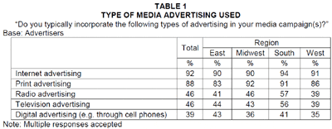

Retrieved from http://www.webpronews.com/topnews/2009/07/22/more-advertisers-turning-to-internet

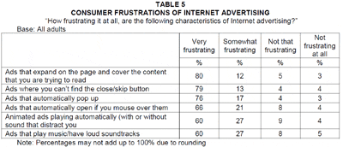
"At least three in five consumers are very frustrated with six of the main Internet advertising characteristics, and there is the potential to see a backlash forming. To be successful, those that advertise on the Internet will need to come up with more engaging ways to connect with consumers." (Sachoff, 2009, p. 1).

Retrieved from http://www.webpronews.com/topnews/2009/07/22/more-advertisers-turning-to-internet

“According to the poll, adult Internet users are spending an average of 13 hours a week online." Of course, people's usage varies greatly; one in five (20%) of adult Internet users are online for only two hours or less a week while one in seven (14%) are spending 24 or more hours a week online," says Harris.
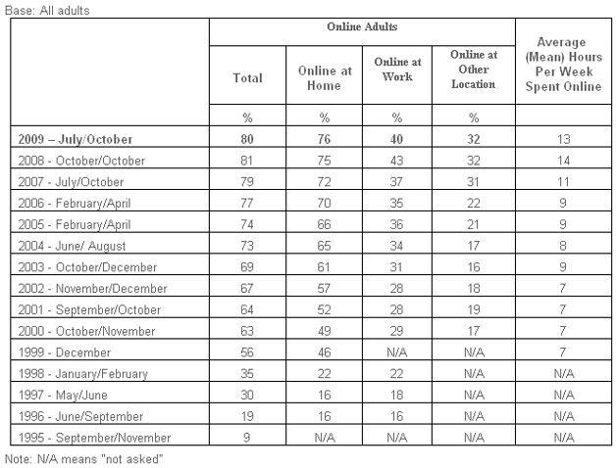
Retrieved from http://www.webpronews.com/topnews/2009/12/23/average-person-spends-13-hours-a-week-online
“The firm presents the following as highlights from the poll: The age groups that spend the most time online are those aged 30-39 (18 hours) and those aged 25-29 (17 hours) and 40-49 (17 hours).
- Half (50%) of all those online bought something on the Internet in the last month. This includes 62% of those aged 30-39 and 56% of those aged 40-49.
- The number of adults online, now 184 million (80%), has not changed significantly since 2008 and 2007. This includes those online at work, at home, at school or any other locations.
- However, the number of adults who are online at home has increased to 76% this year, and 75% last year, compared to 70% in 2006, and 66% in 2005.
More findings from the poll can be found here, including more graphs, breaking them down by hours spent each week online by age, purchased online in last month by age, and PC/Internet use trends, as well as the estimated numbers of adults who are online - all by year” (Crum, 2009, p.1).
Section 2 Glossary of Terms

Product decisions | Pricing decisions | Placement decisions | Promotion decisions
- Brand name – recognized trade name, product or service due to properly orchestrated brand awareness, brand recognition and brand equity marketing tactics.  - Functionality – the ability to fulfill specified or required needs.  - Styling – custom manner to differentiate a product and / or service.  - Quality – a product or service specified and reflected as excellent performance or attributes.  - Safety – avoidance of detriment, harm or risk.  - Packaging – containment utilized for additional branding.  - Repairs and Support – primarily replacement of defective parts and customer service related issues.  - Warranty – term or length of time where product and / or services rendered will be replaced without a repurchase.  - Accessories and services – value added components to original product line. | - Pricing strategy (skim, penetration, etc.) – evidentiary ways in which the price will penetrate and meet demands of clientele.  - Suggested retail price – merely the retail price difference from actual price.  - Volume discounts and wholesale pricing – pricing which usually decreases due to voluminous scaled purchases.  - Cash and early payment discounts – decreased actual retail price for cash paying benefits or discounted leasing terms (No prepayment penalties).  - Seasonal pricing – pricing increase or decrease due to particular weather conditions or holiday  - Bundling – vast array of products and / or services included in one package.  - Price flexibility – pricing varies and fluctuates contingent upon various factors.  - Price discrimination – price changes due to ethnicity or favoritism. | - Distribution channels - methods to which product availability are accessible for purchase to targeted consumers through points of presence.  - Market coverage (inclusive, selective, or exclusive distribution) – demographic and geographic terrain to target market.  - Specific channel members – chosen channels of communications or distribution.  - Inventory management – POS Point of Sale, Accounting methodologies.  - Warehousing – where is inventory is housed for distribution to distribution centers.  - Distribution centers – points of presence whereby sales or promotions are located.  - Order processing – merchant services and database designs.  - Transportation – methods for delivery.  - Logistics – the coordination and implantation of such business objectives. | - Promotional strategy – the methodology in which branding and sales is triggered.  - Advertising – exposure of a particular business, product, or service.  - Personal selling & sales force – methodology in which an organization facilitates sales. i.e. direct sales  - Sales promotions – specialized methods to induce a certain sale of product or service.  - Public relations & publicity – integrating in a specified community and inducing exposure.  - Marketing communications budget – human and financial resources allocated to expose desired company, product, and / or service.

Exhibits Below

MaxTech and MaxBox

Consolidated product / service description, business objectives, scopes and missions.

The product comprises the choice for hardware, software, and web-based applications designed to drive traffic to electronic storefronts and brick and mortar store fronts, hence, maximizing return on investments (ROI). MaxTech (web based application) and MaxBox (hardware and web based application are two choices for use. B2C entertainment, “MaxBox Entertainment in a Box” and computing for residential use and B2B entrepreneurs and small businesses to choose from, “MaxBox Biz in a Box”.

Business to Business (B2B) and Business to Consumer (B2B) Applications

The MaxTech Web Based Application is strictly for entrepreneurs and small to large business to utilize our proprietary information architecture and design for a soluble integrated marketing methodology, “Push” “Pull” and “Push Pull” platform. The integrated platforms comprise of traditional print media, multi-media, Internet Marketing, and cell phone marketing. The only one of its kind without competition currently. Healthy competition is good, our platforms are streamlined and automated granting the ability to cut competitive pricing or remain the leader in areas we establish a foothold.

Worldwide Associates, MaxTech, MaxBox, MaxTowers introduce its exclusive and proprietary (B2B) and (B2C) products and services.

- MaxBox hardware, software, and web based applications.

- One complete entertainment and business application

- MaxBox hardware and software applications for complete entertainment and biz in a box

- Our database comprises of 19 million small business database, consolidated into regionalized “county to global programs.

- Telemarketing, direct sales, dealerships for “county to global build out” for expansionary measures

- MaxBox pay to be seen, “maximum exposure in a box” the do it yourself reality TV of commercial trade

MaxBox PCTV Maximum Exposure in a Box (B2B) Commercial Application

“Biz in a Box” comes equipped do it yourself video production for you multimedia In-eShop website, marketing and advertising interface for traditional, online and cell phone advertising.

Service Line

- Local County Merchants: free ecommerce website virtual storefront (SEO and VSEO ready), not just an ad on a local directory which search engines can’t read and perpetrates competition when Internet searches are looking for narrow specific companies. Multimedia reality TV webmercial Internet site and onsite integrations, blogs, directions, open source county platform. True social business network.

- Global Entrepreneurs and small businesses entire mall for, for their own products or drop shipping turn key internet marketing systems, video production and editing, advertising projectile, turn-key cell phone marketing platforms, traditional media and print campaigns.

- MaxBox merchant account services.

- MaxBox security system.

- MaxBox real time video for consumer interaction and security.

- MaxBox electronic sales, advertising, marketing, security agent and more.

MaxBox PCTV Maximum Entertainment in a Box (B2C) Entertainment Application

MaxBox is a multifunctioning computational commercial, educational, and / or entertainment personal, business or family orientated device. Including all household’s “Liquidation Station” My electronic garage sale the pictorial or video scroll and buy exclusive feature.

Product Line

- tv + movies,
- music + radio,
- pictures + videos,
- news + sports,
- pictures + videos,
- games & more.

Standard Windows Vista Operating System and wireless. Custom specifications available.
(Biz in a Box inclusive)

Slogan 1 - “Take the personal out of personal computer, for business or pleasure and bring the vision back into television, hence, unifying our world; one family at a time”.

Squint Slogan - You can squint and plug into your monitor or don’t squint and plug into your big screen or projectile real life size on wall. “Unify the world; one family at a time”.

Mission: “To utilize utilities, communications, commerce, the Internet and technological advancements to unite a global world and eliminate social, cultural, technical and economic boundaries”.

Motto: “From day to day mandated utilities to cyberspace; the world is our marketplace”.

In the world of technology competition is fierce. Our business objectives have been to align and support local small businesses, from our 19 million business database, broken down to regional counties. The “county to global” electronic points of presence and the physical brick and mortar points of presence will assist in saturating the market for what we aspire to as a paradigm shift as to commerce and entertainment deployment in one platform and one device, MaxTech Marketing and MaxBox.

Merchants have a vested interest in marketing themselves through our systems and then earn commissions on sales derived from their brick and mortar storefronts and electronic storefronts. Simply MaxTech and MaxBox drive traffic to the local businesses with the MaxTech and MaxBox merchant services. We leverage the small business and they leverage us for a win win scenario.

The company also has signed agreements with hundreds of name brand outlets, i.e. Wal-Mart, Macy’s, Tiger Direct etc. to earn on a pay per click basis and or commission on products sold. Parts of the proceeds are allocated to churches, temples, other faith-based action programs and community action programs. Not to serve as a corporate mandated societal responsibility, but a chosen right to assist those in need and to enhance our “redistribution of wealth” community action program by action and satisfy our simplified slogan, “Unify the world, one family at a time”. By the grace of God, penetrate globally and giving to others will become contagious, “Flow of money as a river, as opposed to restricted in a reservoir”, our part in the redistribution of wealth.

There are vast services to be marketed and variations of integrated products to be marketed. MaxTech local business services are considered, “Worldwide Associates: Social Business Network". Its targeted market is to penetrate small businesses and entrepreneurs in the promotion element of their current business and assist in potentially globalization expansionary measures through an integrated means of marketing methodologies. The integrated marketing methodologies include traditional "county to global" print advertising, media, e-commerce and multimedia Internet adaptations and marketing, and promotional campaigns to cell phones.

MaxTech is the branding for the aforementioned services to be rendered to small businesses and entrepreneurs.

"Integrated marketing communications (IMC) could be called simply common sense. In the past, many marketing functions - advertising, promotion, packaging, direct marketing, public relations, events - were created and managed independently in most organizations. Today, a brand's equity is best strengthened through the integrated use of all marketing communication tools working from a single strategy. It is imperative to projects a single, cohesive brand image into the marketplace and into the consumers mind. The result has been what is labeled integrated marketing communications" (Lane, King, & Russell, 2008, p. 11).

Worldwide Associates MaxTech DataWare, Corp. is designed to aid in marketing and advertising campaigns for the clients existing businesses and also enhances return on investment in advertising and marketing budgetary expenditures. Furthermore, Worldwide Associates and Max have contractual arrangements with hundreds upon hundreds of small to large corporations, including, Wal-Mart, Macy's, Tiger Direct and allows for pay per click and / or commissions to be earned by the local merchant from products and clicks derived from their In-eShop websites.

As far as the demographics and geographic concerns, our database consists of a 19 million business database and is consolidated through, what we call a "county to global" web portal. The demographics of human population and population segments which include small businesses and entrepreneurs are between the ages of 18 to as old as their 80's. The geographic expansionary business objectives are to continue to engage in joint ventures for our proprietary information architecture for an entrepreneur to capitalize in his or her city or county.

MaxBox is an exclusive hardware configuration, which includes, the MaxTech marketing services technologies, platforms and databases to assist local businesses. The MaxBox also serves as an exclusive entertainment multi-functioning computational device. The demographics would range from the ages of mid twenties, due to purchasing capability, however, population segment and psychographic personality characteristics would be anyone interested in for the entertainment, educational, computing capabilities of the MaxBox hardware device. Any computer literate individual or consumer desirous of purchasing a computer with exponential capabilities would represent a grandiose market segment.

The psychographic elements and populous would simply be anyone who is seeking a product which will implement all aspects of today's computer functionalities and our exclusive commercial, entertainment and educational components. All computing, entertainment, education, communications, and commercial shopping are integrated in our MaxBox Technology with the option to use monitor or wide screen television for optimal enjoyment and practical usages.

"MaxBox fits in the palm of your hand and allows the television to become the window to the information age"



Click below to view logo full size on desktop screen on TV.

Commercial Application Slogan "Maximum Exposure in a Box - Biz in a Box" "We drive traffic to your electronic store and your brick n mortar door".

Entertainment Application Slogan "Unify the world, on family at a time" "Bring the vision back into television and take the personal out of personal computer"

Built in Merchant Account Services (Visa, MasterCard, Discover, American Express based on approval)
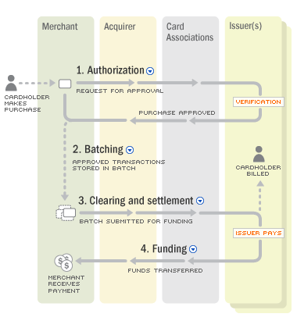

Full-page magazine advertisement
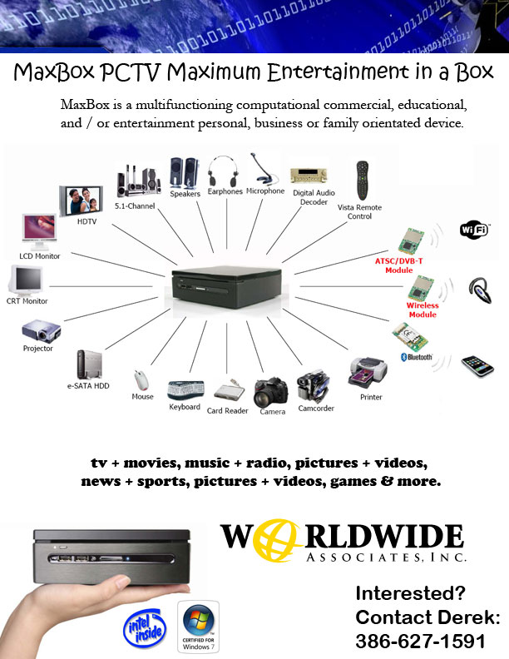

Newspaper advertisement

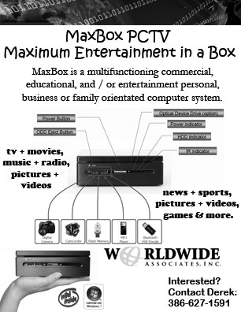

Billboard Advertisement

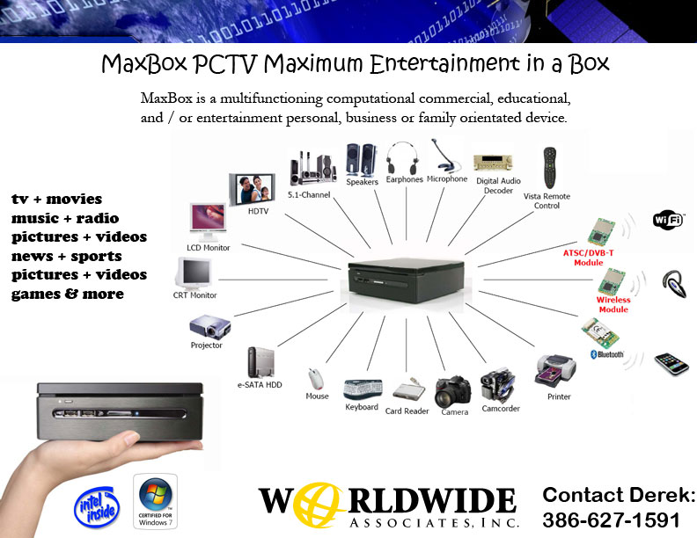

30 second radio commercial script
“Bring the Vision back into television and take the personal out of personal computer: Unify the world, one family at a time.” For all your families entertainment needs the MaxBox can be your personal workstation or your families entertainment system. Surf the net, download movies, download music, play games, complete with surround sound and Windows Vista operating system. Anything your computer will do now on your TV, living room wall, ceiling, you name it, yet, so small the MaxBox fits in the palm of your hand for easy travel.

15 second television storyboard / 30 Second Spot
Although an instrumental device for individuals and families across the globe our company’s objective is to, “Bring the vision back into television and take the personal out of personal computer, unifying the world…..one family at a time.

Pictorial video message would include the family all gazing at their wide screen TV with everyone passing the wireless keyboard playing the Disney (with license rights) Pirates of the Caribbean. Then switching to check email and then quickly typing out a letter to Grandma using Microsoft Word through voice recognition dictation capabilities of the MaxBox PC/TV.
Dear Great Nan,

Thanks for the wonderful gift; we are using it right now.

Love you,
Derrick Tanner Sarah

Jtds…

Television campaign reaching 13,800,000 Households.

Because MaxBox has a higher pricing point, ideally, we will pick 4-8 networks and do 100 -150 ads on EACH network. The next amount of Households is 27,500,000. Nationwide, a network has 85,000,000 - 95,000,000 Households

30 and 60 second daytime ad grid for 13,800,000 Households. Please note that these ads are priced to start at $100.00 per ad.

For the 13,800,000 platform, the available cable networks and pricing per ad include:

Platform 2 - 13,800,000 Households 30 second days 30 secs overnight 60 sec days 60 secs overnight

ABC FAM | $300 | $225 | $600 | $450
ANIMAL PL | $160 | $120 | $320 | $240
BET | $300 | $225 | $600 | $450
BIOGRAPHY | $160 | $120 | $320 | $240
BRAVO | $160 | $120 | $320 | $240
CMT | $100 | $75 | $200 | $150
CNBC | $160 | $120 | $320 | $240
CNN-HLN | $160 | $120 | $320 | $240
COMEDY | $300 | $225 | $600 | $450
DIY | $100 | $75 | $200 | $150
E! | $160 | $120 | $320 | $240
ESPN CL | $100 | $75 | $200 | $150
ESPN NEWS | $100 | $75 | $200 | $150
ESPN 2 | $300 | $225 | $600 | $450
GOLF | $100 | $75 | $200 | $150
HISTORY | $300 | $225 | $600 | $450
LIFET MOVIE | $100 | $75 | $200 | $150
LOCALNEWS | $160 | $120 | $320 | $240
MSNBC | $160 | $120 | $320 | $240
MTV | $300 | $225 | $600 | $450
MTV 2 | $100 | $75 | $200 | $150
OXYGEN | $100 | $75 | $200 | $150
REGIONAL SPORTS NET | $160 | $120 | $320 | $240
SYFY | $160 | $120 | $320 | $240
SOAP | $100 | $75 | $200 | $150
SPEED | $100 | $75 | $200 | $150
SPIKE | $300 | $225 | $600 | $450
TLC | $300 | $225 | $600 | $450
TNT | $300 | $225 | $600 | $450
TRAVEL | $100 | $75 | $200 | $150
TRU TV | $160 | $120 | $320 | $240
TV LAND | $160 | $120 | $320 | $240
VERSUS | $100 | $75 | $200 | $150
VH1 | $300 | $225 | $600 | $450
WEATHER | $300 | $225 | $600 | $450

Market | Subscribers
Los Angeles, CA | 2,900,031
New York City | 1,690,820
Charlotte, NC | 669,220
Raleigh/Fayetteville, NC | 616,230
Dallas, TX | 602,331
Columbus, OH/Zanesville | 504,370
Milwaukee, WI | 461,690
Greensboro, NC | 425,330
Buffalo, NY | 400,460
San Antonio, TX | 394,750
Albany,NY | 384,589
Hawaii, HI | 383,200
Kansas City, KS | 369,454
Cincinnati, OH | 360,490
Austin,TX | 355,295
Rochester, NY | 317,500
Syracuse/Watertown, NY | 272,170
Portland, ME | 229,580
Cleveland, OH | 209,764
Wilmington, NC | 179,760
Market | Subscribers
Florence/Myrtle Beach, NC | 180,370
Lincoln, NE | 160,800
Harligen, TX | 141,540
Desert Cities, CA | 137,531
Toledo, OH | 126,242
Green Bay, WI | 121,794
El Paso, TX | 108,490
Waco, TX | 104,860
Corpus Christi, TX | 98,460
Youngstown, OH | 96,010
Beaumont/Pt Arthur, TX | 95,250
Binghamton, NY | 87,250
Erie, PA | 73,730
San Diego | 60,292
Elmira, NY | 53,470
Laredo, TX | 39,700
Lima, OH | 38,260
Utica, Ny | 32,510
Clarksburg, WV | 23,200
Terre Haute, IN | 21,104

Internet Marketing and MaxTech’s exclusive Cash From Cell

Internet Marketing and Cell Phone marketing, in juxtaposition with, local business points of presence are the primary marketing resources which will catapult brand awareness, brand recognition, and brand equity for the MaxBox PC/TV.

MaxTech and cellemall.com are the marketing divisions for the MaxBox PC/TV

www.maxtechdataware.com and www.cellemall.com

The companies “county to global” platforms include free ecommerce and paid multimedia platform websites, which include every business in a particular county. The notion of the free ecommerce website platforms and paid multimedia search engine optimization (SEO) and video search engine optimization (VSEO), not only drive traffic to the local business electronic website store and local business brick n’ mortar doors.

The final and most instrumental marketing methodology for the MaxBox PC/TV is to leverage the electronic store and brick and mortar store, to procure and maintain market awareness and purchasing points of presence. In other words, our trade-off, allows for our company to market the local business for their purpose, in turn, market the MaxBox PC/TV, from electronic ecommerce transactions from the local business websites and tangible point of presence.

Furthermore, Maxtech’s cash from cell phone platform, allows the local business to electronically transmit coupons, promotions, ticketing, and branding, enhancing and insuring return on investment (ROI).

Max Dig Digital Signage, Internet Banner Ad, Direct Mail Piece, & “Cash from Cell”

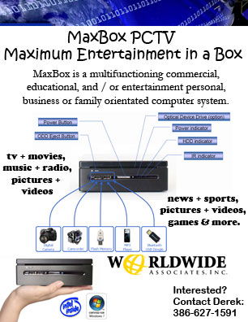

MaxTech has given birth to the leveraging component of these huge conglomerates and established, “The First Cooperative CyberCity” which includes its own bedroom economic stimulus package, whereby merchants earn money on hundreds of millions of products through the “global shopping” and MaxBox PC/TV. Portions of proceeds also given to churches, charities, temples, and other community action programs.

MaxTech and its affiliated concerns specialize in the open forum of the global Internet, initially designed to mass market, has transcended its business acumen and expertise in geo specified traditional, Internet marketing, and cell phone marketing methodology mix, clearly, designed to rejuvenate or catapult more customers to local business merchants, hence, leverage their physical resources for the Max Worldwide consortium products and services.

All purchasers for MaxBox “Entertainment in a Box” (B2C) and “Biz in a Box” (B2B) also truncate to the “county to global” website. Consumer’s can choose and purchase from hundreds of millions of products from worldwide, world renowned stores, with all name brand products. Purchasers of the MaxBox PC/TV can receive a lifetime of cash back rebates of up to 10% on all purchases, which consumers would normally buy. Every time an end user goes on the Internet the mall is right on their big screen TV.

“Save money, save gas, save time; we bring the mall to you”. (Restrictions do apply)

http://eflagler.com/keyword.aspx

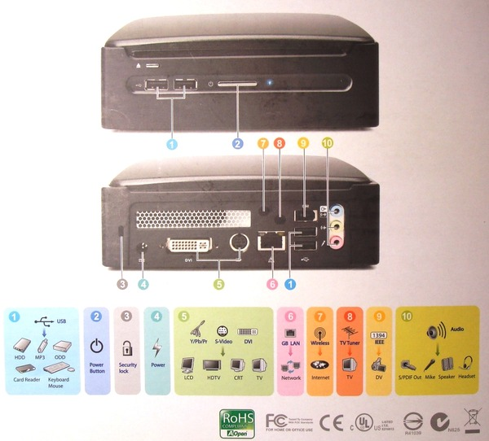

MaxBox PCTV “Maximum Entertainment in a Box”

“Watch on your time not their time and your dime”
Say Good-Bye-Bills No more Cable Bills!!! No More Phone Bills!!! Save $100.00 dollars or more a month.
That’s$1,200 to $2,000 a year. $144,000 average lifetime savings
(Depending on your existing cable and landline telephone bill).

- FREE TV (New movie releases, classics, to TV episodes and programming)
- FREE MOVIES
- FREE MUSIC
- FREE NEWS
- FREE SPORTS
- FREE LONG DISTANCE CALLING
- FREE COMPUTER / WINDOWS OPERATING SYSTEM
- FREE DVD / BLURAY PLAYER
- FREE BLUETOOTH
- FREE SURROUND SOUND SYSTEM
- FREE WIRELESS INTERNET DEVICE
- FREE WIRELESS KEYBOARD AND MOUSE
- FREE WIRELESS REMOTE
- FREE FREE FREE

MaxBox PCTV - Find More Than 100,000 DVD Titles on MaxBox PCTV and its affiliates with up to 17,000 movies to watch on your TV NOW!!!
- MaxBox and its affiliate concerns now feature more than 100,000 titles and television programs.
- MaxBox and its affiliated concerns also offers free DVD shipping, no late fees with so many titles to choose from, you will love the convenience and value MaxBox has to offer.
- In conjunction with, “county to global” website and affiliated concerns Facebook, Yahoo, Twitter, Google, Bing, MSN, MSNBC, Fox, Disney, PBS, CBS, ABC, Universal Studios, Hollywood studios such as Walt Disney Pictures, Sony Pictures Entertainment, Overture Films, Revolution Studios, Miramax Films, Touchstone Pictures, Hollywood Pictures, Pixar, TriStar, Screen Gems, Sony Classics and Warren Miller Films. Select first-run theatrical films The Weinstein Company, IFC and Yari Film Group are also available. You name it we got it. If we don’t contact us.
New Releases and watch immediately
Action & Adventure
Anime & Animation
Blu-ray
Children & Family
Classics
Comedy
Documentary
Drama
Faith & Spirituality
Foreign
Horror
Independent
Music & Musicals
Romance
Sci-Fi & Fantasy
Special Interest
Sports & Fitness
Television
Thrillers

Slogan “Bring the vision back into television; take the personal out of personal computer”

Slogan “Unify the world; one family at a time”. The ultimate in family fun, entertainment and education!!!
Get Yours Today!!! Limited Time Only and Restrictions Apply*
*****Please Read and agree or disagree to all Disclaimers on any revision of Max. (Commercial and Residential Applications).

*Restrictions apply up to one year subscription with MaxTech’s and or its assignees

MaxBox PCTV “Maximum Biz in a Box”

Earn money from the comfort of your home, on your wide screen TV, laptop or computer monitor

FREE Business Opportunity / Local Merchant Complete Solution

Licensing and Dealerships available

Max Box / MaxTech / Max Towers Merchant Service Integration

The Max MDU Model comprises a target approach to, including but not limited to, hospitals, educational facilities, libraries, municipalities, hotels, motels, any infrastructure to use all or in part the following descriptions. The collaboration of MaxTech, MaxBox, and Max Towers allows for the final solution for hardware, software, telecommunications and wireless mandates.

The ardent fact and bottom line initiative and justification for a wide array of channels of distribution and channel members are to cut costs and establish as many points of presence as possible, whether that point of presence is the purposeful intention for branding or an actual point of sale. The proper implementation of channel management and the allocation of as many points of presence are to leverage and utilize the co-existence of various joint venture relationships and/or affiliated concerns.
“Channels are the routes to and relationships with customers” (Brandweek, 1999, p. 1). The question is, are these channels beneficial or detrimental to the overall branding of an organization? Various components must be taken into consideration, including, the implementation of a well sought out structural flow and dissemination of information, including but not limited to, branding, product and service lines. The persona of the channel marketer is a key factor and must be considered carefully, when potentially utilizing and leveraging from other peoples resources (OPR).

MaxBox Merchant Executive
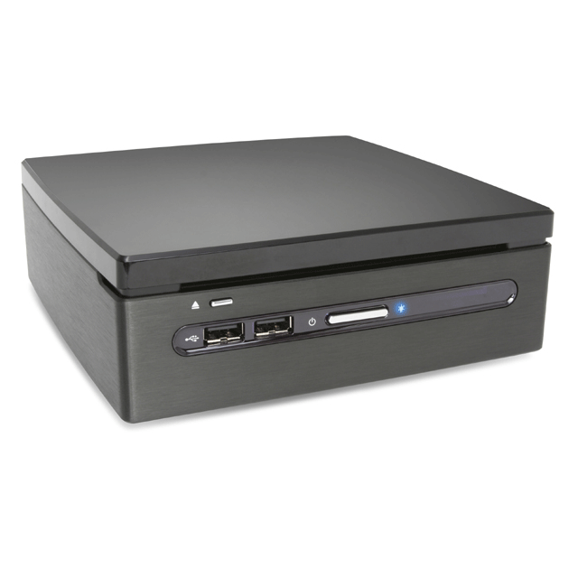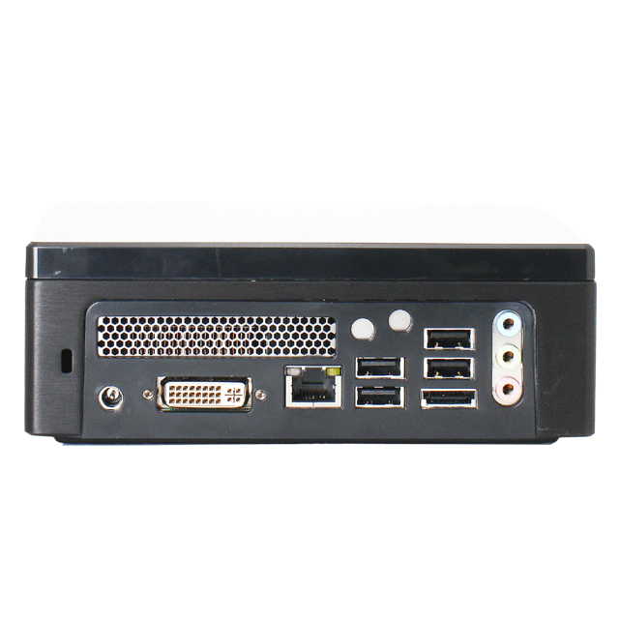
- Intel Core 2 Duo P8400 – 2.26GHz, 1066MHz, 3MB
- 4B DDR2-800MHz SODIMM Memory
- 320GB 7200rpm SATA2 8MB Hard Drive
- 8X SATA DVD+/- Slim Optical Drive
- Windows 7 Home Premium
- 8.2.11b/g Wireless Kit
- Mini USB Keyboard & Mouse
- DC 20V Jack x 1
- DVI-i Port x 1
- USB 2.0 Port x 4
- eSATA Port x 1
- RJ-45 LAN Jack x 1
- Line-In (Surround-Out L/R) with S/PDIF_Out x 1
- Line_Out (Front-Out L/R) x 1
- Mic-In(Central/Subwoofer out) x 1

$1997.00

MaxBox Merchant Professional
- Intel Celeron M 575 – 2.0GHz, 667MHz, 1MB Processor
- 2GB DDR2-800MHz SODIMM Memory
- 250GB 5400rpm SATA2 8MB Hard Drive
- 8X SATA DVD+/- Slim Optical Drive
- Windows Vista Home Basic
- DC 20V Jack x 1
- DVI-i Port x 1
- USB 2.0 Port x 4
- eSATA Port x 1
- RJ-45 LAN Jack x 1
- Line-In (Surround-Out L/R) with S/PDIF_Out x 1
- Line_Out (Front-Out L/R) x 1
- Mic-In(Central/Subwoofer out) x 1

$1497.00

MaxBox Merchant Administrative
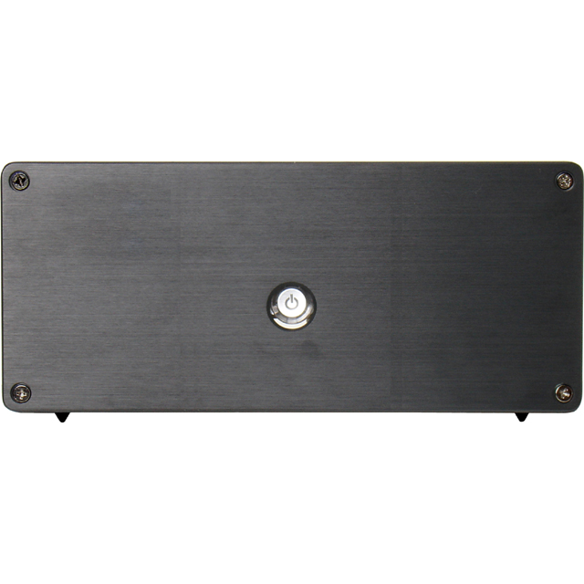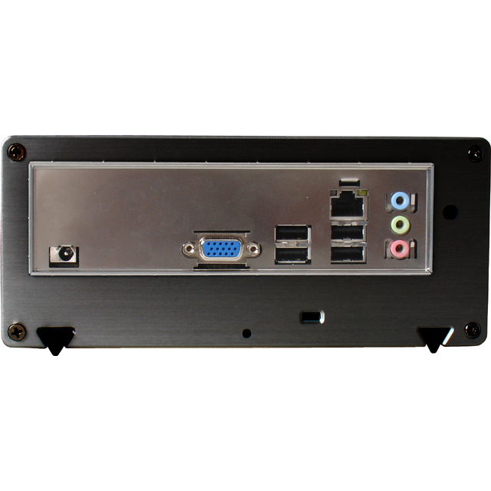
- Intel Atom 330 – 1.6GHz, 533MHz, 1MB Processor
- 1GB DDR2 PC6400 (800MHz) Memory
- 160GB 5400rpm SATA2 8MB Notebook Hard Drive
- Speaker-out : x 1
- Power DV-in Jack : x 1
- USB 2.0 : x 4
- VGA : x 1
- LAN : x 1
- Line-in : x 1
- Mic-in : x 1

$497.00

References:

King, K.W., Lane, W.R., Russell, J.T. (2008). Kleppner's advertising procedure. (17th
ed.) NJ: Pearson-Prentice Hall.

N.A. Channel management: A framework for revolution. (Nov.15, 1999), Brandweek, 40
(43), 28-33. http://www.findarticles.com/p/articles/mi_m0BDW/is_43_40 Retrieved
from: http://findarticles.com/p/articles/mi_m0BDW/is_43_40/ai_57841478/ on
October 30, 2009.

Crum, C. Retrieved from http://www.webpronews.com/topnews/2009/12/23/average-person- spends-13-hours-a-week-online Retrieved on December 27, 2009.

Crum, C. Retrieved from http://www.webpronews.com/topnews/2009/12/23/average-person-spends-13-hours-a-week-online Retrieved on December 27, 2009.

Hawkins, D. I., Mothersbaugh, D. L. & Best, R. J. (2007). Consumer behavior: Building
marketing strategy (10th ed.). New York: McGraw-Hill.

Kotler , P. & Keller, K.L. (2006). Marketing management. (12th edition). NJ: Prentice
Hall.

Sachoff, M. Retrieved from http://www.webpronews.com/topnews/2009/07/22/more-advertisers-turning-to-internetRetreived from 26, 2009.

Sachoff, M. Retrieved from http://www.webpronews.com/topnews/2008/12/15/americans-would-give-up-sex-for-internet-access Retrieved on December 26, 2009.
Green, R., & Katz, J. (2009). Entrepreneurial small business. (2nd Ed.). New York, NY:
McGraw-Hill Companies Inc.
Hawkins, D. I., Mothersbaugh, D. L. & Best, R. J. (2007). Consumer behavior: Building
marketing strategy (10th ed.). New York: McGraw-Hill.
Kotler , P. & Keller, K.L. (2006). Marketing management. (12th edition). NJ: Prentice
Hall.

Lane, W. R., Whitehill King, K. & Russell, J. T. (2008). Kleppner’s advertising
procedure. (17th edition). NJ: Pearson Prentice Hall.

Thurman, P. W. (2008). MBA fundamentals statistics. New York, New York: Kaplan Publishing.
Zinkhan, G.M. (September, 1994). Advertising ethics: Emerging methods and trends. Journal of
^{Advertising, 23 (3), 1-4.}

